Instructions for cleaning and maintenance
If the mouthpiece is used to actuate the cursor movements via lip/mouth movements, a careful cleaning procedure is essential to avoid bacteria and health problems! Read this section carefully and apply the needed cleaning procedures whenever necessary.

Exchanging the saliva filter:
The saliva filter is placed inside the mouthpiece. Usually, no (or nearly no) saliva should enter the stick – but it strongly depends on the person using the mouthpiece and his/her condition. If saliva enters the hygienic stick, the saliva filters prevents the moisture entering the inner parts of the FLipMouse (respectively the pressure sensor). The filter can be replaced as follows:

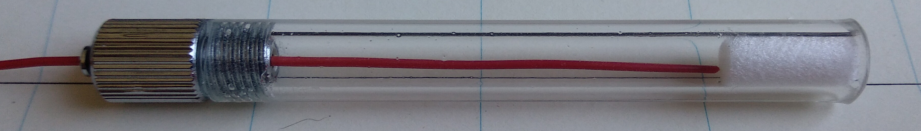
Remove the filter by pressing it out with the included wire. (alternative: use something with a diameter of up to 1.5mm)

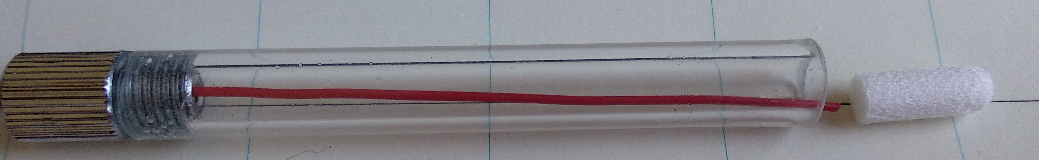
The removed filter

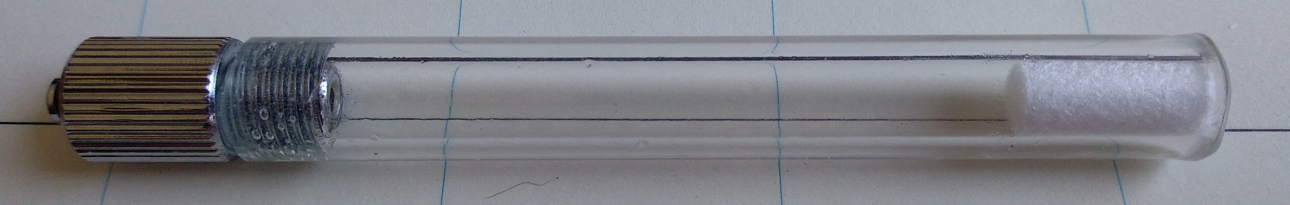
Inserting a new filter (pushing it back into the mouthpiece)

Disinfection of the mouthpiece/hygienic stick:
To disinfect a mouthpiece, use boiling water or disinfection alcohol. Place the mouthpiece (without saliva filter) in boiling water for at least five minutes. Then let the hygienic stick dry before inserting a new filter and using it.

Ordering replacement sticks and filters:
You can order replacement filters or mouthpieces here:

https://assistronik.info

