

AsTeRICS

WebACS - Quick-Start Guide
KI-I
Stefan Parker
(based on work by Brigitte Nußbaumer)

Document Information
Issue Date
Status | draft
Dissemination Level | PU  PU Public  PP Restricted to other programme participants (including the Commission Services)  RE Restricted to a group specified by the consortium (including the Commission Services)  CO Confidential, only for members of the consortium (including the Commission Services)
Table of Contents

1 General Information 4
1.1 Definition AsTeRICS 4
1.2 Definition ACS 4
1.3 Definition ARE 4
1.4 Required devices and conditions 4
2 Installation 5
2.1 Start the installation 5
2.2 Define the installation path 5
2.3 Select components 6
2.4 Define Start Menu folder entry 7
2.5 Progress of installation 7
2.6 Installation finish 8
2.7 Complete (check) the installation 8
2.7.1 Desktop Short Cuts 8
2.7.2 Programs in the Start Menu 8
3 Creating Models – a first Example 9
3.1 Reducing Tremor 12
3.2 Adjusting the Webcam 13

General Information
These instructions will help you to install the open-source-software AsTeRICS and use it together with the latest graphical editor, the WebACS. The installation process will be described step-by-step.

Definition AsTeRICS
„Assistive Technology Rapid Integration and Construction Set“.
With AsTeRICS, you can easily and economically build, use and adapt your efficient and individual "Assistive Technologies". The input capabilities of AsTeRICS are very flexible. AsTeRICS can be used and combined with different input-devices such as a webcam, switches or an on-screen scanning keyboard.
The various output-capabilities of the system include PC device emulation, game control, environmental control applications and utilization of embedded devices.

Definition WebACS
AsTeRICS Configuration Suite is a graphical editor for easy building and adapting “Assistive Technologies”.
For this purpose you use sensors, actuators and processors, which are included in the software. You can connect these elements and build your own individual setup (also called a “model”), which is specially adapted for your needs, easily and fast.
The WebACS is a fully accessible and platform independent web application, optimised for usage with Mozilla Firefox, version 35.0.1 or higher. The AsTeRICS suite for Windows also contains the old version of the ACS, which is platform dependent and not accessible, but can of course also be used.

Definition ARE
The AsTeRICS Runtime Environment is the basic software framework for all AsTeRICS applications and use-cases. The models built in the WebACS will run in the ARE. The WebACS can be seen as a configuration program for the ARE.

Required devices and conditions
- A PC / notebook / tablet with Windows XP / VISTA / 7 or later
- Mozilla Firefox version 35.0.1 or later
- Internet access

Installation
To be able to use all AsTeRICS software components you will have to install the software framework as well as the WebACS.

Installation oft the AsTeRICS software framework
AsTeRICS provides an installer for Windows, Linux and Mac OSX, but only on Windows the full AsTeRICS suite is supported. On the other platforms the installer only contains the ARE. For detailed platform-specific installation instructions, please refer to the release documentation.
The following steps describe how the AsTeRICS software framework can be installed on a PC with Windows operating system.
Download the AsTeRICS setup executable from the github releases section.

Start the installation
Start the setup file.

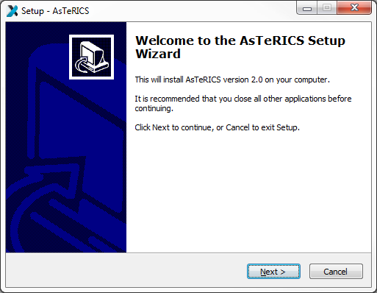
You should see the welcome window. It informs you which version of the software you are installing. Click the button „Next“.

Define the installation path

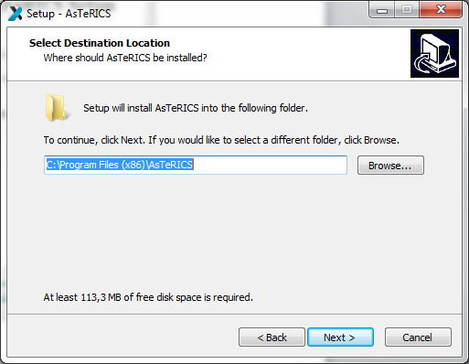
In this dialogue you can define the installation path. That means you can choose the folder, where AsteRICS will be installed. We suggest using the standard installation path. Then click the button „Next“.

Select components
You can see the component selection window:
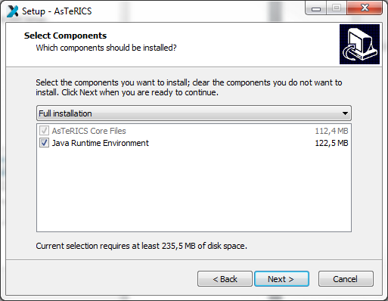
AsTeRICS needs the Java Runtime Environment (>= Version 7, 32-Bit Version). If you have already installed the Java Runtime Environment on your computer, please deselect this option and install only AsTeRICS (Note: The 32-bit version of the JRE is recommended, because some plugins only work in 32-bit mode).
Then, click the button „Next“.

Define Start Menu folder entry
In the next dialogue you can define the name of the start menu entry. You can see the following window:
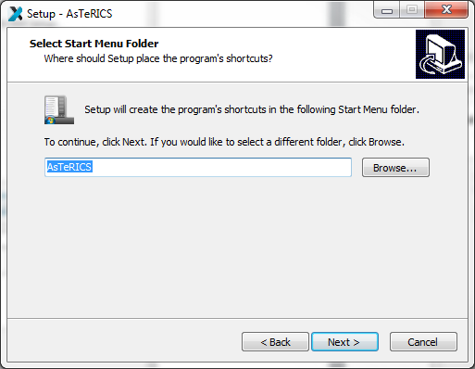
Click the button „Next“.

Progress of installation
In the next dialogue you can see the progress of the installation. It can take a few minutes until the process is finished:
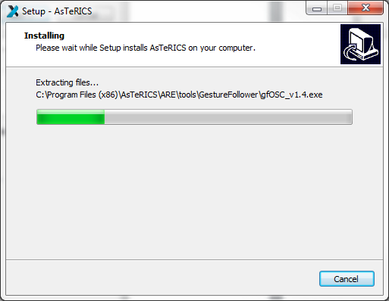

Finish the Installation
You can see the following window:
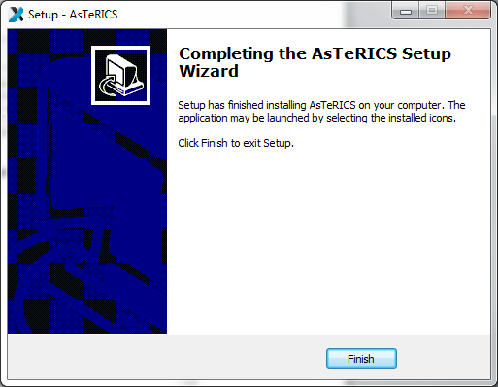
Click the button „Finish“.
You have successfully installed AsTeRICS.

Complete (check) the installation

Desktop Short Cuts
On your desktop you will find the following links (short cuts):
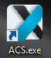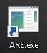
These short cuts can be used to start ACS (old version) and ARE. However, for the ARE to work together with the WebACS, it has to be started from console using the “—webservice”-flag. To do this, open a console window, cd to the folder containing ARE.exe and then type “start_debug –webservice”:
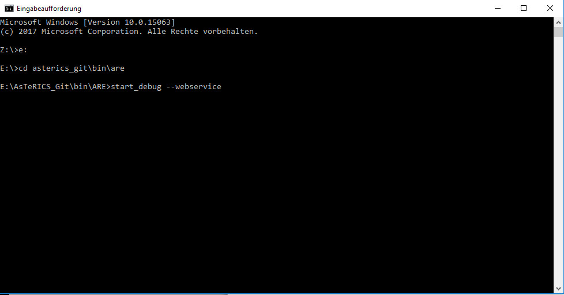
After pressing Enter. the ARE will start with a webservice running in the background, which enables the ARE to communicate with the WebACS.

Installation of the WebACS
The WebACS needs no dedicated installation. All that has to be done is to download the files and place them in a folder. You can download the WebACS directly from the Github repository. To do so, find the button “Clone or Download”:

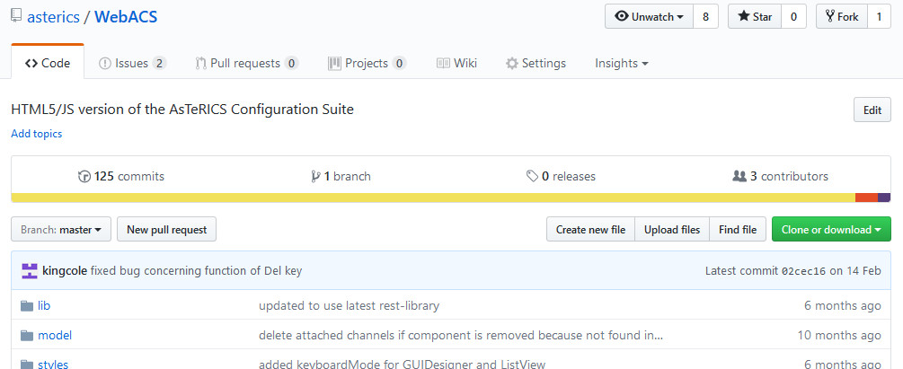

Click that button and then click “Download ZIP”, which will download the WebACS as ZIP-archive. On your computer create a folder “WebACS” and extract the contents of the archive there.
To start the WebACS, open the file “WebACS.html” in Mozilla Firefox.

Creating Models – a first Example

A model is a collection of 1 to n components, where a component represents a plugin of the ARE. These components are connected via cannels (for data connections) and event channels (representing events). The following example will illustrate the creation of a simple webcam mouse, using the position of the nose to control the cursor and opening the mouth to trigger a mouse click. This model requires a connected and installed webcam.

In a first step, open “WebACS.html” in Mozilla Firefox and start the ARE incl. webservice as described above. In the WebACS window select the tab ‘Components’, then ‘Sensors’ and within the sensors the menu item ‘Computer Vision’. There select the component FacetrackerLK. The component is now on the drawing area and, if the component is selected, properties can be set (or changed) in the rightmost part of the WebACS window.
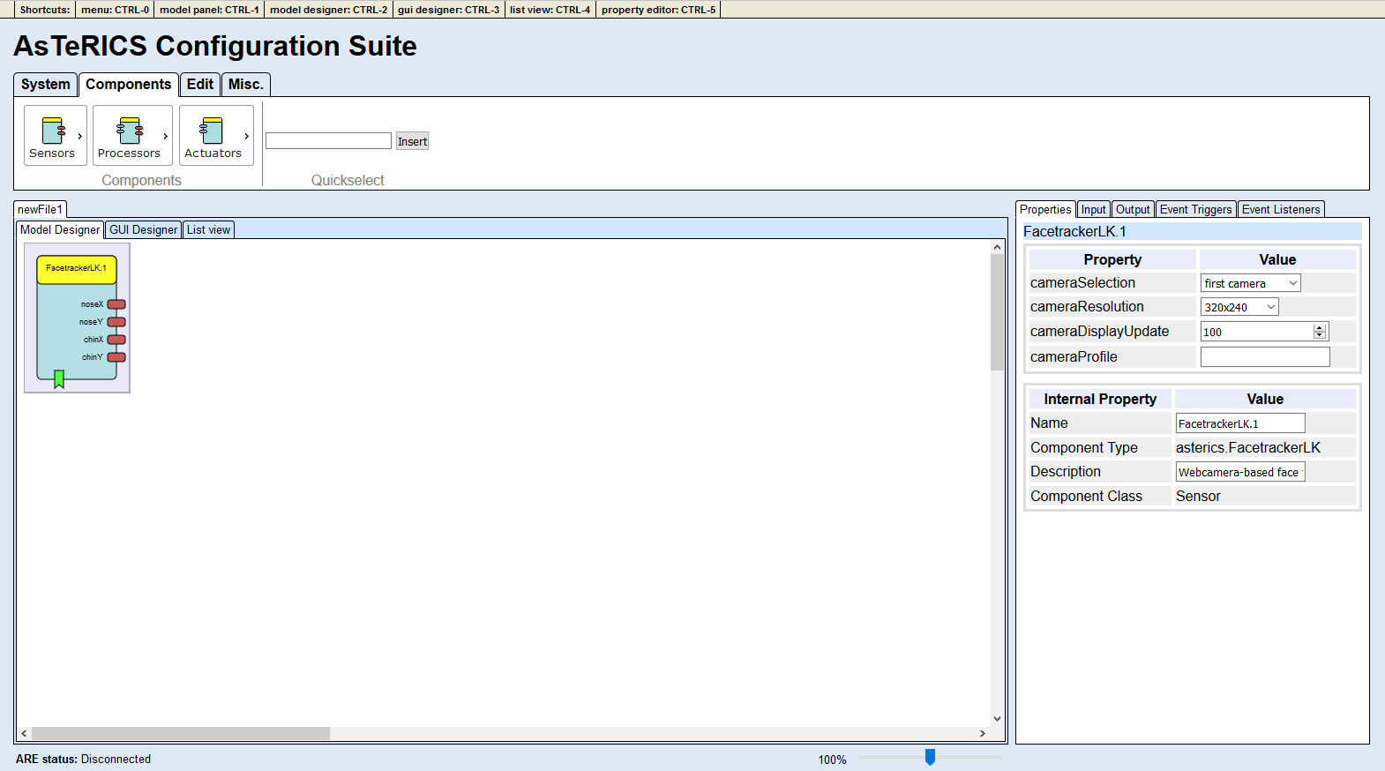
The next needed component is the ‘Mouse’, it can be found by selecting ‘Actuators’ -> ‘Input Device Emulation’. After the insert, select the Mouse component and adapt the properties. Deactivate absolutePosition and set the xMax and yMax to your screen resolution (or to 0 for auto-detection of your screen resolution).
In the next step, connect the noseX and the noseY outputs of the ‘FacetrackerLK’ with the mouseX and mouseY inputs of the Mouse. Finally, it should look like the screenshot below.
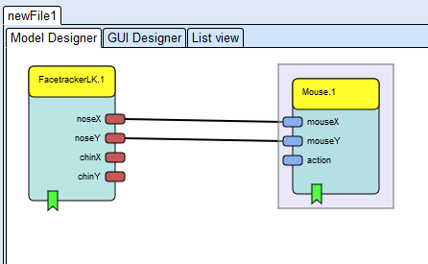
The model now would be able to use the coordinates of the nose to control the mouse cursor, but the mouse click is still missing.
For the mouse clicking functionality, we first need the ‘MathEvaluator’ (‘Processors’ -> ‘Basic Math’) plugin. We connect the noseY output of the ‘FacetrackerLK’ the with the inA input of the ‘MathEvaluator’ and likewise the chinY with inB. In the properties of the ‘MathEvaluator’, we set the property expression to ‘b-a’.
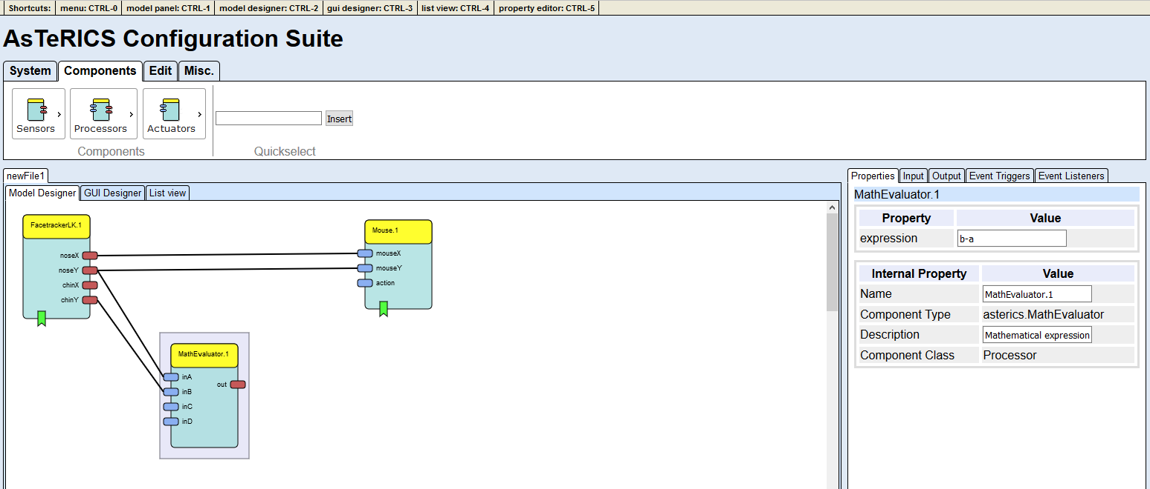
We will ‘Differentiate’ (‘Processors’ -> ‘Basic Math’) the out value to react on a fast change of the nose to chin distance.
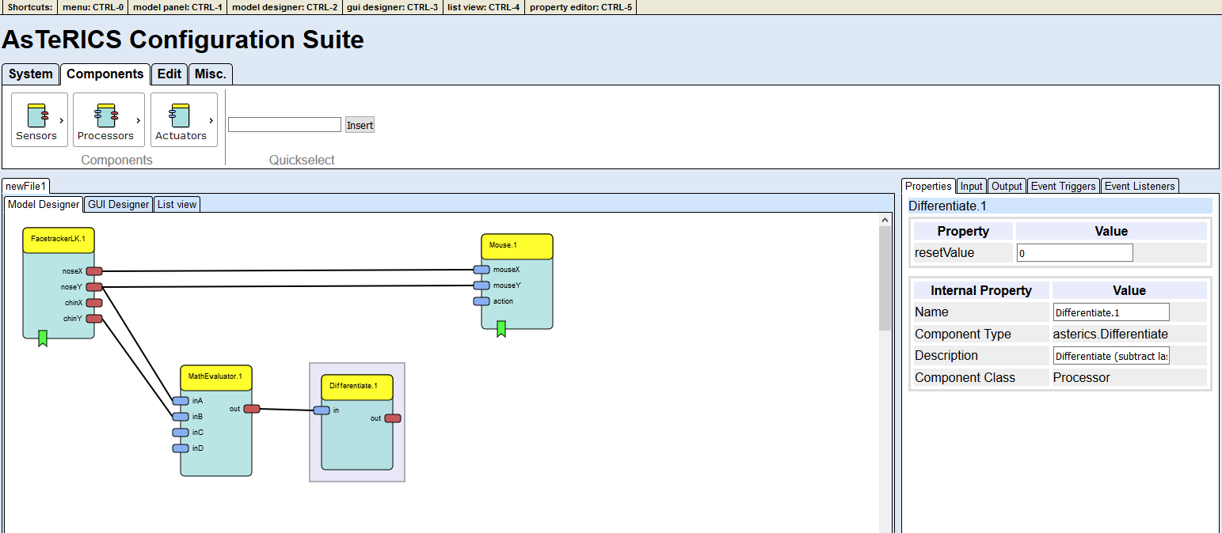
This processed value will then be forwarded to a ‘Threshold’ (‘Processors’ -> ‘Basic Math’) component. Set the thresholdLow and thresholdHigh values to 30.
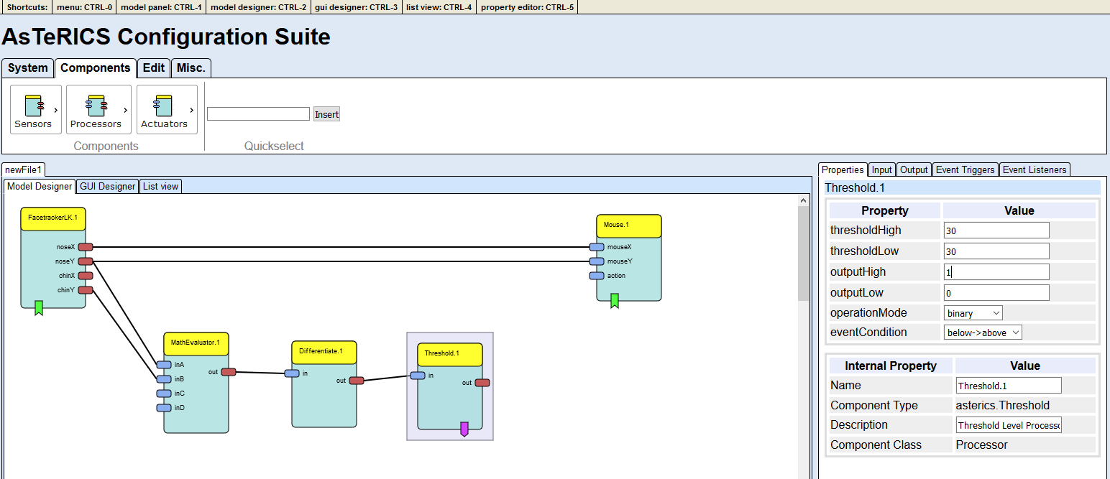
As a final step, connect the event trigger output of the ‘Threshold’ with the event listener input of the ‘Mouse’ – the event triggers and listeners are at the bottom of the components. After the connection has been made, set the leftClick to eventPosEdge in the property editor at the right. If everything was done right, it should look like the following screenshot:
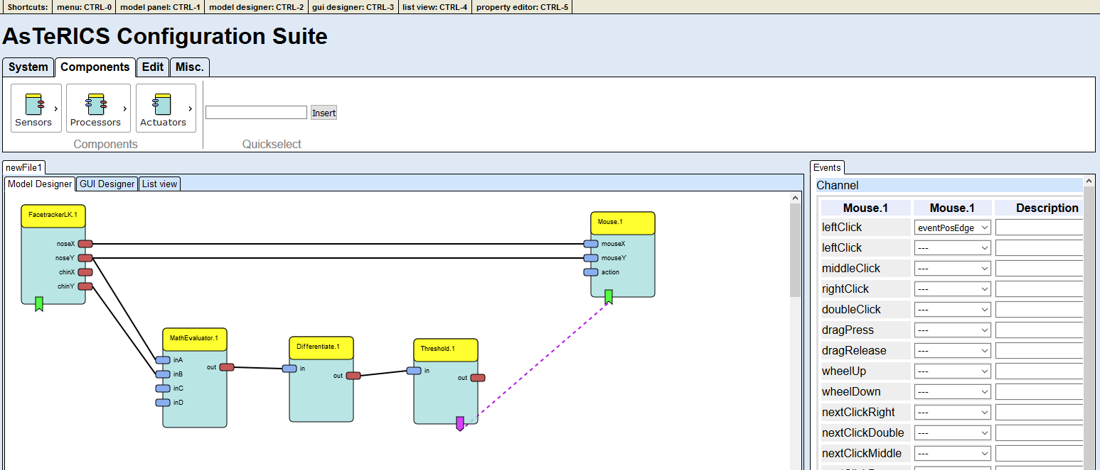
Now, change to the “System”-Tab of the menu and hit “Connect to ARE”. This should result in many previously deactivated buttons being activated and the ARE status showing “Model running / not synchronised”:
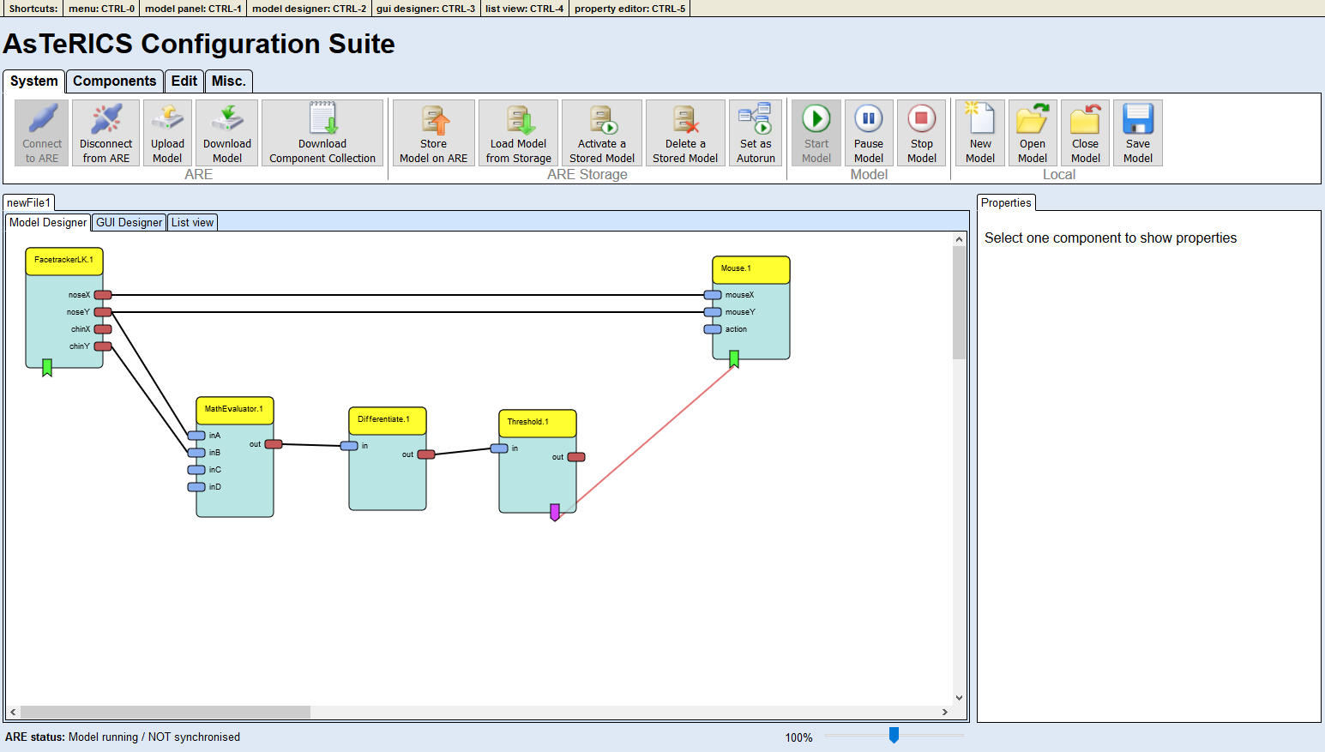
Now, click the “Upload Model” button to upload the model to the ARE and then press the ‘Start Model’ button. A window with the camera screen will appear, marking with a green and yellow circle - the position of nose and chin. Press the ‘Stop Model’ button or press F7 to stop the model and get the control of the mouse back. Below is a screenshot of the system, when running.
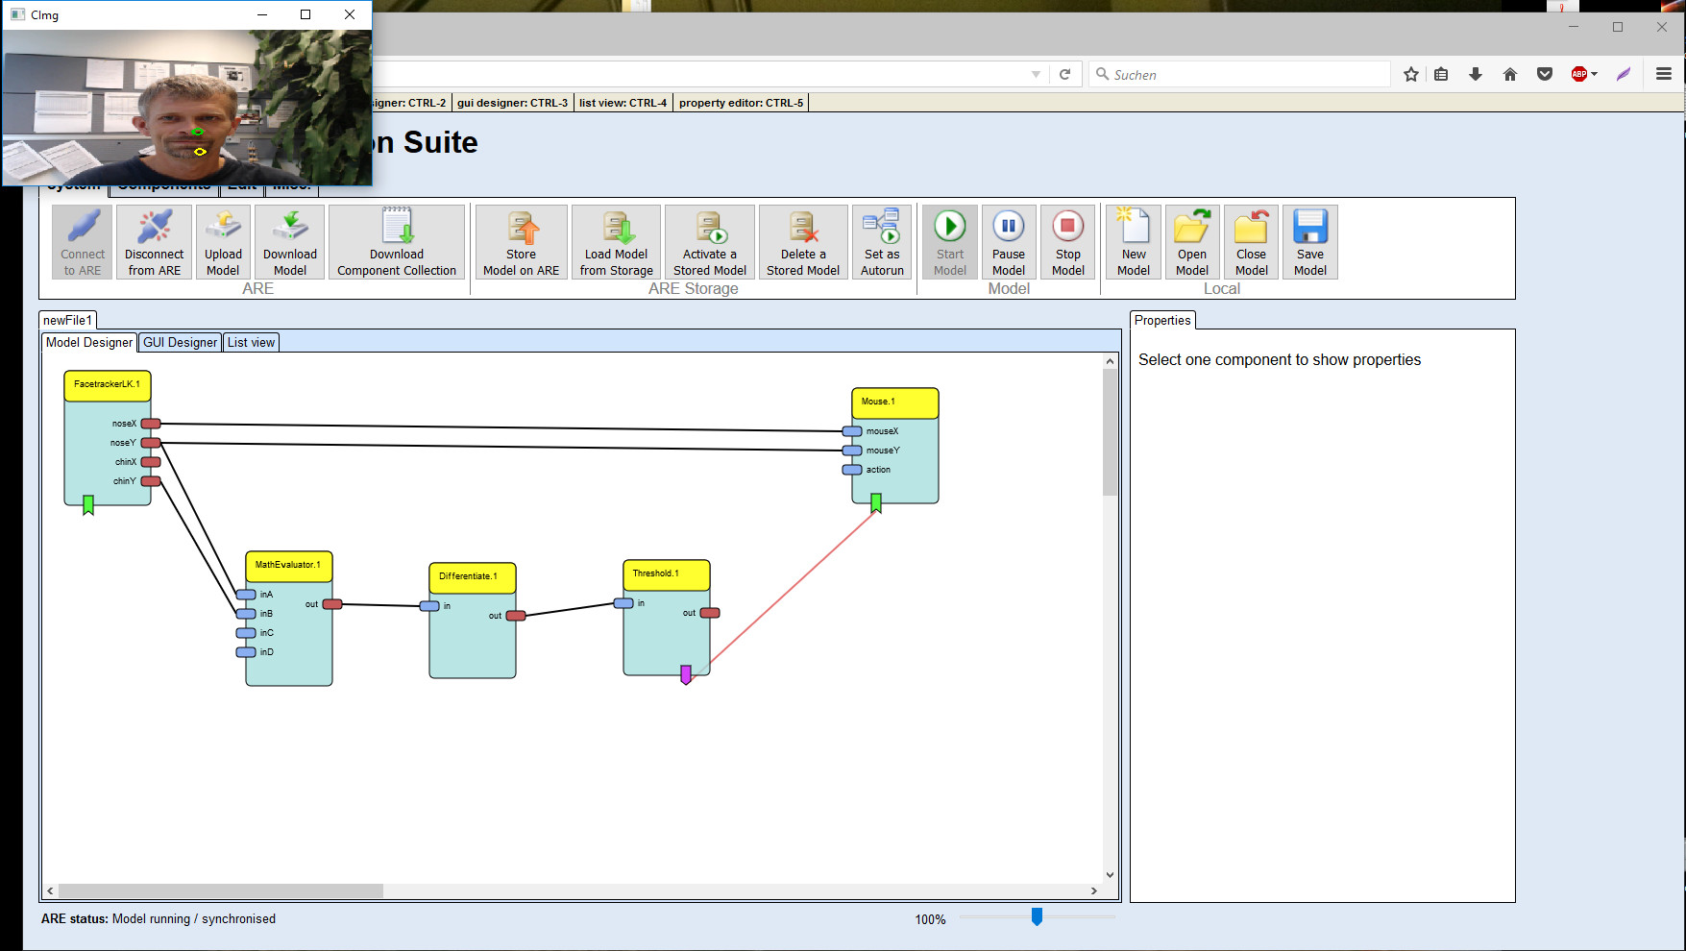
Congratulations, your first AsTeRICS model is running!

Reducing Tremor

You might have noticed that the mouse pointer has a tremor, because the head is always in movement to a certain extent. To reduce this tremor, an ‘Averager’ (‘Processors’ -> ‘Basic Math’) will be used to smoothen the X coordinates and another ‘Averager’ for the Y coordinates between the ‘FacetrackerLK’ and the ‘Mouse’. The bufferSize in the properties shall be set to 5 (a higher value will result in a calmer, but more inert mouse pointer).
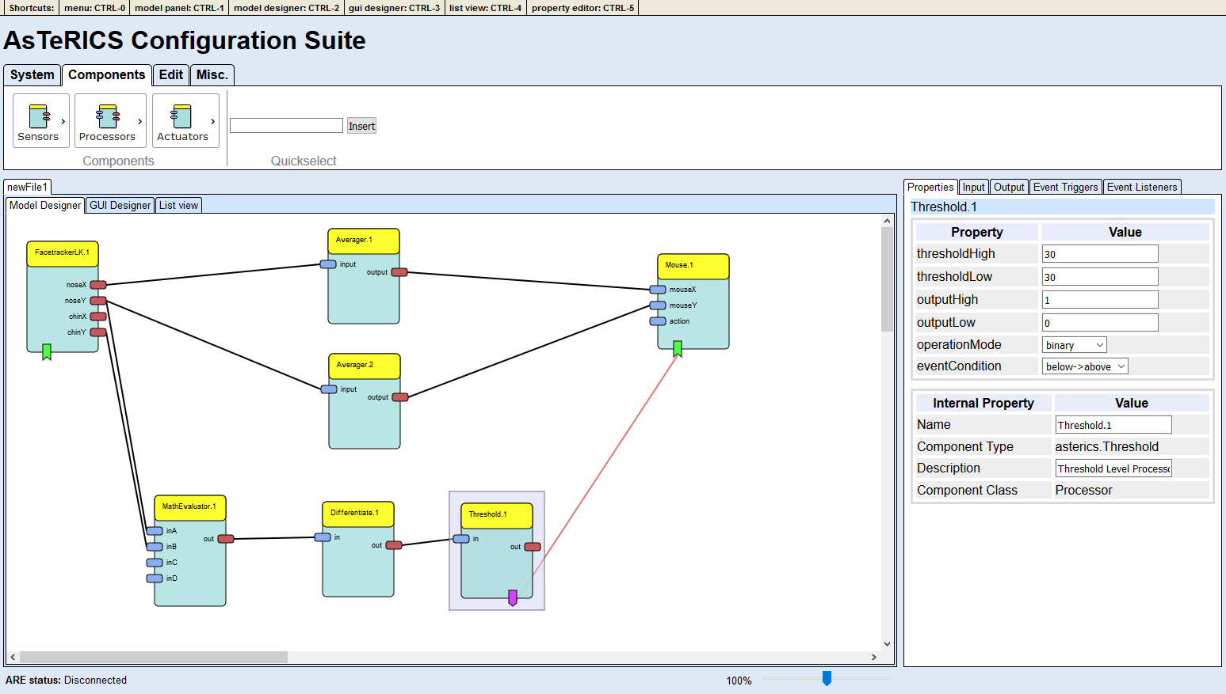
That’s all, just upload the model and start it now.

Adjusting the Webcam

If you don’t like the position of the webcam after starting the model, you can set a different start position. Select the ‘GUI Designer’ tab above the drawing area and move the FacetrackerLK window to an area, which is comfortable to you. Also the size of the window can be adjusted.

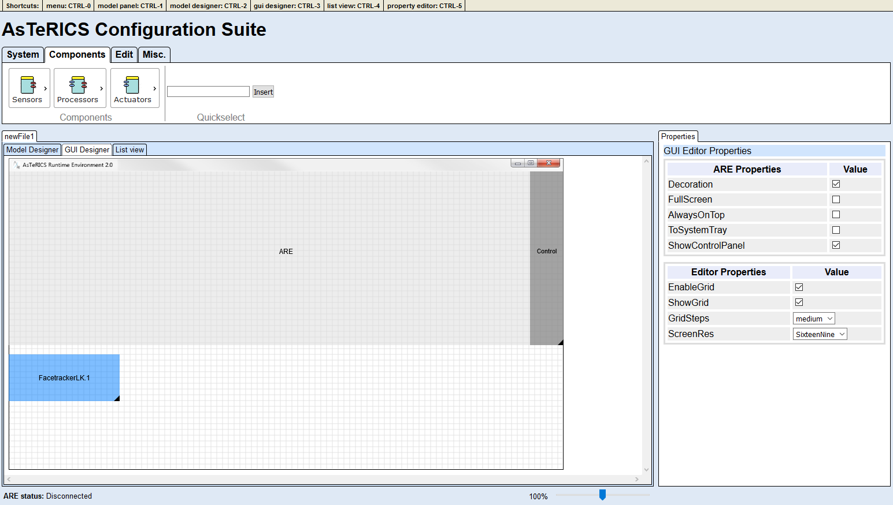

Upload and start the model to work with the changes.

Additional Features

Listview
The Listview is just a different view of the same model that is already displayed in the Model Designer and is always updated in parallel. In the Listview the model is presented textually as a list of components, with sub-lists for ports and channels. Especially for people with low vision or blind people this view is a chance to work with the WebACS, but it also poses an alternative for anyone who may not be comfortable with the graphical editor.

Keyboard Mode
Apart from usage with a mouse, the WebACS can also be used by keyboard only. To switch between the different regions of the program, the TAB-key can be used as in any other webpage. The tabpanels and menus can be navigated using the arrow keys.
The drawing area poses a special case, since the canvas cannot be navigated using the TAB-key. A dedicated keyboard mode can be activated on all three tabs of the drawing area, by pressing the Enter-key. Here is a brief description of the possible keys and their functions when in keyboard mode:
Model Designer:
- Arrow keys: move from one component to another
- shift-arrow: move component
- Space key: change to port-mode
  - Arrow keys: move from one port to another
  - shift-space: start new channel from port
    - the model designer automatically switches back to component-mode to let the user choose another component and an input-port to attach the new channel to (by pressing shift-space when the port is focussed)
  - space: switch to channel mode
    - Arrow keys: move between the channels attached to this port
    - Esc: switch back to port mode
  - Esc: switch back to component mode

GUI Designer:
- Arrow keys: move from one element to another
- shift-arrow: move element
- alt-arrow: resize element

List view:
- Arrow keys: move from one component to another
- Space key: change to port-mode
  - Arrow keys: move from one port to another
  - space: switch to channel mode
    - Arrow keys: move between the channels attached to this port
    - Esc: switch back to port mode
  - Esc: switch back to component mode

