Arcade Button – Construction Manual
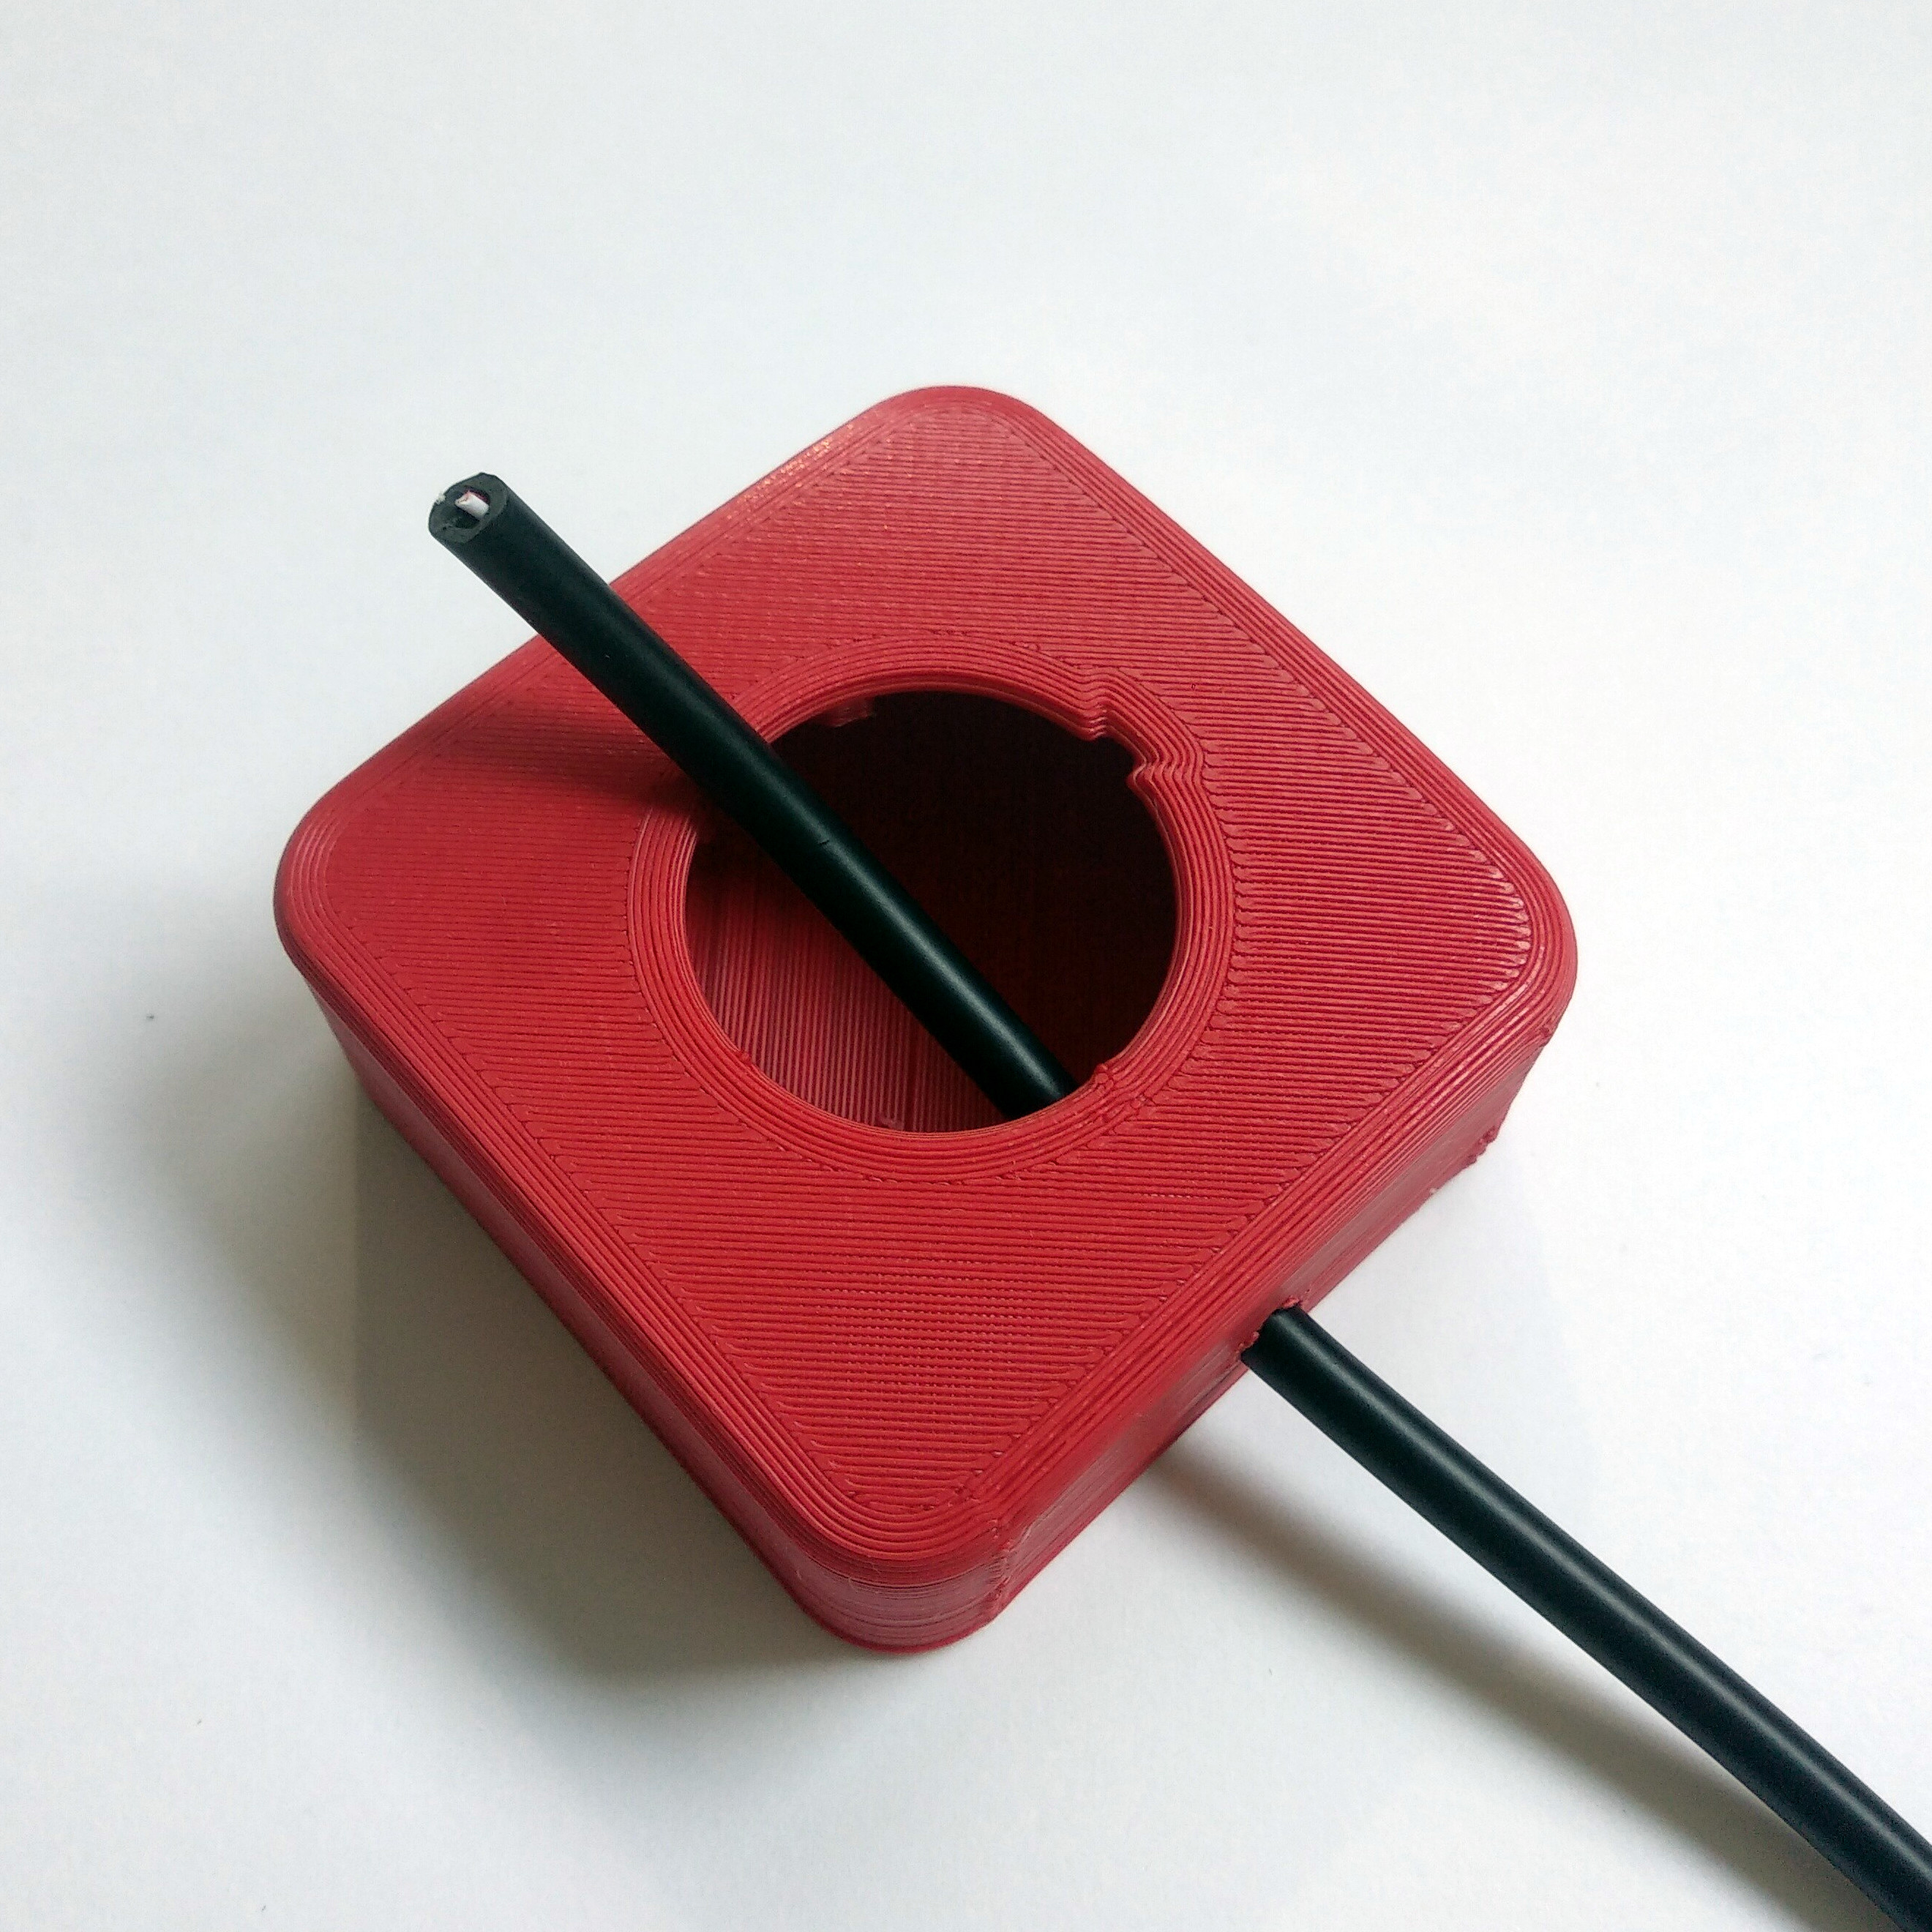  Feed the cable through the hole of the case. | 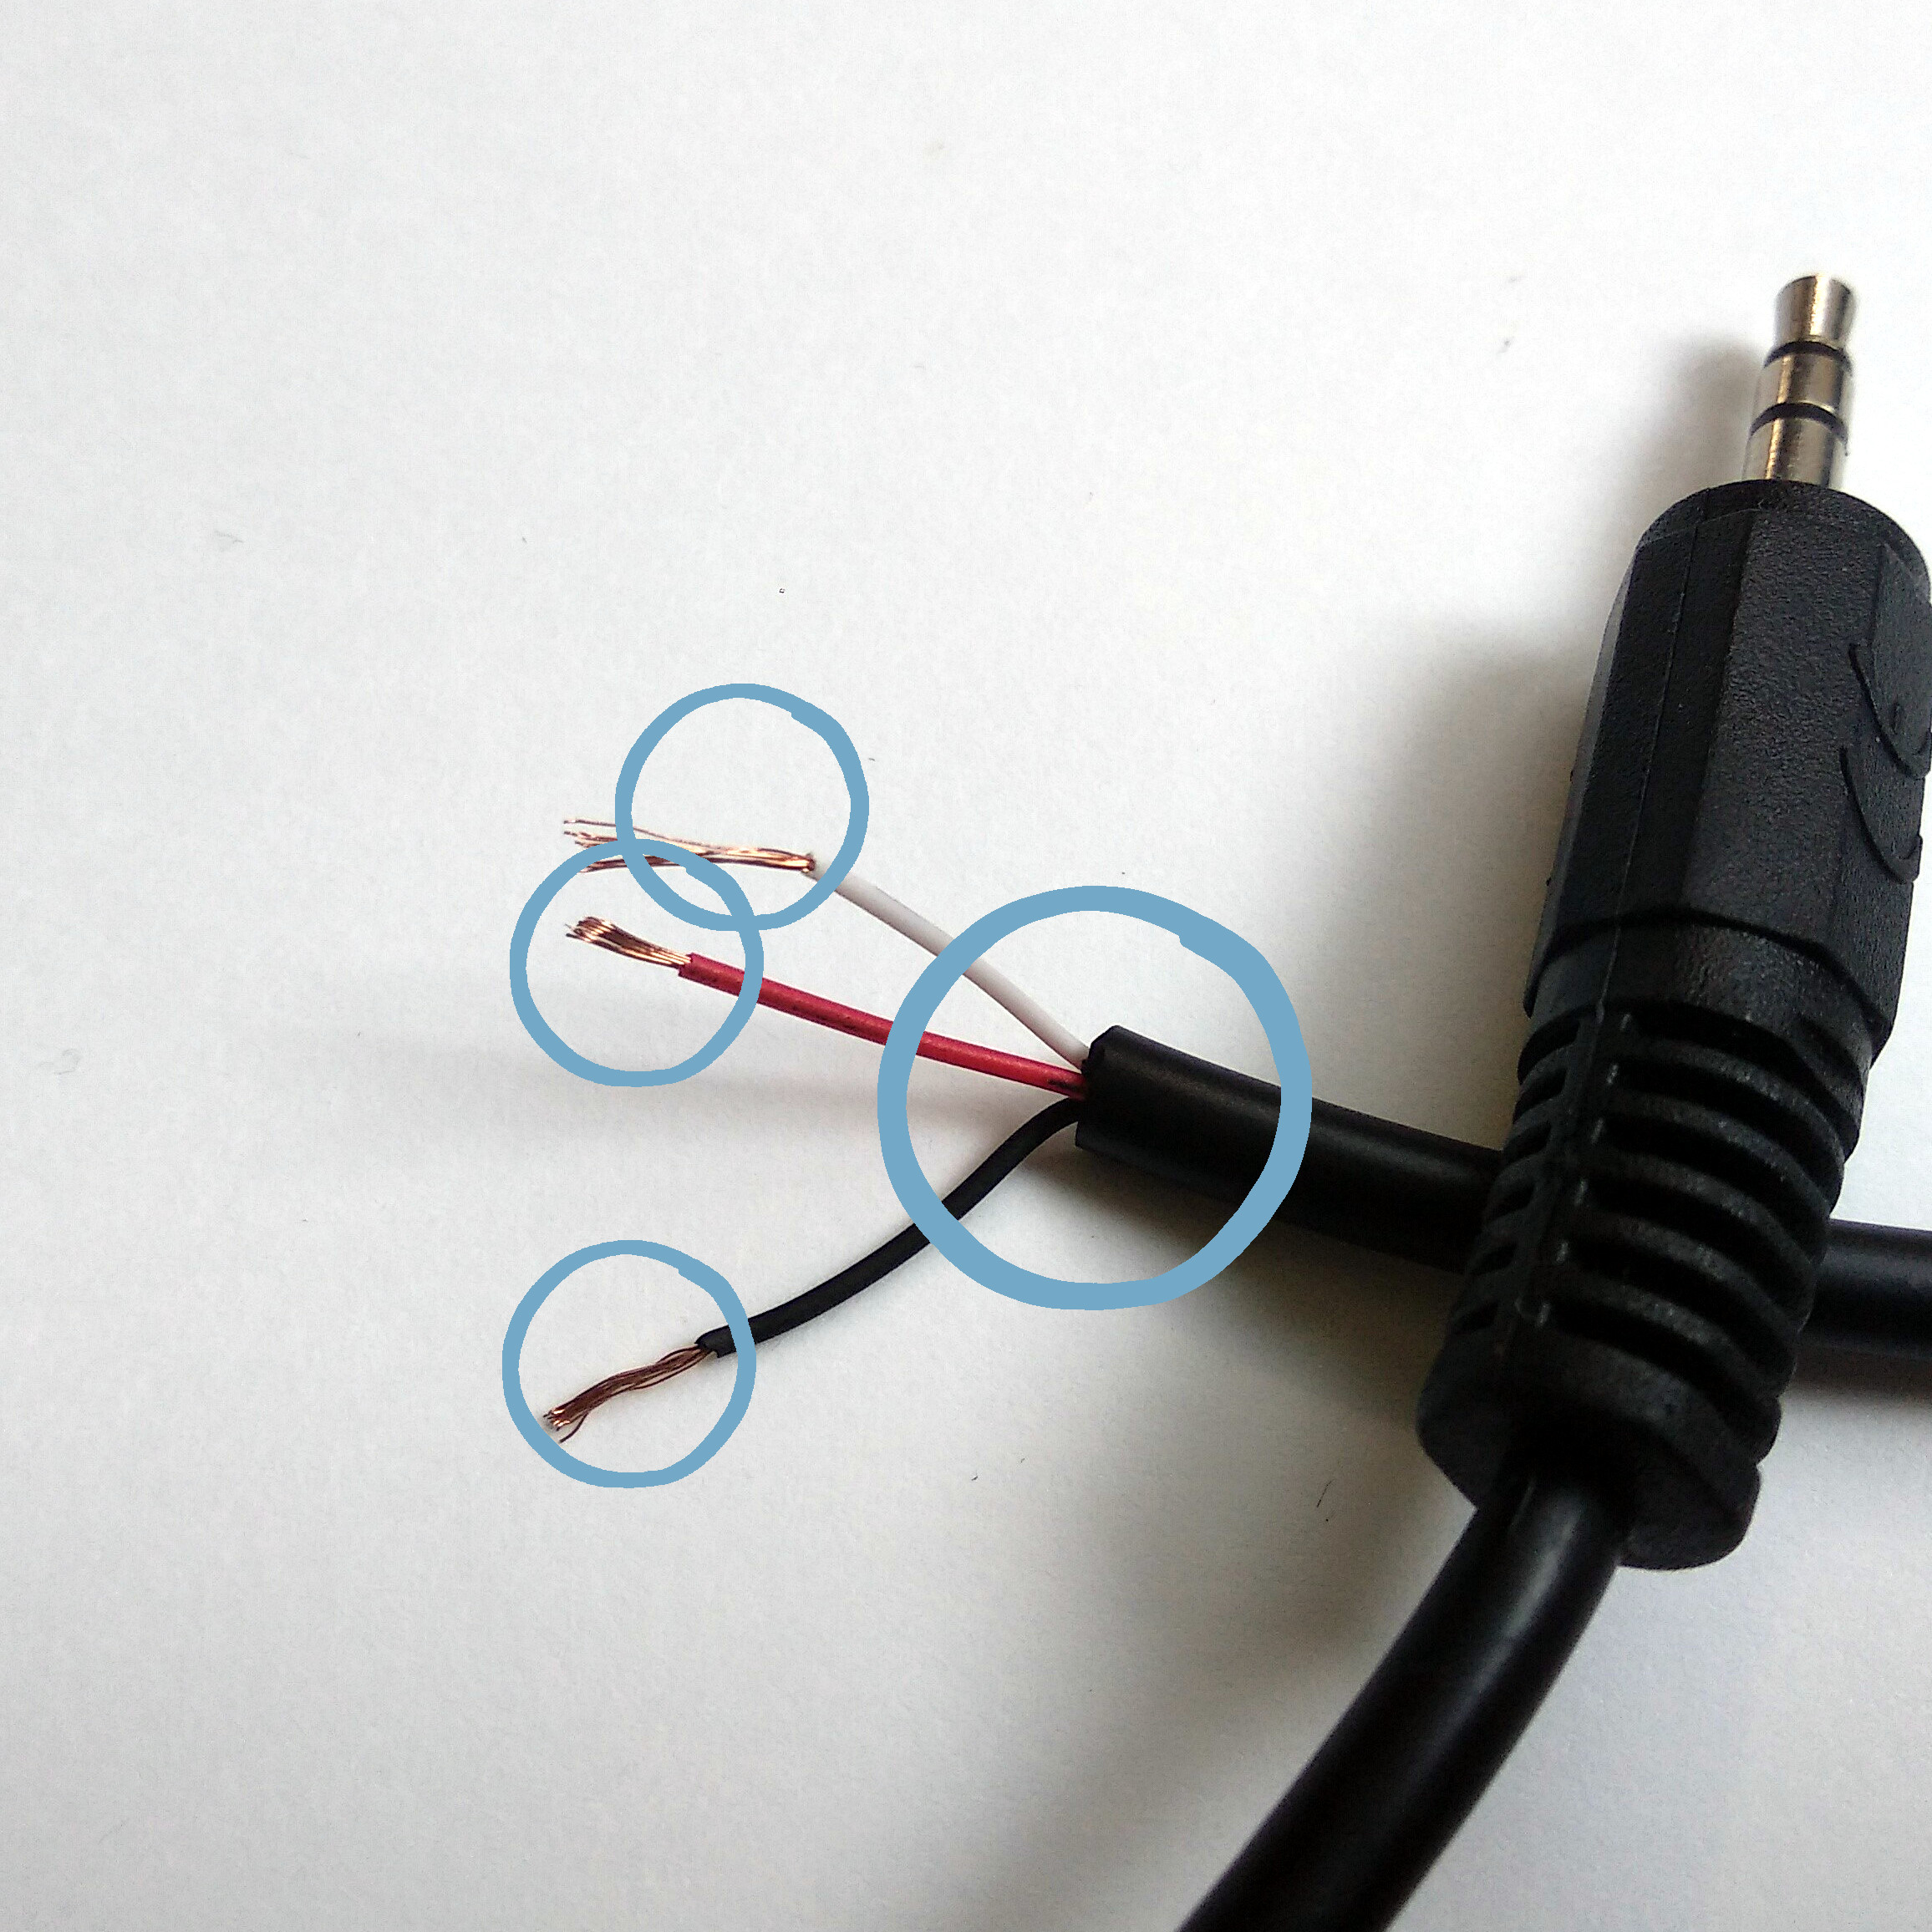  Remove the black insulation, ~3cm.  Remove the coloured insulation of all 3 wires, ~4mm.
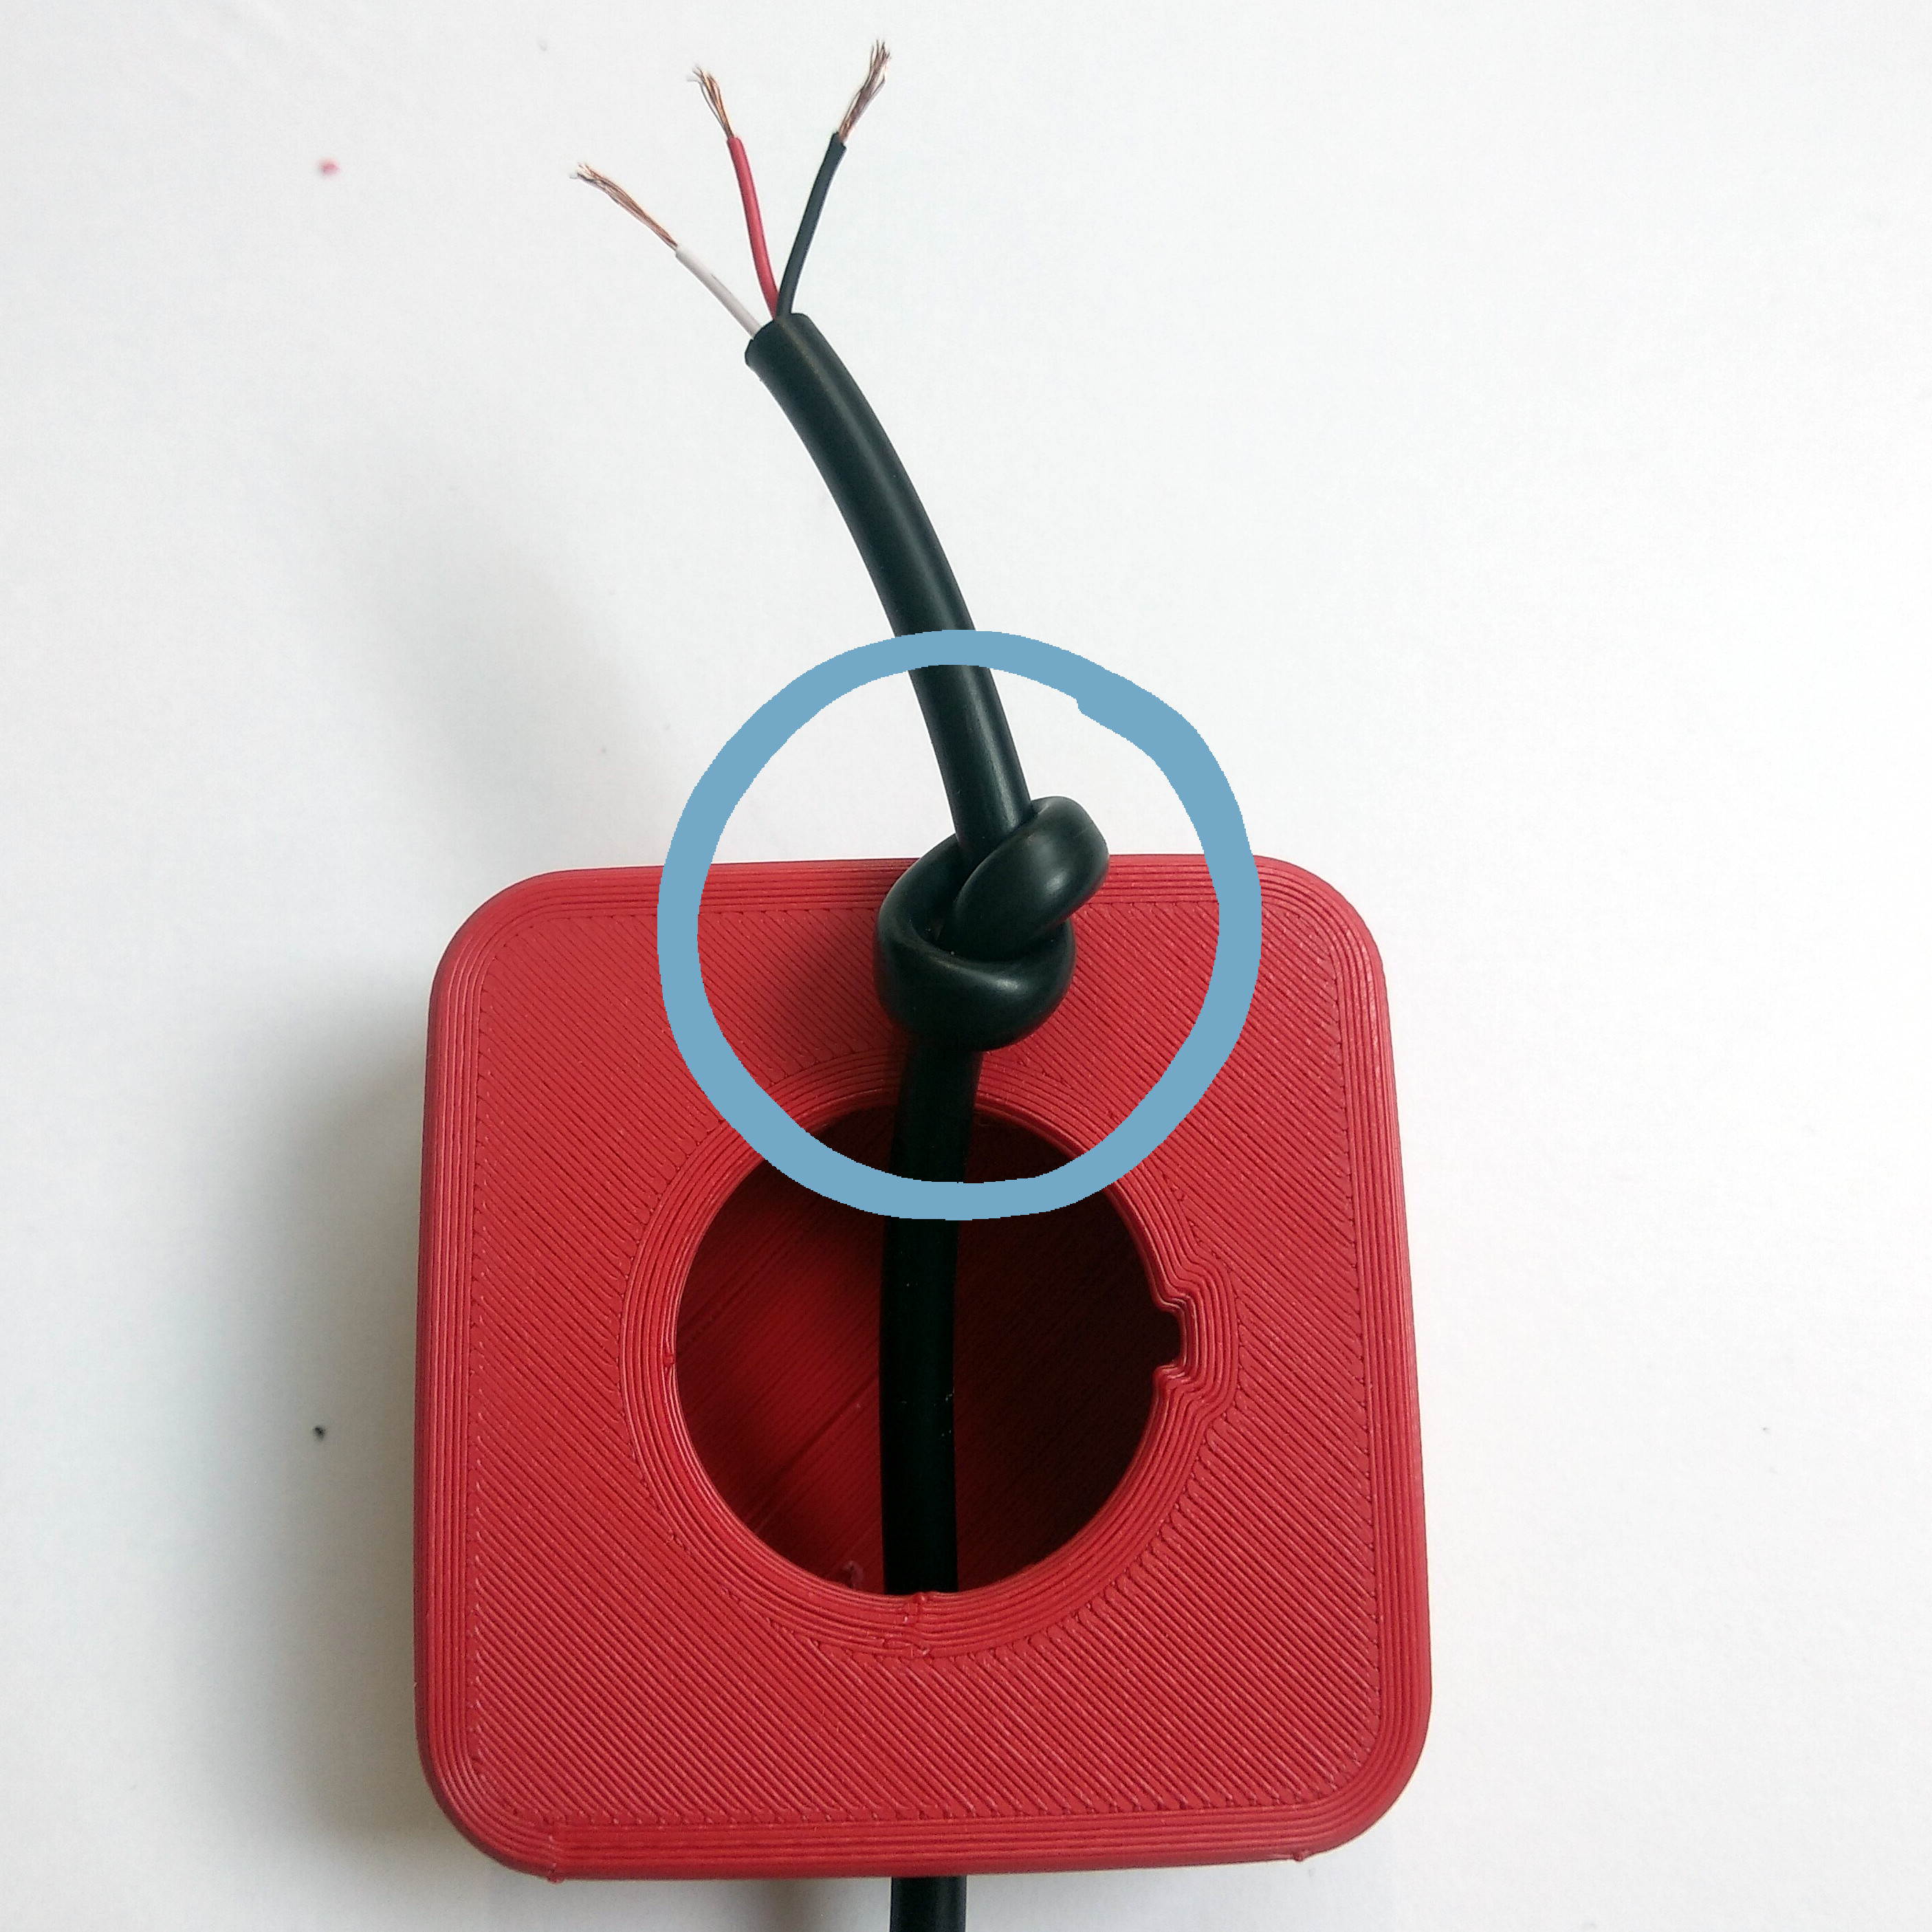  Knot the cable, ~5cm from the beginning | 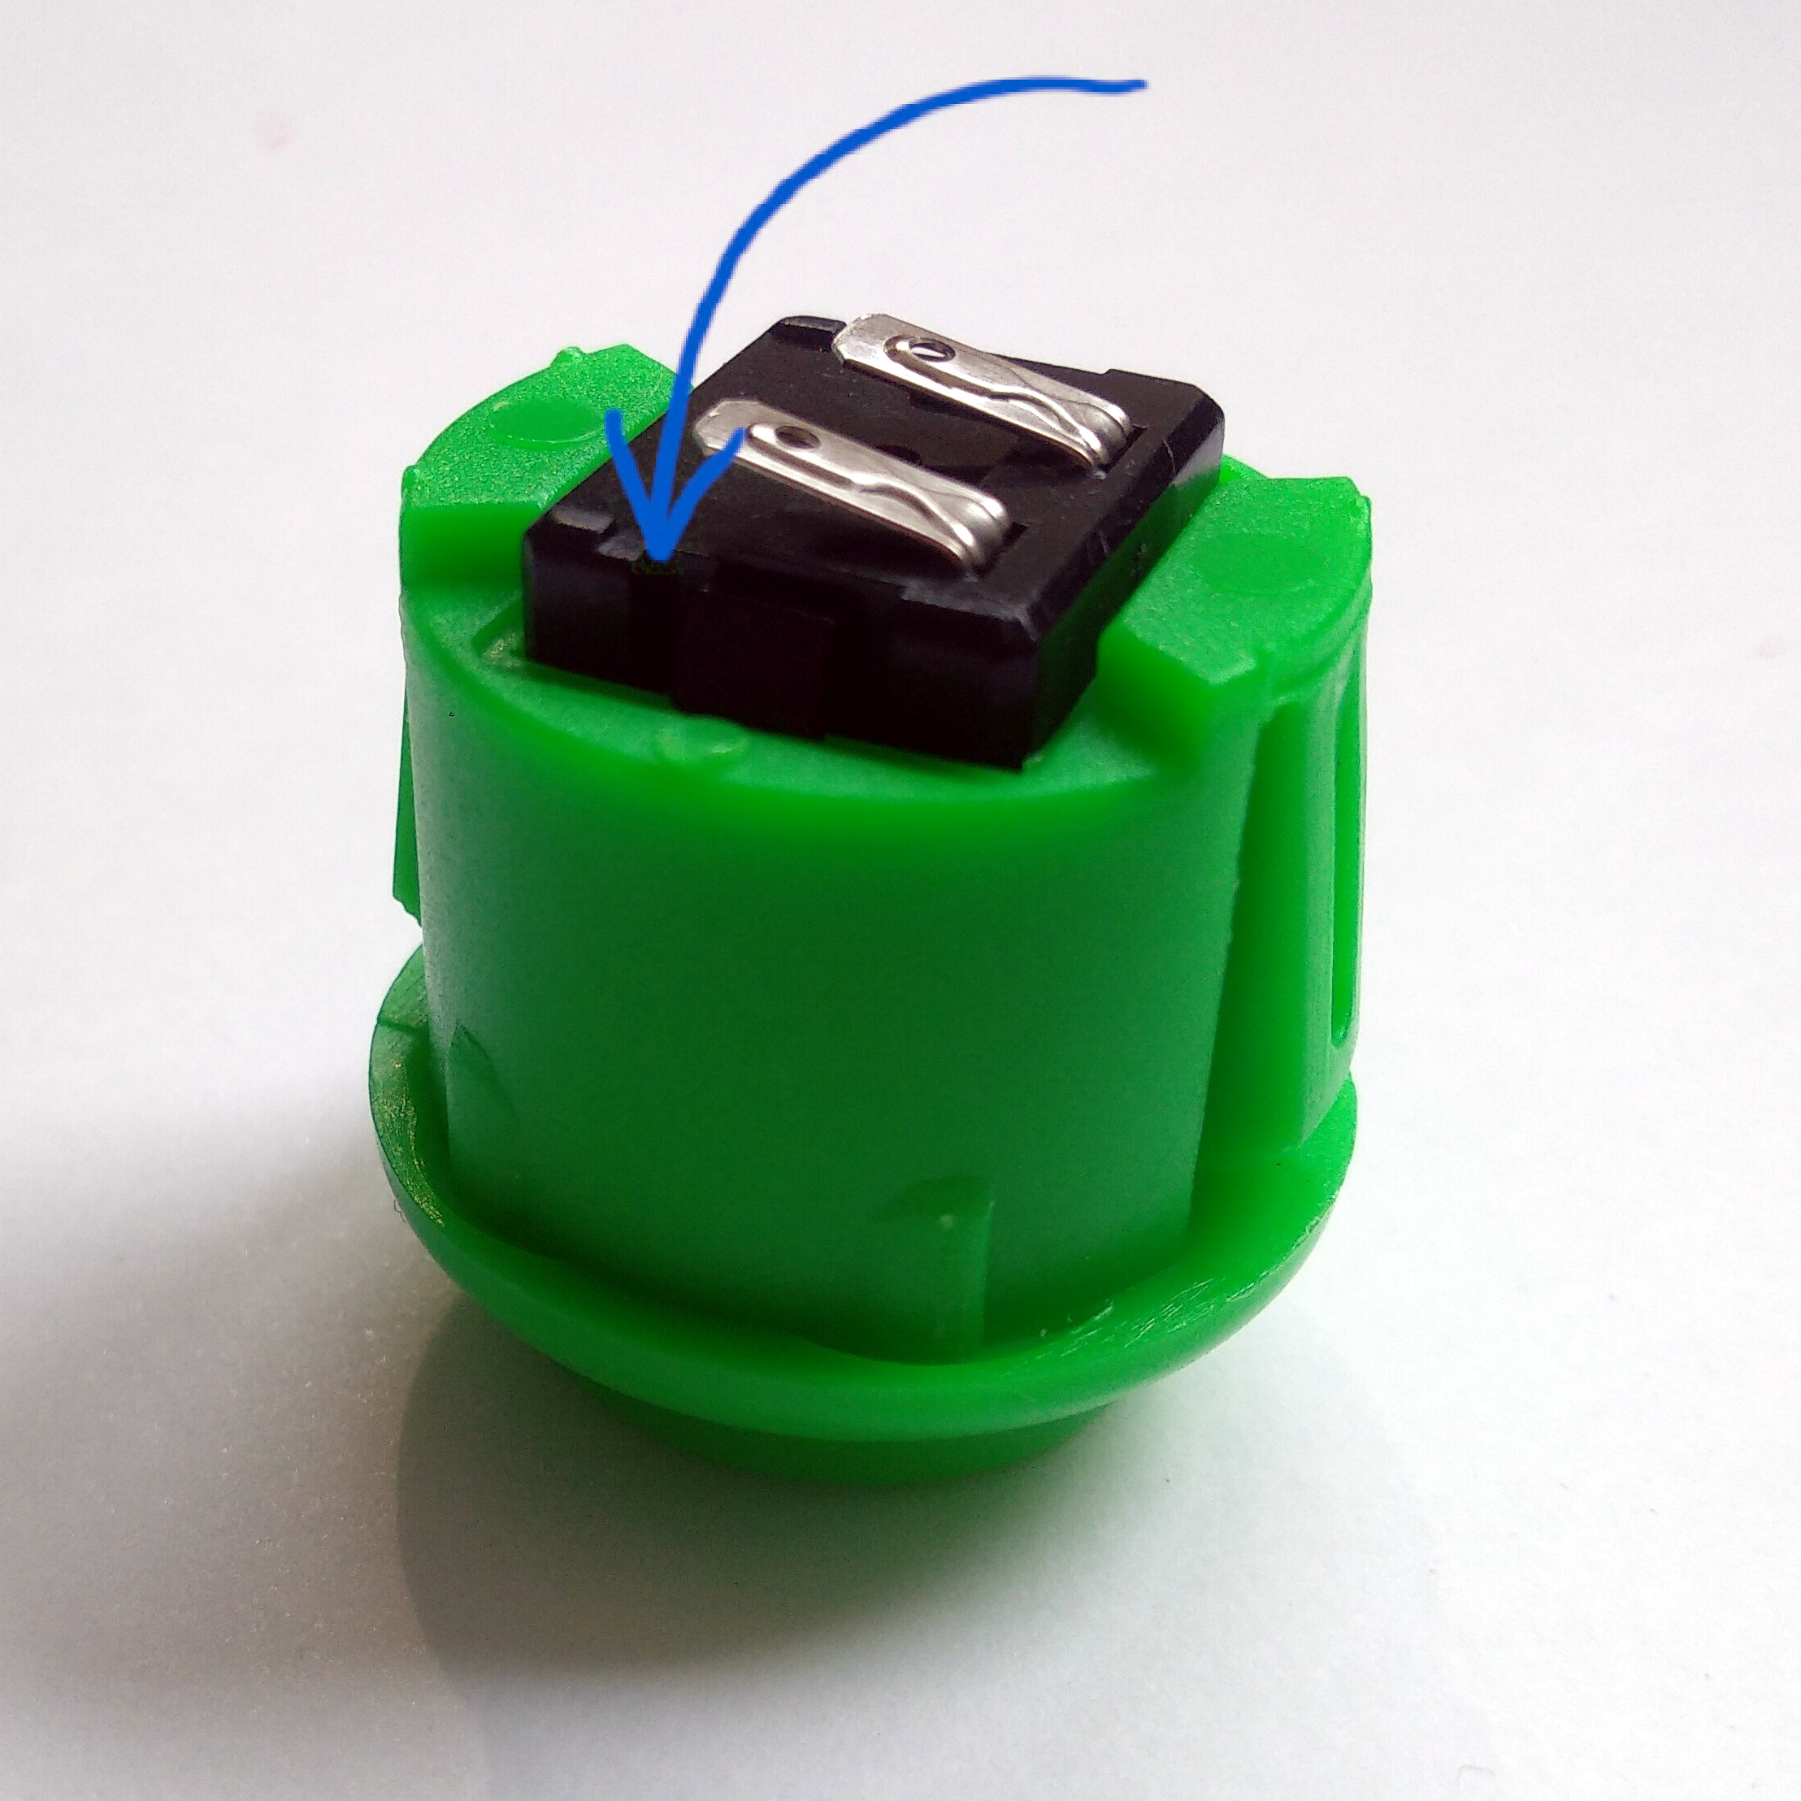  Bend both contacts of the button
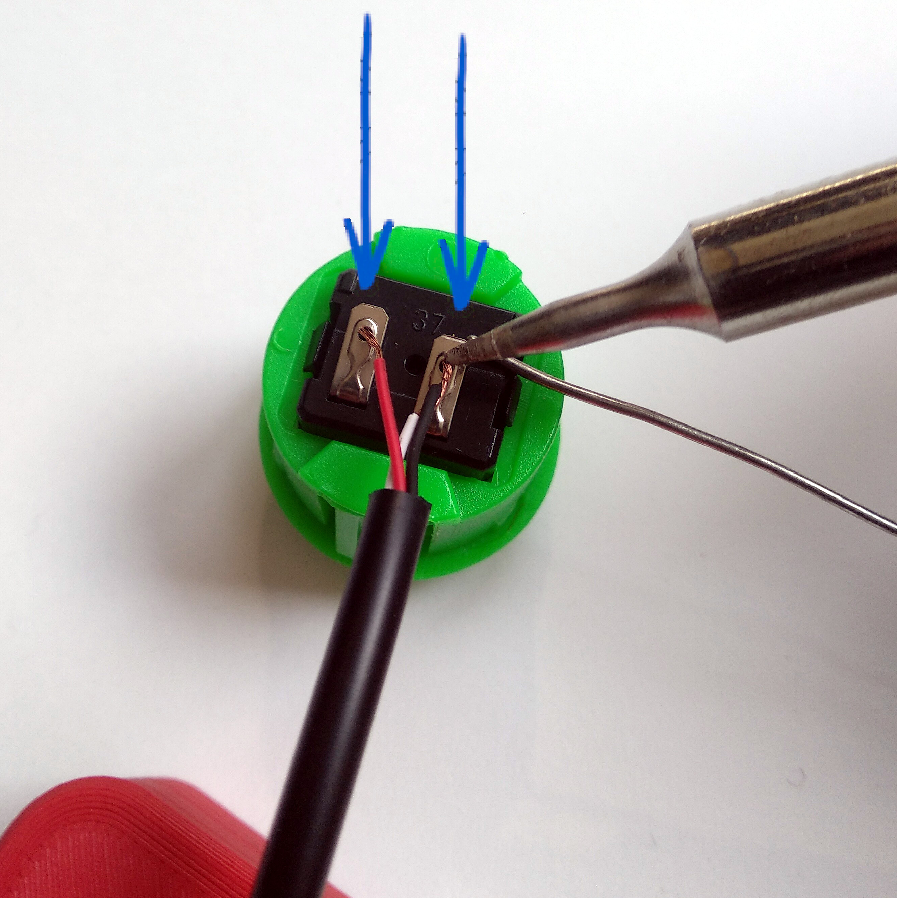  Solder the red wire on one contact,  solder the black & white wire on the other contact. | 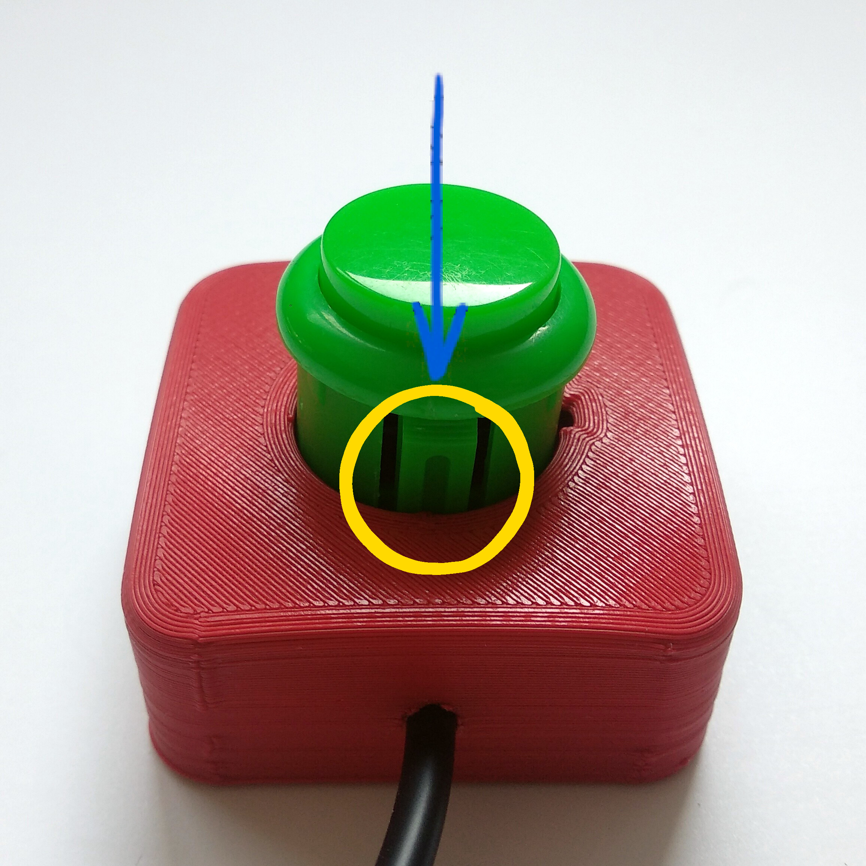  Push the button into the case. Please take care of the  orientation, as shown in the picture.

