



BigGorilla is an open-source data integration and data preparation ecosystem (currently in Python) to enable data scientists to perform integration and analysis of data. BigGorilla brings decades of research on data integration into an open-source platform with the goal of accelerating progress in the field and adoption of its techniques. http://www.biggorilla.org

**Example Project: BigGorilla**

**Enriching lifestyles with Information Technology**

Recruit Institute of Technology (RIT) is the technology hub and research lab for Recruit Holdings, a company that provides over 200 online services in the areas of human resources, travel, housing, education, restaurants and many other areas in which people make daily lifestyle decisions.

We conduct research in several areas, including data management, data integration, natural language processing, machine learning, and artificial intelligence. We collaborate with universities and publish in top-notch conferences.

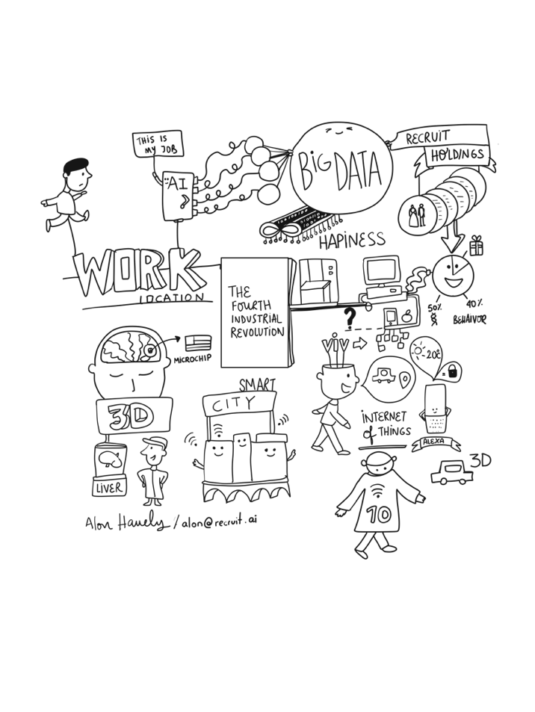



We are hiring! Go to www.recruit.ai

*Illustration by Melisa Machuret

444 Castro St Suite 900, Mountain View, CA 94041, USA