9222A – Cognitive Neuroscience of Memory

Term Paper

Avital Sternin

**Background**

Human beings store memories in their brains in complex ways. Memories may be stored as separate, discrete events or can be recalled by bringing together individual pieces stored across multiple episodes. The ability to integrate pieces of memories is termed *memory integration* and gives humans the flexibility to recombine events in novel ways and to adapt to an ever changing environment. Memory integration allows us to use information about old events to inform new behaviours. In particular, memory integration refers to the idea that memories are stored in overlapping neural connections that form memory networks for related events (Schlichting & Preston, 2015). Although the neural mechanisms by which this integration occurs are not yet well understood there are researchers working to elucidate these complex neural relationships.

Zeithamova, Dominick, and Preston (2012) showed that a participant's ability to infer a novel relationship between two discrete events is predicted by reactivation of related memories. For example, if a participant is presented with and asked to encode an event that includes a dog and then asked to encode a separate event that also includes a dog the memories of the first event are reactivated during the encoding of the second. See Figure 1. The amount of reactivation of prior memories is predictive of whether or not the participant will subsequently infer a relationship between the first and second event. The integration and association of memories uses multiple brain structures and this study showed that the hippocampus, the ventromedial prefrontal cortex (VMPFC), and the anterior medial temporal lobe (MTL) are involved. In particular Zeithamova et al. (2012) propose that it is the hippocampus in connection with the anterior MTL that drives reactivation of old memories during encoding of new ones.

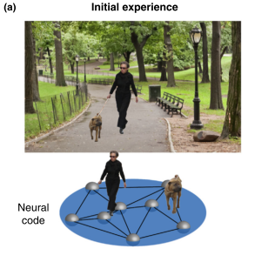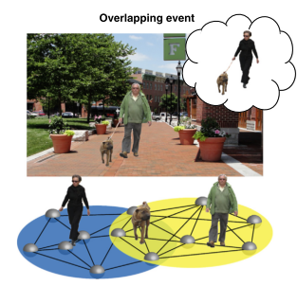

**Figure 1.** An example of overlapping events that might lead to integration. If both events involve a dog, the memory of the first may be reactivated during the experience of the second. The neural connections involving the dog are the same in both memories.

A study done by Wimmer and Shohamy (2012) also investigated the role of the hippocampus during association of memories and the effect of prior experiences on new events. In particular, these researchers were interested in how memory integration and related hippocampal activity can bias decision making. They found that by pairing a rewarded stimulus with an unrewarded stimulus the unrewarded stimulus gained a positive value by association. The researchers also found that increased activity in the hippocampus during the reward-learning phase of the task was correlated with later behavioural decision bias.

A paper by John H.R. Maunsell (2004) shows that the structure of reward studies and attention studies are very similar and argues that modulating reward or attention will produce the same increase in neuron activation making it difficult to attribute effects to one or the other. I would like to investigate whether the decision bias seen in the Wimmer and Shohamy (2012) paper was a result of an increase in reward for some stimuli or if the results seen were due to an increase in attention.

**Goals and Predictions**

I would like to replicate the study used in the Wimmer and Shohamy (2012) paper, but further investigate two aspects: level of reward and level of attention. I am interested to know if the amount of reward affects the amount of activation in the hippocampus. I will also investigate the role of attention during an association task.

I will have two groups of participants: an undistracted group and a distracted group. Both groups will encounter three levels of reward. More details on proposed methods will be described below. I predict that the results from the Wimmer and Shohamy paper will be replicated, but will be modulated by reward level. The amount of reward will influence hippocampal activity and therefore decision bias. Decision bias will be seen for stimuli not directly rewarded and hippocampal activity will modulate the amount of decision bias.

There are two possibilities for the attention manipulation. If decision bias is abolished in the distracted group then the results seen in the Wimmer and Shohamy (2012) paper could possibly be attributed to simply an increase in attention as a result of the reward. If decision bias is *not* abolished then it may be possible to say that memory integration occurs regardless of the level of attention. Wimmer and Shohamy state that decision bias was strong in participants for some associations, but not for others. I hypothesize that this difference could be due to loss of attention during parts of the task and I predict that in my experiment decision bias will be abolished when participants do the task at the same time as a distractor task is presented.

**Proposed Methods**

The proposed study will be similar to the one conducted by Wimmer and Shohamy. See Figure 2. FMRI data will be collected during all 3 stages.

**Stage 1:** Participants will build associative memories during this phase. Participants will see a series of paired neutral stimuli: real object with abstract stimulus. Neutrality will be determined by a pre-fMRI stimulus rating score. In order to make sure that participants are not aware of the task's true purpose they will be asked to identify any upside-down stimuli with a button press. To control for memory based on aspects other than stimulus content (such as stimulus shape) all stimuli will be round: faces, scenes, round objects (S1), and round, abstract stimuli (S2).

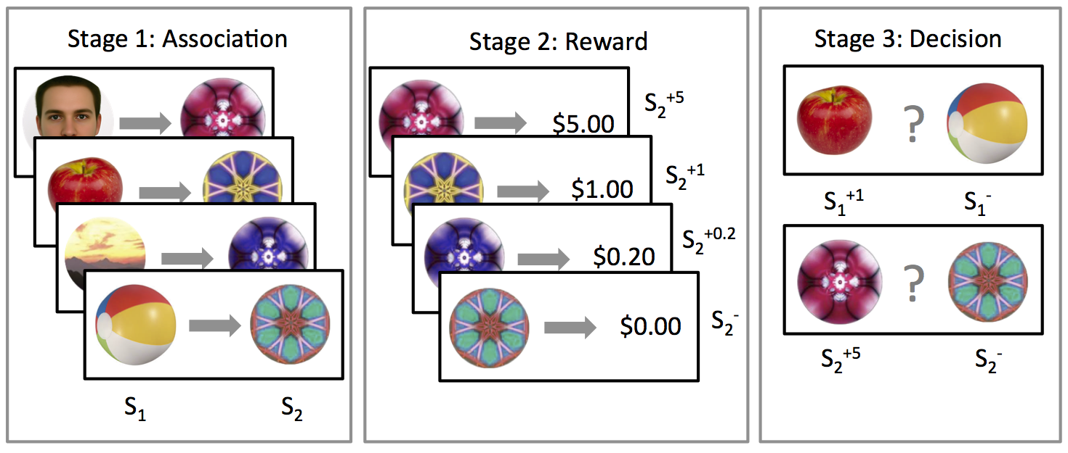 **Figure 2.** The three phases of the task. During stage 1 participants will learn associations between pairs of pictures. During stage 2 participants will be classically conditioned to know that some of the stimuli are followed by a reward. During stage 3 participants will choose the stimulus in a pair that is most likely to result in a reward. Some stimuli are directly associated with reward while others are indirectly associated.

**Stage 2:** Participants will learn to associate value with the abstract stimuli from stage 1 through classical conditioning. The abstract shapes will be presented immediately followed either by a monetary reward (S2+) or by a neutral outcome (S2-). Participants will be asked to press one button every time the abstract stimuli appear or a second button when the monetary reward appears. When they press the proper button for the monetary reward the money will be added to their virtual account.

Three levels of monetary compensation will be presented. Participants will be presented with $5.00 (S2+5), $1.00 (S2+1), and $0.20 (S2+0.2). The Wimmer and Shohamy paper used a constant reward of $1. Here, the reward value has been increased by 5x and decreased by 5x.

A second, separate group of participants will complete stage 2 at the same time as a distractor task is presented. While performing the same stage 2 task as the first group these participants will be asked to listen to a series of repeating tones at 440Hz (A4) and to count the number of deviant tones presented at 329Hz (E4). The idea is that the distractor task will hold participant's attention and not allow them to learn the associations between the stimuli and the reward.

**Stage 3:** The stimuli from the first stage will be presented in pairs on the screen and participants will make decisions about which stimuli are more likely to lead to a monetary reward. The stimuli shown will either be the directly rewarded or unrewarded stimuli from stage 2 (S2+ or S2-) or the paired stimuli from stage 1 now either indirectly associated with a reward or not (S1+ or S1-). Stimuli will always be presented in pairs of stimuli from the same class (i.e. scenes together, faces together etc.). Decision bias is operationalized as choosing S1+ items more often than S1- items in this stage.

**Anticipated Results**

**Behavioural results**

During stage 3 I predict that those abstract stimuli that were directly rewarded in stage 2 (S2+) will be chosen more often as “being lucky” over the unrewarded stimuli (S2-). I also predict that the stimuli that were associated with the rewarded abstract stimuli during stage 1 (S1+) will be chosen more often as “lucky” over the stimuli associated with unrewarded stimuli (S1-).

I predict that the rewarded response will be larger than the decision bias responses. This means that directly rewarded stimuli (S2+) will be chosen more will be chosen more often as “lucky” over the stimuli associated with unrewarded stimuli (S1-). See Figure 3.

I predict that participants in the distractor group will choose stimuli as being lucky at chance levels. See Figure 3.

I also anticipate that the amount of reward will modulate the amount of times that a rewarded stimulus is chosen as being lucky: S2+5 > S2+1 > S2+0.2 > S2-. I also anticipate that stimuli associated with abstract stimuli during stage 1 will be chosen more often as “lucky” over stimuli associated with unrewarded stimuli: S1+5 > S1+1 > S1+0.2 > S1-. See Figure 4.

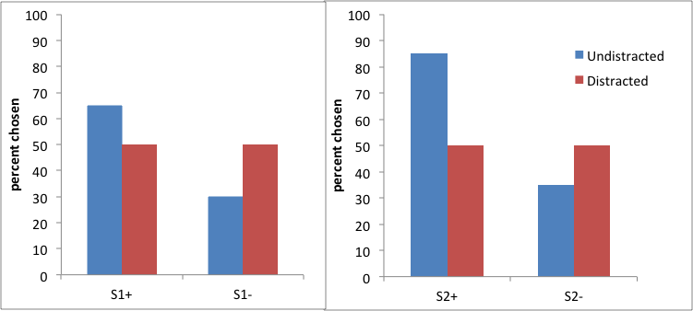

**Figure 3.**Anticipated behavioural results regarding the number of times a stimulus is chosen as being “lucky”.

**Figure** 3**.** Anticipated behavioural results regarding the number of times a stimulus is chosen as being “lucky”.

I predict that participants in the distractor group will choose stimuli as being lucky at chance levels. See Figure 4.

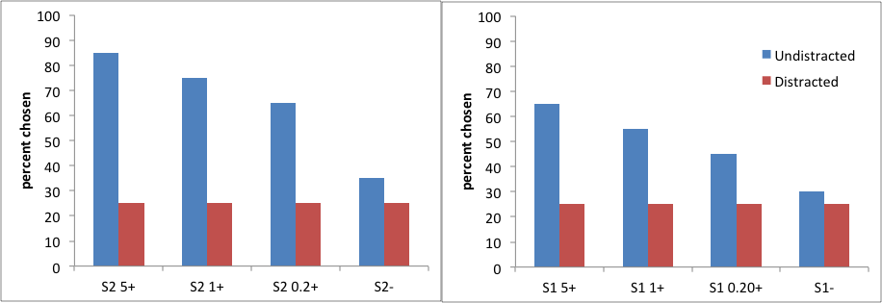 **Figure 4.** Anticipated behavioural results showing how behaviour in the undistracted condition is modulated by reward level.

I also expect to replicate the results of the previous study and not see any differences in decision bias between categories.

**FMRI results**

Based on activation during the association phase individual masks for BOLD responses will be created to look for activation during the learning reward phase in individually relevant voxels. During stage 2 I expect to see greater BOLD activation to stimuli that produce high decision bias in stage 3 than to stimuli that produce lower decision bias in stage 3.

I expect to find activation in the posterior hippocampus during stage 2 (reward phase) as was seen in the initial Wimmer and Shohamy paper. I am expecting to find greater activation for items that lead to more decision bias. S2+5 > S2+1 > S2+0.2 > S2-. See Figure 5. In the distracted group I expect to see no difference in BOLD activation across stimuli and for the BOLD signal to be significantly lower than to any of the rewarded stimuli. The participants will have been paying less attention to the stimuli and will therefore not pick up on the differences in reward. Without attention I do not expect their BOLD signal to be modulated.

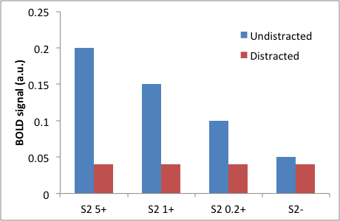 **Figure 5.** Anticipated results showing how BOLD signal in the undistracted condition is expected to be modulated by reward level.

**Implications of Research Outcome**

If we see behavioural and BOLD results modulated by level of reward then we can conclude that the hippocampus’s role in memory integration is not an all or nothing process and can be influenced by external factors.

As mentioned earlier there are two main possibilities for the results of the attention manipulation: attention may or may not abolish decision bias.

If decision bias is abolished in the distracted group then the results seen in the Wimmer and Shohamy (2012) paper could be attributed to simply an increase in attention as a result of the reward. This may indicate that participants learned that certain stimuli were associated with reward (as we want them too), but that the actual increase in the undistracted group is due to an increase in attention. With this result we can not untangle whether the results are solely attributed to reward or attention.

If decision bias is *not* abolished in the distracted group then it may be possible to say that memory integration occurs regardless of the level of attention. In this case we can conclude that there is another mechanism responsible for memory integration and this would prompt further research into elucidating what that mechanism involves. By looking at the connectivity of the hippocampus with surrounding regions we may be able to investigate how memory integration occurs over time which will give us a better idea of how the process works without attention.

**References**

Maunsell, J. H. R. (2004). Neuronal representations of cognitive state: reward or attention? *Trends in Cognitive Sciences*, *8*(6), 261–265. doi:10.1016/j.tics.2004.04.003

Schlichting, M. L., & Preston, A. R. (2015). Memory integration: neural mechanisms and implications for behavior. *Current Opinion in Behavioral Sciences*, *1*, 1–8. doi:10.1016/j.cobeha.2014.07.005

Wimmer, G. E., & Shohamy, D. (2012). Preference by Association: How Memory Mechanisms in the Hippocampus Bias Decisions. *Science (New York, N.Y.)*, *338*(October), 270–3. doi:10.1126/science.1223252

Zeithamova, D., Dominick, A. L., & Preston, A. R. (2012). Hippocampal and Ventral Medial Prefrontal Activation during Retrieval-Mediated Learning Supports Novel Inference. *Neuron*, *75*(1), 168–179. doi:10.1016/j.neuron.2012.05.010