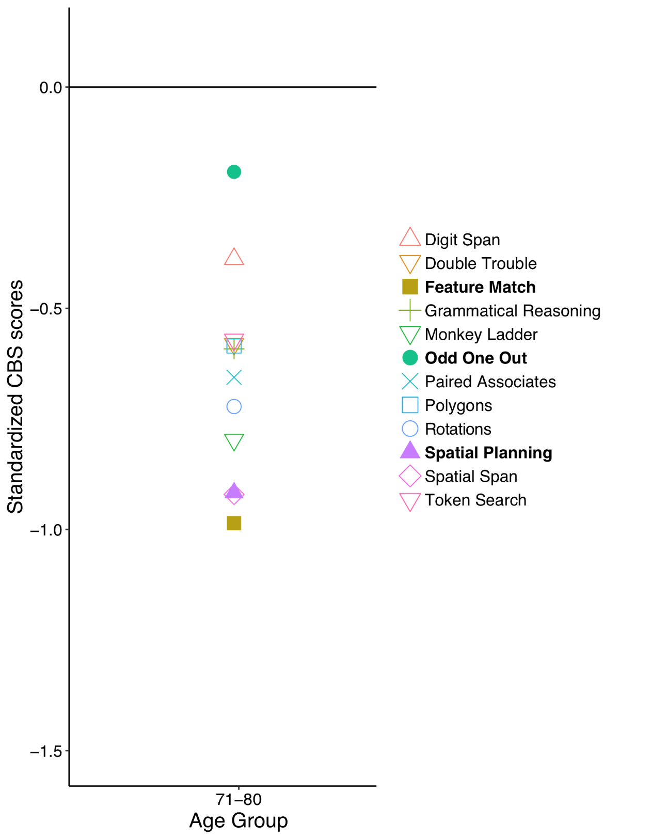

FigureB1*.* As part of a large online study 327 participants (age 71-80 years) completed all 12 CBS tasks. The standardized scores are presented in this figure and show relative task difficulty. The three tests in bold (Feature Match, Odd One Out, Spatial Planning) are those identified by the analyses in the current paper. As described in the main text, task difficulty can not account for the effects observed.