**Fine tuning cognitive assessment in older adults: The benefits of an online screening battery**

Avital Sternin1*, Jessica A. Grahn1, Adrian M. Owen1

1. Brain and Mind Institute, University of Western Ontario, London, Canada

* avital.sternin@uwo.ca

Brain and Mind Institute  
Department of Psychology  
University of Western Ontario  
London, Ontario, Canada  
N6A 3K7  
519 661 2111 x86057

**ABSTRACT**

As the population ages, and millions more become at risk of developing undiagnosed dementia, an easy-to-use screening tool will become crucial for the health and safety of the growing population of older adults. We sought to test the feasibility of using an online cognitive battery to screen for dementia by categorizing individuals with ambiguous cognitive scores; specifically, we asked which combination of online tests, best categorizes individuals with ambiguous MoCA and MMSE scores.

52 older adults completed 12 online tests on a tablet computer, a MoCA, and a MMSE.

The MoCA categorized 72% of participants as impaired or unimpaired. The addition of a single online test increased categorization to 92%. A multiple regression identified two other tests that best predicted MoCA scores. The combination of scores from the three identified tests were highly correlated with MoCA scores. A regression also identified two tests that best predicted MMSE scores, but the categorization analysis was not performed because of a ceiling effect in MMSE scores.

The addition of a single online test to the MoCA improved categorization of individuals with ambiguous scores and a short battery of three CBS tests is a viable alternative to the paper-pencil tests currently used to screen for and monitor cognitive changes in older adults. This online testing battery may have significant consequences for care and quality of life in the aging population.

Keywords: MMSE, MoCA, cognitive impairment, cognitive screening measures, aging

**INTRODUCTION**

Physicians around the world fail to diagnose patients with dementia every day1–3. Many of these patients suffer needlessly: they experience falls and fractures4. In some cases, a late diagnosis of dementia leads to life-limiting illness and preventable death5. Effective screening and accurate diagnosis of dementia saves lives6. Unfortunately, the most reliable current screening tools for dementia, including the Mini-Mental State Examination (MMSE)7 and Montreal Cognitive Assessment (MoCA)8, are widely underused by primary care physicians9. The underuse of these tools can be attributed to barriers such as expense, lack of training, and time constraints10. As the population ages, and millions more become at risk of developing undiagnosed dementia, an easy-to-use screening tool will become crucial for the health and safety of the growing population of older adults.

In this study, we assessed the feasibility of using a new online battery of cognitive tests with a small group of older adults. We used the Cambridge Brain Sciences (CBS) test battery (cambridgebrainsciences.com)16 to examine whether a battery of 12 cognitive tests would improve identification of individuals with cognitive impairments relative to the MoCA and the MMSE. Specifically, we asked which CBS test, or combination of tests, best categorizes individuals with ambiguous MoCA and MMSE scores in order to understand whether this novel screening battery could be used to follow long term cognitive changes in older adult populations.

The CBS test battery’s novel approach to cognitive testing is based on standard neuropsychological tests. However, the tests are computerized and available online, with comprehensive instructions, practice trials, and ‘guided learning’ videos to ensure that individuals can complete them without an examiner being present. Additionally, difficulty levels scale with ability, and test items are randomized, creating a unique set of stimuli for the participant every time the test is taken.

This easy to use, independently completed cognitive testing battery could regularly be administered on a portable computer prior to seeing a physician. This novel testing platform could flag potential cognitive decline and serve as a signal to the primary care physician that more in-depth cognitive testing is warranted. Given the rates of undiagnosed dementia, such screening measures could allow physicians to more accurately diagnose dementia in their patients.

We compared the results of this online battery to the MoCA and MMSE scores of the same patients to:

i) replicate the flow of testing that might occur in the primary care setting,

ii) evaluate the feasibility of using an online battery

iii) begin examining non-inferiority of the new test to current standards of care

This study builds on previous work11 and serves as a first step in considering how to improve the state of cognitive testing and screening for dementia.

**METHODS**

**Subjects**

Participants over the age of 50 were recruited from retirement homes in Toronto and London, Ontario. Any participant who was unable to provide informed consent, or understand task instructions, was excluded. Fifty-two participants (43 female) participated. Possibly because of the location of the retirement homes, the sample was highly educated. All but one earned high school diplomas, 24 earned postsecondary degrees, and 16 earned postgraduate degrees. The researchers were blind to any pre-existing medical conditions. The study was approved by the University of Western Ontario Research Ethics Board.

**Procedure**

All participants were asked to complete the 12 online tests from the Cambridge Brain Sciences (CBS) battery in random order (task descriptions are in the Supplementary Materials) Each task was presented on a touchscreen tablet computer and was preceded by instructions and practice trials. Researchers offered clarification if necessary. Participants took breaks between tasks to prevent fatigue. Afterward, the MoCA (version 7.1 English)8 and MMSE7 were administered in interview format, always by the same person (AS). Participants also completed a paper demographic questionnaire.

**RESULTS**

Fifty-two older adults (average age = 81 years, 62-97 years) were asked to complete 12 CBS tests, the MoCA, and the MMSE. Two participants did not complete all 12 tasks due to fatigue and loss of interest, thus 50 participants’ scores were analysed. MoCA scores ranged from 12-30 (mean=24.6) and MMSE scores ranged from 16-30 (mean=27.7). A summary of all task scores is in Table 1.

*** Table 1 about here please***

A step-wise multiple regression showed that MoCA scores were best predicted by two CBS tests: Feature Match and Odd One Out (R2=0.65). Age did not significantly predict any variance over and above these tests. Alone, age predicted 22% of the variance in MoCA scores (R2=0.22). Another step-wise multiple regression showed that MMSE scores were best predicted by Feature Match and Grammatical Reasoning (R2=0.38). Age did not explain a significant amount of variance over and above the task scores. Alone, age predicted 8% (R2=0.08) of the variance in MMSE scores.

A third regression showed that level of education did not explain a significant amount of variance in MMSE or MoCA scores, although this may be due to overall high educational levels and the ceiling effect seen in MMSE scores (see Figure 1 and Supplementary Figure 2).

Participant scores were split into three categories based on MoCA scores (See Figure 1): unimpaired (n=25) MoCA score ≥26, borderline cognitive impairment (n=14) MoCA score 23-25, and impaired (n=12) MoCA score ≤ 22, based on thresholds from previous literature (e.g. 13–15) The ceiling effect precluded performing this analysis on MMSE results.

Using the same method as Brenkel et al. (2017), each participant in the borderline group was reallocated to either the impaired or unimpaired groups based on their CBS test scores as follows: If the participant’s score on one of the 12 tasks was less than or equal to the average score of the impaired group (on that task) they were categorized as impaired. If their score on a particular task was greater than or equal to the average score of the unimpaired group (on that task) they were classified as unimpaired. If their score fell between the average scores of the impaired and unimpaired groups they remained classified as borderline. This procedure was conducted for each individual CBS test as well as all possible combinations. When multiple tests were used, participants were only categorized if categorization was consistent across all tests in the combination.

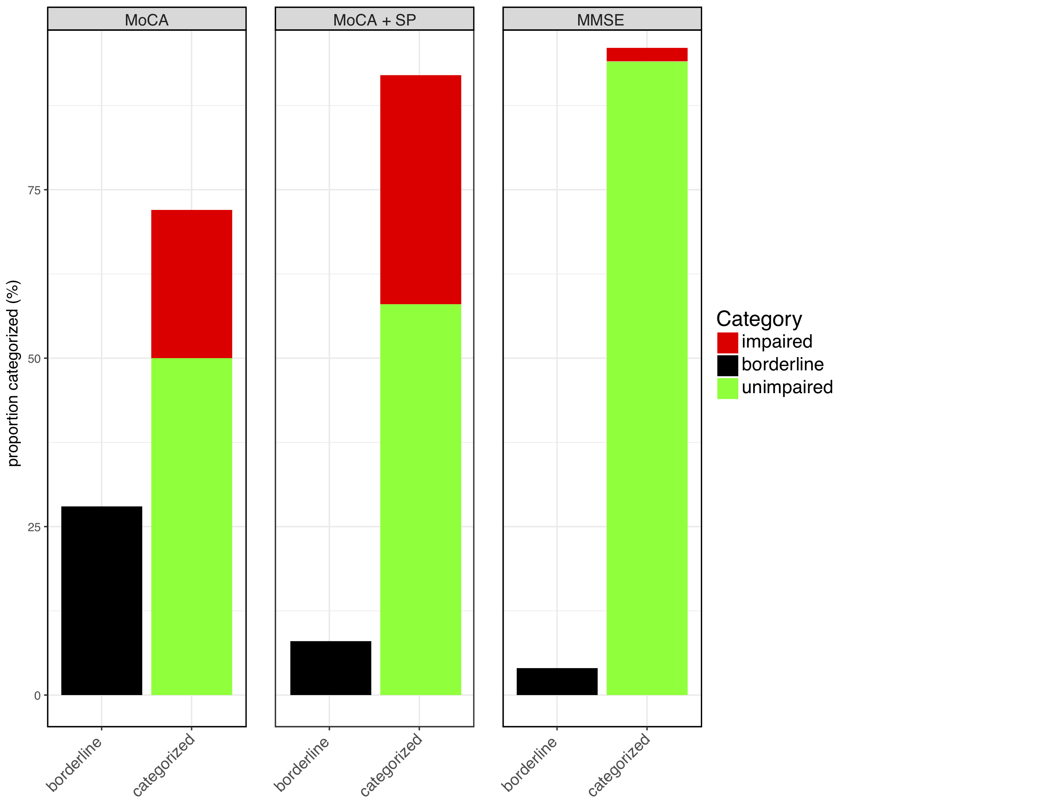

Figure 1. The proportion of participants categorized as unimpaired, impaired, or borderline is shown. The MoCA alone categorizes 72% of participants leaving 28% in the borderline category. The addition of the Spatial Planning task categorizes 92% of participants leaving only 8% in the borderline category. The MMSE scores are at ceiling and are not informative in this population.

With the MoCA alone, 72% of participants were classified as impaired (scores<22) or unimpaired scores(26-30). Adding one CBS test (Spatial Planning) increased categorization the most (92%), leaving only 4 participants in the borderline group (See Figure 1). This was not because Spatial Planning was the most difficult test, as the equally difficult Spatial Span test left 5 participants in the borderline group. Test difficulty was determined from an unrelated study with scores from 327 participants age 71-80 (see Supplementary Figure 1).

Participants’ scores on the three tests identified in the stepwise regressions (Feature Match, Odd One Out, and Spatial Planning) were converted to z-scores and averaged to create a composite. This composite score strongly correlated with MoCA scores *r*=0.74 (*p*<0.001), and was slightly less correlated with MMSE scores (*r*=0.55, *p*<0.001; see Supplementary Figure 2).

**DISCUSSION**

The goal of this study was to evaluate the feasibility of improving the state of cognitive testing and screening for dementia using a novel online test battery. Dementia is highly underdiagnosed and such a testing platform could help primary care physicians flag potential cognitive decline and serve as a signal that more in-depth cognitive testing is warranted. We found that tests from the CBS online cognitive battery successfully identified cognitive impairment when the MoCA or MMSE returned ambiguous scores. Specifically, Feature Match and Odd One Out tasks best predicted MoCA scores. A further categorization analysis showed that considering one computerized test, Spatial Planning, in conjunction with the MoCA, classified 92% of participants as impaired or unimpaired (compared to 72% with the MoCA alone). Better classification of individuals with ambiguous scores has implications for treatment and quality of life. We were unable to perform this same analysis on MMSE results due to a ceiling effect in MMSE score distribution suggesting that the MMSE may not be appropriate for highly educated, aging populations.

The composite score created from Feature Match, Odd One Out, and Spatial Planning was highly correlated with MoCA scores (*r*=0.74), indicating that these three tests may be an effective way to track cognitive changes in aging adults over time, independent of the MoCA.

This study also suggests that an online test battery is feasible to use with older adults. By 2036, 25% of the Canadian population will be over 65 years of age17, and the ability to easily assess these individuals will be increasingly important. The CBS battery is ideal because it can be administered without a one-on-one interview, reducing administrator burden, and produces novel test versions each time it is administered, reducing potential practice effects. Moreover, the addition of a single CBS test to the MoCA better identifies individuals with ambiguous scores, and a short (under 10 minutes) battery of just three CBS tests is a viable alternative to the MoCA or MMSE for monitoring cognitive changes in older adults.

The current study successfully indicated that an online testing battery like the CBS battery could be used to efficiently screen for and monitor cognitive changes in older adults. To move towards the clinical implementation of such a testing battery, more work needs to be done to determine the sensitivity and specificity for the CBS tests. Therefore, future studies will use large samples of older adults with known diagnoses to define thresholds for this novel testing battery in populations with a range of age-related conditions.

**ACKNOWLEDGEMENTS**

Special thanks to residents of Christie Gardens Apartments and Care in Toronto, Ontario and to Grand Wood Park in London, Ontario for their willingness to participate in our research. Thank you to Emily S. Nichols and Alexandra A. Pearce for their help with data collection.

**Author’s Contributions**

AS, JAG, and AMO all contributed to the experimental design, result interpretation, and the preparation of this manuscript. AS was also responsible for the data collection and analysis.

**Conflict of Interest Statement**

The online cognitive tests used in this study are marketed by Cambridge Brain Sciences Inc, of which Dr. Owen is the Chief Scientific Officer. Under the terms of the existing licensing agreement, Dr. Owen and his collaborators are free to use the platform at no cost for their scientific studies and such research projects neither contribute to, nor are influenced by, the activities of the company. As such, there is no overlap between the current study and the activities of Cambridge Brain Sciences Inc, nor was there any cost to the authors, funding bodies or participants who were involved in the study.

**Funding**

This project was supported by the National Science and Engineering Research Council [418550/2012] and the Canada Excellence Research Chairs Program [#215063].

**REFERENCES**

1. Connolly A, Gaehl E, Martin H, Morris J, Purandare N. Underdiagnosis of dementia in primary care: Variations in the observed prevalence and comparisons to the expected prevalence. *Aging Ment Heal*. 2011;15(8):978-984. doi:10.1080/13607863.2011.596805.

2. Lang L, Clifford A, Wei L, et al. Prevalence and determinants of undetected dementia in the community: A systematic literature review and a meta-analysis. *BMJ Open*. 2017;7(2):1-8. doi:10.1136/bmjopen-2016-011146.

3. Valcour VG, Masaki KH, Curb JD, Blanchette PL. The detection of dementia in the primary care setting. *Arch Intern Med*. 2000;160(19):2964-2968. doi:10.1001/archinte.160.19.2964.

4. Ballard CG, Shaw F, Lowery K, McKeith I, Kenny R. The prevalence, assessment and associations of falls in dementia with Lewy bodies and Alzheimer’s Disease. *Dement Geriatr Cogn Disord*. 1999;10:97-103.

5. Keene J, Hope T, Fairburn CG, Jacoby R. Death and dementia. *Int J Geriatr Psychiatry*. 2001;16(10):969-974. doi:10.1002/gps.474.

6. Prince M, Bryce R, Ferri C. World Alzheimer Report - The benefits of early diagnosis and intervention World Alzheimer Report. *Alzeheimer’s Dis Int*. 2011:72. doi:10.1088/1742-6596/160/1/012043.

7. Folstein MF, Folstein SE, McHugh PR. “Mini-mental state”. A practical method for grading the cognitive state of patients for the clinician. *J Psychiatr Res*. 1975;12(3):189-198. doi:10.1016/0022-3956(75)90026-6.

8. Nasreddine ZS, Phillips NA, Bédirian V, et al. The Montreal Cognitive Assessment, MoCA: a brief screening tool for mild cognitive impairment. *J Am Geriatr Soc*. 2005;53(4):695-699. doi:10.1111/j.1532-5415.2005.53221.x.

9. Parmar J, Dobbs B, McKay R, et al. Diagnosis and management of dementia in primary care: Exploratory study. *Can Fam Physician*. 2014;60(5):457-465.

10. Bradford A, Kunik ME, Schulz P, Williams SP, Singh H. Missed and Delayed Diagnosis of Dementia in Primary Care. *Alzheimer Dis Assoc Disord*. 2009;23(4):306-314. doi:10.1097/WAD.0b013e3181a6bebc.

11. Brenkel M, Shulman K, Hazan E, Herrmann N, Owen AM. Assessing Capacity in the Elderly: Comparing the MoCA with a Novel Computerized Battery of Executive Function. *Dement Geriatr Cogn Dis Extra*. 2017;7(2):249-256. doi:10.1159/000478008.

12. Nasreddine ZS, Phillips N, Chertkow H. Normative data for the montreal cognitive assessment (MOCA) in a population-based sample. *Neurology*. 2012;78(10):765-766. doi:10.1212/01.wnl.0000413072.54070.a3.

13. Gluhm S, Goldstein J, Loc K, Colt A, Liew C Van, Corey-Bloom J. Cognitive Performance on the Mini-Mental State Examination and the Montreal Cognitive Assessment Across the Healthy Adult Lifespan. *Cogn Behav Neurol*. 2013;26(1):1-5. doi:10.1097/WNN.0b013e31828b7d26.Cognitive.

14. Damian AM, Jacobson SA, Hentz JG, et al. The montreal cognitive assessment and the mini-mental state examination as screening instruments for cognitive impairment: Item analyses and threshold scores. *Dement Geriatr Cogn Disord*. 2011;31(2):126-131. doi:10.1159/000323867.

15. Malek-Ahmadi M, Powell JJ, Belden CM, et al. Age- and education-adjusted normative data for the Montreal Cognitive Assessment (MoCA) in older adults age 70–99. *Aging, Neuropsychol Cogn*. 2015;22(6):755-761. doi:10.1080/13825585.2015.1041449.

16. Hampshire A, Highfield RR, Parkin BL, Owen AM. Fractionating Human Intelligence. *Neuron*. 2012;76(6):1225-1237. doi:10.1016/j.neuron.2012.06.022.

17. Canada S. *Census of Population, 1851 to 2016*.; 2016.

Table 1.

|  |  |  |  |  |
| --- | --- | --- | --- | --- |
| **Task** | **Participant**  **scores** | | **Population norms**  **age 70-94** | |
|  | **Mean** | **SD** | **Mean** | **SD** |
| MoCA | 24.6 | 4.0 |  |  |
| MMSE | 27.7 | 2.8 |  |  |
| Double Trouble (CBS) | 9.4 | 11.9 | 17.8 | 11.2 |
| Odd One Out (CBS) | 11.4 | 3.5 | 13.4 | 2.4 |
| Spatial Planning (CBS) | 12.4 | 7.1 | 14.4 | 7.5 |
| Grammatical Reasoning (CBS) | 10.4 | 5.9 | 13.8 | 4.6 |
| Digit Span (CBS) | 4.8 | 1.8 | 6.8 | 1.6 |
| Token Search (CBS) | 5.8 | 1.7 | 6.3 | 1.9 |
| Paired Associates (CBS) | 3.5 | 0.9 | 4.3 | 1.0 |
| Spatial Span (CBS) | 4.3 | 1.2 | 4.9 | 0.9 |
| Feature Match (CBS) | 68.3 | 25.6 | 95.8 | 24.8 |
| Rotations (CBS) | 32.4 | 26.1 | 62.4 | 28.6 |
| Polygons (CBS) | 17.7 | 16.8 | 32.4 | 19.9 |
| Monkey Ladder (CBS) | 5.7 | 1.8 | 6.6 | 1.3 |

Summary of task scores for the 50 participants included in this study and relevant population norms from 342 older adults aged 70-94 acquired from the CBS Inc. database of 70 000 participants. In the current study, only 7 participants were younger than 70. For details about the named CBS tests, see Supplementary Materials.