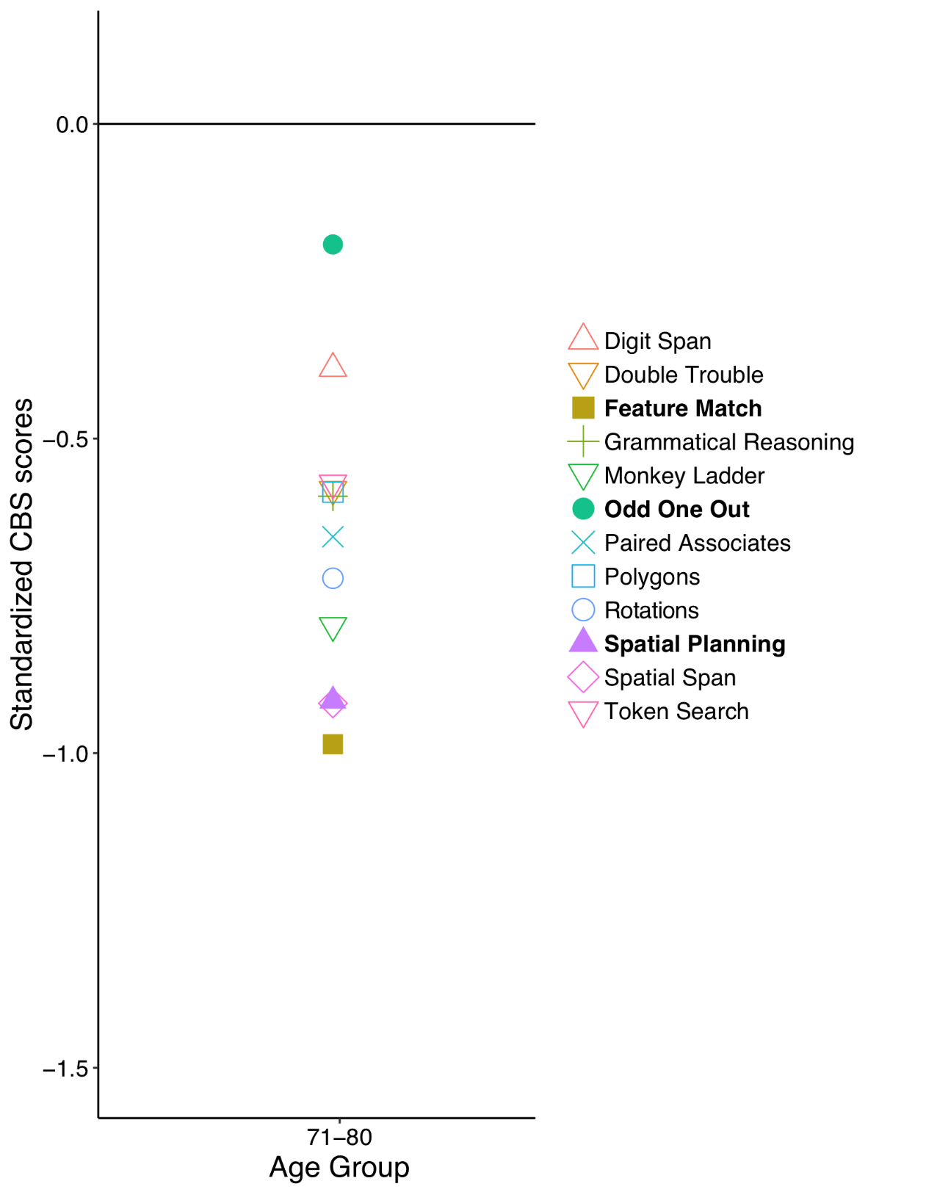

FigureS1*.* As part of a large online study (unrelated to the current study), 327 participants age 71-80 completed all 12 CBS tasks. The standardized scores are presented in this figure. The three highlighted tests (Feature Match, Odd One Out, Spatial Planning) are those identified by the analyses in the current paper.