Cognition & Age

Avital Sternin

1. What cognitive or other outcomes have been used to judge the success of clinical trials in cognitive impairment?

**Searched:** ClinicalTrials.gov

**Search criteria:**

Cognitive Impairment

Completed Studies

Interventional Studies

Available

Adult (18-65), and senior (66+)

**Results:** 545 Studies

* Large variability in the outcome measures used
* Not all studies list details of outcome measures (e.g. change in memory measures without listing which memory tests are used)
* From a glance over the first studies, broad categories emerge:
  + Executive functions
    - If cognitive functions are directly assessed, it is often done with a comprehensive neuropsychological battery
    - Not all trials give specific test names
  + Memory
    - Word list tests
    - Face-name memory is often used
    - Memory tests are included in the comprehensive neuropsychological batteries
    - Not all trials give specific test names
  + Psychological well-being
    - Depression (Beck or Geriatric)
    - Anxiety
  + Quality of Life
    - Quality of life questionnaires
    - Activities of daily living

2. What are the existing norms for how executive functions change as we age?

* What do we mean by 'executive function’?
* There is no single measure of ‘executive function’ because there are many distinct components of executive function e.g. ‘attentional control/ inhibitory control’, planning, problem solving, reasoning, ‘attentional switching’, working memory etc.
* It is likely that all components of executive functions degenerate in aging at different rates and will depend on the exact tests chosen
* Picking one test to draw a general conclusion about executive function and aging may not be the right approach. Rather, in general ‘executive functions’ are susceptible to aging in a way that other cognitive functions, like verbal abilities, are not.
* The image below (fig 4A from Hampshire et al, 2012) shows results from the CBS test battery (12 cognitive tests). Three composite scores are created: verbal, short-term memory, and reasoning. From the figure you can see that with age, the short-term memory and the reasoning abilities deteriorate more quickly than verbal ability.

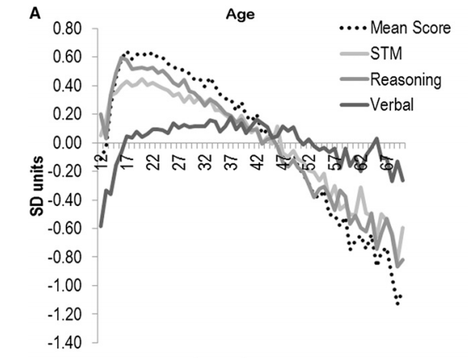

* One of the great strengths of the CBS battery is that it covers a wide variety of executive functions
* Performance on the CBS battery can predict age as well as a 2-3 hour traditional neuropsychological battery (see attached poster).
* This battery is at the cutting edge in terms of efficiency and breadth of testing
* I think we need to be weary of extrapolating from performance on a single test to talking about ‘executive function’ in general.