Q1 hash tree - A1_yulaipo_207410141
A [[[[1, 4, 5], [4, 1, 8], [4, 7, 8]],
[[[1, 2, 4], [4, 5, 7]], [1, 2, 5], [[1, 2, 3], [1, 5, 9]]],
[[1, 3, 6], [4, 6, 7]]],
[[8, 4, 7],
[[2, 5, 9], [8, 2, 4], [8, 5, 1]],
[[[2, 3, 4], [8, 9, 1], [8, 3, 7], [8, 3, 1]], [8, 6, 2], [8, 3, 6]]],
[[[], [3, 4, 5], [[6, 1, 3], [6, 4, 3], [6, 7, 9]]],
[[6, 2, 1], [], [[3, 5, 6], [3, 5, 9], [3, 8, 9], [3, 2, 6], [6, 8, 9]]],
[6, 3, 4]]]

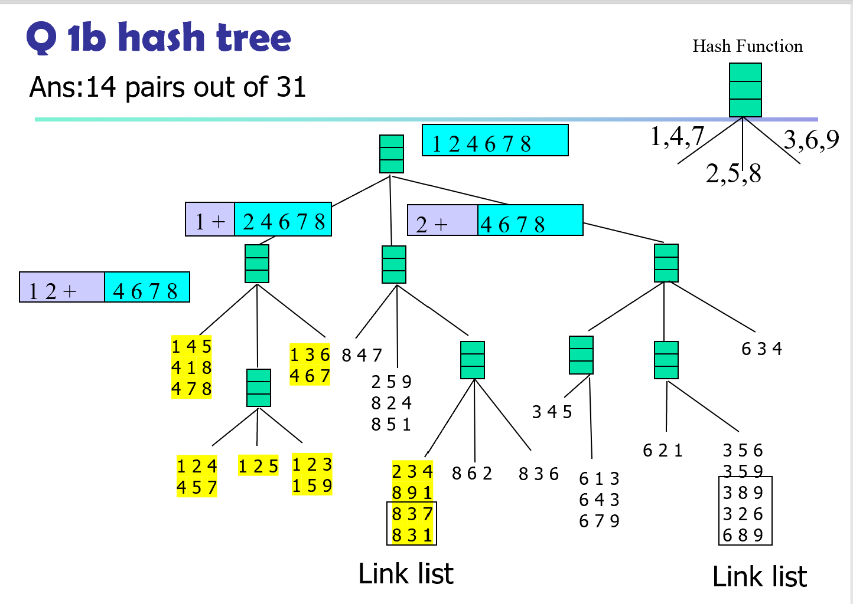
Q2 b
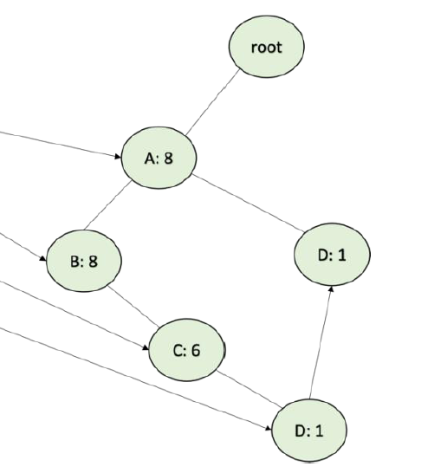
{A: 1, B:1, C:1,D:1}
{A:1, D:1}
A | 2
B | 1
C | 1
d | 2
Threshold =2
{A,D}

