K-Means Clustering – Example

We recall from the previous lecture, that clustering allows for unsupervised learning. That is, the machine / software will learn on its own, using the data (learning set), and will classify the objects into a particular class – for example, if our class (decision) attribute is tumorType and its values are: malignant, benign, etc. - these will be the classes. They will be represented by cluster1, cluster2, etc. However, the class information is never provided to the algorithm. The class information can be used later on, to evaluate how accurately the algorithm classified the objects.

 | Curvature | Texture | Blood  Consump | Tumor  Type
x1 | 0.8 | 1.2 | A | Benign
x2 | 0.75 | 1.4 | B | Benign
x3 | 0.23 | 0.4 | D | Malignant
x4  .  . | 0.23 | 0.5 | D | Malignant

(learning set)
 | Curvature | Texture | Blood  Consump | Tumor  Type
x1 | 0.8 | 1.2 | A | Benign
x2 | 0.75 | 1.4 | B | Benign
x3 | 0.23 | 0.4 | D | Malignant
x4  .  . | 0.23 | 0.5 | D | Malignant

Curvature
Texture
Blood
Consump
0.8
0.23
1.2
0.4
A
B
D
.x1
The way we do that, is by plotting the objects from the database into space. Each attribute is one dimension:

Curvature
Texture
Blood
Consump
0.8
0.23
1.2
0.4
A
B
D
.
.
.
.
.
.
.
Cluster 1
benign
Cluster 2
malignant
.

After all the objects are plotted, we will calculate the distance between them, and the ones that are close to each other – we will group them together, i.e. place them in the same cluster.

With the K-Means algorithm, we recall it works as follows:

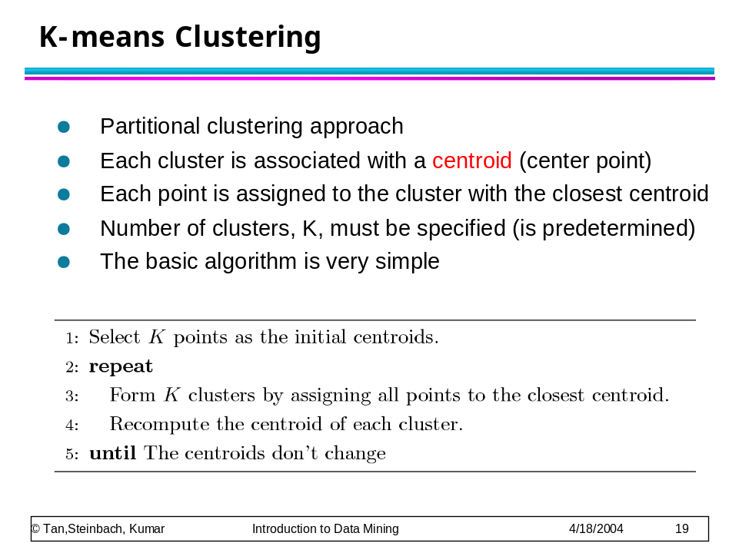

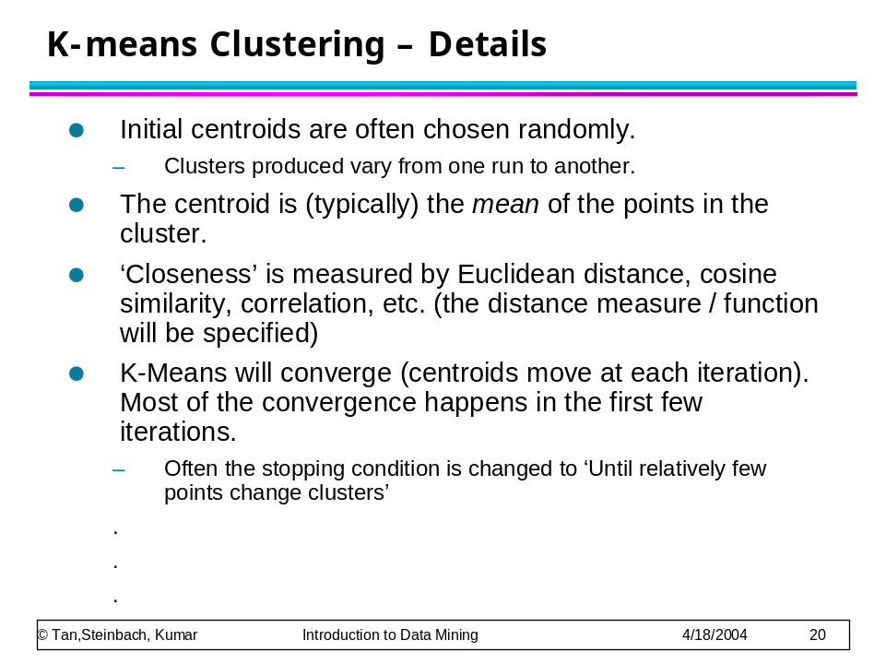

Example

Problem: Cluster the following eight points (with (x, y) representing locations) into three clusters A1(2, 10) A2(2, 5) A3(8, 4) A4(5, 8) A5(7, 5) A6(6, 4) A7(1, 2) A8(4, 9). Initial cluster centers are: A1(2, 10), A4(5, 8) and A7(1, 2). The distance function between two points a=(x1, y1) and b=(x2, y2) is defined as: ρ(a, b) = |x2 – x1| + |y2 – y1| .
Use k-means algorithm to find the three cluster centers after the second iteration.

Solution:

Iteration 1
 |  | (2, 10) | (5, 8) | (1, 2)
 | Point | Dist Mean 1 | Dist Mean 2 | Dist Mean 3 | Cluster
A1 | (2, 10)
A2 | (2, 5)
A3 | (8, 4)
A4 | (5, 8)
A5 | (7, 5)
A6 | (6, 4)
A7 | (1, 2)
A8 | (4, 9)

First we list all points in the first column of the table above. The initial cluster centers – means, are (2, 10), (5, 8) and (1, 2) - chosen randomly. Next, we will calculate the distance from the first point (2, 10) to each of the three means, by using the distance function:

point mean1
x1, y1 x2, y2
(2, 10) (2, 10)

ρ(a, b) = |x2 – x1| + |y2 – y1|

ρ(point, mean1) = |x2 – x1| + |y2 – y1|
= |2 – 2| + |10 – 10|
= 0 + 0
= 0

point mean2
x1, y1 x2, y2
(2, 10) (5, 8)

ρ(a, b) = |x2 – x1| + |y2 – y1|

ρ(point, mean2) = |x2 – x1| + |y2 – y1|
= |5 – 2| + |8 – 10|
= 3 + 2
= 5

point mean3
x1, y1 x2, y2
(2, 10) (1, 2)

ρ(a, b) = |x2 – x1| + |y2 – y1|

ρ(point, mean2) = |x2 – x1| + |y2 – y1|
= |1 – 2| + |2 – 10|
= 1 + 8
= 9

So, we fill in these values in the table:

 |  | (2, 10) | (5, 8) | (1, 2)
 | Point | Dist Mean 1 | Dist Mean 2 | Dist Mean 3 | Cluster
A1 | (2, 10) | 0 | 5 | 9 | 1
A2 | (2, 5)
A3 | (8, 4)
A4 | (5, 8)
A5 | (7, 5)
A6 | (6, 4)
A7 | (1, 2)
A8 | (4, 9)

So, which cluster should the point (2, 10) be placed in? The one, where the point has the shortest distance to the mean – that is mean 1 (cluster 1), since the distance is 0.

Cluster 1 Cluster 2 Cluster 3
(2, 10)

So, we go to the second point (2, 5) and we will calculate the distance to each of the three means, by using the distance function:

point mean1
x1, y1 x2, y2
(2, 5) (2, 10)

ρ(a, b) = |x2 – x1| + |y2 – y1|

ρ(point, mean1) = |x2 – x1| + |y2 – y1|
= |2 – 2| + |10 – 5|
= 0 + 5
= 5

point mean2
x1, y1 x2, y2
(2, 5) (5, 8)

ρ(a, b) = |x2 – x1| + |y2 – y1|

ρ(point, mean2) = |x2 – x1| + |y2 – y1|
= |5 – 2| + |8 – 5|
= 3 + 3
= 6

point mean3
x1, y1 x2, y2
(2, 5) (1, 2)

ρ(a, b) = |x2 – x1| + |y2 – y1|

ρ(point, mean2) = |x2 – x1| + |y2 – y1|
= |1 – 2| + |2 – 5|
= 1 + 3
= 4
So, we fill in these values in the table:

Iteration 1
 |  | (2, 10) | (5, 8) | (1, 2)
 | Point | Dist Mean 1 | Dist Mean 2 | Dist Mean 3 | Cluster
A1 | (2, 10) | 0 | 5 | 9 | 1
A2 | (2, 5) | 5 | 6 | 4 | 3
A3 | (8, 4)
A4 | (5, 8)
A5 | (7, 5)
A6 | (6, 4)
A7 | (1, 2)
A8 | (4, 9)

So, which cluster should the point (2, 5) be placed in? The one, where the point has the shortest distance to the mean – that is mean 3 (cluster 3), since the distance is 0.

Cluster 1 Cluster 2 Cluster 3
(2, 10) (2, 5)

Analogically, we fill in the rest of the table, and place each point in one of the clusters:

Iteration 1
 |  | (2, 10) | (5, 8) | (1, 2)
 | Point | Dist Mean 1 | Dist Mean 2 | Dist Mean 3 | Cluster
A1 | (2, 10) | 0 | 5 | 9 | 1
A2 | (2, 5) | 5 | 6 | 4 | 3
A3 | (8, 4) | 12 | 7 | 9 | 2
A4 | (5, 8) | 5 | 0 | 10 | 2
A5 | (7, 5) | 10 | 5 | 9 | 2
A6 | (6, 4) | 10 | 5 | 7 | 2
A7 | (1, 2) | 9 | 10 | 0 | 3
A8 | (4, 9) | 3 | 2 | 10 | 2

Cluster 1 Cluster 2 Cluster 3
(2, 10) (8, 4) (2, 5)
(5, 8) (1, 2)
(7, 5)
(6, 4)
(4, 9)
Next, we need to re-compute the new cluster centers (means). We do so, by taking the mean of all points in each cluster.

For Cluster 1, we only have one point A1(2, 10), which was the old mean, so the cluster center remains the same.

For Cluster 2, we have ( (8+5+7+6+4)/5, (4+8+5+4+9)/5 ) = (6, 6)

For Cluster 3, we have ( (2+1)/2, (5+2)/2 ) = (1.5, 3.5)

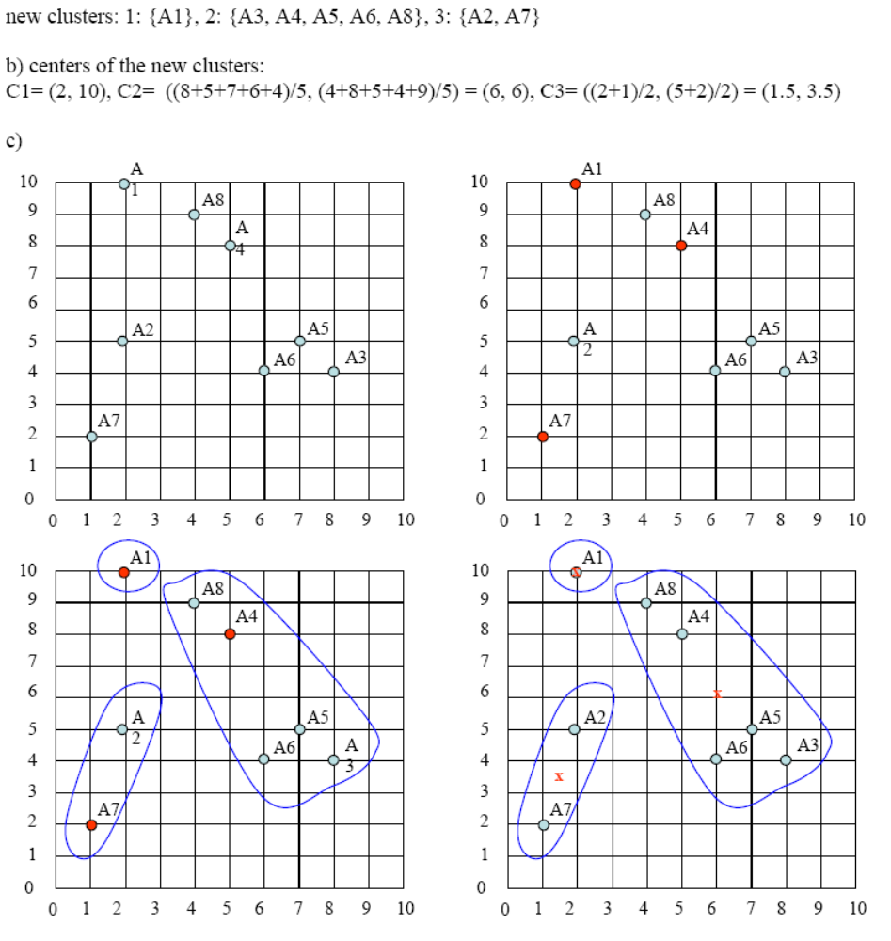

The initial cluster centers are shown in red dot. The new cluster centers are shown in red x.

That was Iteration1 (epoch1). Next, we go to Iteration2 (epoch2), Iteration3, and so on until the means do not change anymore.
In Iteration2, we basically repeat the process from Iteration1 this time using the new means we computed.

