# Statistical & Graphical Analysis of Housing Dataset

## 1. Box Plots

plt.figure(figsize=(10, 6))  
sns.boxplot(data=df['price'])  
plt.title('Box Plot for Price')  
  
sns.boxplot(data=df.drop(columns=['price','area']))  
plt.title('Box Plot (excluding price and area'))  
plt.show()

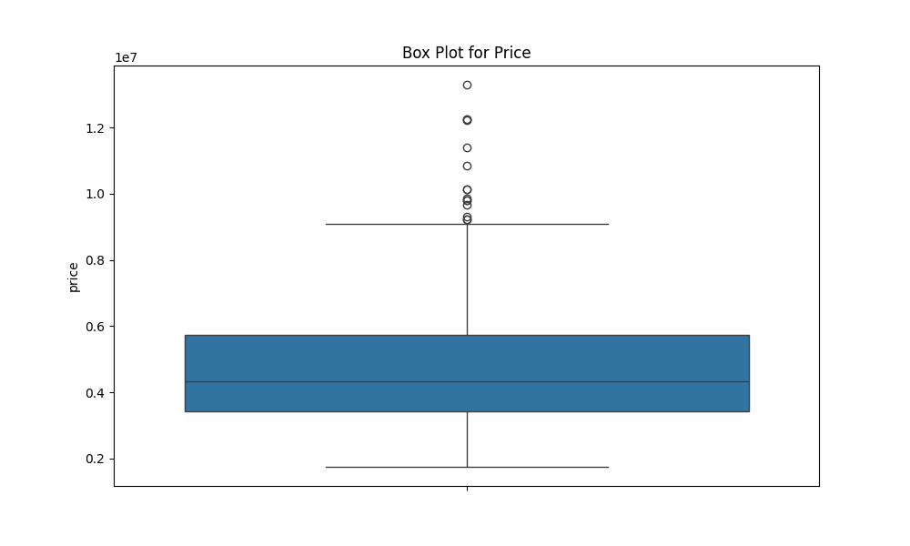

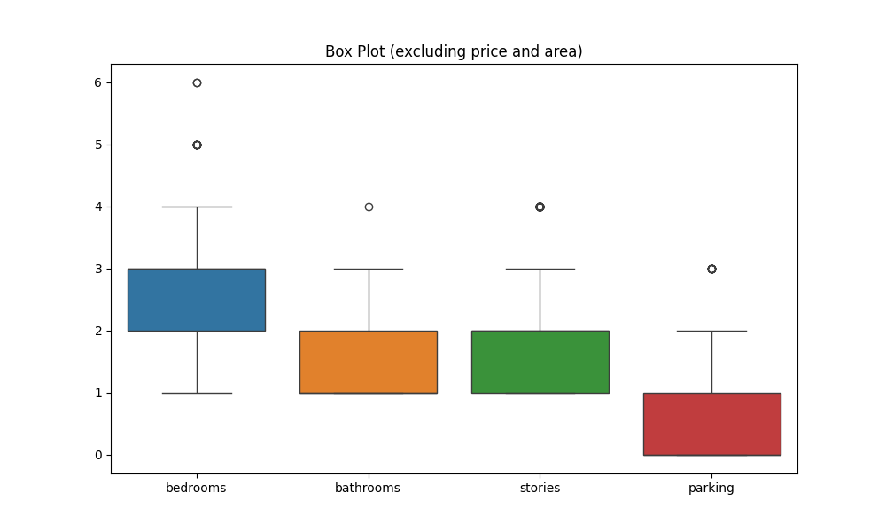

## 2. QQ Plot for Price

stats.probplot(df["price"].dropna(), dist="norm", plot=plt)  
plt.title("QQ Plot — price")

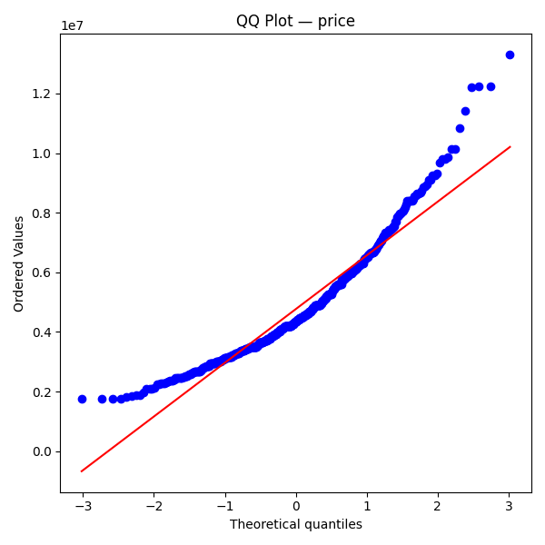

## 3. Histogram for Price

sns.histplot(df["price"], bins=30, kde=True)  
plt.title("Histogram — price")

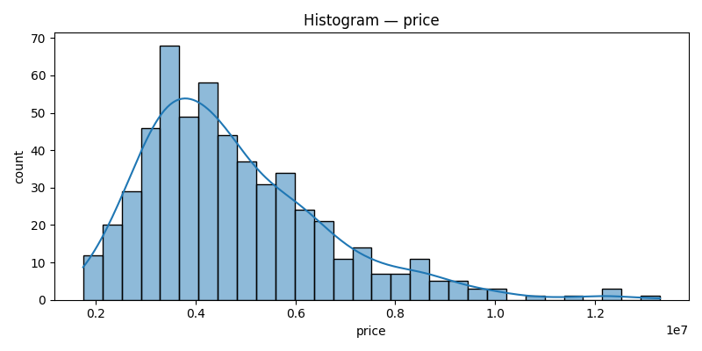

## 4. Chi-Square Test for Price Bin vs Furnishing Status

ct = pd.crosstab(df["price_bin"], df["furnishingstatus"])  
chi2, p, dof, expected = chi2_contingency(ct.values)  
print(ct)  
print("Chi-square:", chi2, "| p-value:", p, "| dof:", dof)  
print("Expected frequencies:\n", expected)

Contingency Table:

|  |  |  |  |
| --- | --- | --- | --- |
| price_bin | furnished | semi-furnished | unfurnished |
| low | 29 | 47 | 110 |
| medium | 43 | 106 | 28 |
| high | 68 | 74 | 40 |

Chi-square = 104.9918, p-value = 8.5045e-22, dof = 4

Expected frequencies:

|  |  |  |
| --- | --- | --- |
| 47.78 | 77.47 | 60.75 |
| 45.47 | 73.72 | 57.81 |
| 46.75 | 75.81 | 59.44 |

Decision: Reject H0 (dependent)

## 5. Pearson Correlation

r_pa, p_pa = pearsonr(df["price"], df["area"])  
print("Pearson r (price, area) =", r_pa, ", p-value =", p_pa)  
  
corr_mat = df[["price","area","bedrooms","bathrooms","stories","parking"]].corr(method="pearson")  
print(corr_mat)

Pearson r (price, area) = 0.5360, p-value = 0.0000

Correlation Matrix:

|  |  |  |  |  |  |  |
| --- | --- | --- | --- | --- | --- | --- |
|  | price | area | bedrooms | bathrooms | stories | parking |
| price | 1.0000 | 0.5360 | 0.3665 | 0.5175 | 0.4207 | 0.3844 |
| area | 0.5360 | 1.0000 | 0.1519 | 0.1938 | 0.0840 | 0.3530 |
| bedrooms | 0.3665 | 0.1519 | 1.0000 | 0.3739 | 0.4086 | 0.1393 |
| bathrooms | 0.5175 | 0.1938 | 0.3739 | 1.0000 | 0.3262 | 0.1775 |
| stories | 0.4207 | 0.0840 | 0.4086 | 0.3262 | 1.0000 | 0.0455 |
| parking | 0.3844 | 0.3530 | 0.1393 | 0.1775 | 0.0455 | 1.0000 |