Technical Details of Recommendation to Enter the Short-Term Rental Market

**I recommend that Watershed should enter into Short Term Market with 16 properties. The details are given below:**

|  |  |  |  |  |  |  |
| --- | --- | --- | --- | --- | --- | --- |
| **Watershed property ID** | **city** | **Property type** | **Net Forecast Change in Cash Flow, Conversion Year** | **Net Change in Cash Flow, Each Year Thereafter (for next 4 years)** | **Net Change in Profits, Conversion year** | **Net Change in Profits, each year thereafter (for next 4 years)** |
| **W156** | Miami | 2 BR house | **106603.3** | 130603.3 | **130603.3** | 124603.3 |
| **W155** | Miami | 1 BR house | **86018.19** | 110018.2 | **110018.2** | 104018.2 |
| **W164** | Miami | 2 BR house | **60371.3** | 84371.3 | **84371.3** | 78371.3 |
| **W163** | Miami | 1 BR house | **46397.57** | 70397.57 | **70397.57** | 64397.57 |
| **W107** | Austin | 1 BR house | **36983.04** | 60983.04 | **60983.04** | 54983.04 |
| **W120** | Austin | 2 BR house | **28570.57** | 52570.57 | **52570.57** | 46570.57 |
| **W108** | Austin | 2 BR house | **26515.74** | 50515.74 | **50515.74** | 44515.74 |
| **W152** | Miami | 2 BR house | **12529.73** | 36529.73 | **36529.73** | 30529.73 |
| **W192** | San Diego | 2 BR house | **8517.527** | 32517.53 | **32517.53** | 26517.53 |
| **W190** | San Diego | 2 BR apartment | **21015.08** | 45015.08 | **45015.08** | $39,015 |
| **W110** | Austin | 2 BR apartment | **9088.725** | 33088.72 | **33088.72** | $27,089 |
| **W114** | Austin | 2 BR apartment | **6727.043** | 30727.04 | **30727.04** | $24,727 |
| **W112** | Austin | 2 BR house | **6577.542** | 30577.54 | **30577.54** | 24577.54 |
| **W111** | Austin | 1 BR house | **2262.853** | 26262.85 | **26262.85** | $20,263 |
| **W160** | Miami | 2 BR house | **8942.123** | 32942.12 | **32942.12** | $26,942 |
| **W119** | Austin | 1 BR house | **6555.998** | 30556 | **30556** | $24,556 |

I would also recommend focusing more on San Diego as it is a potential Short Term Rental Market. Moreover, the market as well as the predicted profits strongly prefer full Houses or 2 BHK apartments

**The analysis that serves as the basis of my recommendation indicates that Watershed and its client would benefit from $___**[$*857,626*]**___ of increased profits during the first year, and yearly profits of $___**[*$761,676*]**___ every year thereafter if my recommendation is enacted. The initial capital investment needed to implement my recommendation would be $___**[*$480,000*]**___.** This analysis is based on financial assumptions that were confirmed by company and industry experts, but sensitivity analyses indicate that Watershed should enter the short-term rental market with their client, even if these initial assumptions need to be revised. Below, I describe the analyses I used to arrive at my conclusion, and report the results of my sensitivity analysis that assesses how expected profits and needed capital expenditure would change if my assumptions are modified.

Analysis Summary

I modeled the relationship between nightly rental price and occupancy rate for short-term rental properties using data from current short-term rentals managed by other companies and owners. I used this model to predict the short-term rental price that would maximize profits from each of Watershed’s client’s properties if it were managed as a short-term rental property. The metrics I report are based on the sum of the forecasted profits that would be gained and the forecasted capital investment that would be needed if my recommendation is followed, after the following are taken into account: (1) initial furnishing costs, (2) upkeep costs, (3) internet service fees, (4) regulatory fees, (5) hospitality charges (including key service and cleaning), (6) typical duration of stay, and (7) utilities. The details of the assumptions I used are provided below (Table 1), followed by a description of the results of my sensitivity analysis.

Analysis Assumptions and Sensitivity Analysis Ranges

Table 1

|  |  |  |  |  |  |
| --- | --- | --- | --- | --- | --- |
| **Consideration** | **Assumed Value** | **Source of Original Assumed Value** | **Minimum Value Tested**  [*Entry Set 5*] | **Maximum Value Tested**  [*Entry Set 6*] | **Rationale for Range of Values Tested**  [*Entry Set 7*] |
| Additional profit needed for a property to be considered “more profitable as a short-term rental” | $6,000 | Watershed Financial Department | $3,000 | $12,000 | Min – Half of assumed value  Max – Double of assumed value |
| Cost to convert property to short-term rental (includes furnishing and decorating) | $30,000 | Watershed Marketing Department | $15,000 | $50,000 | Min – Half of assumed value  Max – Double of assumed value |
| Years to depreciate capital expenditures | 5 | Watershed Financial Department | 2.5 | 10 | Min – Half of assumed value  Max – Double of assumed value |
| Yearly upkeep | $6,000 | Watershed Marketing Department | $3,000 | $10,000 | Min – Half of assumed value  Max – Realistic Values |
| Service fees to short-term stay website (e.g. Airbnb) | 20% | Watershed Marketing Department | 15% | 35% | Realistic Values |
| Regulatory fees (taxes and potential legal fees) | 10% | Watershed Financial Department | 5% | 20% | Realistic Values |
| Hospitality charges (key service, cleaning, re-stocking) | $100 | Watershed Financial Department | $50 | $200 | Min – Half of assumed value  Max – Double of assumed value |
| Typical stay duration (days) | 3 | Watershed Marketing Department | 2 | 7 | Realistic Values |
| Monthly utilities per property | $300 | Watershed Financial Department | $150 | $600 | Min – Half of assumed value  Max – Double of assumed value |

As agreed upon at the beginning of the project, some issues were NOT incorporated into the analysis, but could be incorporated in the future to help optimize short-term rental rates or to further refine projected profits (Table 2):

Table 2

|  |  |
| --- | --- |
| **Factor not included in analysis** | **Reason for exclusion from analysis** |
| Weekly or seasonal changes in rental prices/occupancy rates | Instructions from Project Manager |
| Promotions, coupons, or special events | Instructions from Project Manager |
| Loss in rental income while property is converted | Instructions from Project Manager |
| Differences in utility rates across properties | Instructions from Watershed Financial Department |

I have created a dashboard that illustrates the effects of changing these assumptions on predicted profits and required capital investment that is available to anybody on the team by request. **The minimum additional profits Watershed could earn when the assumptions were modified within the ranges described above was $___**[*$60,792*]**___**, if all the properties that are “more profitable” as a short-term rental are converted. **The maximum additional profits Watershed could earn when the assumptions were modified within the ranges described above was $___**[*$5,751,981*]**___**, if all the properties that are “more profitable” as a short-term rental are converted. The modified set of parameters associated with this minimum and maximum value are provided below (Table 3). Overall, the parameter that affected profits most was ___________[*Regulatory & Rental Fees***]**____________.

Table 3

|  |  |  |
| --- | --- | --- |
| **Consideration** | **Value in Assumption Set that led to Minimum Profits**  [*Entry Set 11*] | **Value in Assumption Set that led to Maximum Profits**  [*Entry Set 12*] |
| Additional profit needed for a property to be considered “more profitable as a short-term rental” | 12000 | 3000 |
| Cost to convert property to short-term rental (includes furnishing and decorating) | 60000 | 15000 |
| Years to depreciate capital expenditures | 3 | 10 |
| Yearly upkeep | 12,000 | 3,000 |
| Service fees to short-term stay website (e.g. Airbnb) | 35% | 10% |
| Regulatory fees (taxes and potential legal fees) | 20% | 5% |
| Hospitality charges (key service, cleaning, re-stocking) | 200 | 50 |
| Typical stay duration (days) | 2 | 7 |
| Monthly utilities | 600 | 150 |

Predictive Modeling Details

**Linear Regression Line:**

y = -0.79x + 0.85  
R² = 0.52

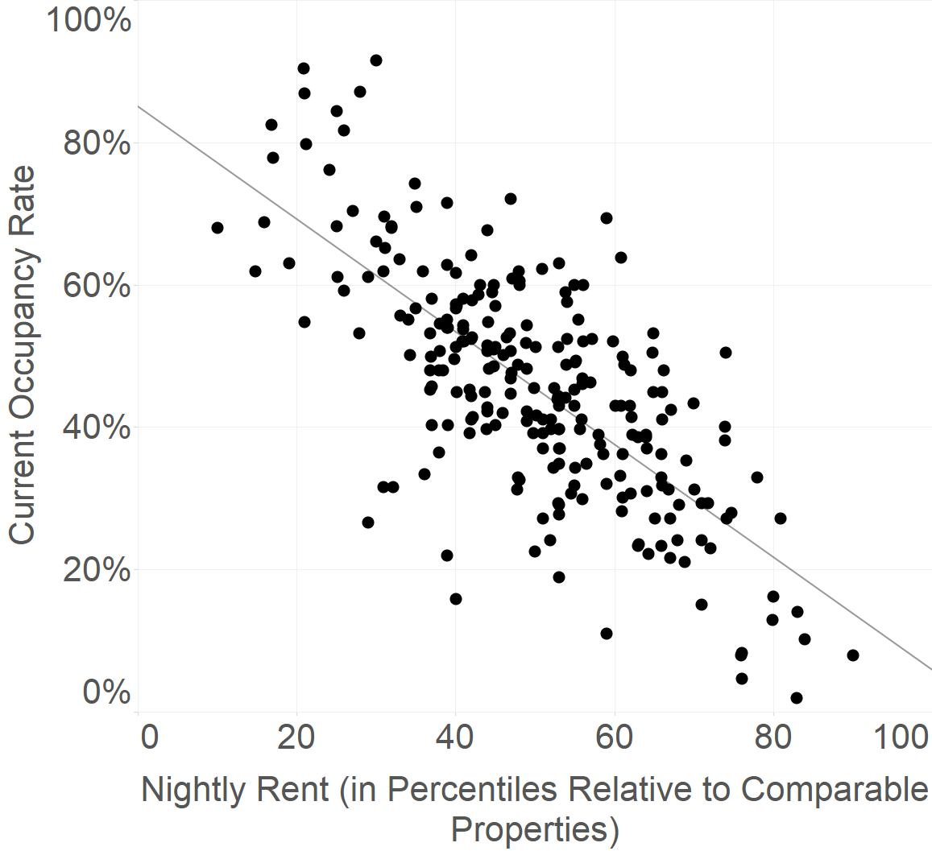

I was provided with four types of information about short-term rentals of the same type (number of bedrooms, apartment or house, kitchen availability, unshared property) and in the same location as Watershed’s client’s 244 properties: a typical short-term nightly rental rate, the corresponding occupancy rate for the property with that rental rate, the 10th percentile nightly rental rate, and the 90th percentile nightly rental rate. When the typical rental prices were expressed in terms of percentiles relative to properties of the same type and in the same location—but not when they were analyzed as raw dollar values—they correlated linearly with occupancy rates:

I used the parameters of the regression line and Excel’s Solver optimization function to find the rental price and occupancy rate that would maximize the profits expected from each of Watershed’s client’s 244 properties. Any optimized price below the 10th percentile rate was replaced with the 10th percentile rate, and any optimized price above the 90th percentile rate was replaced with the 90th percentile rate, in order to account for lack of data outside of these ranges in the linear model. These optimized rental rates were entered into a financial cash flow and profit model that computed the expected revenue from each property based on its projected occupancy rate, and the expected costs according to the financial assumptions described above.

**Regulatory Laws (Latest)**

|  |  |  |  |  |
| --- | --- | --- | --- | --- |
| **Country** | **Restrictions** | **Fines** | **Enforcement** | **Registration** |
| **New York** | In buildings with three or more units, renting out for less than 30 days is illegal, unless the owner is present during the rental. | Hosts to be fined $1,000 for the 1st violation, $5,000 for the 2nd violation and $7,500 for the 3rd violation. | Several cases of hosts being fined have been reported and the city has allocated $2.9 million towards enforcement. | Not currently required, although Airbnb have proposed a comprehensive set of clear, fair rules for home-sharing in New York City including registration |
| **Chicago** | Both hosted and non-hosted stays are legal, but are allowed only in specific zoning districts and under strict conditions | Hosts can be delisted and/or fined between $1,500 to $3,000 per violation, with each day that a violation exists being treated as a separate offense. | The city is not enforcing some penalties outlined in the new rules, as many listings are currently stamped with "city registration pending" | All hosts must be registered and can do so via Airbnb by clicking: Your Listings > Calendar and More > Then on the left hand menu, there's an item called "City Registration" |
| **San Francisco** | Only Permanent residents are allowed to rent out their primary residences, and not second or vacation homes.  Rentals where the host is not present in the unit is limited to a maximum of 90 days per year. | Hosts who rent out their apartments beyond the 90 days are subject to a daily fine of $484 for first offenders up to $968 for repeat offenders.  Rentals where the host is present in the unit are not subject to this limit. | Since 2015, San Francisco has issued over $1 million in fines to hosts | All hosts must apply for a Short-Term Residential Rental Certificate and Business Registration Certificate, both of which can be done on the Airbnb website |
| **Seattle** | Short-term rental transactions currently operate outside of a solid regulatory framework in Seattle.  A new set of regulations have been proposed which would see hosts requiring a license and be limited to 2 dwelling units. | Not applicable at this time. | Not applicable at this time. | All rental property owners in Seattle must register their properties with the City and obtain a Seattle business license tax certificate. |
| **Orlando** | Most standard residential zoning districts do not allow for short-term rentals.  An accommodation that allows for a stay less than seven days is considered a hotel/motel, which are not allowed in most residential zoning districts | Not having a license can subject the owner to fines of $250 per day for non-compliance.  In Orange County, homes must be zoned as R-3 transient residential to legally be rented or leased for 30 days or less.  Repeat violators can be fined up to $1,000 per day. | Code-enforcement leaders have received several complaints about homes being improperly used as rentals. Letters are sent to hosts notifying them of violations for the first offence, with hefty fines following for repeat violators | Hosts need to apply for an operating license as well as a business license and a tourism tax license from the county where their property is located |
| **Austin** | Austin is no longer accepting applications forType 2 Short Term Rentals (single-family or duplex residences that are not occupied by the owner).  A short-term rental may not be used by more than ten adults at one time; or six unrelated adults. | Hosts without an operating license could be subject to fines up to $2,000 per day. | Several cases have been reported of Austin's Code Enforcement officers actively seeking those who are operating without a license | Hosts are required to get an inspection of the property and obtain an operating license (Ordinance No. 20160223-A.l). This applies to all properties (including rooms and guest houses) rented for less than 30 consecutive days |
| **Louisville** | The total number of guests is limited to no more than two times the number of bedrooms plus four individuals. For example if your home has 3 bedrooms, then 10 people may reside at one time. | Hosts failing to comply with regulations will eventually result in fines up to $1,000. | So far, city officials have taken a lenient approach to enforcing the new rules with only a few dozen hosts receiving warnings. | Hosts must pay an annual $25 registration fee and file with the Metro Revenue Commission to pay transient occupancy taxes each year. Conditional use permits are required if you live in a Traditional Neighbourhood Zoning District e.g. Old Louisville or Limerick. |
| **Philadelphia** | Primary residences can be rented out for 90 days or less per year without a permit, however these rentals may not exceed 30 consecutive days for any visitor. | Not applicable at this time.​ | Not applicable at this time.​ | If you rent for more than 90 days (but 180 days or less) per calendar year or you are renting a secondary residence/vacation home, you must obtain a use registration permit as a “Limited Lodging Home”. |
| **Las Vegas** | Short-term rentals less than 30 days are not allowedin Unincorporated Clark County (near the Strip), and most of Henderson. | Renting your home in a prohibited area is a misdemeanor criminal charge. Hosts could face jail time and a $1,000 fine. | There has been an increase in complaints made to the county with code enforcement officers investigating many of these complaints | Hosts must obtain a business license, paying an annual fee of $500 for each rental unit and apply for either a Conditional Use Verification or a Special Use Permit. |
| **Los Angeles** | Hosts can rent out  their primary residence for a maximum of 180 days per year.  Renters and lessees must have written approval from the landlord.  Rent-controlled units are not eligible for home sharing. | Homes that fail to comply with the city ordinance may be subject to fines of $500 or two times the nightly rent charged (whichever is greater).  Hosts home-sharing beyond the 180 day annual limit may be subject to fines of at least $2,000. | Los Angeles City Council is currently reviewing the Short-Term Rental Ordinance, and strict enforcement is being considered -- short-term rental platforms could be fined for refusing to turn over the addresses of rentals that had not registered with the city. | All hosts must register with the city and obtain a permit from the Department of City Planning.  Hosts must also obtain a Transient Occupancy Registration Certificate from the Office of Finance. |
| **Miami** | Rentals in unincorporated Miami-Dade have occupancy limits capped at 180 days per year. The maximum overnight occupancy should not exceed two people per room, plus two per property for a maximum of 12. During the day, capacity is limited to 16 people.If you live 2,500 feet from a school, you will be required to ensure that a prospective guest is not a registered sexual offender or sexual predator. | Fines for violations range from $100 for a first offense to $2,500 for a third offense within 24 months. | This new ordinance goes into effect in 90 days (January 2018).  Miami has a history of tough enforcement and levying some of the highest fines in the country | Hosts must apply for a certificate of use and must obtain a vacation rental license with the Florida Department of Business and Professional Regulation. |
| **Washington DC** | Current laws ban the rental of non-owner occupied houses for less than 30 days.  Home-sharing is only legal if the host is present for the duration of the guest's stay. Regulations are set to change under the latest proposed bill.  Hosts will only be able to register one residential unit, which must be their permanent residence | Hosts found in violation of the proposed bill could be fined up to $1,000 for the first violation, $4,000 for the second violation, and $7,000 for the third and subsequent violations. | Tougher fines and clear transparency and reporting requirements are included in the proposed bill, however there is a grace period of 120 days after the law becomes effective so that hosts have adequate time to register for their Basic Business License. | All hosts must obtain a Basic Business License. |
| **Boston** | Short-term rentals are currently unregulated in Boston, however a new bill has been proposed which would regulate Airbnb and other short-term rentals | No fines or fees have been instituted as of yet. | Not applicable at this time. | Under the proposed bill, hosts will be required to register on the Short-Term Residential Rental Registry. |
| **San Diego** | Short-term rentals are currently unregulated, as San Diego's zoning codes do not define STRs at all.  City council is reviewing proposals to regulate short-term rentals with a hearing to be rescheduled. | Not applicable at this time. | Under the current ordinance enforcement actions are unlikely to be taken however, hosts are required to pay taxes on all short-term rentals. | Hosts are currently required to obtain a Transient Occupancy Registration Certificate. |

**Source :** [**https://getpaidforyourpad.com/airbnb-regulations/**](https://getpaidforyourpad.com/airbnb-regulations/)

**This is just the basic information, to know more about the current status of legislations more through research is required.**