**Chatbot Report**

**Similar Product:**

1. **Woebot**

**-**Woebot is an app that works as a therapist. It uses natural language processing and cognitive-behavioral therapy. It is a talk therapy chatbot for people who struggle with mental health issues.

The chatbot can do a variety of things:

* It can track your mood and show the mood changes visually
* Accessible 24/7 and helps you feel better
* Teaches you techniques from cognitive behavioral therapy

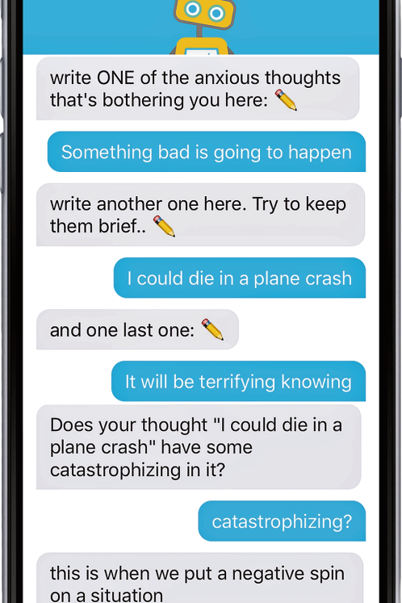

1. **Wysa**

Wysa is an AI-based 'emotionally intelligent' bot, a virtual coach which responds to the emotions you express and uses evidence-based cognitive-behavioral techniques (CBT), DBT, meditation, breathing, yoga, motivational interviewing and micro-actions to help you build mental resilience skills and feel better.

**Research Papers:**

* <https://github.com/andrewt3000/carl_voice>

Carl is a proposed project to create a deep learning chatbot for counseling. Counselors chat with clients using reflective listening and generate dialog training data. This training data and advanced machine learning techniques train a chatbot capable of counseling clients or assisting counselors with suggestions. Carl is an acronym for computer assisted reflective listener, and an homage to Carl Rogers, the pioneer of reflective listening.

Research papers and potential data sources proved to be very useful.

**Data Availability**

Data set can be obtained through external partnership

# <https://www.hindawi.com/journals/misy/2019/9517321/> (A Chatbot System for Mental Healthcare Based on SAT Counseling Method)

**Data Availability**

The data used to support the ﬁndings of this study are

available from the corresponding author upon request.

* <https://www.researchgate.net/publication/318123438_A_Chatbot_for_Psychiatric_Counseling_in_Mental_Healthcare_Service_Based_on_Emotional_Dialogue_Analysis_and_Sentence_Generation>

**Data Availability**

Not Available

* <http://www.ijpn.in/article.asp?issn=2231-1505;year=2019;volume=16;issue=2;spage=126;epage=128;aulast=Vijayarani>

**Data Availability**

Not Available

* <https://www.ncbi.nlm.nih.gov/pmc/articles/PMC6610568/>

**Data Availability**

Not Available

# 