**Assignment-5**

**Part 1: Views**

1.Your advertisement team made a mistake with the name of an ad campaign. Create a new View that changes all campaigns named “SummerSale2016” to “SummerSale2017”.

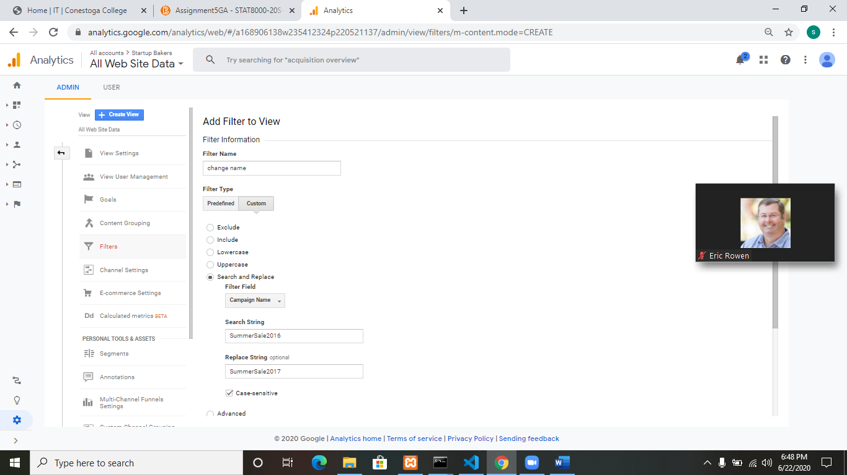

2.Create a new view that filters all hits from Switzerland and Japan.

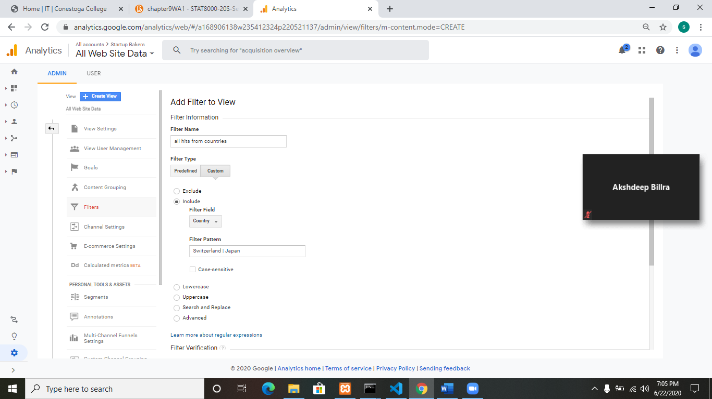

**Part 2: Segments**

1.Create a segment that shows all users who spent more than $100.00

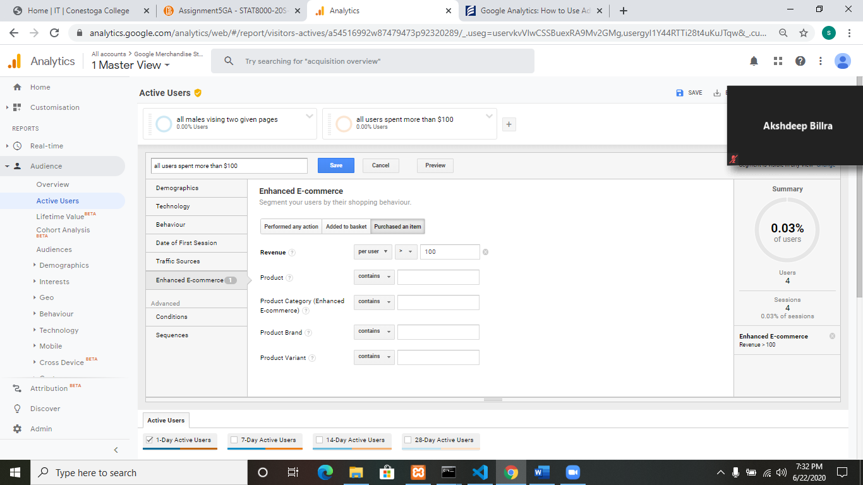

2.Create a segment that shows all Males who first visited /home and then visited /signin.html

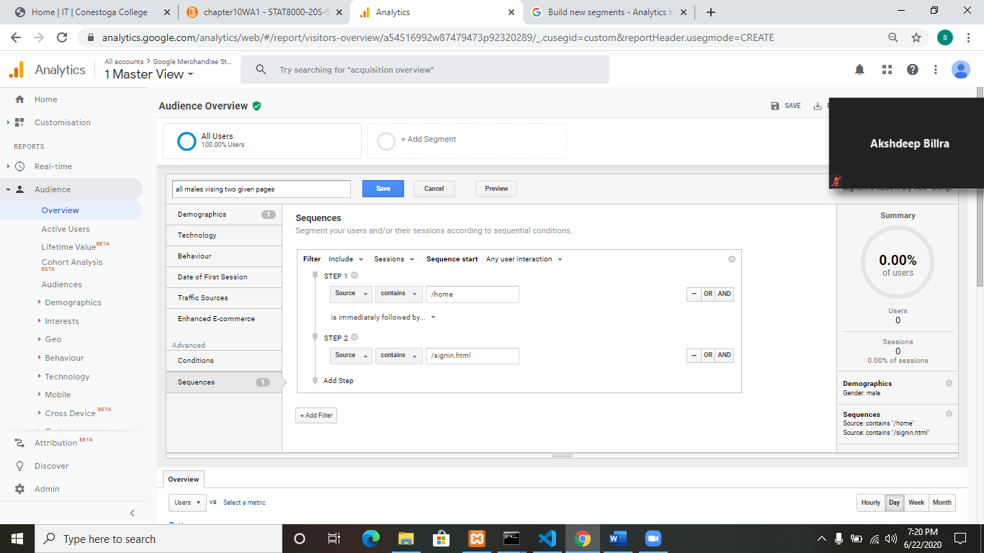

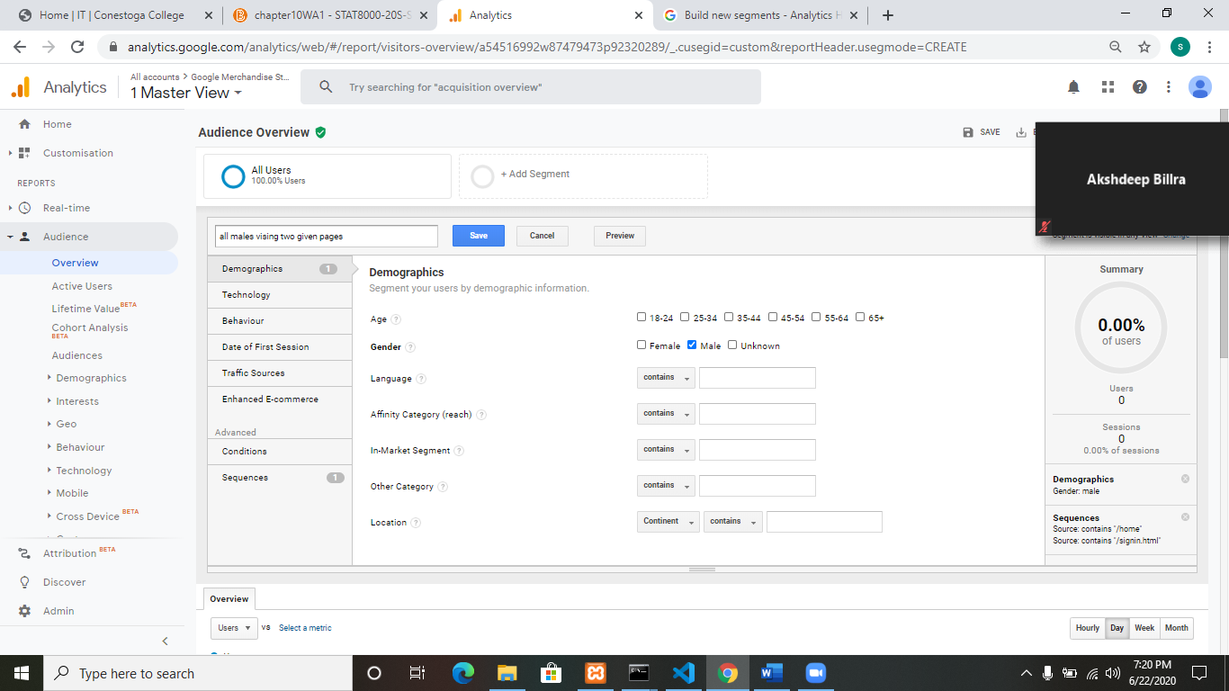

**Part 3: Constituencies**

Imagine you have created a website that functions similarly to eBay. What constituencies would you be able to divide the site traffic into

1. **New Customers:** They will visit MY ACCOUNT page of site.
2. **Regular Customers:** Regular customers will visit BUY page of our site.
3. **Seller:** People who want to sell, they will visit SELLING ACTIVITIES or START SELLING page of site.
4. **Community Members:** They will visit community page which includes news, policies, instructions etc.

We can segment them using different properties of segments in google analytics. We can also apply advanced conditions on those segments to filter out traffic. As our site is large e-commerce site, so sampling can be used to handle large data.