**PYTHON**

**PROJECT REPORT**

**On**

**Eatables FeedBack**

Submitted To: Submitted By:

Annie(1510991090)

Ashima Verma(1510991126)

Ms. Kanika Mam Astha Jindal(1510991134)

Astha Parmar(1510991135)

**ACKNOWLEDGEMENT**

We take this occasion to thank God, almighty for blessing us with his grace and taking our endeavour to a successful culmination. We extend our sincere and heartfelt thanks to our esteemed guide, Miss Kanika Garg, for providing us with the right guidance and advice at the crucial junctures and for showing me the right way. We also take this opportunity to express a deep sense of gratitude to our project head and team members. We extend our sincere thanks to our respected faculty of Chitkara University, for allowing us to use the facilities available. We would like to thank the other faculty members also, at this occasion. Last but not the least, we would like to thank our friends and family for the support and encouragement they have given us during the course of our work.

**EATABLES FEEDBACK**

**Introduction**

Analytics and data gives us all sorts of insights into what our customers want from our business. But sometimes… don’t you wish you could get an answer straight from your customers?

That’s what eatables feedback website is all about.

It helps us understand the WHY behind what people are doing. Why are people using one feature three times as often as another? Why do most of your customers stop creating accounts on the last step? Or what causes customers to use your product less frequently (and eventually stop altogether)?

When we match customers’ eatables feedback to what we’re seeing in our analytics, we get a much clearer picture of what’s going on. Then we’ll know how to fix problems and go after the right opportunities.

The project is related to the feedback given to the any food item selected.Everytime we go somewhere its a trend to rate that thing and to give a feedback to the particular thing in order to appreciate or improve.Hence online Feedback involves the website called “Eatables Feedback” where customer has personal account where he/she logins and gives the weedback.The website involves:

1)SIGNUP-to create a new account.

2)LOGIN-to login or to access the created account.In case the user forgot the password while logging then “forgot and reset password” facility also available.

3)FEEDBACK-to fill the feedback.

**Requirements:**

1. **Hardware Requirements:**

|  |  |  |
| --- | --- | --- |
| **Component** | **Minimum** | **Recommended** |
| Processor | 2.5 gigahertz (GHz) | Dual processors that are each 3 GHz or faster |
| RAM | 1 gigabyte (GB) | 2 GB |
| Disk | NTFS file system–formatted partition with a minimum of 3 GB of free space | NTFS file system–formatted partition with 3 GB of free space plus adequate free space for your Web sites |
| Drive | DVD drive | DVD drive or the source copied to a local or network-accessible drive |
| Display | 1024 × 768 | 1024 × 768 or higher resolution monitor |
| Network | 56 kilobits per second (Kbps) connection between client computers and server | 56 Kbps or faster connection between client computers and server |

1. **Software Requirements:**

• Mozilla Firefox 3.5 and above

• Apple Safari 5.0 and above

• Google Chrome 1.0 and above

* Sublime Text 3 :

Sublime Text has a powerful, Python [API](https://www.sublimetext.com/docs/3/api_reference.html) that allows plugins to augment built-in functionality. Sublime Text is built from custom components, providing for unmatched responsiveness. From a powerful, custom cross-platform UI toolkit, to an unmatched syntax highlighting engine, Sublime Text sets the bar for performance.

* Command Prompt:

Also known as cmd.exe or cmd (after its executable file name), is the [command-line interpreter](https://en.wikipedia.org/wiki/Command-line_interpreter) .Command Prompt interacts with the user through a [command-line interface](https://en.wikipedia.org/wiki/Command-line_interface). In Windows, this interface is implemented through [Win32 console](https://en.wikipedia.org/wiki/Win32_console). Command Prompt may take advantage of features available to native programs of its own platform. For example, in OS/2, it can use real [pipes](https://en.wikipedia.org/wiki/Pipeline_(Unix)) in command pipelines, allowing both sides of the pipeline to run concurrently. As a result, it is possible to redirect the [standard error stream](https://en.wikipedia.org/wiki/Standard_error_stream).

**Languages Used(Required to install all these to run project):**

1. **Python**

In this project we have used Python language to block a website. We can selectively block website for a particular time of the dayPython is an easy to learn, powerful programming language. It has efficient high-level data structures and a simple but effective approach to object-oriented programming. Python’s elegant syntax and dynamic typing, together with its interpreted nature, make it an ideal language for scripting and rapid application development in many areas on most platforms.The Python interpreter and the extensive standard library are freely available in source or binary form for all major platforms from the Python Web site,<https://www.python.org/>, and may be freely distributed. The same site also contains distributions of and pointers to many free third party Python modules, programs and tools, and additional documentation.The Python interpreter is easily extended with new functions and data types implemented in C or C++ (or other languages callable from C). Python is also suitable as an extension language for customizable applications.

1. **Django**

Django is a high-level Python Web framework that encourages rapid development and clean, pragmatic design. Built by experienced developers, it takes care of much of the hassle of Web development, so you can focus on writing your app without needing to reinvent the wheel. It’s free and open source.

1. **CRIPSY-FORMS**

django-crispy-forms is a Django application that lets you easily build, customize and reuse forms using your favorite CSS framework, without writing template code and without having to take care of annoying details. You are currently looking at the documentation of the development release.

1. **HTML/CSS/JQuery**

**HTML** : HTML is Hypertext Text Markup Language ,a standardized system for tagging text files to achieve font,color,graphic.

**CSS** : CSS stands for Cascading Style Sheets. CSS describes how HTML elements are to be displayed on screen, paper, or in other media.

**JQUERY** : jQuery is a [JavaScript](https://techterms.com/definition/javascript) library that allows web developers to add extra functionality to their websites. It is [open source](https://techterms.com/definition/opensource) and provided for free under the MIT license. In recent years, jQuery has become the most popular JavaScript library used in [web development](https://techterms.com/definition/web_development).

**Supported Operating System**

We can configure this project on the following operating system.

* **Windows** : This project can easily be configured on windows operating system. For running this project on Windows system, you will have to install Python 2.7, PIP, Django.
* **Linus** : We can run this project also on all versions of Linux operatong system.
* **Mac** : We can also easily configure this project on Mac operating system.

**Methodology**

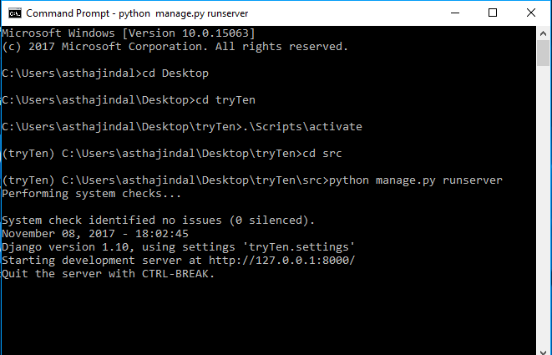

Following commands are run on command prompt to activate and start the server

1) >cd Desktop

2)>cd tryTen

3)>.\Scripts\activate

4)>cd src

5)>python manage.py runserver

The project is related to the feedback given to the any food item selected.Everytime we go somewhere its a trend to rate that thing and to give a feedback to the particular thing in order to appreciate or improve.Hence online Feedback involves the website called “Eatables Feedback” where customer has personal account where he/she logins and gives the weedback.The website involves:

1)SIGNUP-to create a new account

2)LOGIN-to login or to access the created account.In case the user forgot the password while logging then “forgot and reset password” facility also available.

3)FEEDBACK-to fill the feedback.

**Output:**

**Screenshot 1:**

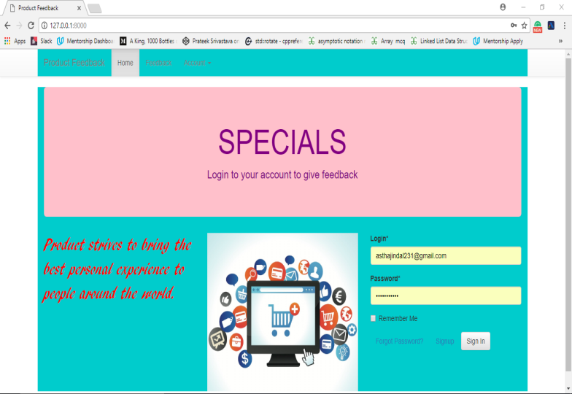

The first page we get when we open our localhost.

**Screenshot 2:**

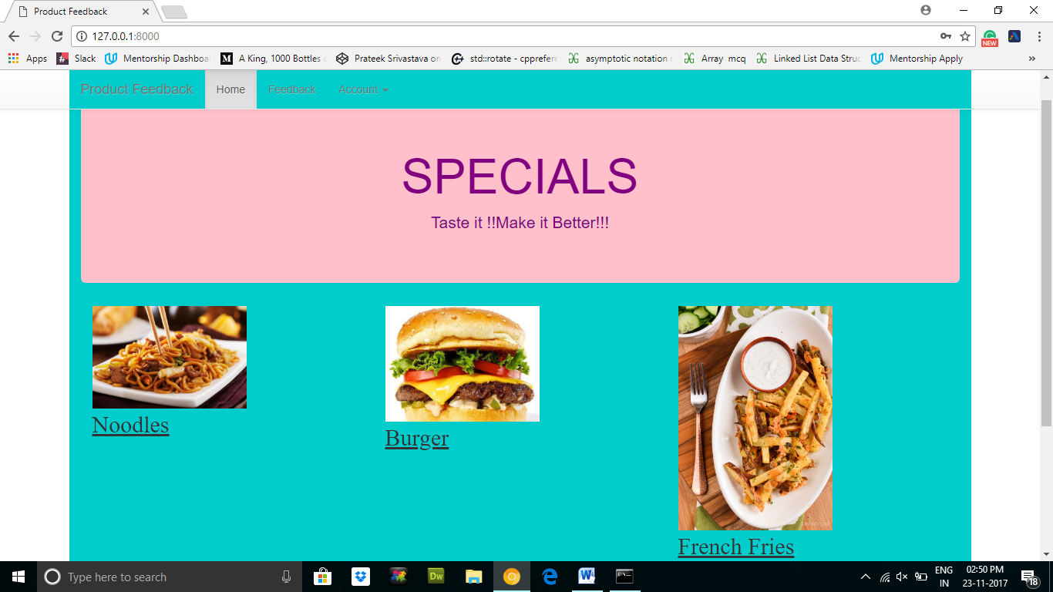

Page we get on making account and signing into it.Here we can see dishes and clicking on feedback tab user can give their feedback for a particular dish.

**Coding :**

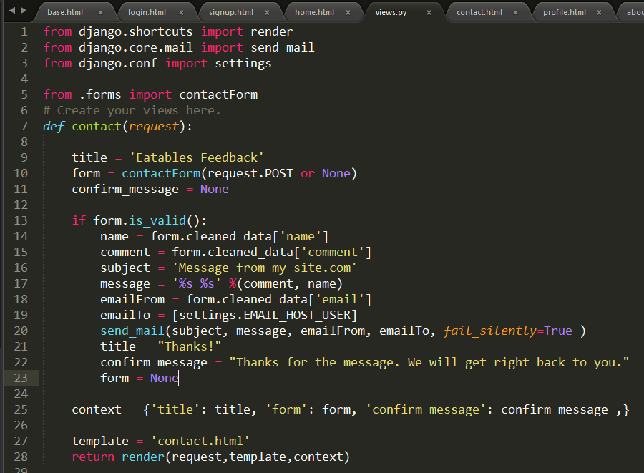

This shows that we have used django for our project.

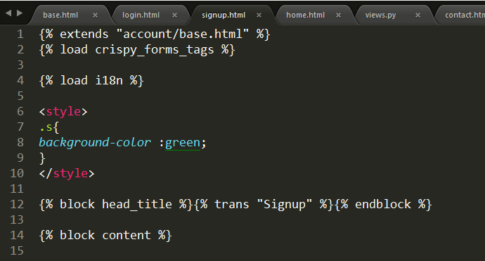

This shows that crispy_forms are used here.

**Conclusion:**

This is a feedback website and has good security.