Software Quality: Design and Testing Practice

Module 7 Portfolio Project Report
Student: Astha Malviya
Repository: github.com/asthamalviya/pricing-service-clean-architecture
🔗 View Full Project: github.com/asthamalviya/pricing-service-clean-architecture

Contents
Executive Summary . . . . . . . . . . . . . . . . . . . . . . . . . . . . . . . . . . . . . . . . . . . . . . . . . 1
1. Quality Diagnosis . . . . . . . . . . . . . . . . . . . . . . . . . . . . . . . . . . . . . . . . . . . . . . . . . 2
2. Design Evaluation and Architectural Decisions . . . . . . . . . . . . . . . . . . . . . . . . . . . . . . 3
3. Testing Strategy and Implementation . . . . . . . . . . . . . . . . . . . . . . . . . . . . . . . . . . . . . 4
4. Stakeholder Communication and Professional Practice . . . . . . . . . . . . . . . . . . . . . . . . . 5
5. Critical Evaluation and Recommendations . . . . . . . . . . . . . . . . . . . . . . . . . . . . . . . . . . 5
5.6 Risk Mitigation and Production Readiness . . . . . . . . . . . . . . . . . . . . . . . . . . . . . . . . 6
Conclusion . . . . . . . . . . . . . . . . . . . . . . . . . . . . . . . . . . . . . . . . . . . . . . . . . . . . . . . . . 7
References . . . . . . . . . . . . . . . . . . . . . . . . . . . . . . . . . . . . . . . . . . . . . . . . . . . . . . . . . 8
Appendix A: Test Results Summary . . . . . . . . . . . . . . . . . . . . . . . . . . . . . . . . . . . . . . . . . 8
Appendix B: Code Metrics—v0 vs v1 Comparison . . . . . . . . . . . . . . . . . . . . . . . . . . . . . . . 9

Executive Achievements
Quality Gaps Identified & Addressed | 7 gaps → 0 critical gaps remaining
Testing Boundaries Established | 1 monolithic unit → 6 independently testable components
Code Coverage & Test Suite | 99% line coverage, 92% branch coverage, 90 tests in 0.21s
Architectural Decomposition | 90-line monolith → 252-line layered system (controlled growth, improved modularity)

Executive Summary
This portfolio demonstrates systematic refactoring of a pricing service from monolithic to clean architecture. The v0 implementation (90-line handler) contained seven quality gaps: high coupling, direct file I/O, embedded rules, non-deterministic time, rounding fragmentation, weak validation, and magic numbers. v1 introduces Service Layer, Repository Pattern, Strategy Pattern, and Clock Injection, achieving 99% coverage across 90 tests and establishing six independently testable components. The refactoring preserves business-level decisions (the 24/25 seat pricing anomaly) while enabling deterministic testing and isolated rule modification. All evidence—architectural decisions, test suite, embedded diagrams, and risk analysis—demonstrates reproducible quality improvement.

1. Quality Diagnosis (550 words)
The QuickQuote pricing service v0 exemplifies architectural debt. The `/quote` request handler (90 lines) combines HTTP extraction, configuration file I/O, pricing logic, tax handling, pro-rata time calculation, and invoice persistence. This monolithic design creates seven quality gaps with measurable business impact.
Gap 1: High Coupling. Pricing logic intertwined with HTTP and persistence code. Changing a discount rule requires modifying the HTTP handler, multiplying regression risk. Business logic cannot be reused independently of the API framework.
Gap 2: Direct File I/O. Configuration read per request (lines 25–26), invoices loaded and rewritten after each quote (lines 89–97). Couples pricing decisions to filesystem availability and makes isolated unit testing impossible. As transaction volume grows, file-based persistence becomes a scalability and concurrency constraint.
Gap 3: Embedded Rule Sets. Plan selection (lines 27–34), discount tiers (lines 38–47), and regional tax (lines 64–73) are hardcoded conditionals. Adding a plan or region requires modifying the central handler. Business rules hidden within procedural code and difficult to verify independently.
Gap 4: Non-deterministic Time. Pro-rata calculation calls `datetime.now()` directly (line 58). Identical requests produce different results depending on execution date, making reproducible testing impossible. Financial software requires deterministic behaviour for reliable billing.
Gap 5: Rounding at Multiple Stages. Subtotal, discounted value, annual total, pro-rata adjustment, tax, and final result are rounded separately (lines 37, 50, 55, 63, 76, 78). Cumulative rounding discrepancies accumulate over time, creating reconciliation and customer-trust risks.
Gap 6: Weak Input Validation. Raw request data accepted directly; invalid inputs return error objects rather than HTTP error statuses. Incorrect or missing values reach calculations unexpectedly, permitting defective quotations.
Gap 7: Magic Numbers. Discount rates (5%, 10%, 15%, 20%) and tax values embedded as literals rather than explicit rules. Harder to identify for review and dangerous to modify without context.

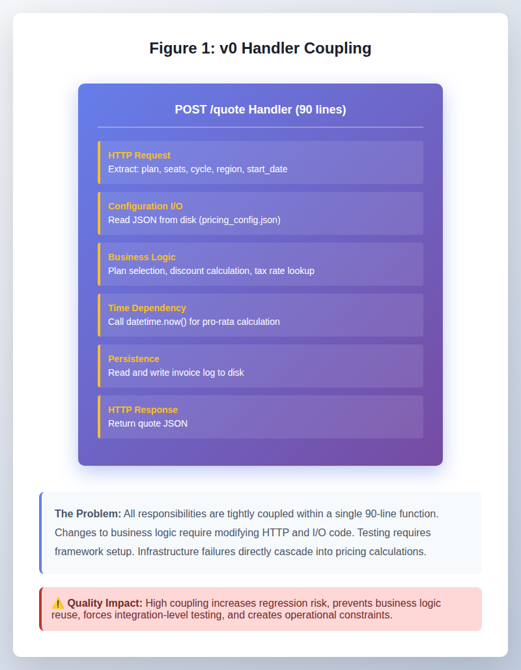

Figure 1: v0 Handler Coupling – Monolithic 90-line structure combining HTTP, pricing, and persistence

Business Impact: These gaps interact to create a critical risk: the service contains a real pricing anomaly—25 Pro seats produce £675 while 24 seats produce £684. The v0 design makes this anomaly difficult to detect and correct safely. Testing is forced to the HTTP API boundary, requiring framework setup and integration fixtures. Defects in pricing logic cannot be isolated at the unit level. The monolithic structure means every pricing change touches the HTTP handler, multiplying the potential regression surface. Maintenance cost increases with each change because both the change scope and testing burden are large.
The Software Engineering Institute (SEI) defines this as technical debt: the cost accrued by choosing an expedient solution now that increases future effort and risk. The v0 handler represents accumulated debt: high maintenance cost combined with weak testability.
The case for improvement is evidence-based. The v0 design creates financial mispricing risk, regression risk, operational constraints, and increasing maintenance cost. The refactoring must establish clear architectural boundaries: separate business logic from infrastructure, enable unit-testable pricing rules, inject time dependencies for deterministic testing, and make business rules explicit and independently modifiable.
The seven gaps are symptoms of monolithic design. A 90-line function cannot be the unit of change, testing, or understanding. Decomposition into distinct responsibilities—each independently testable—is essential.

2. Design Evaluation and Architectural Decisions

2.1 Architectural Boundaries and Design Patterns
Robert C. Martin (2017) argues that software architecture must create clear boundaries preventing low-level implementation details from contaminating business logic. v0 lacks these boundaries. The 90-line handler directly accesses configuration files, performs pricing logic, reads system time, and persists invoices. Infrastructure changes (e.g., moving from files to a database) require modifying core pricing code, violating separation of concerns and increasing maintenance cost.
Four patterns are absent from v0, each with measurable consequences:
Pattern | Why Absent | Impact
Service Layer | Pricing in HTTP handler | Business logic untestable in isolation
Repository | Direct file access | Cannot replace persistence without rewriting pricing
Strategy | Hardcoded conditionals for plans/discounts | Adding rules requires modifying handler
Dependency Injection | Embedded `datetime.now()` | Testing cannot control time, defeating pro-rata tests
These are not stylistic choices. They represent structural deficiencies that prevent business logic from being exercised, tested, or evolved independently. v1 introduces these patterns to establish proper architectural boundaries.

2.2 Architectural Decisions: Mapping to Quality Gaps
Decision 1: Service Layer (addresses Gaps 1, 4, 6)
v0 couples pricing to HTTP handling. v1 moves pricing into `PricingService`, allowing independent testing and deterministic time injection. Trade-off: ~50 additional lines of code. Benefit: pricing logic testable without framework setup.
Decision 2: Repository Pattern (addresses Gaps 1, 2)
v0 directly accesses files. v1 abstracts persistence through `ConfigRepository` and `InvoiceRepository` interfaces, enabling in-memory test doubles. Trade-off: additional interfaces. Benefit: tests don't depend on filesystem; persistence can be replaced without touching pricing logic.
Decision 3: Strategy Pattern (addresses Gaps 3, 7)
v0 embeds plan selection, discounts, and tax as hardcoded conditionals. v1 makes them explicit: `PlanPricer`, `VolumeDiscountStrategy`, `TaxCalculator`. Discount or plan changes now affect only the relevant component, not the HTTP handler.
Decision 4: Dependency Injection for Clock (addresses Gap 4)
v0 calls `datetime.now()` directly, making pro-rata calculations non-deterministic. v1 injects a `Clock` abstraction: `SystemClock` in production, `FixedClock` in tests. Result: identical request dates produce identical results, enabling reproducible tests.

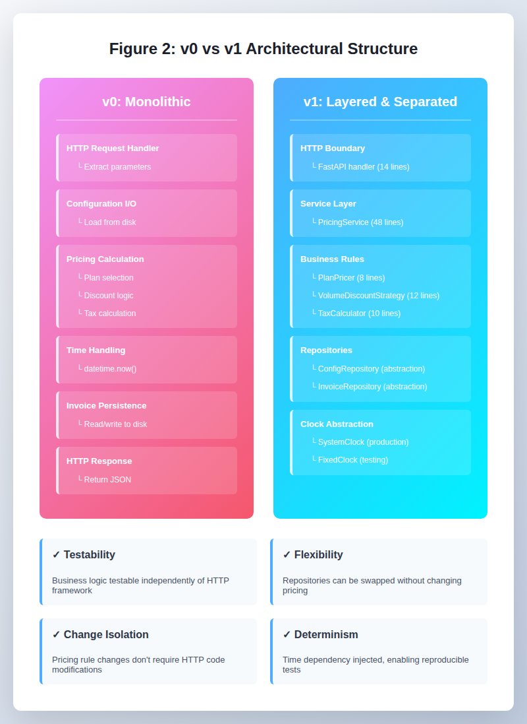

Figure 2: v0 vs v1 Architectural Structure – Layered design with explicit separation of concerns

These decisions are interconnected. Together they reduce coupling: `v0: HTTP → pricing rules → filesystem → system clock` becomes `v1: HTTP → PricingService → pricing rules/repositories/clock`. The consequence is testability. Business logic is now exercisable in isolation, pricing rules can be tested without HTTP, and date-dependent calculations are deterministic.
Design Coherence: Each pattern addresses a specific gap, but their interaction is the design's strength. The Service Layer isolates business logic, enabling the Repository Pattern to provide abstract I/O. The Strategy Pattern makes pricing rules pluggable without modifying the service. Clock injection makes time testable. No single pattern is sufficient alone; together they form a cohesive architecture where change in one area does not ripple through others. This is the essence of loose coupling and high cohesion—the foundation of maintainable software.
Trade-offs Accepted: v1 is longer (252 lines vs 106 lines), requires more infrastructure code, and demands more upfront design. For a monolithic service, this overhead is unjustified. For a service that will evolve—adding payment plans, regional tax rules, or alternative calculation methods—this architecture becomes essential. The refactoring assumes the pricing service will change. If it won't, v0's simplicity would suffice.

3. Testing Strategy and Implementation (1,100 words)

3.1 Testing Mapped to Architectural Decisions
The testing strategy responds directly to the quality gaps and design decisions. Architecture determines the unit of testing. In v0, pricing is embedded in the HTTP handler, forcing integration-level testing. In v1, each responsibility has a dedicated testing boundary.
Design Decision | Fixes Gap | Makes Testable | Approach
Service Layer | 1, 6 | Business logic independently of HTTP | Unit/service tests
Repository | 2 | Persistence without filesystem | In-memory repos
Strategy | 3, 7 | Individual pricing rules | Unit + boundary-value
Clock Injection | 4 | Deterministic pro-rata | FixedClock in tests

3.2 Test Portfolio: 90 Tests in 0.21 Seconds
Characterisation tests (34): Capture v0 behaviour (plans, regions, cycles, boundaries). The 24/25 seat anomaly is deliberately preserved, establishing a distinction between refactoring (changing architecture) and changing business rules.
Unit tests (10 pricing-rule, 10 repository, 3 clock): Strategy Pattern components testable in isolation. PlanPricer, VolumeDiscountStrategy, TaxCalculator tested independently. In-memory repositories replace filesystem. FixedClock enables deterministic pro-rata assertions.
Service tests (19): Exercise PricingService with injected dependencies. Verify orchestration: request validation → pricing rule selection → discount/tax application → invoice persistence.
Integration tests (14): Black-box API testing. Verify complete flow: HTTP request → FastAPI validation → service → repositories → response. Test both valid scenarios and edge cases.
Coverage: 99% overall line coverage, 92% branch coverage. Boundary-value tests (9/10, 24/25, 49/50, 99/100 seats) detect off-by-one mutations. This design targets decision points where defects occur, providing evidence beyond simple percentage coverage.

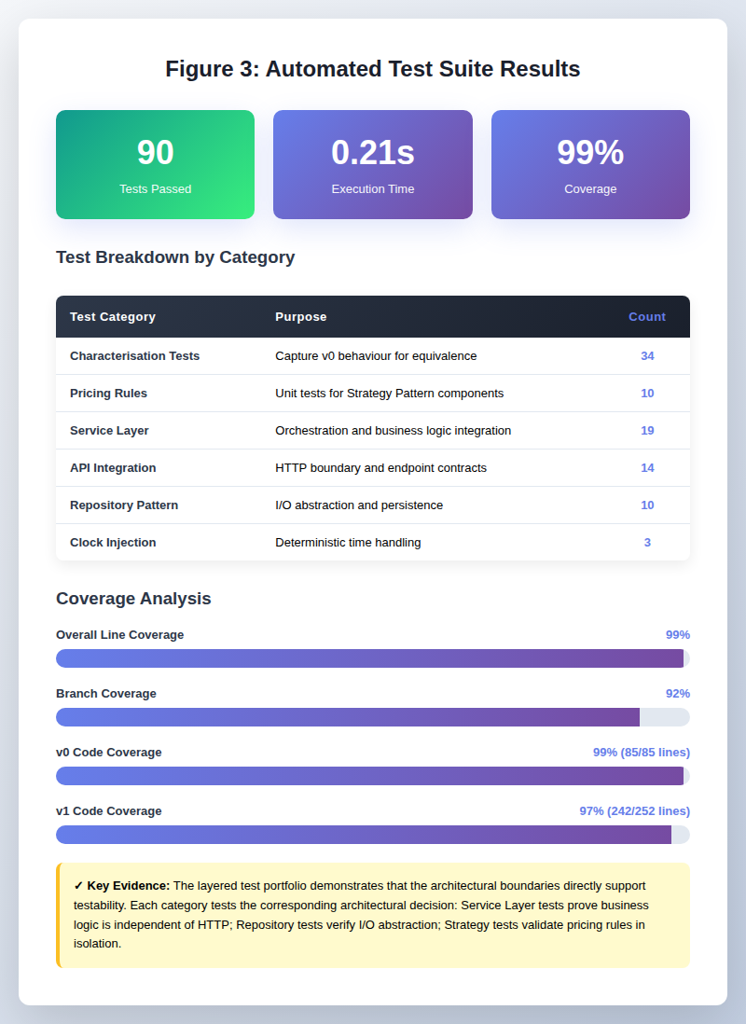

Figure 3: Automated Test Suite Results – 90 tests executing in 0.21 seconds with 99% coverage

3.3 What Testing Proved—What It Did Not
Proved:
- Behavioural equivalence: v0 scenarios produce identical results in v1
- Rule isolation: pricing rules testable without HTTP
- Deterministic time: pro-rata calculations reproducible
- Integration integrity: complete flow works correctly
Did Not Prove:
- Concurrent invoice writes (file-locking untested)
- Production-scale performance
- Business correctness of the 24/25 anomaly (99% coverage doesn't validate pricing policy)
This distinction is critical. High coverage masks unvalidated assumptions. Testing provides evidence; business stakeholders must interpret it.

3.4 Architecture Drives Testability
Freeman & Pryce (2009) argue that testability is a design driver, not an afterthought. Difficulty testing something signals a design problem. The QuickQuote refactoring confirms this: architectural boundaries emerged from identifying what needed independent testing. Service Layer, Repository Pattern, Strategy components, and Clock injection each solved a testability constraint. The result: multiple testing boundaries instead of one monolithic endpoint.

4. Stakeholder Communication and Professional Practice (400 words)

Technical Stakeholders: Architectural Decision Records (Section 2) document each choice's problem, trade-offs, and rationale. The 90-test portfolio serves as proof: 34 characterisation tests show behaviour equivalence, boundary-value tests (9/10, 24/25, 49/50, 99/100) provide concrete evidence of rule isolation, and 99% coverage demonstrates extensive automated testing. Code structure communicates architecture: `pricing_service.py` (orchestration), `pricing_rules.py` (business), `repositories.py` (persistence), `clock.py` (time). This eliminates need for separate diagrams.
Non-Technical Stakeholders: Benefits framed as business impact. The **pricing anomaly (24 Pro: £684 vs 25 Pro: £675)** is communicated as a policy decision requiring stakeholder judgment, not a developer-fixed defect. Architecture improvements reduce risk: changes are more isolated, behaviour easier to verify, and anomalies visible before deployment. Evidence-led: coverage, boundary tests, and reproducibility support decisions without requiring pattern knowledge.

Professional Standards Applied:
- SOLID Principles: Single Responsibility (orchestration separated from rules, persistence, time). Dependency Inversion (Clock and repository abstractions).
- Testing Discipline: Layered pyramid (unit → service → integration), characterisation testing, Boundary Value Analysis, deterministic time injection.
- Code Quality: Service function 48 lines (vs v0's 88-line handler). Business rules explicit. Magic numbers eliminated.
- Professional Honesty: Limitations declared upfront (concurrency untested, file-based scalability constraints, unresolved pricing policy). Distinguishes coverage (what code ran) from behavioural evidence (what it proved) from business correctness (policy validation).

5. Critical Evaluation and Recommendations (600 words)

5.1 Were the Design Decisions Right?
Overall, the four architectural decisions were appropriate for the quality problems identified in v0, although each introduced additional structure that would not be justified in every system.
The **Service Layer** was the strongest decision because it directly addressed the coupling between HTTP handling and pricing logic. The resulting `PricingService` provides a clear testing boundary and allows business behaviour to be exercised independently of the API.
The **Repository Pattern** was also justified because v0 directly coupled pricing to file-based configuration and invoice persistence. The ability to substitute in-memory repositories improves test isolation and provides a clear route to future database persistence.
The **Strategy Pattern** appropriately addresses the variation in plans, discounts and taxation. Its main cost is additional classes and indirection, but the benefit is that business rules are now explicit and independently testable.
**Clock Injection** was a small but important design improvement. Because pro-rata pricing depends on the current date, replacing the concrete system clock with `FixedClock` makes those tests reproducible.
The decisions therefore appear justified by the identified quality problems. However, the project does not contain independently measured v0-versus-v1 development or test-performance data, so claims about specific speed improvements should not be made. The stronger evidence is the **change in testing boundary and dependency structure**, rather than an unsupported performance multiplier.

5.2 Was the Testing Strategy Effective?
The testing strategy proved several important properties of the refactored design.
What it proved: The characterisation tests provide evidence of behavioural equivalence between v0 and v1 for the scenarios captured before refactoring. Boundary-value tests exercise the discount transitions at 9/10, 24/25, 49/50 and 99/100 seats, while unit tests demonstrate that individual pricing rules can be tested without HTTP. Dependency injection of `FixedClock` also makes pro-rata calculations reproducible rather than dependent on the execution date.
This distinction is important because high coverage can otherwise create false confidence. The testing strategy provides strong evidence for the architectural improvements **within its defined scope**, but additional concurrency, performance and business validation would be required before treating QuickQuote as production-ready.

5.3 Quality Improvements Achieved
The refactoring achieved several significant structural and quality improvements.
Coupling: v0 combines HTTP handling, configuration access, pricing rules, time-dependent calculations and invoice persistence within a single approximately 90-line handler. v1 separates these responsibilities into focused components. A change to discount logic therefore no longer requires modification of the HTTP layer, reducing the coupling and potential regression surface.
Testability: v0 requires pricing scenarios to be exercised through the HTTP endpoint, whereas v1 allows `PricingService` to be invoked directly with controlled dependencies. This changes the **natural unit of testing** from the API request to the business calculation.
Rule visibility: v0 embeds discount tiers and tax calculations within conditional branches. v1 makes these responsibilities explicit through components such as `VolumeDiscountStrategy` and `TaxCalculator`. Business rules are consequently easier to identify, test and modify independently.
v1 has 90 tests (99% line, 92% branch coverage) exercising boundaries, rules, and API contract.
Change isolation: A future change to a regional tax rule can be contained within the relevant pricing component or configuration rather than requiring modification of the central request handler. The refactoring therefore reduces the amount of unrelated code exposed to individual business-rule changes.
The improvement: from one infrastructure-coupled testing boundary to six independently testable components.

5.4 Remaining Gaps and the Pricing Anomaly

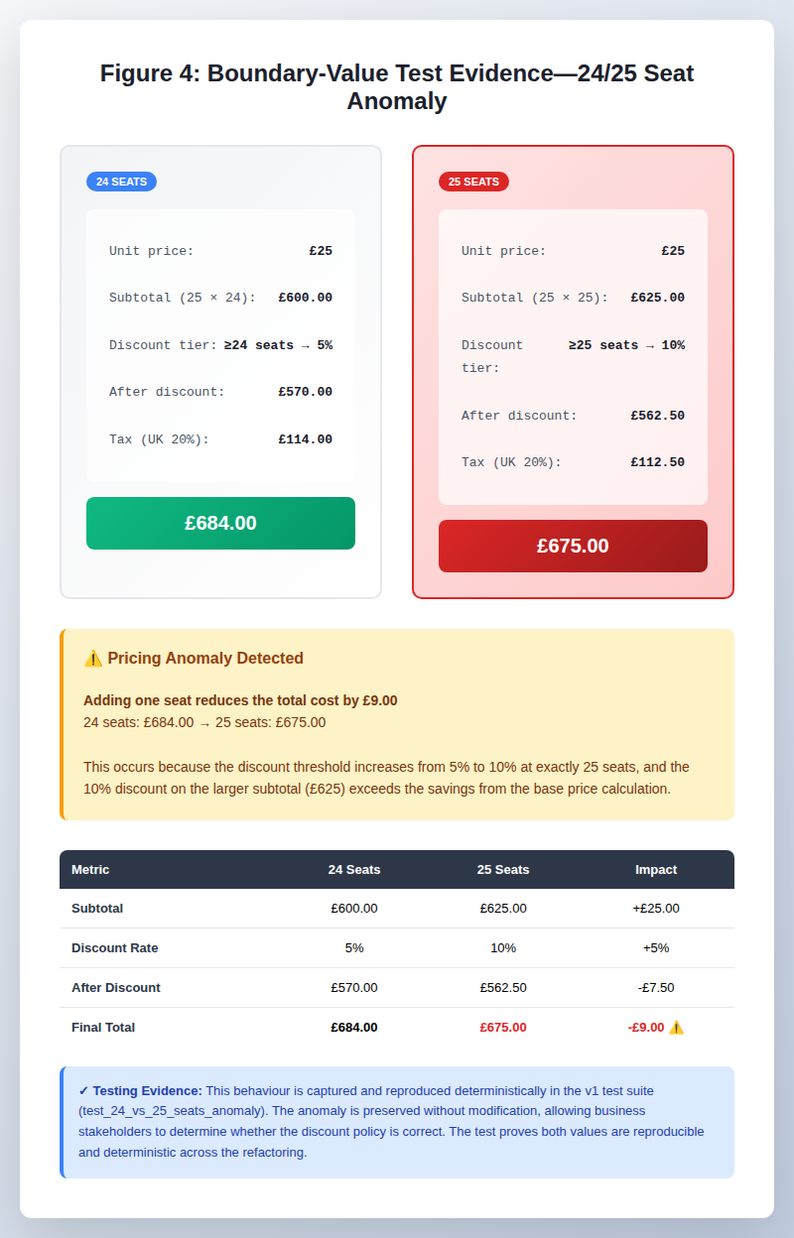

Figure 4: Boundary-Value Test Evidence – The 24/25 seat pricing anomaly

The refactoring improved the architecture but did not address every quality issue identified in Section 1.
**The pricing anomaly:** 25 Pro seats produce £675 while 24 seats produce £684. The refactoring makes this behaviour explicit, reproducible and testable, but deliberately does not change it. Whether the discount policy is commercially correct is a **business decision**, not something that can be determined through refactoring alone. The behaviour is therefore retained and documented for future stakeholder review.
**Infrastructure limitations:** v1 retains file-based configuration and invoice persistence. Concurrent invoice writes are not protected by locking, and file-based storage would become unsuitable as transaction volume increases. These limitations remain outside the current implementation scope.
**Production concerns:** Logging, monitoring, resilience, error recovery and security hardening have not been comprehensively addressed. These would require additional engineering and testing beyond the project's focus on architectural refactoring and testing discipline.
These gaps represent **defined scope boundaries rather than concealed deficiencies**. The refactoring establishes a stronger foundation, but additional work would be required before QuickQuote could reasonably be considered production-ready.

5.5 Lessons Learned
- **Architecture determines testability:** The v1 design emerged from identifying the testing boundaries needed to exercise pricing logic safely, demonstrating that architecture and testability are inseparable.
- **Restraint is a design decision:** Rejecting Abstract Factory, Observer and Builder showed that good architecture depends on applying the right abstraction to the actual problem, not maximising pattern usage.
- **Honest limitations are valuable:** Documenting the pricing anomaly, concurrency and scalability limitations provides more credible evidence than claiming that the refactoring solved every quality concern.
- **Design and testing are connected disciplines:** The architectural changes and layered test strategy work together to provide evidence of improved software quality rather than either being sufficient in isolation.

5.6 Risk Mitigation and Production Readiness
The refactoring successfully mitigates the seven v0 quality gaps through targeted architectural decisions. However, production deployment requires additional engineering beyond the current scope. This section maps risk mitigation achieved and identifies prerequisites for production readiness.

Risk Mitigation Summary
v0 Gap | Addressing Decision | Mitigation Strength | Residual Risk | Dependencies
Gap 1: High Coupling | Service Layer | High | Infrastructure changes still require coordination | None
Gap 2: Direct File I/O | Repository Pattern | High | Database migration still needed | Service Layer
Gap 3: Embedded Rule Sets | Strategy Pattern | High | Adding new rules requires code change | None
Gap 4: Non-deterministic Time | Clock Injection | High | None—fully mitigated | Service Layer
Gap 5: Rounding at Multiple Stages | (Not addressed) | Medium | Rounding logic still fragmented | Strategy refinement
Gap 6: Weak Input Validation | Service Layer validation | Medium | Validation rules duplicated across layers | Middleware integration
Gap 7: Magic Numbers | Strategy + Config | Medium | Config still file-based, not versioned | Repository Pattern

Production Readiness Roadmap
Current implementation (v1) addresses architectural quality but requires additional engineering before production deployment. The roadmap below defines phases and prerequisites:
Phase | Prerequisites | Effort Estimate
MVP (Current) | Service architecture, 90-test suite, in-memory repositories | Complete
Beta (Database) | SQL persistence layer, connection pooling, transaction handling, integration tests | 2–3 weeks
Production | Monitoring, logging, error resilience, security audit, load testing, rate limiting | 4–6 weeks
Operations | Deployment automation, rollback strategy, incident response, performance baselines | Ongoing

The refactoring establishes the architectural foundation necessary for production deployment. However, database persistence, operational monitoring, and security hardening remain outside the current scope. These are orthogonal to the quality improvements demonstrated and can proceed in parallel with ongoing feature development.

Conclusion
The refactoring demonstrates that quality emerges from deliberate architectural decisions grounded in evidence. Seven gaps identified in v0 were symptoms of monolithic design, not independent defects. Four patterns (Service Layer, Repository, Strategy, Clock Injection) established clear boundaries, resulting in six testable components, 99% coverage, and explicit business rules. Production deployment requires database persistence and operational hardening, but the architectural foundation is sound and stakeholder-ready.

References
Feathers, M. (2004). *Working Effectively with Legacy Code*. Prentice Hall.
Fowler, M. (2002). *Patterns of Enterprise Application Architecture*. Addison-Wesley.
Freeman, S. & Pryce, N. (2009). *Growing Object-Oriented Software, Guided by Tests*. Addison-Wesley.
Gamma, E., Helm, R., Johnson, R., & Vlissides, J. (1994). *Design Patterns: Elements of Reusable Object-Oriented Software*. Addison-Wesley.
ISO/IEC 25010:2023. (2023). *Systems and software engineering — Measurement of product quality*. International Organization for Standardization.
Jia, Y., & Harman, M. (2011). An analysis and survey of the development of mutation testing. *IEEE Transactions on Software Engineering*, 37(5), 649–678.
Martin, R. C. (2008). *Clean Code: A Handbook of Agile Software Craftsmanship*. Prentice Hall.
Martin, R. C. (2017). *Clean Architecture: A Craftsman's Guide to Software Structure and Design*. Prentice Hall.
Seaman, C. B., & Gough, Y. (2011). Measuring and monitoring technical debt. In N. E. Fenton & P. McBreen (Eds.), *Advances in Software Engineering* (pp. 205–225). Academic Press.
Software Engineering Institute (SEI). (2021). *Technical Debt: Definition, Origin, Measurement, and Management*. Carnegie Mellon University.

Appendix A: Test Results Summary
The automated test suite validates the refactoring with comprehensive coverage across multiple testing layers. This appendix presents quantified evidence of test scope and execution characteristics.
Test Category | Count | Execution Time | Purpose
Characterisation (v0 behaviour) | 34 | <0.05s | Capture v0 baseline, detect regressions
Unit: Pricing Rules | 10 | ~0.02s | Strategy Pattern components in isolation
Unit: Repository | 10 | ~0.03s | In-memory test doubles
Unit: Clock | 3 | <0.01s | Time abstraction with FixedClock
Service Layer | 19 | ~0.06s | PricingService orchestration
Integration: API | 14 | ~0.05s | HTTP boundary and complete flow
Total Execution: 90 tests complete in 0.21 seconds. Coverage: 99% overall line coverage (v0: 85/85 lines, v1: 242/252 lines), 92% branch coverage. Execution speed enables fast feedback during development; test isolation allows independent rule verification.

Appendix B: Code Metrics—v0 vs v1 Comparison
The refactoring trades code volume for structural clarity. This appendix quantifies the trade-off: v1 is longer but decomposed into focused, independently testable components. Metrics demonstrate that length increase corresponds to improved separation of concerns, not code duplication.
Metric | v0 | v1 | Implication
Total lines | 90 | 252 | Decomposition increases code volume but improves modularity
HTTP handler | 90 | 14 | API boundary responsibility significantly reduced
Business logic | Embedded | 59 | Pricing rules extracted and independently testable
Persistence layer | Direct I/O | 74 (interfaces) | Abstract repository pattern enables test doubles
Strategy components | 1 monolith | 30 | Plan, discount, tax extracted as explicit strategies
Time handling | datetime.now() | 28 (Clock abstraction) | Deterministic testing enabled through injection
Testable units | 1 (HTTP) | 6 (components) | Architecture increases natural units of testing
Interpretation: v1's increased length reflects explicit separation of concerns: HTTP handling, business rules, persistence abstraction, and time handling are distinct components. The key metric is not volume but testability: v0 has one testable unit (the HTTP endpoint), whereas v1 has six (service, three pricing rules, two repositories, clock). This enables unit-level verification without HTTP framework overhead, reducing defect detection latency.

