**Exercise 1: Control Structures**

**Scenario 1:** The bank wants to apply a discount to loan interest rates for customers above 60 years old.

* **Question:** Write a PL/SQL block that loops through all customers, checks their age, and if they are above 60, apply a 1% discount to their current loan interest rates.

**SOLUTION:**

BEGIN

FOR cust IN (

SELECT c.CustomerID, l.LoanID, l.InterestRate,

TRUNC(MONTHS_BETWEEN(SYSDATE, c.DOB) / 12) AS age

FROM Customers c

JOIN Loans l ON c.CustomerID = l.CustomerID

)

LOOP

IF cust.age > 60 THEN

UPDATE Loans

SET InterestRate = InterestRate - 1

WHERE LoanID = cust.LoanID;

DBMS_OUTPUT.PUT_LINE('Applied discount to Loan ID: ' || cust.LoanID || ' | New Rate: ' || (cust.InterestRate - 1));

END IF;

END LOOP;

END;

/

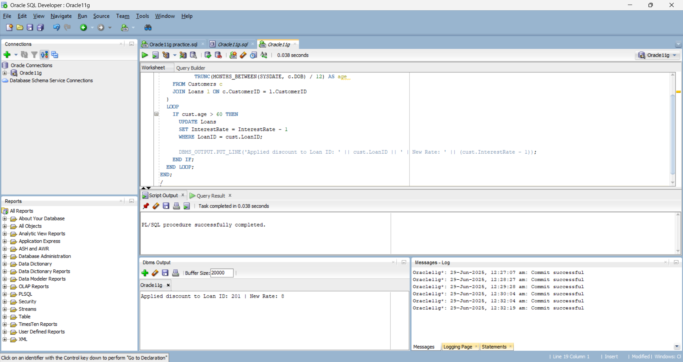

**Scenario 2:** A customer can be promoted to VIP status based on their balance.

* **Question:** Write a PL/SQL block that iterates through all customers and sets a flag IsVIP to TRUE for those with a balance over $10,000.

**SOLUTION:**

ALTER TABLE Customers ADD IsVIP VARCHAR2(5);

BEGIN

FOR c IN (SELECT CustomerID, Balance FROM Customers) LOOP

IF c.Balance > 10000 THEN

UPDATE Customers SET IsVIP = 'TRUE' WHERE CustomerID = c.CustomerID;

ELSE

UPDATE Customers SET IsVIP = 'FALSE' WHERE CustomerID = c.CustomerID;

END IF;

END LOOP;

DBMS_OUTPUT.PUT_LINE('VIP status updated.');

END;

/

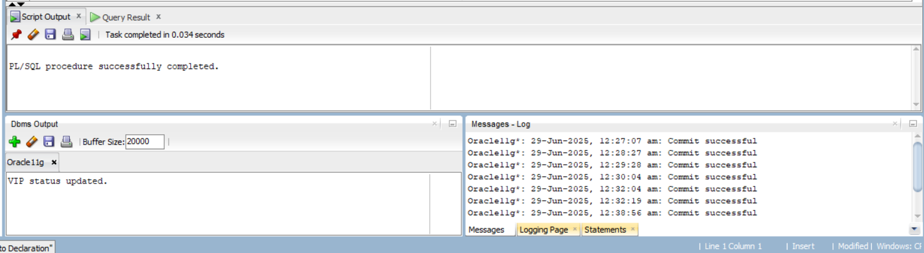

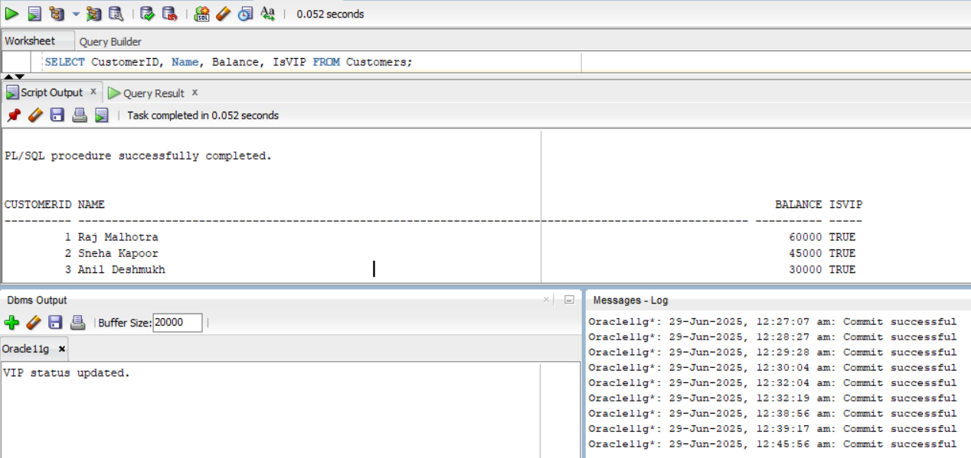

**Scenario 3:** The bank wants to send reminders to customers whose loans are due within the next 30 days.

* **Question:** Write a PL/SQL block that fetches all loans due in the next 30 days and prints a reminder message for each customer.

**SOLUTION:**

BEGIN

FOR result IN (

SELECT l.LoanID, l.CustomerID, c.Name, l.EndDate

FROM Loans l

JOIN Customers c ON l.CustomerID = c.CustomerID

WHERE l.EndDate BETWEEN SYSDATE AND SYSDATE + 30

) LOOP

DBMS_OUTPUT.PUT_LINE(

'Reminder: Dear ' || result.Name ||

', your loan (ID: ' || result.LoanID ||

') is due on ' || TO_CHAR(result.EndDate, 'DD-Mon-YYYY')

);

END LOOP;

END;

/

