**Exercise 3: Stored Procedures**

**Scenario 1:** The bank needs to process monthly interest for all savings accounts.

* + **Question:** Write a stored procedure **ProcessMonthlyInterest** that calculates and updates the balance of all savings accounts by applying an interest rate of 1% to the current balance.

**SOLUTION:**

**Stored Procedure:**

CREATE OR REPLACE PROCEDURE ProcessMonthlyInterest IS

BEGIN

-- Apply 1% interest to all savings accounts

UPDATE Accounts

SET Balance = Balance + (Balance * 0.01)

WHERE LOWER(AccountType) = 'savings';

DBMS_OUTPUT.PUT_LINE('Monthly interest processed for all savings accounts.');

END;

/

**To Run Procedure:**

BEGIN

ProcessMonthlyInterest;

END;

/

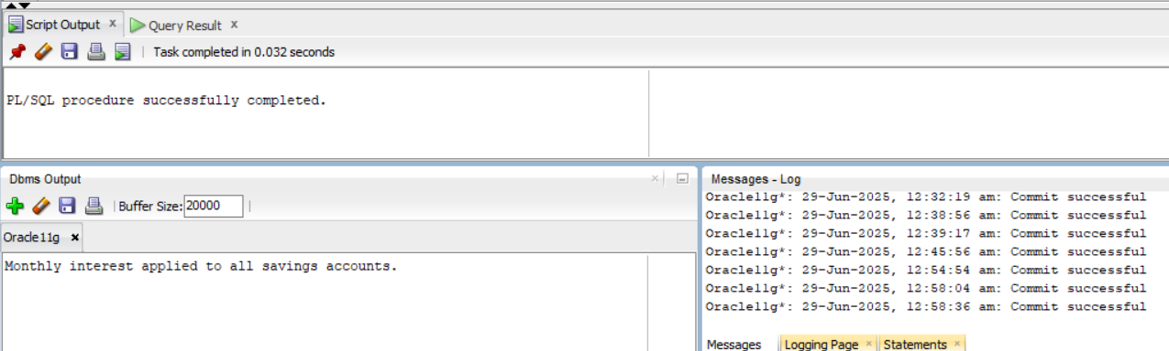

**Scenario 2:** The bank wants to implement a bonus scheme for employees based on their performance.

* + **Question:** Write a stored procedure **UpdateEmployeeBonus** that updates the salary of employees in a given department by adding a bonus percentage passed as a parameter.

**SOLUTION:**

**Stored Procedure:**

CREATE OR REPLACE PROCEDURE UpdateEmployeeBonus (

p_department IN VARCHAR2,

p_bonus_pct IN NUMBER -- e.g., pass 10 for 10% bonus

)

IS

BEGIN

UPDATE Employees

SET Salary = Salary + (Salary * p_bonus_pct / 100)

WHERE Department = p_department;

DBMS_OUTPUT.PUT_LINE(

'Bonus of ' || p_bonus_pct || '% applied to department: ' || p_department

);

END;

/

**To run Procedure:**

BEGIN

UpdateEmployeeBonus('Finance', 10);

END;

/

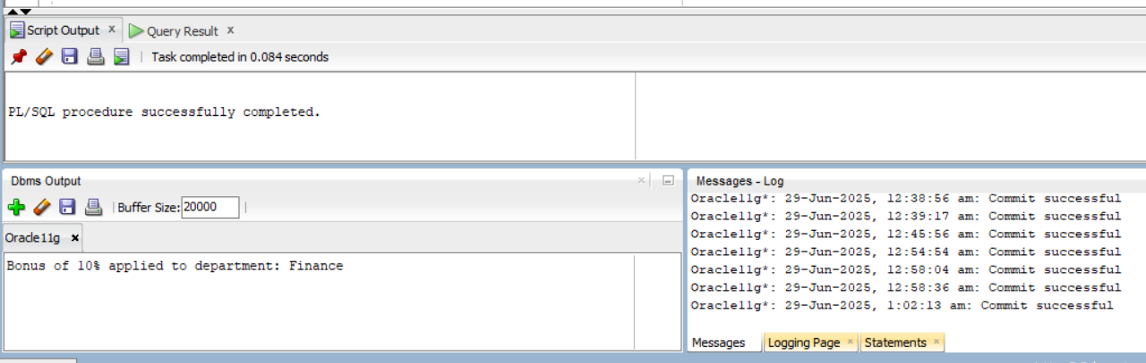

**Scenario 3:** Customers should be able to transfer funds between their accounts.

* + **Question:** Write a stored procedure **TransferFunds** that transfers a specified amount from one account to another, checking that the source account has sufficient balance before making the transfer.

**SOLUTION:**

**Stored Procedure:**

CREATE OR REPLACE PROCEDURE fundtransfer(

from_account IN NUMBER,

to_account IN NUMBER,

amount IN NUMBER

)

IS

v_balance NUMBER;

BEGIN

SELECT balance INTO v_balance

FROM accounts

WHERE accountid = from_account

FOR UPDATE;

IF v_balance < amount THEN

RAISE_APPLICATION_ERROR(-20001, 'Insufficient balance in source account');

END IF;

UPDATE accounts

SET balance = balance - amount,

lastModified = SYSDATE

WHERE accountid = from_account;

UPDATE accounts

SET balance = balance + amount,

lastModified = SYSDATE

WHERE accountid = to_account;

DBMS_OUTPUT.PUT_LINE('Transfer of ' || amount || ' completed from Account ' ||

from_account || ' to Account ' || to_account);

END;

/

**To run Procedure:**

BEGIN

fundtransfer(101, 103, 5000);

END;

/

