ReviewSetu — UI/UX Design Spec (for Claude Code)
Scope note: This spec restyles the existing built flow. It does not change question order, option wording, category logic, or the draft-edit submit gate — those stay exactly as already implemented per REVIEWSETU_BRIEF.md. Everything below is CSS/component-level only.
The reference images attached to this file are visual style references only — colors, layout, component shapes, spacing. Do not copy their question text, question order, or option wording (e.g. do not use "Not satisfied" — the built app correctly uses "Average," which follows the brief's neutral-wording rule).

Reference Images
Add these below before handing this file to Claude Code:
- Mobile — Question step (delivery example): 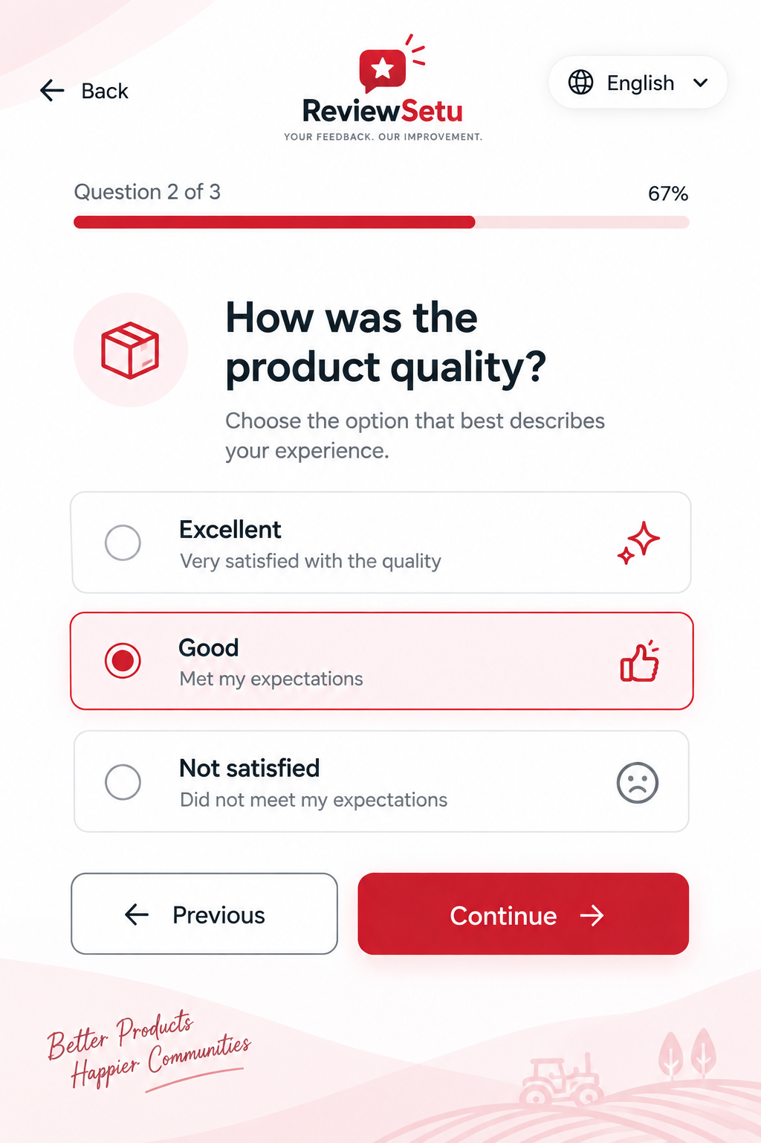
- Mobile — Question step (quality example, with Previous/Continue): 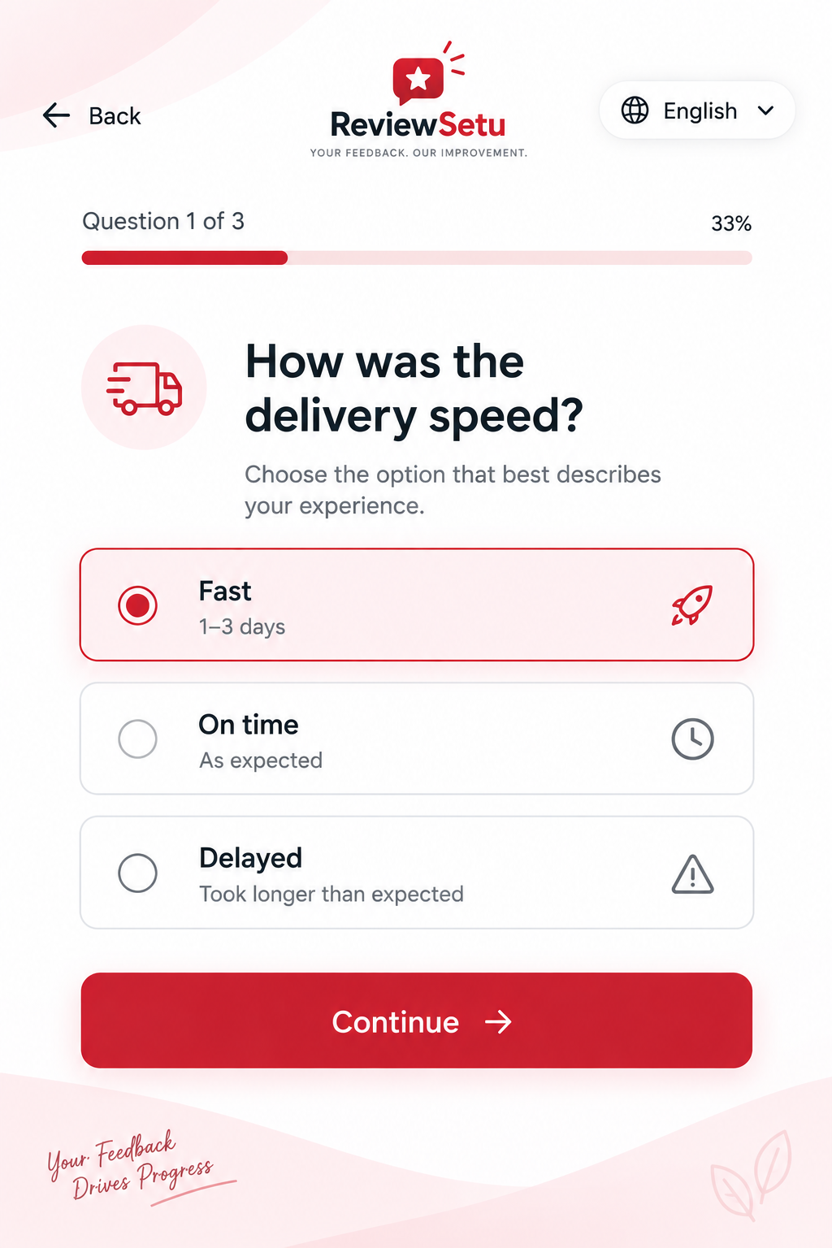
- Mobile — Intro/landing screen: 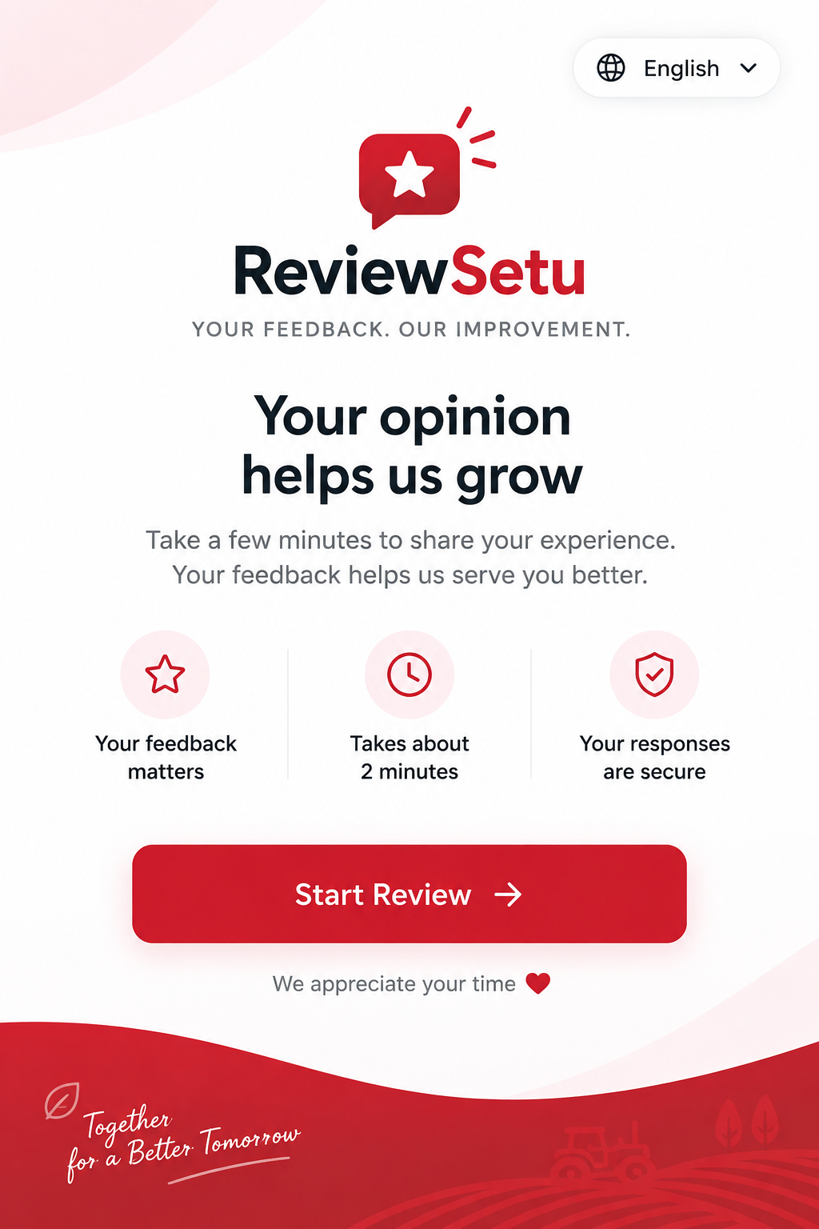
- Desktop — Question step, full layout: 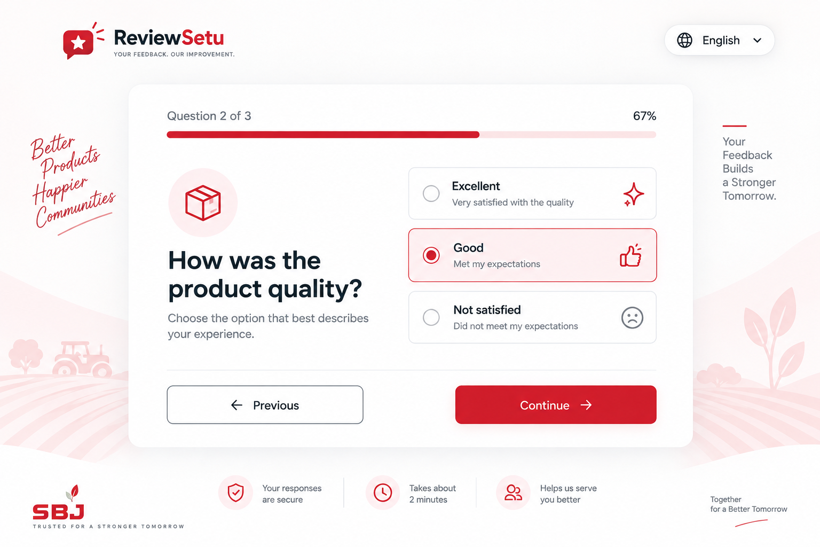
- SBJ Nirmal logo (real, confirmed asset): 
  - Confirm the logo's exact source hex before using it as a CSS variable. Do not eyeball the color from the PNG — get it from the original design file. It appears close to #D32F2F but has not been confirmed as identical.

Assets
- SBJ Nirmal logo (image 5 above): icon-only red interlocking-S mark, no wordmark. Place in the page footer, alongside "SBJ" wordmark text (--ink, bold) and tagline "TRUSTED FOR A STRONGER TOMORROW" (small caps, gray) — matches the treatment shown in the desktop reference (image 4).
- ReviewSetu logo (the app's own mark — speech bubble + star, already in use): stays in the header, top-left, on every screen. This is the tool's own identity, separate from SBJ's, and does not move to the footer.

Color Tokens
--red: #D32F2F; /* primary brand red — from REVIEWSETU_BRIEF.md */
--ink: #1A1A1A; /* text/accents */
--bg: #FFFFFF; /* background */
--muted: #E5E5E5; /* borders, disabled states */

--red-tint: #FDECEC; /* selected-card fill */
--red-tint-deep: #F8D7D7; /* background wave / gradient fill */

Typography
- Headings/UI: Poppins or Quicksand — 600/700 weight for headings, 500 for buttons/labels, 400 for body text.
- One script/handwritten font (Caveat or Kalam) — used only for the decorative corner taglines (e.g. "Together for a Better Tomorrow"), nowhere else.

Shared Components (mobile + desktop)
Option card
- Rounded-xl (16px), 1px --muted border, 16px padding
- Icon left, in a circular tinted swatch (--red-tint background)
- Label bold (--ink) + gray sublabel beneath
- Selected state: --red-tint fill, --red border, filled red radio dot, icon switches to solid red
Icon mapping — exact, do not improvise per-option
The reference mockups establish two patterns: delivery-speed questions use literal icons, all other questions use abstract sentiment icons (best → positive/sparkle-style, middle → neutral/thumbs-up-style, worst → warning/frown-style). Apply that same two-pattern logic to every option set in the app — do not invent new icon styles for the sets not shown in the mockups.
Question type (applies to categories) | Best option icon | Middle option icon | Worst option icon
Delivery speed (all categories — shared question) | rocket | clock | warning triangle
Quality / build quality / performance (Blades, Gears, PTO, Lubrication, Other) | sparkles | thumbs-up | frown face
Fitment (Blades, Yoke, PTO) — Perfect fit / Needed adjustment / Didn't fit | checkmark (in circle) | wrench | X (in circle)
Load handling (Gears) — Yes / Mostly / No | sparkles | thumbs-up | frown face
Price vs. quality (Yoke) — Great value / Fair / Expensive | tag / price-check | scale (balanced) | warning triangle
Wear/friction reduction (Lubrication) — Yes noticeably / Somewhat / Not much | sparkles | thumbs-up | frown face
Met expectations (Other) — Yes / Mostly / No | sparkles | thumbs-up | frown face
Reuse the same icon set (sparkles / thumbs-up / frown) across every 3-tier "sentiment" question rather than sourcing a unique icon per category — this matches how the mockups reused the same style across both shown questions and keeps the icon set small and consistent.
Progress bar
- Track: --muted. Fill: --red. Rounded ends.
- Label row above: "Question X of Y" (left), percentage (right)
Primary button
- --red fill, white bold text, rounded-xl, trailing arrow icon (→), subtle drop shadow
Secondary / Back button
- Outline style, same border radius, --ink text, no fill
Language switcher
- White pill shape, globe icon + current language name + chevron

Mobile Layout (<1024px)
- Edge-to-edge white page — no card container
- Background: soft diagonal wave shape in --red-tint-deep, decorative only, pointer-events: none, does not shift on scroll or interfere with tap targets
- Footer trust strip ("Your responses are secure" / "Takes about 2 minutes" / "Helps us serve you better"): intro screen only, not repeated on question/category/draft screens
- Rotate one cursive tagline per major step (intro / mid-flow / end) near the wave shape — flavor text, can default to English regardless of selected language

Desktop Layout (≥1024px)
- Centered card: max-width ~960px, white background, rounded-2xl, soft shadow
- Page background: full-bleed, --red-tint-deep fading to white
- Side taglines: absolutely positioned outside the card, rendered only at ≥1200px width — hidden entirely below that, never wrapped or overlapping the card
- Footer trust strip + SBJ logo block: page footer, below the card, appears on all screens (matches desktop reference) — not duplicated inside the card per-question
- Header (ReviewSetu logo + language switcher): same as mobile, given more horizontal breathing room

Draft / Edit Screen (not shown in any reference — styled here to match)
This is the most important screen in the app — it's where the non-negotiable edit-gate rule lives. No mockup reference exists for it; the styling below is a proposed default, not a reference-backed decision. Review it specifically once built.
- No progress bar (this isn't a numbered question)
- Heading "Your review draft" — same weight/style as question headings
- Textarea styled as a card: rounded-xl, --muted border, generous padding; on focus, border becomes --red with a subtle glow — this is the visual cue that the field is editable, not a locked confirmation
- Helper text above the textarea, gray, matching question-sublabel style: "Edit, add, or remove anything you like before posting."
- Primary button below, same style as "Continue," labeled "Post Review"
- No decorative wave/gradient background on this screen — keep it visually calm; this is the one moment that should have zero decorative competition with the text the customer is reading and editing

Explicitly Out of Scope for This Restyle
- Question order, question text, option wording, category logic — unchanged, see REVIEWSETU_BRIEF.md
- The draft-edit submit gate logic (draftLoaded enforcement in js/state.js) — unchanged
- The farm/leaf decorative line art from earlier AI-generated references — not brand-specific, dropped, do not implement
- Any fabricated logo/leaf mark from earlier AI-generated mockups — superseded by the real SBJ logo (asset 5 above)

