Technical Documentation - Clarity AI

Table of Contents
- Architecture Overview
- Core Components
- Data Flow
- API Design
- Machine Learning Models
- Processing Pipeline
- Database & Storage
- Error Handling
- Testing Strategy
Architecture Overview

System Architecture
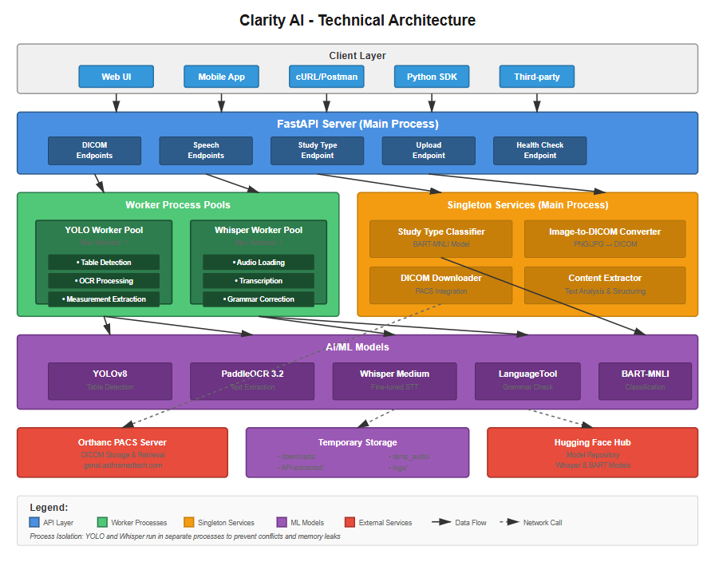

Key Design Decisions
- Process Isolation: YOLO and Whisper run in separate processes to prevent model conflicts and memory leaks
- Spawn Method: Uses multiprocessing.spawn for clean process initialization
- Singleton Models: Study type classifier loads once and is reused across requests
- Async I/O: FastAPI's async endpoints for non-blocking operations
- Temporary Storage: Automatic cleanup of downloaded files and audio

Core Components

1. API Layer (clarityAIApi.py)
Purpose: RESTful API interface for all services
Key Features:
- FastAPI framework with automatic OpenAPI documentation
- Async endpoint handlers
- Process pool management via lifespan context
- Request validation using Pydantic models
- Comprehensive error handling with HTTP status codes
Request Models:
class MeasurementExtractRequest(BaseModel):
file_id: str # DICOM StudyInstanceUID

class FolderPathRequest(BaseModel):
folder_path: str # Local folder path

class StudyTypeRequest(BaseModel):
report_text: str # Medical report text

Process Lifecycle:
@asynccontextmanager
async def lifespan(app: FastAPI):
# Startup
- Initialize process pools
- Load singleton models
- Setup directories

yield # Application runs

# Shutdown
- Close process pools gracefully
- Cleanup resources

2. DICOM Processing Pipeline

2.1 DICOM Downloader (dicomDownloader.py)
Purpose: Interface with Orthanc PACS server
Functions:
- download_study_by_uid(study_instance_uid)
  - Searches Orthanc for study
  - Downloads as ZIP archive
  - Extracts to structured directory
  - Returns file list and folder path
  - Cleanup: Deletes previous downloads before new fetch
- download_single_instance(study_instance_uid, output_filename)
  - Downloads first DICOM instance only
  - Used for quick metadata extraction
Technical Details:
- Uses requests library with SSL verification disabled (for internal networks)
- Implements retry logic for network issues
- Handles ZIP extraction with zipfile
- Returns absolute paths for cross-platform compatibility

2.2 DICOM Handler (dicomHandler.py)
Purpose: Convert DICOM to processable image formats
Key Function: dicom_to_pngUpdated(dicom_path)
Process:
1. Read DICOM with pydicom
2. Extract pixel_array
3. Normalize to 0-255 range
4. Convert to PIL Image
5. Handle grayscale → RGB conversion
6. Return as OpenCV BGR array

Photometric Interpretation Handling:
- MONOCHROME1: Inverted grayscale (handled)
- RGB: Convert to BGR for OpenCV
- YBR_FULL: Standard processing

2.3 File Manager (dicomFileManager.py)
Purpose: Directory scanning and metadata extraction
Functions:
- readDirectory(dicomDirectory)
  - Validates directory existence
  - Filters valid DICOM files
  - Extracts metadata from first file
  - Returns file list and metadata dict
- findMetaData(dicomPath)
  - Extracts DICOM tags:
    - Patient information (Name, ID, Age, Gender)
    - Study details (Date, Time, Type, Modality)
    - Hospital and physician information
  - Handles byte string decoding (UTF-8, Latin-1)
  - Cleans control characters (^) from data
DICOM Tags Extracted:
{
(0x0010, 0x0010): "PatientName",
(0x0010, 0x0020): "PatientID",
(0x0010, 0x0030): "PatientAge",
(0x0010, 0x0040): "PatientGender",
(0x0008, 0x0080): "HospitalName",
(0x0008, 0x0090): "PhysicianName",
(0x0008, 0x1030): "scanType",
(0x0008, 0x0020): "scanDate",
(0x0008, 0x0030): "scanTime",
(0x0008, 0x0060): "scanModality"
}

3. Measurement Extraction System

3.1 Main Processor (measurementExtraction.py)
Purpose: Orchestrate complete DICOM analysis workflow
Main Function: processDicom(dicomDirectory, yoloDetector, metaDataFlag, MeasurementFlag, organLabelFlag)
Parameters:
- dicomDirectory: Path to DICOM files
- yoloDetector: YOLO model instance (or None)
- metaDataFlag: Extract metadata only
- MeasurementFlag: Extract measurements
- organLabelFlag: Identify organ labels
Processing Flow:
1. Read DICOM directory
2. Extract metadata (if requested)
3. For each DICOM file:
a. Convert to PNG
b. Preprocess image
c. Detect measurement tables
d. Identify organ labels
e. Extract structured data
4. Aggregate results by slice
5. Return structured output

Output Format:
(
{
"patientInformation": {
"PatientName": "...",
"PatientID": "...",
...
}
},
{
"slice1": {
"organLabel": "kidney",
"value": [
["1", "d1", "2.5 cm"],
["2", "d2", "3.1 cm"]
]
},
"slice2": {...}
}
)

3.2 YOLO Detector (measurementTableDetection.py)
Purpose: Deep learning-based table detection
Class: YOLODetector
Initialization:
def __init__(
model_path: str = "path/to/best.pt",
conf_threshold: float = 0.5,
class_name: str = "measurementTable"
)

Detection Process:
def detect(image_input):
1. Load model (cached on first call)
2. Run inference on image
3. Extract bounding boxes
4. Filter by confidence threshold
5. Return detection list with:
- bbox: [x, y, width, height]
- confidence: float
- class_name: str
- roi: [x1, y1, x2, y2]

Optimization Features:
- Model loaded once and reused
- GPU acceleration if available
- Non-verbose inference
- Configurable confidence thresholds

3.3 OCR Processor (OCRProcessor.py)
Purpose: Text extraction from image regions
Class: OCRHandler
Initialization:
- Loads PaddleOCR with:
- use_angle_cls=True (handles rotated text)
- lang='en' (English language)

Preprocessing Pipeline:
For Measurement Tables (preProcess(roi)):
- Upscale 3x using INTER_CUBIC
- Convert to grayscale
- Apply CLAHE (Contrast Limited Adaptive Histogram Equalization)
- Convert back to BGR

For Organ Labels (preProcessLabel(roi)):
- Dynamic gamma correction based on image brightness
- Gamma range: 0.3 to 2.5
- Adaptive to image lighting conditions

OCR Output Structure (PaddleOCR 3.2):
[
{
'rec_texts': ["text1", "text2", ...],
'rec_scores': [0.95, 0.88, ...],
'rec_boxes': [array([[x,y], ...]), ...]
}
]

3.4 Content Extractor (contentExtractor.py)
Purpose: Extract and structure text from detected regions
Class: ContentExtractor
Key Methods:
- extract_table_content(image, bbox, flag)
  - Crops ROI from image using bbox
  - Performs OCR with preprocessing
  - Extracts text elements with positions
  - Structures data using TextAnalyzer
  - Returns structured measurements
- organLabelIdentification(img)
  - Runs OCR on full image
  - Combines all text
  - Searches for organ keywords
  - Uses longest-match-first strategy
  - Returns list of found organs
Organ Keywords:
["right kidney", "rt kidney", "lt kidney", "LT KIDNEY",
"left kidney", "kidney", "renal", "nephron", "ureter",
"bladder", "rt ovary", "RT OVARY", "lt ovary", "uterus",
"ss", "subscap ten", "breast", "rt breast", "lt breast",
"rt ax", "lt ax", "transplant kidney"]

3.5 Text Analyzer (textAnalyzer.py)
Purpose: Structure OCR results into meaningful data
Class: TextAnalyzer
Core Functionality:
- split_measurement(text)
  - Pattern 1: (\d+)\s+(\d*[a-zA-Z]+\d*)\s*[.\s]*\s*(\d+(?:\.\d+)?\s*cm)
    - Example: "1 d1 2.5 cm" → ('1', 'd1', '2.5 cm')
  - Pattern 2: (\d*[a-zA-Z]+\d*)\s*[.\s]*\s*(\d+(?:\.\d+)?\s*cm)
    - Example: "d1 2.5 cm" → ('d1', '2.5 cm')
- structure_table_data(text_elements)
  - Groups text by Y-coordinate (same line)
  - Sorts by X-coordinate (left to right)
  - Applies measurement splitting
  - Filters unwanted characters
  - Returns structured value lists
Processing Steps:
1. Filter unwanted characters: -, _, |, /, \, ~, etc.
2. Sort by Y-coordinate (vertical position)
3. Group into lines (threshold: 15px)
4. Sort each line by X-coordinate
5. Process each word:
- Try to split as measurement
- Keep original if splitting fails
6. Combine into final structure

3.6 Table Analyzer (ultrasoundTableAnalyzer.py)
Purpose: Orchestrate table detection workflow
Class: UltrasoundTableDetector
Main Method: detect_measurement_table(image, yoloDetector)
Workflow:
1. Run YOLO detection on image
2. Get list of candidate regions (ROIs)
3. Return ROI list for processing

Method: extract_table_content(image, bbox)
- Delegates to ContentExtractor
- Returns structured data from table region
Method: identifyOrganName(image)
- Delegates to ContentExtractor
- Returns identified organ names

3.7 Logging Configuration (logging_config.py)
Purpose:
Centralized logging setup for application-wide debugging, monitoring, and error tracking.
Function:
setup_logging()

Initialization:
- Creates a configurable logging system with:
  - File logging (all logs + error-only logs)
  - Console logging (customizable severity level)
- Automatically creates the log directory if missing
- Optionally clears existing log files on startup

Log Files:
- logData.log
  - Contains ALL log levels
  - Levels: DEBUG, INFO, WARNING, ERROR, CRITICAL
- error.log
  - Contains ERROR and CRITICAL logs only
  - Used for fast issue diagnosis and production monitoring

Logger Configuration:
- Root logger level: DEBUG
  - Ensures full verbosity for file logging
- Existing handlers are cleared to avoid duplicate logs
Standardized log format:
YYYY-MM-DD HH:MM:SS - logger_name - LEVEL - message

Handlers:
File Handlers
- FileHandler(logData.log)
  - Level: DEBUG
- FileHandler(error.log)
  - Level: ERROR
Console Handler
- Outputs logs to terminal
- Default level: ERROR (configurable via console_level)

4. Speech Processing System

4.1 Whisper Transcriber (whisperTranscriber.py)
Purpose: Audio transcription using fine-tuned Whisper
Class: WhisperTranscriberHandler
Model Configuration:
Repository: "sankar-asthramedtech/finetuned_whisper-medium_on_pods_V-1.1"
Base Model: "openai/whisper-medium"
Device: Auto (GPU if available, else CPU)
Language: English
Task: Transcription

Pipeline Configuration:
{
"task": "automatic-speech-recognition",
"return_timestamps": True,
"stride_length_s": 15,
"num_beams": 1,
"repetition_penalty": 1.0,
"length_penalty": 1.0
}

Transcription Process:
def transcribe(audio_path):
1. Validate file existence
2. Load audio with librosa (16kHz, mono)
3. Convert to numpy array
4. Run inference through pipeline
5. Extract transcription text
6. Return (text, success_flag)

Audio Requirements:
- Sample Rate: 16kHz (auto-resampled)
- Channels: Mono
- Supported Formats: WAV, MP3, M4A, FLAC, OGG

4.2 Grammar Checker (spellChecker.py)
Purpose: Post-process transcriptions for medical accuracy
Class: GrammarChecker
Implementation:
- Library: language_tool_python
- Language: en-US
- Model Storage: language_tool_model/ directory
- Auto-download on first use
Process:
def check_and_correct(text):
1. Validate input (not empty)
2. Run grammar correction
3. Log changes made
4. Return (corrected_text, success_flag)

Features:
- Handles medical terminology
- Context-aware corrections
- Preserves technical terms
- Logs all corrections for audit trail

5. Study Type Classification
File: reportStudyTypeIdentification.py
Class: StudyTypeProcessor
Design Pattern: Singleton with thread-safe initialization
Model:
- BART-MNLI for zero-shot classification
- Repository: facebook/bart-large-mnli
- Multi-label classification enabled
Supported Study Types:
[
"liver", "gallbladder", "kidney", "uterus",
"ovary", "spleen", "pancreas", "urinary bladder",
"prostate", "thyroid", "breast"
]

Classification Process:
def identify(text: str, confidence_threshold=0.5):
1. Validate input (min 3 characters)
2. Run zero-shot classification
3. Filter by confidence threshold
4. Return highest scoring label
5. Return "No US Study Type Found" if none meet threshold

Output Format:
(status: bool, study_type: str)

6. Image to DICOM Conversion
File: img2dcmCreation/uploader.py
Class: FolderToDicomPacsUploader
Purpose: Convert standard images to DICOM and upload to PACS
Supported Input Formats: JPG, JPEG, PNG
Process Flow:
- Folder Analysis:
  - Check for existing DICOM files
  - Identify valid image files
  - Determine processing mode
Case 1: DICOM Files Present:
- Extract StudyInstanceUID
- Upload directly to PACS
- No conversion needed

Case 2: Images Only:
- Generate unique StudyInstanceUID
- Generate unique SeriesInstanceUID
- Create patient identifiers
- For each image:
a. Convert to DICOM format
b. Add metadata
c. Upload to PACS

DICOM Metadata Creation:
- PatientName: "Anonymous_YYYYMMDD_HHMM SS_XXXX"
- PatientID: "IDTIMESTAMP###"
- StudyDate: Current date
- StudyTime: Current time
- Modality: "OT" (Other)
- SOPClassUID: Secondary Capture Image Storage

Upload Endpoint:
POST https://genai.asthramedtech.com/instances
Content-Type: application/dicom

Data Flow

Measurement Extraction Flow
User Request (file_id)
│
▼
Download from PACS
│
▼
Extract to Directory
│
▼
Read Directory → Get DICOM List + Metadata
│
▼
For Each DICOM:
│
├─→ Convert to PNG
│
├─→ Submit to YOLO Worker Process
│ │
│ ├─→ Detect Tables (YOLO)
│ │
│ ├─→ Extract ROIs
│ │
│ ├─→ OCR on Each ROI
│ │
│ ├─→ Structure Data
│ │
│ └─→ Identify Organs
│
└─→ Aggregate Results
│
▼
Return JSON Response

Speech-to-Text Flow
User Upload (audio_file)
│
▼
Save to Temp Directory
│
▼
Submit to Whisper Worker Process
│
├─→ Load Audio (librosa)
│
├─→ Transcribe (Whisper)
│
└─→ Correct Grammar (LanguageTool)
│
▼
Cleanup Temp File
│
▼
Return Transcription

Error Handling Strategy

HTTP Status Codes
- 200 OK: Successful operation
- 400 Bad Request: Invalid input parameters
- 404 Not Found: Resource not found (DICOM file, audio file)
- 500 Internal Server Error: Processing errors
- 504 Gateway Timeout: Operation exceeded 5-minute timeout

Error Handling Layers
API Level:
try:
# Processing logic
except HTTPException:
raise # Re-raise HTTP exceptions
except Exception as e:
logger.error(...)
raise HTTPException(status_code=500, detail=str(e))

Worker Process Level:
return {
"success": bool,
"result": data or None,
"error": error_message,
"traceback": full_traceback
}

Timeout Handling:
result = await asyncio.wait_for(
loop.run_in_executor(...),
timeout=300 # 5 minutes
)

Logging Strategy
Log Levels:
- DEBUG: Detailed diagnostic information
- INFO: General informational messages
- WARNING: Warning messages for unexpected but handled situations
- ERROR: Error messages for failures
- CRITICAL: Critical system failures
Log Files:
- logs/logData.log: All log levels
- logs/error.log: Errors and critical messages only
Silenced Loggers:
- numba
- transformers
- torch
- librosa
- huggingface_hub
- language_tool_python
- urllib3

Performance Considerations

Memory Management
- Process Pools: Separate pools prevent memory leaks
- Temporary Files: Auto-cleanup after processing
- Model Loading: Models loaded once and cached
- Garbage Collection: Explicit cleanup in worker functions

Optimization Techniques
- GPU Acceleration: Automatic GPU detection for models
- Parallel Processing: Multiple DICOM files processed concurrently
- Async I/O: Non-blocking file operations
- Image Preprocessing: Optimized preprocessing pipelines

Scalability
Current Limits:
- YOLO Workers: 1 process
- Whisper Workers: 1 process
- Timeout: 300 seconds per request
Scaling Recommendations:
# For higher throughput
yolo_executor = ProcessPoolExecutor(max_workers=4)
whisper_executor = ProcessPoolExecutor(max_workers=2)

# For production
uvicorn.run("main:app", host="0.0.0.0", port=9001, workers=4)

