SKILL 1

A. ICMP Protocol
- Display filter: `icmp`
- Purpose: ICMP (Internet Control Message Protocol) is used for network diagnostics and error reporting. Tools such as ping use ICMP Echo Request and Echo Reply messages.
- How to capture: Start a capture, open Command Prompt, run `ping 8.8.8.8`, and then apply the `icmp` display filter.
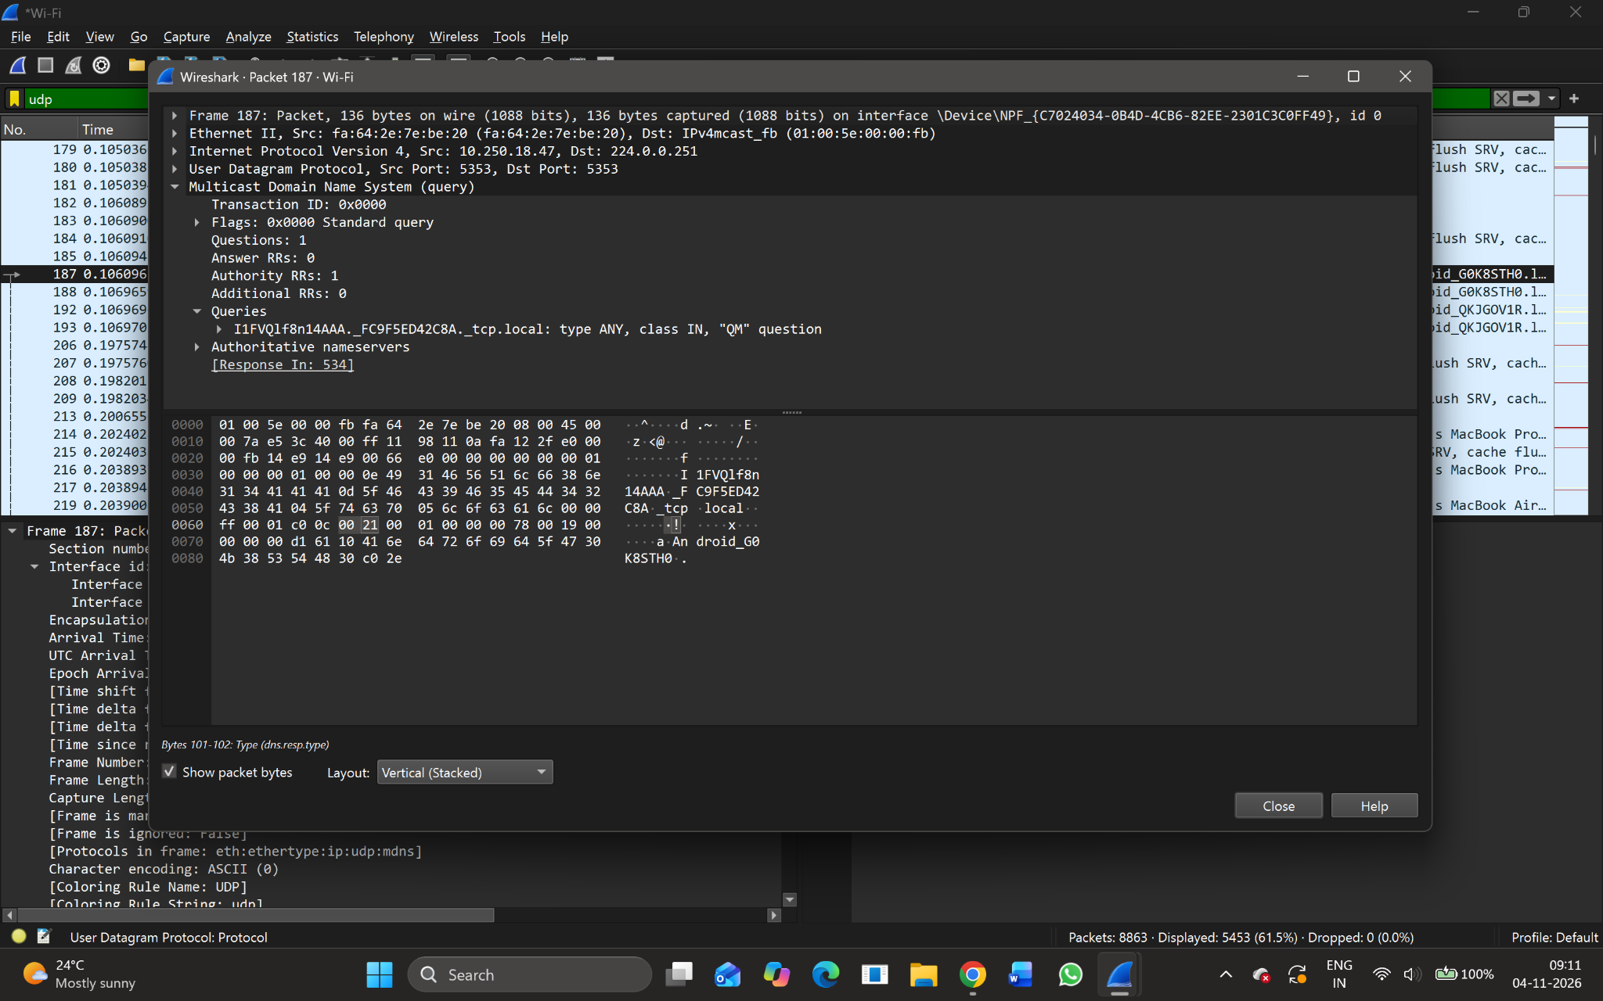
Figure A1. Supplied screenshot: ICMP display filter with no matching packets.
Result: The ICMP filter was applied, but no ICMP packets are visible in the supplied capture. A new capture while generating ping traffic is required to complete the ICMP observation.

B. TCP Protocol
- Display filter: `tcp`
- Purpose: TCP (Transmission Control Protocol) is connection-oriented and provides reliable, ordered delivery of data using acknowledgements and retransmission when required.
- Observed packet: Frame 202
- Frame length: 210 bytes
- Capture length: 210 bytes
- Interface / encapsulation: Wi-Fi interface; Ethernet II
- Observed IP and transport details: The packet details screenshot identifies IPv4 traffic from 10.250.22.55 to 149.154.167.99 and TCP traffic using destination port 443 (HTTPS).
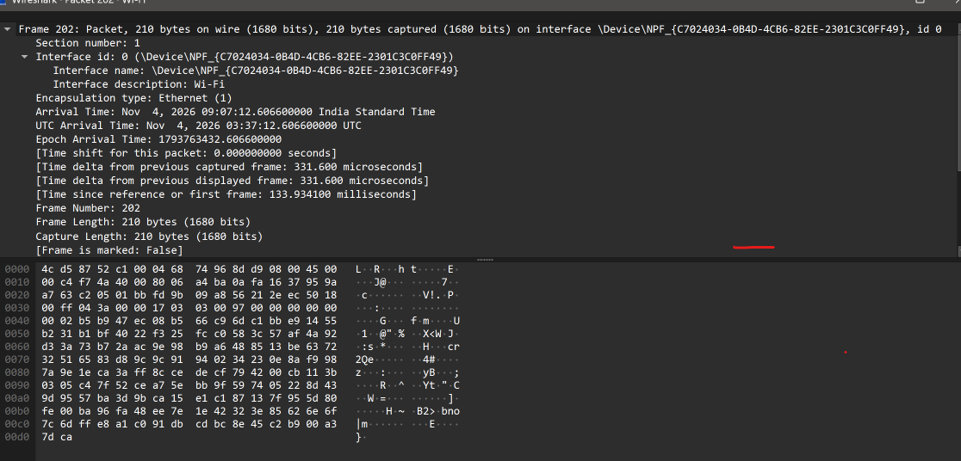
Figure B1. Frame 202: Wireshark frame summary and packet bytes.
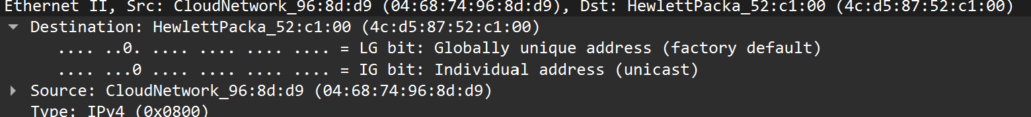
Figure B2. Ethernet II header showing source and destination MAC addresses.
Result: The selected packet is a TCP packet. The supplied capture reports a frame size of 210 bytes.

C. TCP Length (tcp.len)
- Display filter: `tcp.len > 0`
- Purpose: The tcp.len field represents the number of bytes of TCP payload carried in a segment. The filter `tcp.len > 0` displays TCP packets that contain at least one byte of TCP payload.
- Observed payload: An additional TCP details screenshot shows TCP payload = 120 bytes and TCP Segment Len = 120. This is a separate TCP packet from Frame 202, so it is recorded separately and is not used in the Frame 202 calculation.
- Additional TCP packet payload length: 120 bytes (as displayed in its packet details).
- How to verify: Apply `tcp.len > 0`, select a matching packet, expand Transmission Control Protocol, and inspect the segment length / TCP payload details.
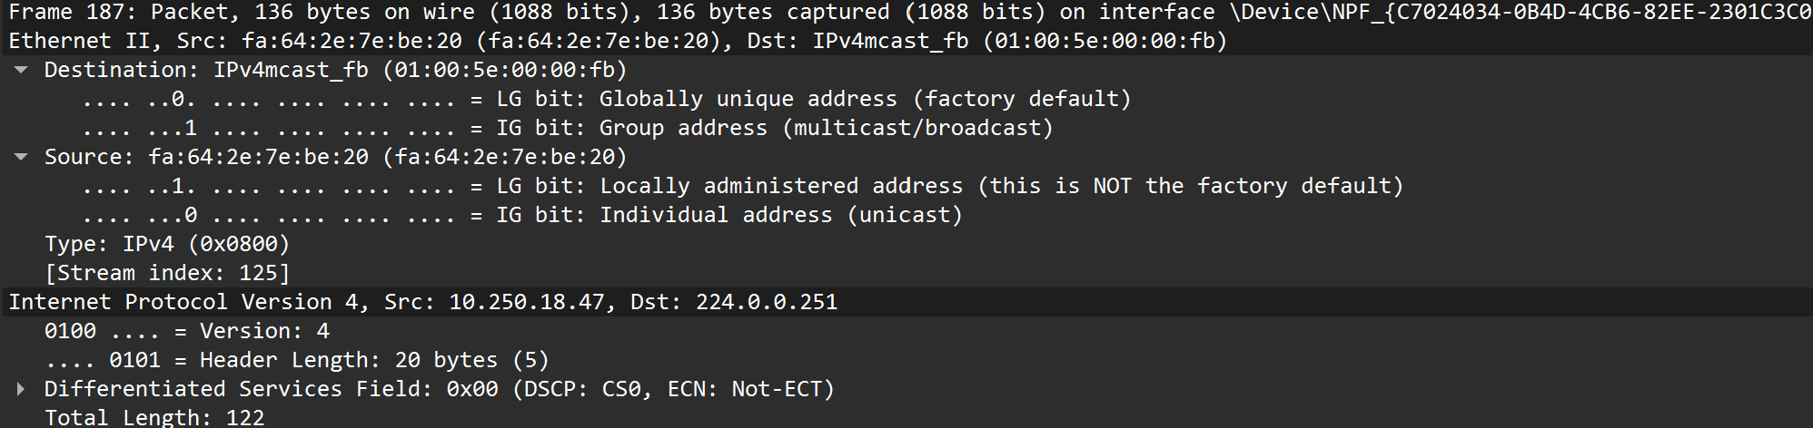
Figure C1. TCP details showing a 120-byte TCP payload.
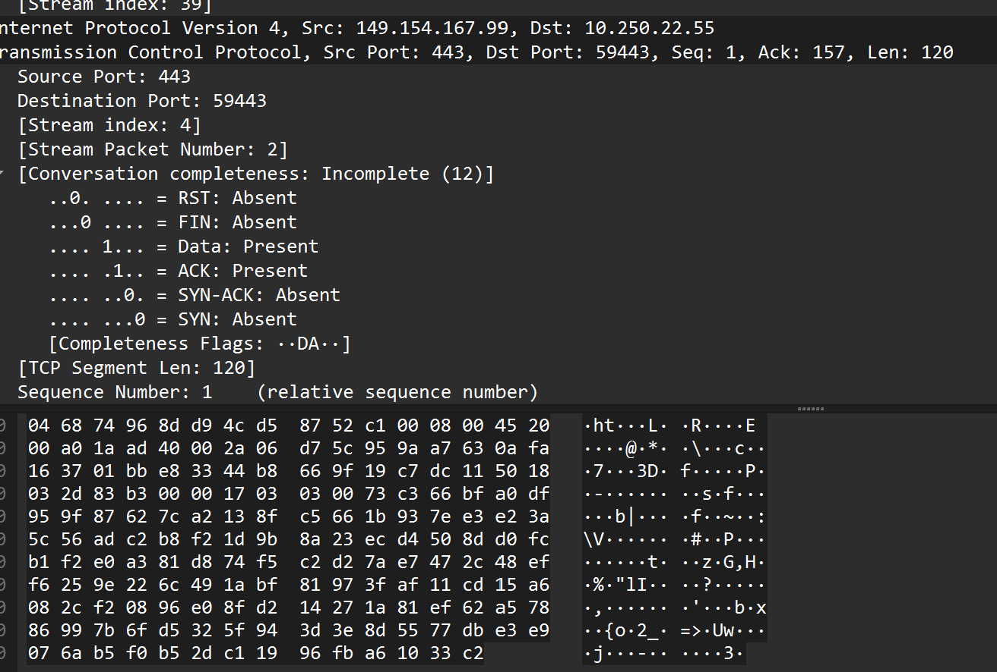
Figure C2. Additional TCP packet details and bytes.
Result: The additional TCP packet details show a payload length of 120 bytes. This value represents TCP data only, not the total Ethernet frame length.

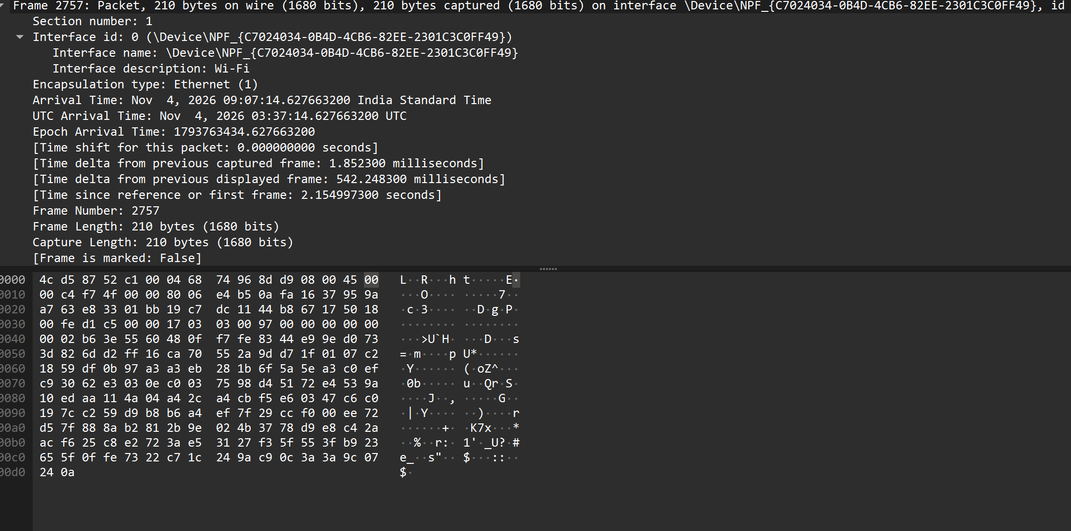

D. UDP Protocol
- Display filter: `udp`
- Purpose: UDP (User Datagram Protocol) is connectionless. It sends datagrams without establishing a connection and does not provide TCP-style delivery acknowledgements or retransmission.
- Observed packet: Frame 187
- Frame length: 136 bytes
- Source and destination ports: 5353 → 5353
- Protocol / service: Multicast DNS (mDNS), which uses UDP port 5353 for local-network service and device discovery.
- Destination IP: 224.0.0.251 (IPv4 multicast address used by mDNS).
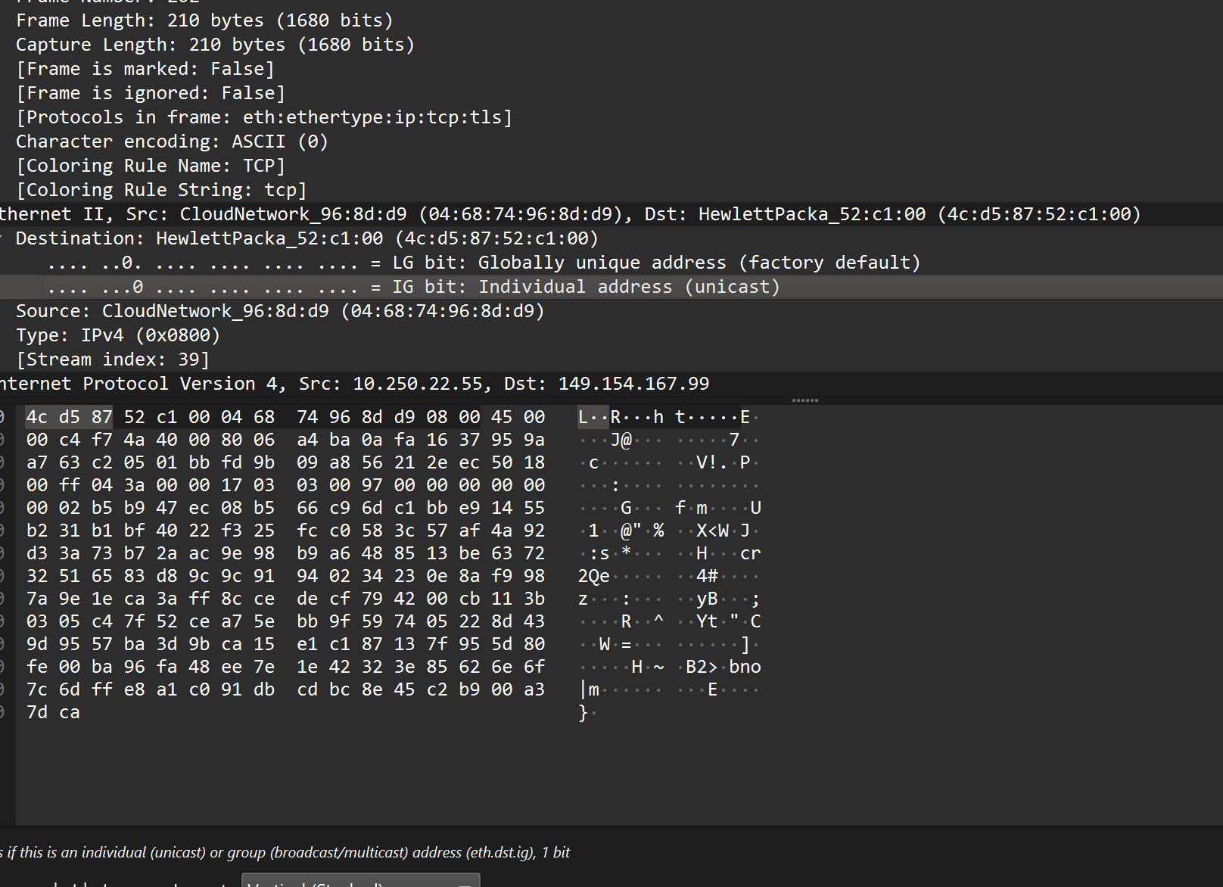
Figure D1. Frame 187: UDP packet decoded as an mDNS query.
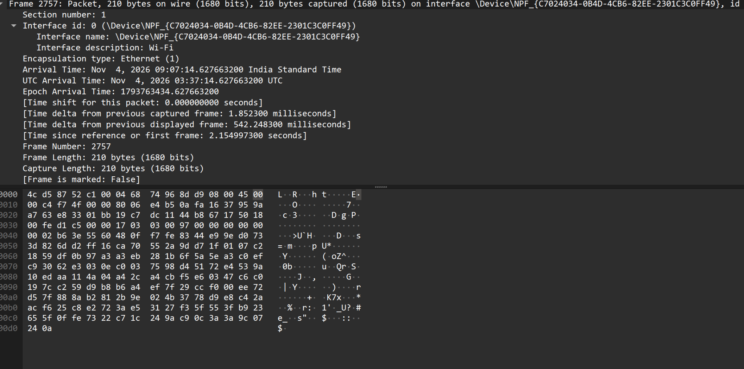
Figure D2. mDNS packet details and packet bytes.
Result: The supplied capture contains a UDP-based mDNS packet with source and destination port 5353. Its frame length is 136 bytes.

E. Observation and Calculation (Encapsulation Builder)
The following observations are taken from the supplied Wireshark screenshots. The TCP calculation uses Frame 202, and the UDP calculation uses Frame 187. The captured frame lengths are used as displayed in Wireshark.

1. TCP packet – Frame 202
- Frame length = 210 bytes
- Ethernet II header = 14 bytes
- IPv4 total length = 196 bytes
- IPv4 header length = 20 bytes
- TCP header length = 20 bytes
TCP payload calculation:
TCP payload = IPv4 total length − IPv4 header − TCP header
= 196 − 20 − 20 = 156 bytes
Total frame check: 14 + 20 + 20 + 156 = 210 bytes
Header overhead = 14 + 20 + 20 = 54 bytes
Payload efficiency = (Payload ÷ Frame length) × 100
= (156 ÷ 210) × 100 = 74.29%
Observation: Frame 202 is a TCP packet. The screenshot shows a frame length of 210 bytes and IPv4 total length of 196 bytes. After subtracting the IPv4 and TCP headers, the TCP payload is 156 bytes.

2. UDP packet – Frame 187
- Frame length = 136 bytes
- Ethernet II header = 14 bytes
- IPv4 total length = 122 bytes
- IPv4 header length = 20 bytes
- UDP header length = 8 bytes
UDP payload calculation:
UDP payload = IPv4 total length − IPv4 header − UDP header
= 122 − 20 − 8 = 94 bytes
Total frame check: 14 + 20 + 8 + 94 = 136 bytes
Header overhead = 14 + 20 + 8 = 42 bytes
Payload efficiency = (Payload ÷ Frame length) × 100
= (94 ÷ 136) × 100 = 69.12%
Observation: Frame 187 is a UDP packet used by Multicast DNS (mDNS). The source and destination ports are both 5353, and the destination IP address is 224.0.0.251. The calculated UDP payload is 94 bytes.

3. Summary observation table
Parameter | TCP (Frame 202) | UDP (Frame 187)
Frame length | 210 bytes | 136 bytes
Ethernet header | 14 bytes | 14 bytes
IPv4 header | 20 bytes | 20 bytes
Transport header | 20 bytes (TCP) | 8 bytes (UDP)
IP total length | 196 bytes | 122 bytes
Payload length | 156 bytes | 94 bytes
Header overhead | 54 bytes | 42 bytes
Payload efficiency | 74.29% | 69.12%

4. Note about the additional TCP screenshot
One of the supplied TCP detail screenshots separately displays “TCP payload (120 bytes)” and “TCP Segment Len: 120”. This is an observation from another TCP packet. It is not the payload value for Frame 202; therefore, the two values are kept separate.

5. Overall result
The experiment demonstrates encapsulation: Ethernet, IPv4 and TCP/UDP headers are added around the application data. In the observed packets, TCP Frame 202 contains 156 bytes of payload with 54 bytes of header overhead, while UDP Frame 187 contains 94 bytes of payload with 42 bytes of header overhead. Payload efficiency is calculated using the captured frame length. The supplied ICMP screenshot shows no matching packets, so an ICMP observation could not be completed from that capture.
Calculation assumption: The displayed captured frame lengths are used. No Ethernet FCS is added separately because it is not shown as part of these captured frame lengths.

F. Answers to the Questions
1. What is encapsulation?
Encapsulation is the process in which each network layer adds its own control information, usually in the form of a header, to the data received from the layer above it. For example, application data is carried in a TCP or UDP segment, which is placed inside an IP packet, and the IP packet is then carried inside an Ethernet frame.
2. What is the purpose of the Ethernet header?
The Ethernet header is used for communication over a local network. It contains the destination MAC address, source MAC address, and EtherType field, which identifies the protocol carried in the Ethernet frame, such as IPv4. These fields help deliver the frame to the correct device and identify the payload protocol.
3. What information is stored in the IP header?
The IPv4 header contains information needed to route and deliver a packet. Important fields include the source IP address, destination IP address, header length, total packet length, identification and fragmentation fields, time to live (TTL), protocol field, and header checksum.
4. What is the difference between TCP and UDP headers?
TCP has a larger, variable-length header (minimum 20 bytes) containing fields such as source and destination ports, sequence number, acknowledgement number, flags, window size, checksum, and options. These support reliable, ordered communication. UDP has a fixed 8-byte header containing source port, destination port, length, and checksum. UDP is connectionless and does not provide TCP-style acknowledgements or retransmissions.
5. Why does each protocol add a header?
Each protocol adds a header to carry the control information required for its function. Ethernet uses MAC addresses for local delivery, IP uses IP addresses and routing-related fields for delivery between networks, and TCP or UDP uses port numbers and transport-specific fields to deliver data to the correct application and manage transport.
6. What is packet overhead?
Packet overhead is the number of bytes used for protocol information rather than application data. It includes headers added by the network layers and may also include trailer information such as the Ethernet Frame Check Sequence (FCS), when it is present in the captured frame.
7. How does header overhead affect network efficiency?
Header overhead reduces the proportion of transmitted bytes available for application data. A larger header means a lower payload efficiency for the same total packet size. However, headers are necessary because they provide addressing, routing, error checking, and transport-control information required for communication.
G. Conclusion
The Wireshark capture was used to examine TCP, UDP, and ICMP traffic and to study protocol encapsulation. The selected TCP frame (Frame 202) has a captured length of 210 bytes, with 54 bytes of Ethernet, IPv4, and TCP headers and a calculated TCP payload of 156 bytes. Its payload efficiency is 74.29%. The selected UDP frame (Frame 187) has a captured length of 136 bytes, with 42 bytes of Ethernet, IPv4, and UDP headers and a calculated UDP payload of 94 bytes. Its payload efficiency is 69.12%. The ICMP filter produced no matching packets in the supplied screenshot, so an additional capture while running ping is needed to complete that observation.
These observations show that encapsulation adds protocol overhead to transmitted data. TCP has a larger transport header than UDP, while both protocols require Ethernet and IP headers for delivery.

