THREE-POINT NETWORK
PACKET CAPTURE & ANALYSIS
Linux Network Namespaces • Routing • Traffic Shaping • TCP Analysis

Practical details | Information
Subject | Computer Networks
Experiment | Three-point packet capture across Host 1, Router and Host 2
Capture files | /tmp/cap1.pcap, /tmp/cap2.pcap, /tmp/cap3.pcap
Transport protocol tested | TCP
Application test | Netcat client/server on TCP port 5000
Date of execution | 11 November 2026 (as shown in terminal capture timestamps)

Prepared from the terminal screenshots and observed command outputs supplied during the experiment.

1. Aim
To build a routed network using Linux network namespaces, configure packet forwarding and traffic shaping on a router, transmit TCP application data from Host 1 to Host 2, and capture/analyse the same communication at three points along the path.

2. Objectives
- Create isolated network namespaces for Host 1, Router and Host 2.
- Configure virtual Ethernet interfaces and IPv4 addresses.
- Enable IPv4 forwarding on the router and add static routes on both hosts.
- Verify end-to-end connectivity using ICMP ping.
- Apply a netem traffic-control rule on the router egress interface.
- Transfer text data using Netcat over TCP port 5000.
- Capture packets at Host 1, Router and Host 2, then compare TCP sequence, length, TTL and conversation statistics.

3. Network topology and addressing
Node / interface | IPv4 address | Connected segment
Host 1 – veth-h1 | 10.0.1.1/30 | 10.0.1.0/30
Router – Host 1 side | 10.0.1.2/30 | 10.0.1.0/30
Router – Host 2 side | 10.0.2.1/30 | 10.0.2.0/30
Host 2 – veth-h2 | 10.0.2.2/30 | 10.0.2.0/30

Host 1 (10.0.1.1/30) ── Router (10.0.1.2/30 | 10.0.2.1/30) ── Host 2 (10.0.2.2/30)
Capture points: cap1 = veth-h1 | cap2 = veth-r1 | cap3 = veth-h2
The host routes direct traffic for the remote /30 subnet through the router. The router forwards packets between the two connected networks.

4. Tools and commands used
- Linux network namespaces and virtual Ethernet (veth) interfaces
- iproute2 commands: ip netns, ip addr, ip link, ip route, sysctl
- tc netem for emulated delay and packet loss
- Netcat (nc) for a TCP client/server test
- TShark / Wireshark command-line tools for packet capture and analysis

5. Experimental procedure

5.1 Configure Host 2 and routing
Host 2 was assigned 10.0.2.2/30 on veth-h2 and the interface was brought up. IPv4 forwarding was enabled on the router. Static routes were added so Host 1 could reach 10.0.2.0/30 via 10.0.1.2 and Host 2 could reach 10.0.1.0/30 via 10.0.2.1.
sudo ip netns exec host2 ip addr add 10.0.2.2/30 dev veth-h2
sudo ip netns exec host2 ip link set veth-h2 up
sudo ip netns exec router sysctl -w net.ipv4.ip_forward=1
sudo ip netns exec host1 ip route add 10.0.2.0/30 via 10.0.1.2
sudo ip netns exec host2 ip route add 10.0.1.0/30 via 10.0.2.1
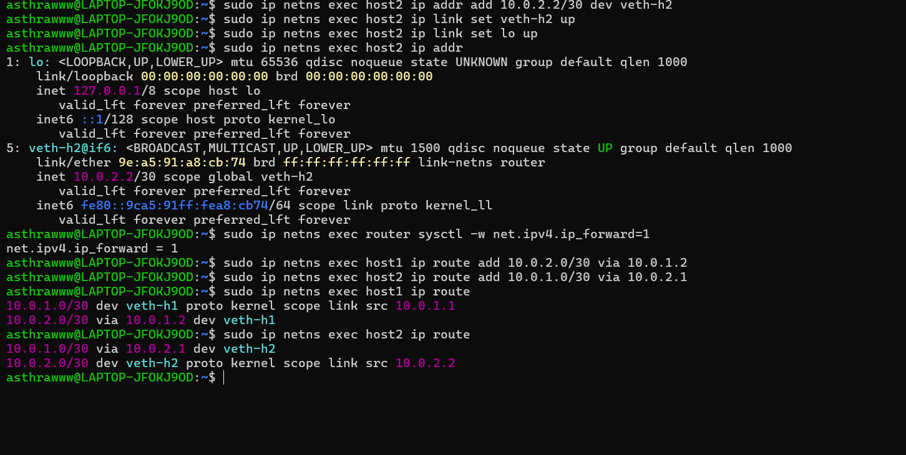
Figure 1. Host 2 address, router forwarding and static routes shown in the terminal.

5.2 Verify end-to-end connectivity
A three-packet ping was sent from Host 1 to 10.0.2.2. All three echo requests received replies, giving 0% packet loss. The displayed round-trip times were 0.113 ms, 0.061 ms and 0.069 ms.
sudo ip netns exec host1 ping -c 3 10.0.2.2
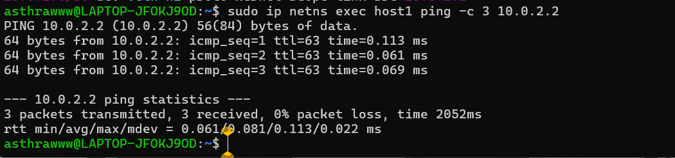
Figure 2. Successful Host 1 to Host 2 ping: 3 packets transmitted, 3 received, 0% loss.

5.3 Apply traffic shaping on the router
A netem queuing discipline was attached to router interface veth-r2 with a configured delay of 20 ms and packet-loss probability of 1%. The subsequent qdisc-show output confirmed that the rule was installed.
sudo ip netns exec router tc qdisc add dev veth-r2 root netem delay 20ms loss 1%
sudo ip netns exec router tc qdisc show dev veth-r2
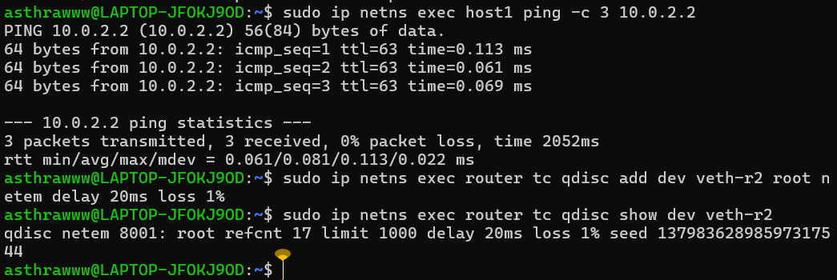
Figure 3. netem rule configured and verified on router interface veth-r2.
Note: the supplied ping result was captured before the netem command in the displayed sequence. Therefore, the 0% ping loss is a baseline connectivity result; it should not be presented as a post-impairment measurement.

5.4 Capture TCP traffic at three points
TShark was started separately in each namespace and bound to the relevant interface. The capture files were written to /tmp.
sudo ip netns exec host1 tshark -i veth-h1 -w /tmp/cap1.pcap
sudo ip netns exec router tshark -i veth-r1 -w /tmp/cap2.pcap
sudo ip netns exec host2 tshark -i veth-h2 -w /tmp/cap3.pcap
The captures were stopped with Ctrl+C after the traffic test. The terminal output showed that all three PCAP files were created.

5.5 Send application data using Netcat
Host 2 listened on TCP port 5000. Host 1 connected to 10.0.2.2:5000 and sent two text messages. The server terminal displayed the connection from 10.0.1.1 and received both messages.
sudo ip netns exec host2 nc -lvn -p 5000
sudo ip netns exec host1 nc -nv 10.0.2.2 5000
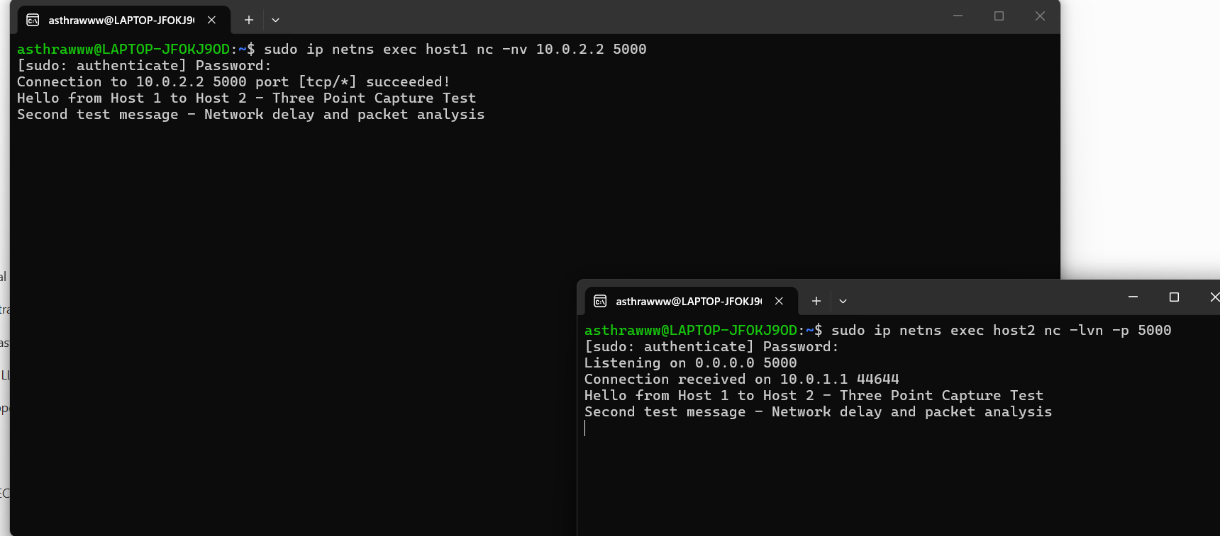
Figure 4. Netcat TCP connection succeeded and both test messages were delivered.

6. Capture file verification
The three files were checked with ls -lh and capinfos. The displayed file sizes were approximately 2.6 KB, 2.6 KB and 2.7 KB. capinfos reported 24 packets in cap1, 24 packets in cap2 and 25 packets in cap3.
Capture file | Interface | Packets | File size | Capture duration
cap1.pcap | veth-h1 (Host 1) | 24 | 2,608 bytes | 162.1337 s
cap2.pcap | veth-r1 (Router) | 24 | 2,608 bytes | 162.1337 s
cap3.pcap | veth-h2 (Host 2) | 25 | 2,684 bytes | 164.4174 s

The packet counts are the total packets in each capture file, not the number of TCP data segments. The small difference in packet counts can occur because each interface may observe a different set of link/control packets or capture timing.

7. TShark packet analysis
The captures were read with TShark using a TCP display filter and fields for frame number, relative time, IP source/destination, TTL, TCP source/destination ports, sequence number, acknowledgement number and TCP payload length.
sudo tshark -r /tmp/cap1.pcap -Y tcp -T fields \
-e frame.number -e frame.time_relative -e ip.src -e ip.dst -e ip.ttl \
-e tcp.srcport -e tcp.dstport -e tcp.seq -e tcp.ack -e tcp.len
Observation | Host 1 capture (cap1) | Router capture (cap2) | Host 2 capture (cap3)
TCP flow | 10.0.1.1:44644 → 10.0.2.2:5000 | Same TCP flow | Same TCP flow
Forward data segment 1 | Seq 1, Len 55, TTL 64 | Seq 1, Len 55, TTL 64 | Seq 1, Len 55, TTL 63
Forward data segment 2 | Seq 56, Len 56, TTL 64 | Seq 56, Len 56, TTL 64 | Seq 56, Len 56, TTL 63
Interpretation | Before router hop | Router-side capture | After router hop

The forward data segments are visible with sequence numbers 1 and 56 and payload lengths of 55 and 56 bytes. The source TTL is 64 in the Host 1 and router-side observations and 63 at Host 2, showing a one-hop TTL decrement across the router.
The packet outputs also show the reverse direction (10.0.2.2 to 10.0.1.1) with TCP acknowledgements. The source/destination ports identify the client ephemeral port 44644 and server port 5000.

8. TCP stream and conversation statistics

8.1 Follow TCP stream
The TCP stream was reconstructed in ASCII mode. The output displayed both application messages in the correct order:
Hello from Host 1 to Host 2 - Three Point Capture Test
Second test message - Network delay and packet analysis
This confirms that the application data was present in the captured TCP stream and could be reconstructed from the packet capture.

8.2 TCP conversation summary
Metric | Observed value
TCP conversations | 1
Endpoints | 10.0.1.1:44644 ↔ 10.0.2.2:5000
Total frames | 10
Total bytes | 787 bytes
Host 1 → Host 2 | 4 frames, 272 bytes
Host 2 → Host 1 | 6 frames, 515 bytes
Conversation duration | Approximately 156.922 seconds

The directional byte counts sum to the total: 272 + 515 = 787 bytes. The conversation duration is the relative time between the first and last packets in the TCP conversation; it includes the long idle interval between the two application messages.
The retransmission display filter tcp.analysis.retransmission produced no matching packet rows in the supplied terminal output. This means no retransmissions were flagged by that filter in these captures; it does not prove that every possible network impairment was absent.

9. Results and discussion
- The routed path between Host 1 and Host 2 was operational, as demonstrated by the successful ICMP ping.
- IPv4 forwarding was enabled on the router and both hosts had routes to the remote subnet.
- The router traffic-control configuration showed netem delay 20ms and loss 1% on veth-r2.
- A TCP connection from 10.0.1.1:44644 to 10.0.2.2:5000 was established successfully.
- Both test messages were received by Host 2 and reconstructed in the TCP stream output.
- The three captures contained the same TCP conversation, and the TTL observations showed a one-hop decrement by the time packets reached Host 2.
- The TCP conversation summary reported 10 frames and 787 bytes, with 4 forward frames and 6 reverse frames.

10. Conclusion
The three-point network capture experiment was completed successfully. Linux network namespaces were used to create two endpoint hosts connected through a router. Static routing and IPv4 forwarding enabled end-to-end communication. A netem rule was installed on the router to configure 20 ms delay and 1% packet loss. TCP data was transferred using Netcat, and captures were collected at Host 1, the router and Host 2. TShark analysis verified the TCP flow, payload segments, acknowledgements, TTL change, reconstructed application messages and conversation statistics. The results demonstrate how packet characteristics can be compared at multiple observation points along a routed network path.

11. Limitations and notes
- The displayed ping test occurred before the netem rule was installed; no separate post-netem ping statistics were supplied.
- The netem configuration was verified by tc qdisc show, but the screenshots do not provide a controlled before/after measurement of the configured 20 ms delay or 1% loss.
- The capture files contain 24, 24 and 25 packets respectively; packet totals should not be confused with TCP conversation frame totals.
- The TShark retransmission filter returned no matching rows in the shown output. This is a capture-specific observation, not a guarantee that retransmission can never occur.

Appendix A – Evidence screenshots
The following screenshots are taken from the terminal outputs captured during the practical. They provide evidence of configuration, connectivity, traffic generation and packet analysis.
Figure A1. Addressing, forwarding and static route configuration.
Figure A2. Baseline ping result and verified netem qdisc configuration.
Figure A3. Netcat client/server test and successful application message delivery.
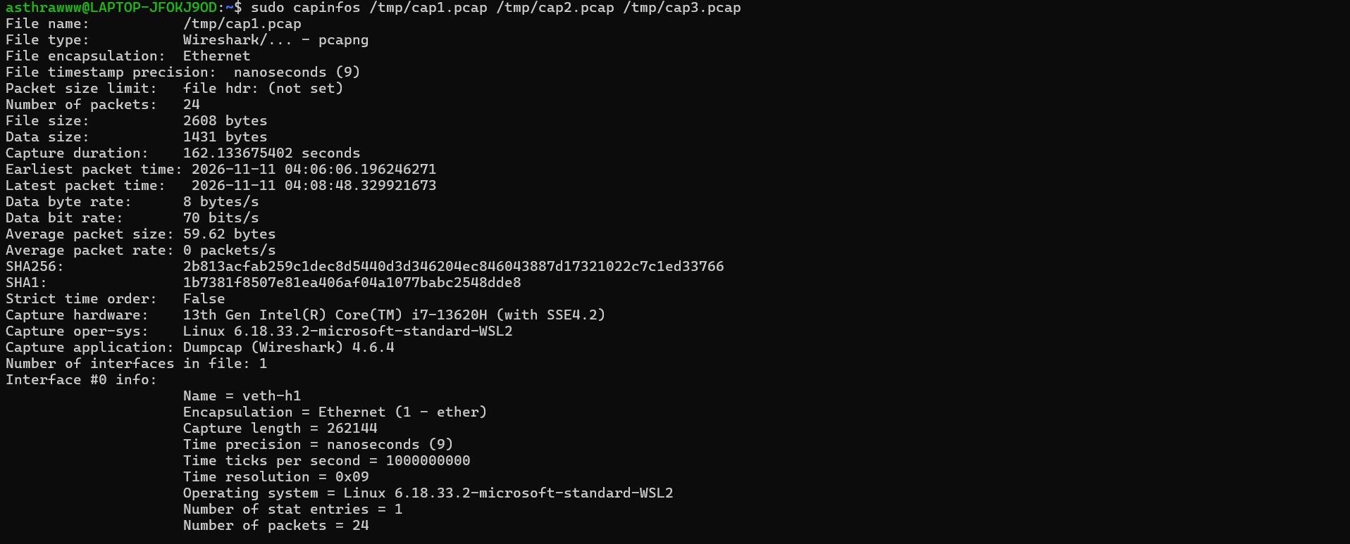
Figure A4. capinfos summary for the first capture file (cap1.pcap, veth-h1).
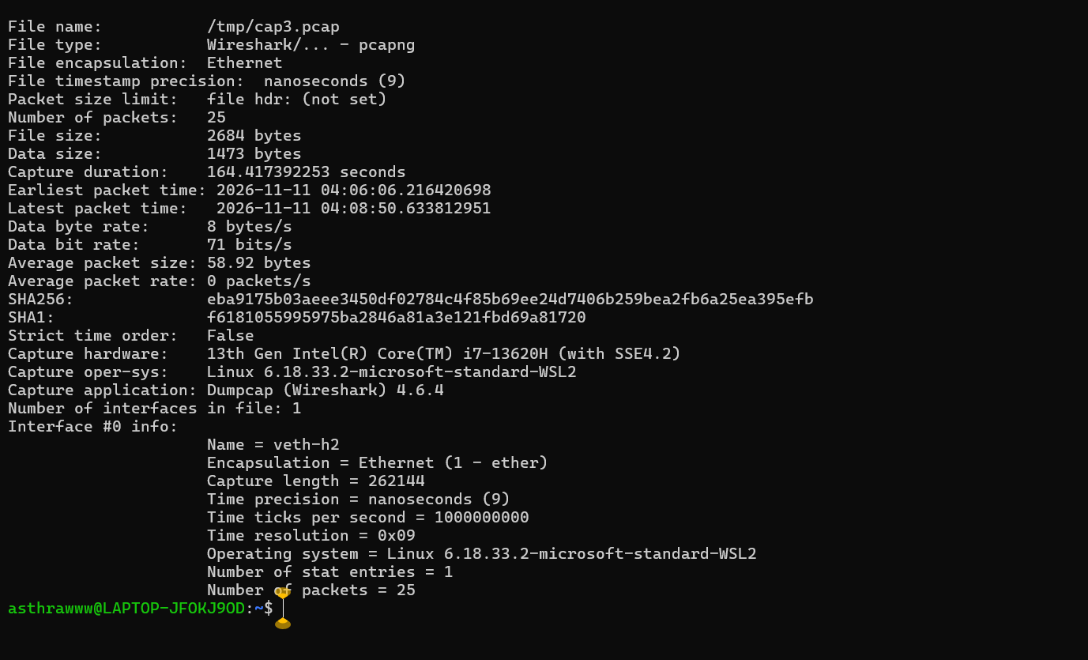
Figure A5. capinfos summary for the second capture file (cap2.pcap, veth-r1).
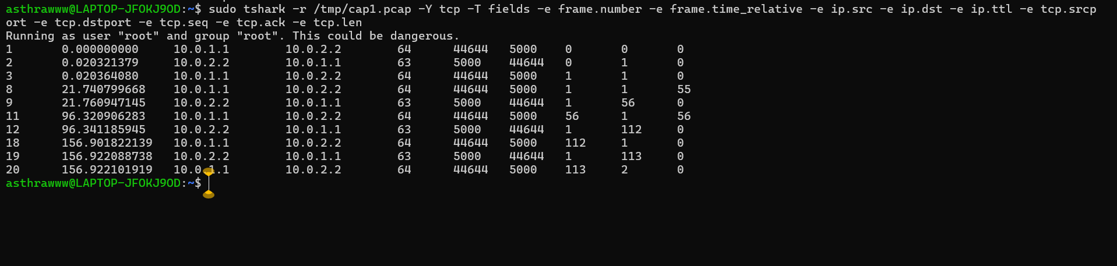
Figure A6. TShark TCP field extraction from the Host 1 capture.
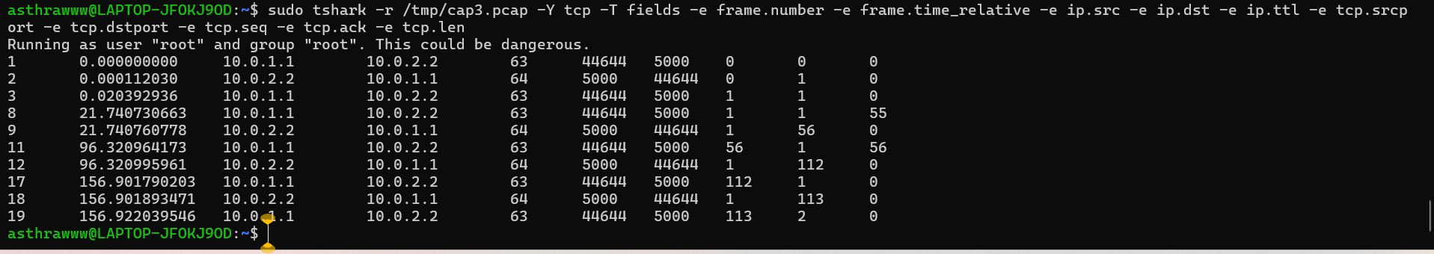
Figure A7. TShark TCP field extraction from the Host 2 capture (cap3.pcap).
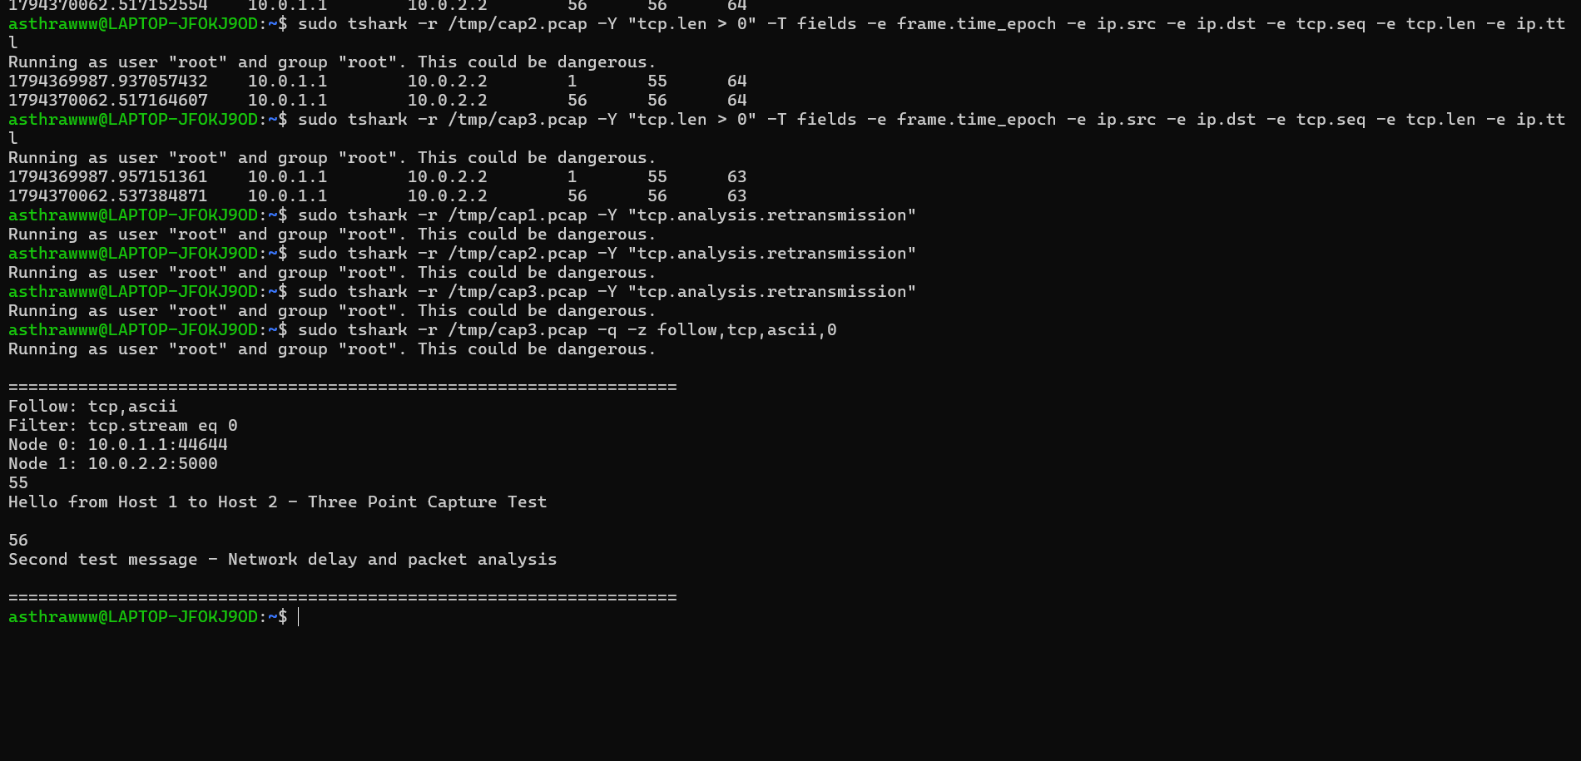
Figure A8. TCP stream reconstruction showing both transmitted messages.
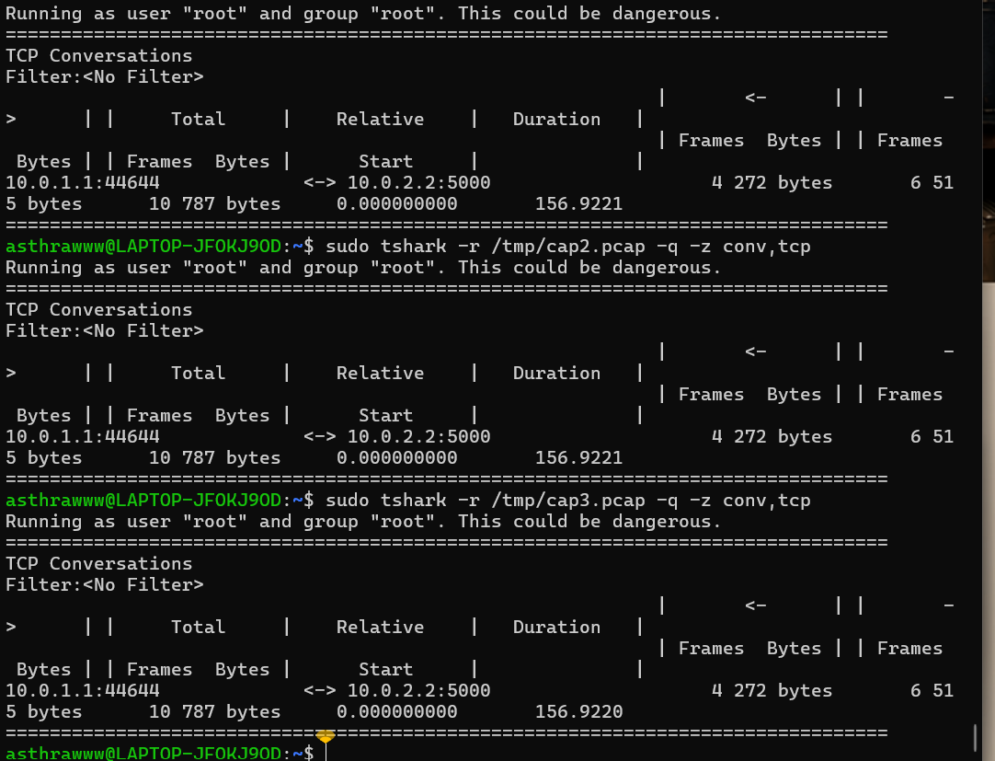
Figure A9. TCP conversation summaries from all three capture files.

Appendix A – Additional capture evidence
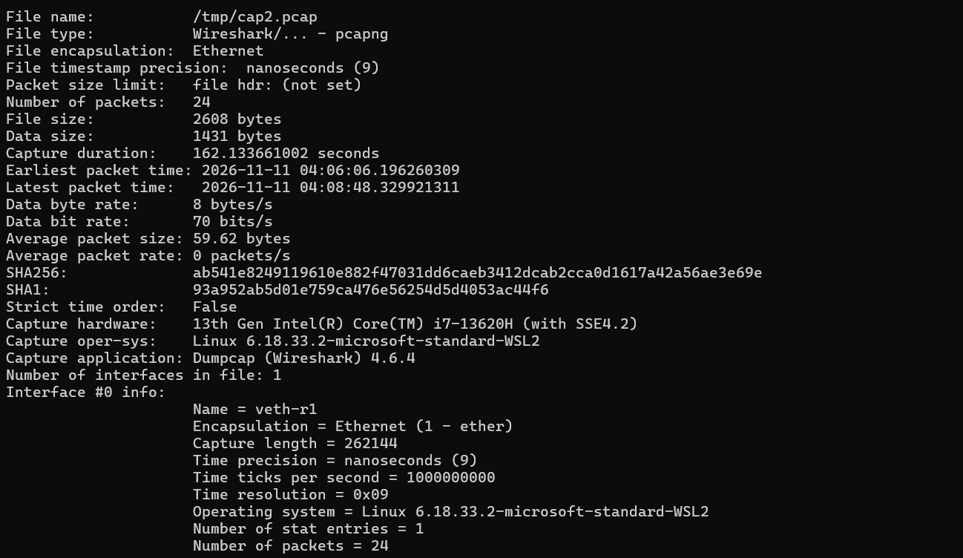
Figure A10. capinfos summary for the router-side capture file (cap2.pcap, veth-r1).
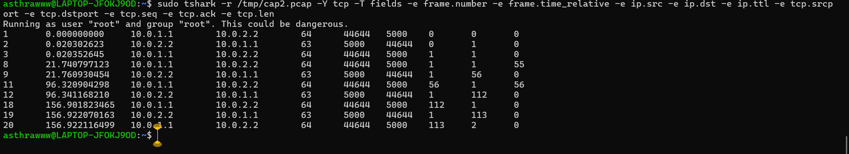
Figure A11. TShark TCP field extraction from the router-side capture (cap2.pcap).

