A. ICMP Protocol
- Display filter: `icmp`
- Purpose: ICMP (Internet Control Message Protocol) is used for network diagnostics and error reporting. Tools such as ping use ICMP Echo Request and Echo Reply messages.
- How to capture: Start a capture, open Command Prompt, run `ping 8.8.8.8`, and then apply the `icmp` display filter.
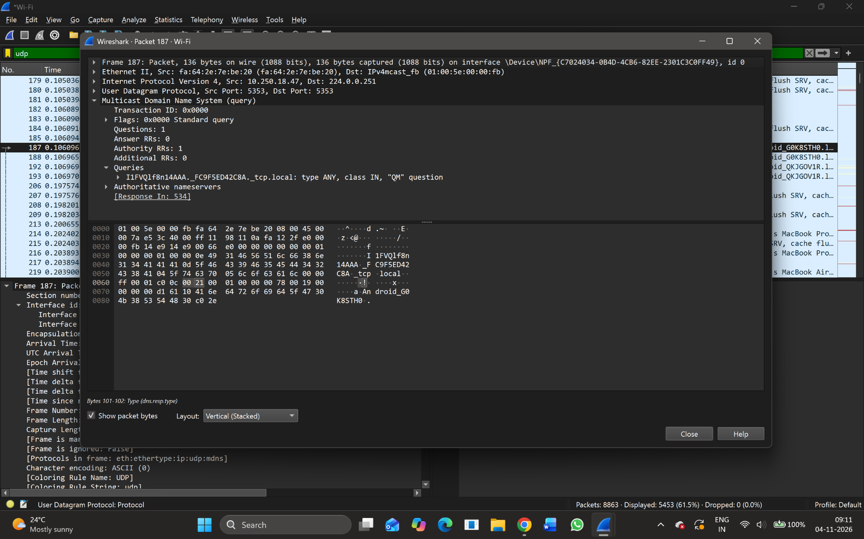
Figure A1. Supplied screenshot: ICMP display filter with no matching packets.
Result: The ICMP filter was applied, but no ICMP packets are visible in the supplied capture. A new capture while generating ping traffic is required to complete the ICMP observation.

B. TCP Protocol
- Display filter: `tcp`
- Purpose: TCP (Transmission Control Protocol) is connection-oriented and provides reliable, ordered delivery of data using acknowledgements and retransmission when required.
- Observed packet: Frame 202
- Frame length: 210 bytes
- Capture length: 210 bytes
- Interface / encapsulation: Wi-Fi interface; Ethernet II
- Observed IP and transport details: The packet details screenshot identifies IPv4 traffic from 10.250.22.55 to 149.154.167.99 and TCP traffic using destination port 443 (HTTPS).
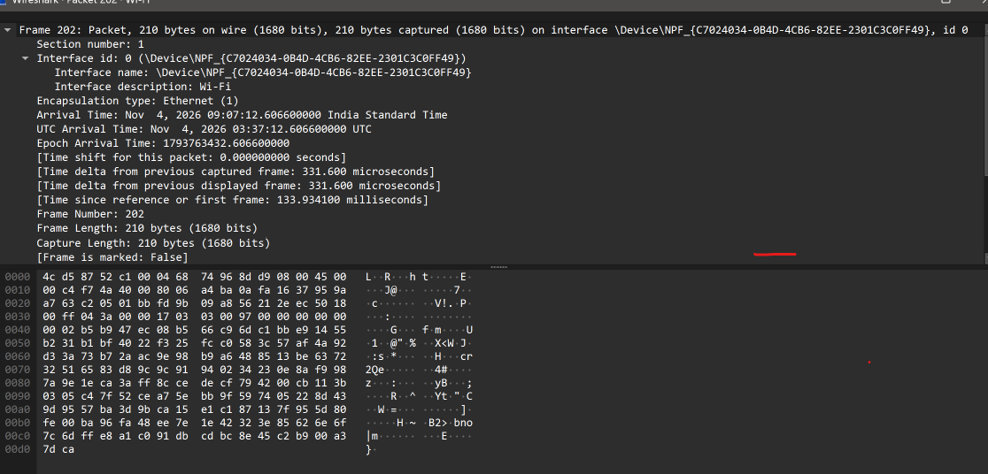
Figure B1. Frame 202: Wireshark frame summary and packet bytes.
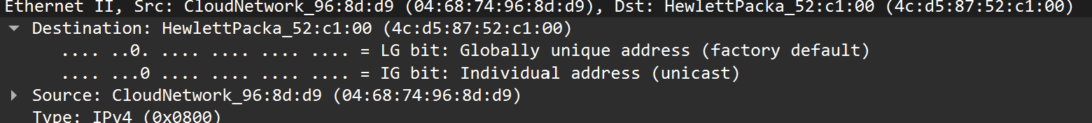
Figure B2. Ethernet II header showing source and destination MAC addresses.
Result: The selected packet is a TCP packet. The supplied capture reports a frame size of 210 bytes.

C. TCP Length (tcp.len)
- Display filter: `tcp.len > 0`
- Purpose: The tcp.len field represents the number of bytes of TCP payload carried in a segment. The filter `tcp.len > 0` displays TCP packets that contain at least one byte of TCP payload.
- Observed payload: One supplied TCP details screenshot explicitly reports `TCP payload (120 bytes)` and `TCP Segment Len: 120`.
- TCP length: 120 bytes (as displayed in the supplied packet details).
- How to verify: Apply `tcp.len > 0`, select a matching packet, expand Transmission Control Protocol, and inspect the segment length / TCP payload details.
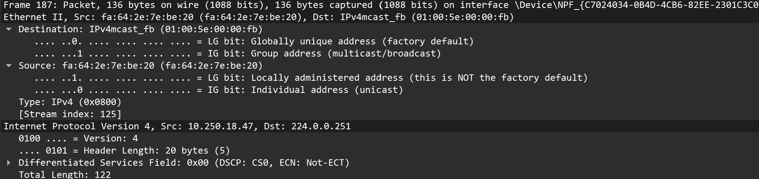
Figure C1. TCP details showing a 120-byte TCP payload.
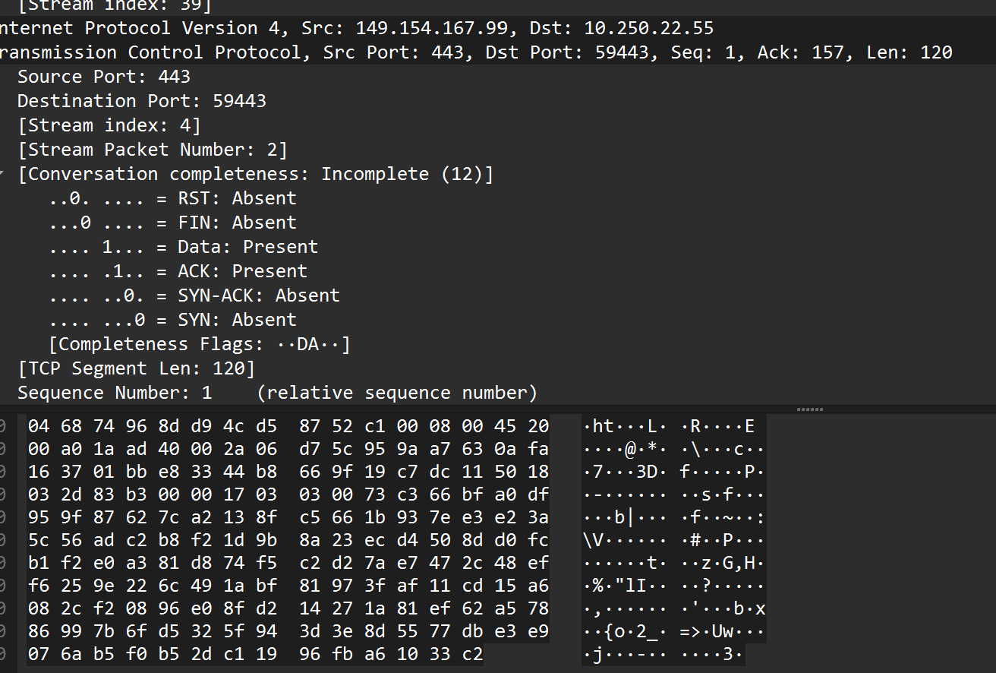
Figure C2. Additional TCP packet details and bytes.
Result: The supplied packet details show a TCP payload length of 120 bytes. This is the TCP data length, not the total Ethernet frame length.

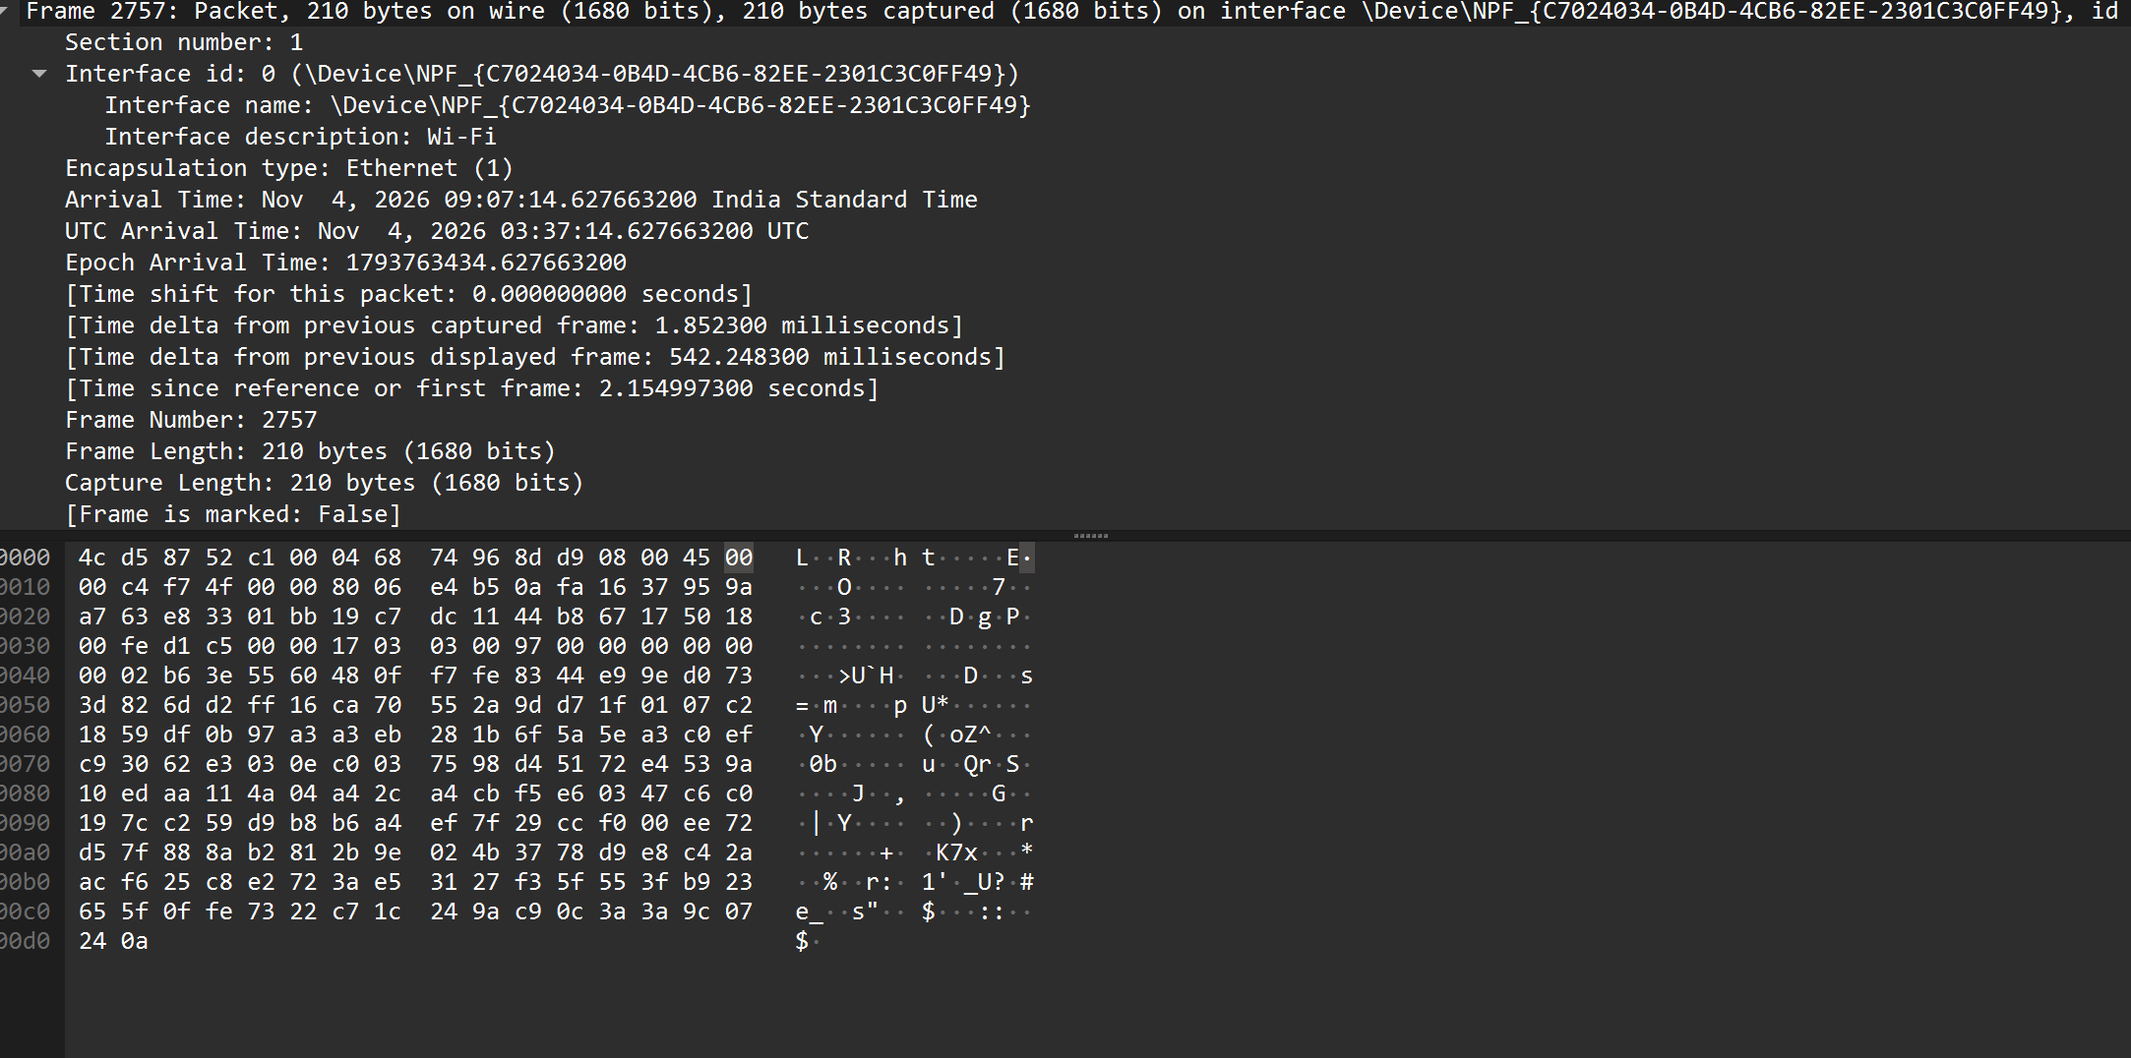

D. UDP Protocol
- Display filter: `udp`
- Purpose: UDP (User Datagram Protocol) is connectionless. It sends datagrams without establishing a connection and does not provide TCP-style delivery acknowledgements or retransmission.
- Observed packet: Frame 187
- Frame length: 136 bytes
- Source and destination ports: 5353 → 5353
- Protocol / service: Multicast DNS (mDNS), which uses UDP port 5353 for local-network service and device discovery.
- Destination IP: 224.0.0.251 (IPv4 multicast address used by mDNS).
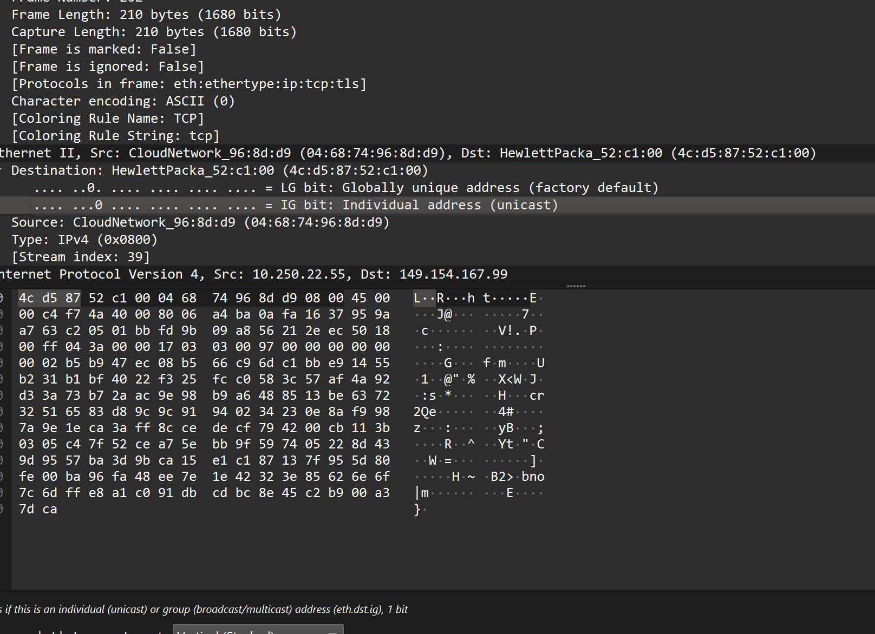
Figure D1. Frame 187: UDP packet decoded as an mDNS query.
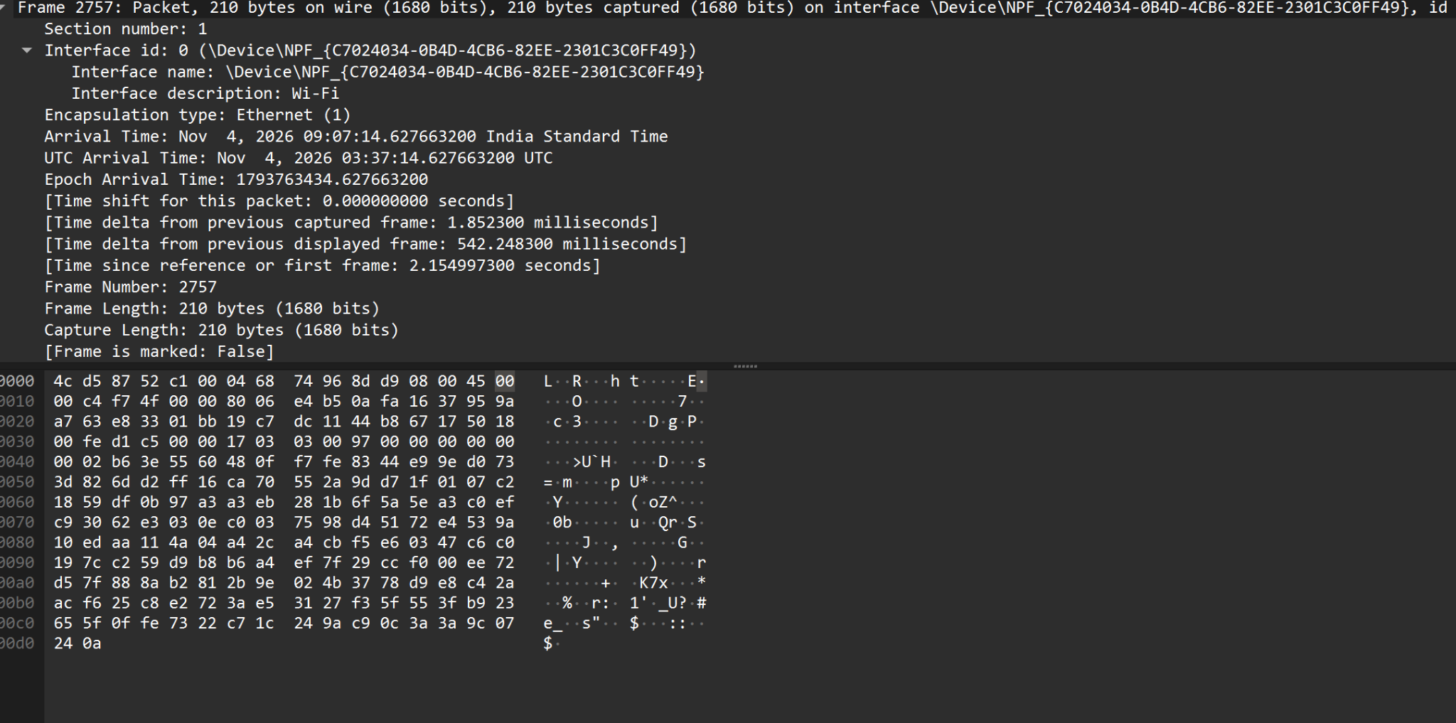
Figure D2. mDNS packet details and packet bytes.
Result: The supplied capture contains a UDP-based mDNS packet with source and destination port 5353. Its frame length is 136 bytes.

E. Header Overhead Calculations
The following calculations use the actual packet observations shown in the supplied Wireshark screenshots. The captured frame lengths do not include an additional Ethernet FCS field.

1. TCP Packet – Frame 202
Parameter | Observed / calculated value
Frame length | 210 bytes
Ethernet II header length | 14 bytes
IPv4 header length | 20 bytes (IHL = 5)
IPv4 total length | 196 bytes (0x00C4)
TCP header length | 20 bytes (data offset = 5)
TCP payload length | 156 bytes
Step 1 – TCP payload length:
TCP payload = IPv4 total length − IPv4 header length − TCP header length
= 196 − 20 − 20 = 156 bytes
Step 2 – Header overhead (Ethernet + IPv4 + TCP):
= 14 + 20 + 20 = 54 bytes
Step 3 – Payload efficiency:
Payload efficiency = (TCP payload ÷ captured frame length) × 100
= (156 ÷ 210) × 100 = 74.29%

2. UDP Packet – Frame 187
Parameter | Observed / calculated value
Frame length | 136 bytes
Ethernet II header length | 14 bytes
IPv4 header length | 20 bytes
IPv4 total length | 122 bytes
UDP header length | 8 bytes
UDP payload length | 94 bytes
Step 1 – UDP payload length:
UDP payload = IPv4 total length − IPv4 header length − UDP header length
= 122 − 20 − 8 = 94 bytes
Step 2 – Header overhead (Ethernet + IPv4 + UDP):
= 14 + 20 + 8 = 42 bytes
Step 3 – Payload efficiency:
Payload efficiency = (UDP payload ÷ captured frame length) × 100
= (94 ÷ 136) × 100 = 69.12%

3. Final Observation Table
Parameter | TCP Packet – Frame 202 | UDP Packet – Frame 187
Frame length | 210 bytes | 136 bytes
Ethernet header length | 14 bytes | 14 bytes
IP header length | 20 bytes | 20 bytes
Transport header length | 20 bytes (TCP) | 8 bytes (UDP)
IP total length | 196 bytes | 122 bytes
Transport payload length | 156 bytes | 94 bytes
Total header overhead | 54 bytes | 42 bytes
Payload efficiency | 74.29% | 69.12%
Note: The original reference table repeats “Transport Header Length” in its last rows. The final payload row above is labelled “Transport payload length” to distinguish data bytes from header bytes. The TCP packet’s 156-byte payload is calculated specifically from Frame 202. A separate screenshot in the supplied document shows a different TCP packet with a 120-byte TCP payload; that 120-byte observation is not used for Frame 202.

F. Answers to the Questions
1. What is encapsulation?
Encapsulation is the process in which each network layer adds its own control information, usually in the form of a header, to the data received from the layer above it. For example, application data is carried in a TCP or UDP segment, which is placed inside an IP packet, and the IP packet is then carried inside an Ethernet frame.
2. What is the purpose of the Ethernet header?
The Ethernet header is used for communication over a local network. It contains the destination MAC address, source MAC address, and EtherType field, which identifies the protocol carried in the Ethernet frame, such as IPv4. These fields help deliver the frame to the correct device and identify the payload protocol.
3. What information is stored in the IP header?
The IPv4 header contains information needed to route and deliver a packet. Important fields include the source IP address, destination IP address, header length, total packet length, identification and fragmentation fields, time to live (TTL), protocol field, and header checksum.
4. What is the difference between TCP and UDP headers?
TCP has a larger, variable-length header (minimum 20 bytes) containing fields such as source and destination ports, sequence number, acknowledgement number, flags, window size, checksum, and options. These support reliable, ordered communication. UDP has a fixed 8-byte header containing source port, destination port, length, and checksum. UDP is connectionless and does not provide TCP-style acknowledgements or retransmissions.
5. Why does each protocol add a header?
Each protocol adds a header to carry the control information required for its function. Ethernet uses MAC addresses for local delivery, IP uses IP addresses and routing-related fields for delivery between networks, and TCP or UDP uses port numbers and transport-specific fields to deliver data to the correct application and manage transport.
6. What is packet overhead?
Packet overhead is the number of bytes used for protocol information rather than application data. It includes headers added by the network layers and may also include trailer information such as the Ethernet Frame Check Sequence (FCS), when it is present in the captured frame.
7. How does header overhead affect network efficiency?
Header overhead reduces the proportion of transmitted bytes available for application data. A larger header means a lower payload efficiency for the same total packet size. However, headers are necessary because they provide addressing, routing, error checking, and transport-control information required for communication.

G. Conclusion
The Wireshark capture was used to examine TCP, UDP, and ICMP traffic and to study protocol encapsulation. The selected TCP frame (Frame 202) has a captured length of 210 bytes, with 54 bytes of Ethernet, IPv4, and TCP headers and a calculated TCP payload of 156 bytes. Its payload efficiency is 74.29%. The selected UDP frame (Frame 187) has a captured length of 136 bytes, with 42 bytes of Ethernet, IPv4, and UDP headers and a calculated UDP payload of 94 bytes. Its payload efficiency is 69.12%. The ICMP filter produced no matching packets in the supplied screenshot, so an additional capture while running ping is needed to complete that observation.
These observations show that encapsulation adds protocol overhead to transmitted data. TCP has a larger transport header than UDP, while both protocols require Ethernet and IP headers for delivery.

