

Department of CSE
B.Tech. CSE Trimester -5

2520030044
Asthra Pilla

Cloud Infrastructure and Services
25CS2206E

LAB RECORD 2026

Experiment -1 (b)

AIM: Enabling Multi-Factor Authentication to Secure Your Access
Description:
The objective of this task is to enable Multi-Factor Authentication (MFA) in an AWS account to improve account security and prevent unauthorized access. MFA provides an additional
layer of protection by requiring users to verify their identity using two different
authentication factors, such as a password and a one-time verification code generated by an authenticator application.
In AWS, MFA can be enabled for the root user and IAM users through the AWS Management Console. An authenticator application such as Google Authenticator or Microsoft
Authenticator can be used to generate time-based one-time passwords (TOTP).

Steps:

Part A: Creating an IAM User
- Open a web browser and navigate to the AWS Management Console.
- Sign in to the AWS account using the root user credentials.
- In the AWS Management Console search bar, type IAM and select Identity and Access Management (IAM).
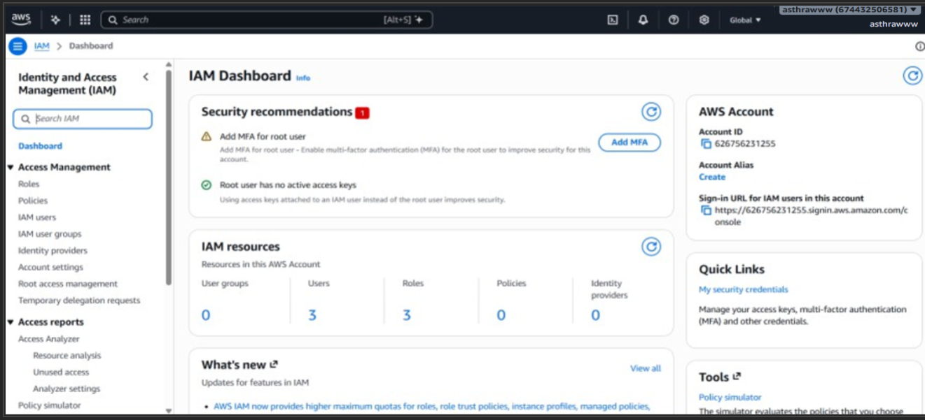

- From the left navigation pane, select Users.
- Click Create user.

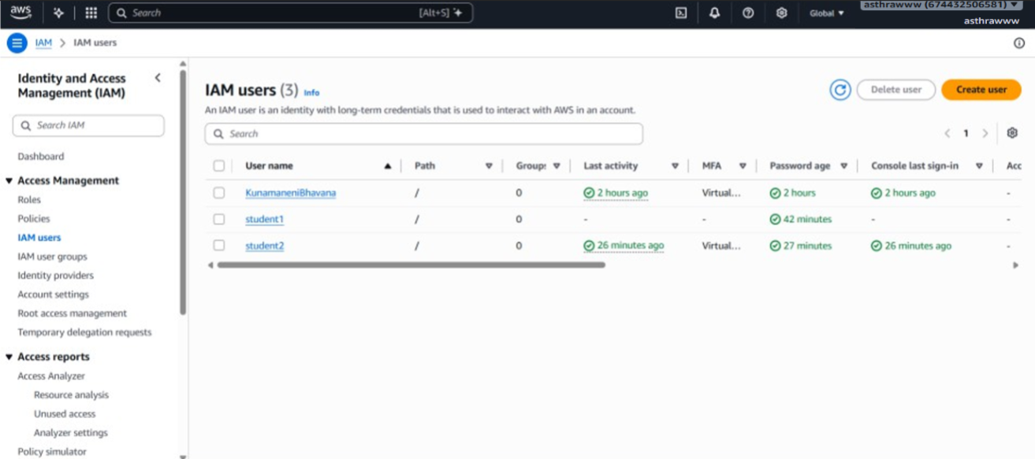
- Enter a username (e.g., StudentUser01).
- If the console provides an option to enable console access, select Provide user access to the AWS Management Console.
- Set a custom password or allow AWS to generate a password (Autogenerated password.)
- Select the option requiring the user to create a new password at the next sign-in, if appropriate. (If required you can opt). Click Next.
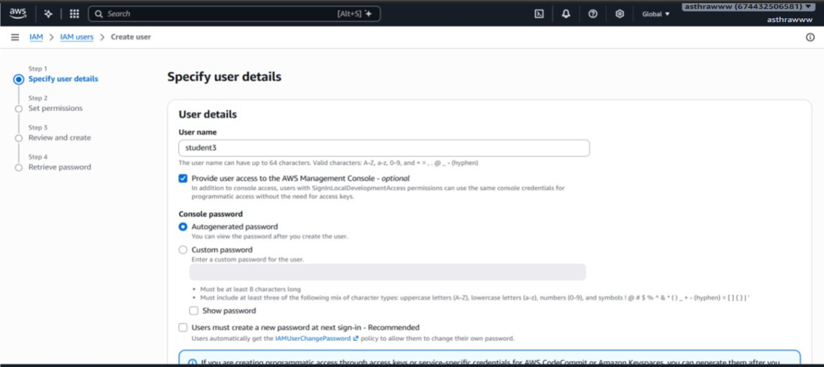
- Under Set permissions, select Attach policies directly.

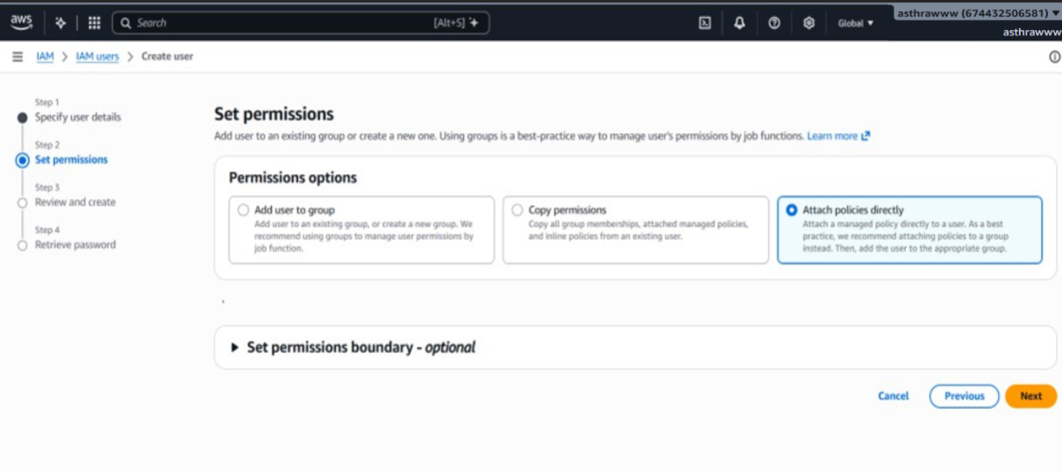
- Select AdministratorAccess - AWS managed - job functionunder policy name and type. Click Next.
- Review the username and permission details. (Tags are optional. You can add if required.)
- Click Create user.
- Note down the IAM user sign-in details and securely save the generated password, if applicable. (You can download .csv file)
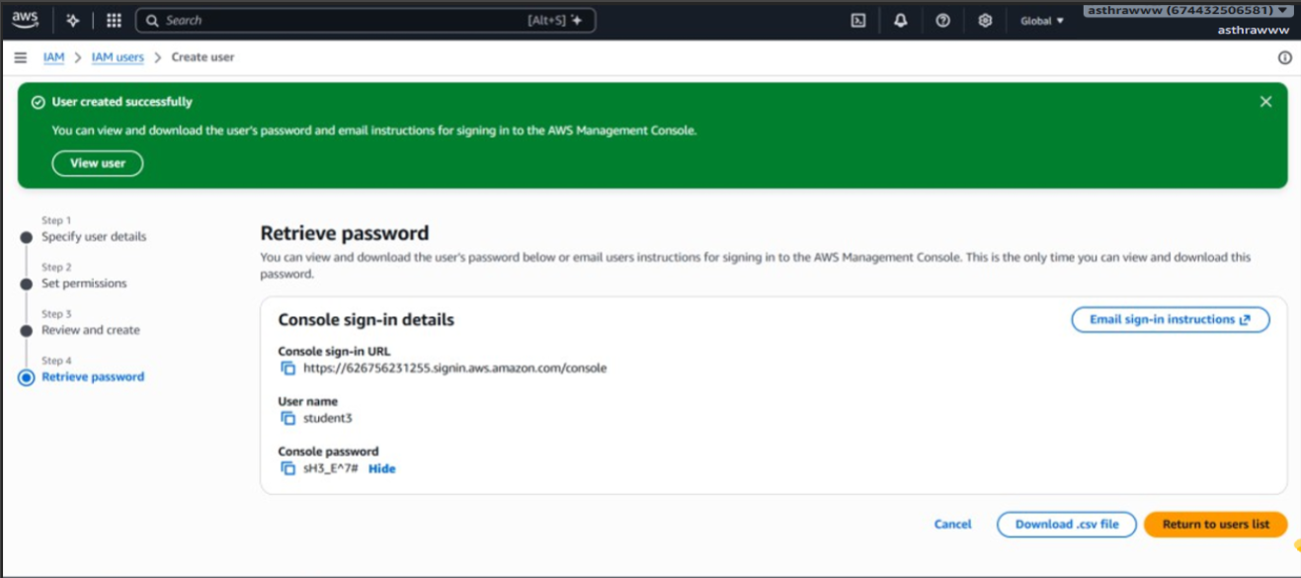
- You can view to see the created IAM user when you click Return to user.
- Sign out of the root account.

Part B: Signing in as an IAM User
- Open the AWS Management Console sign-in page
- Select IAM user as the sign-in type.

Or instead of steps 1 and 2 .( Use the Console sign-in URL saved in the downloaded csv file)
- Enter the AWS account ID or account alias. (automatically seen if Console sign-in URL from downloaded csv file is used)

- Enter the newly created IAM username and password. (present in the downloaded csv file)
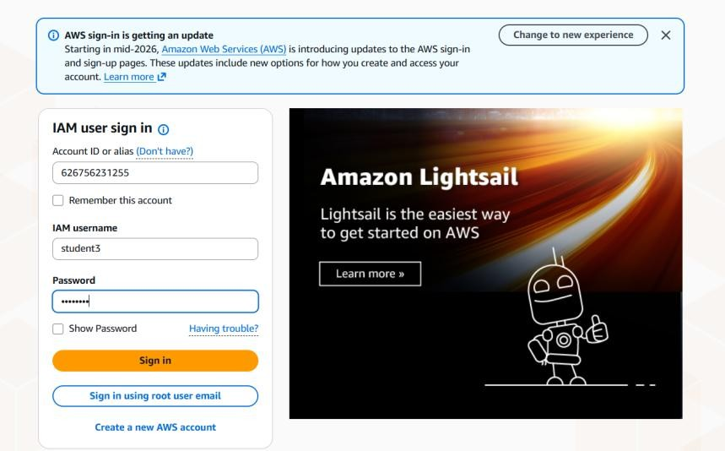
- If prompted, change the temporary password and set a new password.
- Verify that you can successfully access the AWS Management Console.
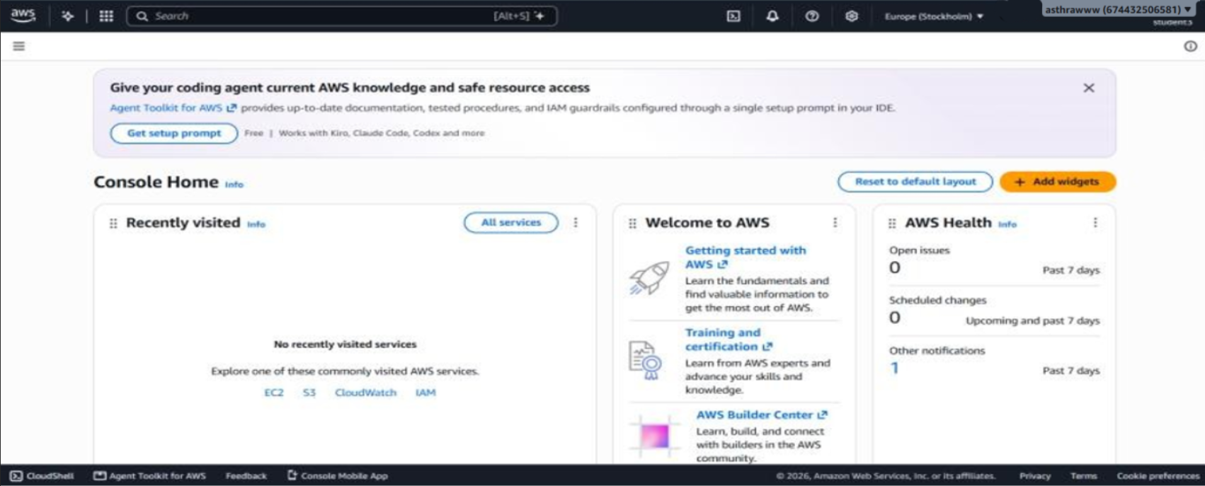

Part C: Enabling Multi-Factor Authentication (MFA)
- Sign in to the AWS Management Console using the IAM user credentials.
- Search for IAM in the AWS Management Console search bar.
- Open the IAM dashboard.
- From the left navigation pane, select Users.
- Click the newly created IAM username.
- Open the Security credentials tab.
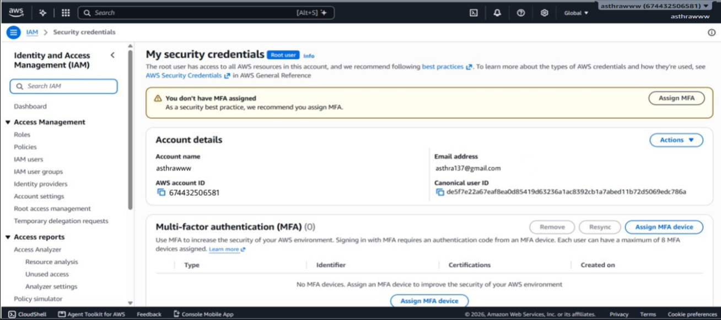
- Locate the Multi-Factor Authentication (MFA) section.
- Click Assign MFA device.
- Enter a device name (e.g., StudentMFA01).
- Select the MFA device type:
  - Passkey or Security key
  - Authenticator app (Google Authenticator or Microsoft Authenticator).
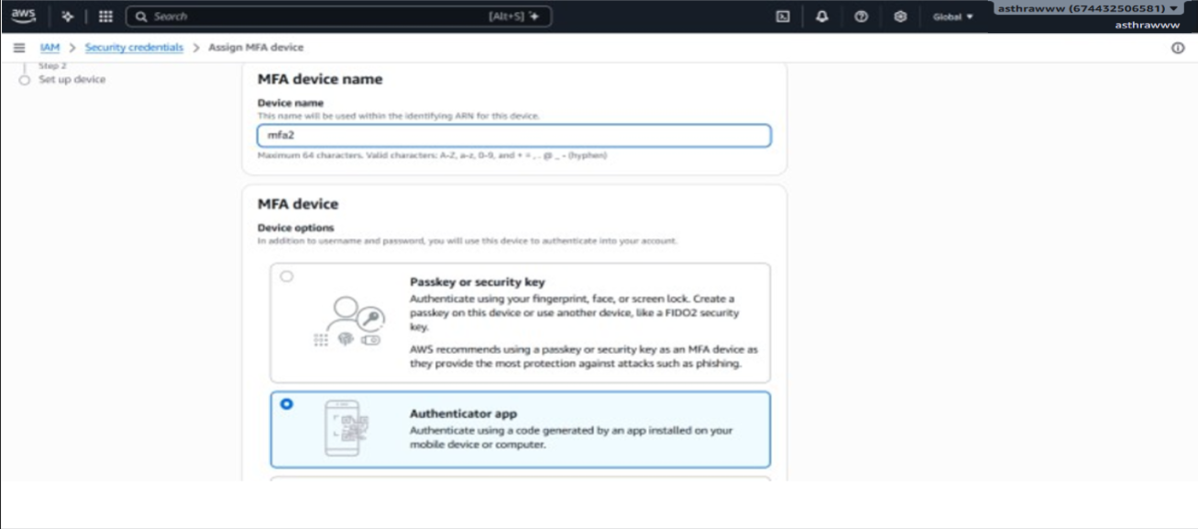

Option B: If you select Authenticator App
- Select Authenticator app and click Next.
- Open an authenticator application on your smartphone (Google Authenticator or Microsoft Authenticator).
- Select the option to add a new account.
- Scan the QR code displayed in the AWS console.
- The authenticator application will generate a six-digit authentication code.
- Enter the first six-digit MFA code displayed in the application.
- Wait for the application to generate the next code.
- Enter the second six-digit MFA code.
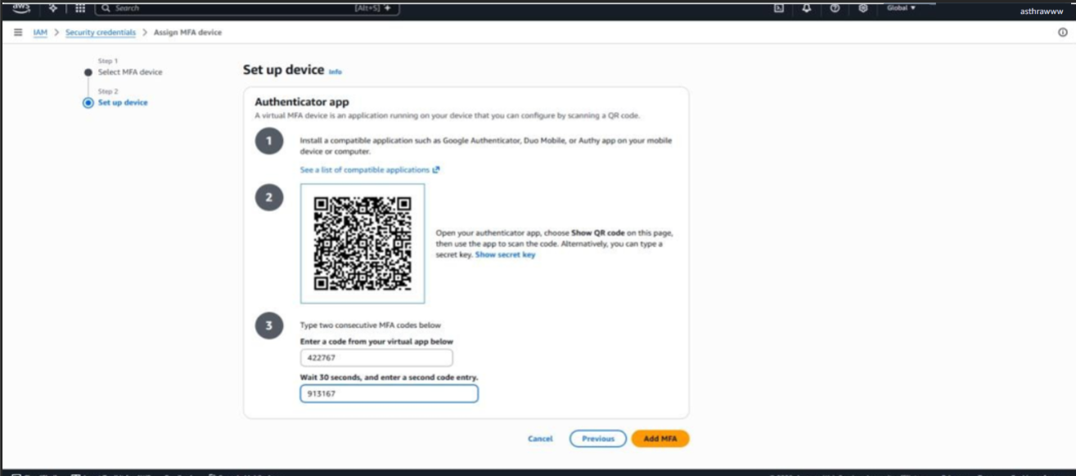
- Click Add MFA or Assign MFA to complete the setup.
- Verify that the selected MFA device is displayed as assigned to the IAM user.
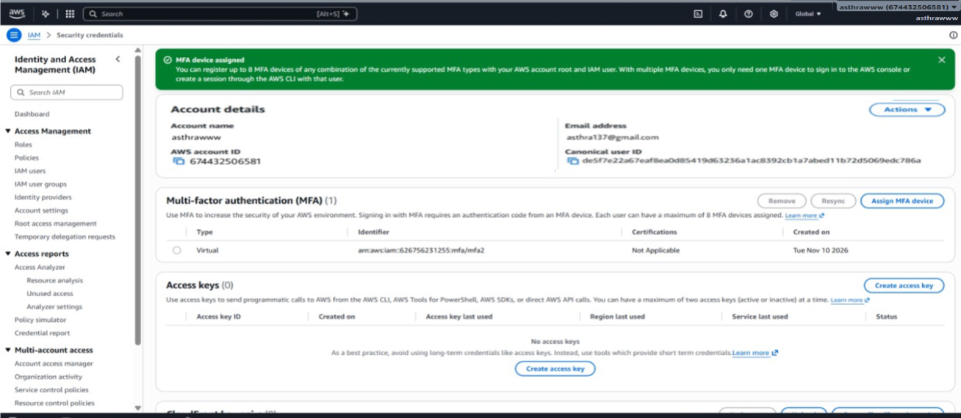

Part D: Testing MFA Authentication
- Sign out of the AWS Management Console.
- Open the AWS sign-in page.
- Select IAM user sign-in.
- Enter the AWS account ID or account alias.
- Enter the IAM username and password.
- Complete the MFA verification based on the device configured: If Passkey or Security Key was selected:
  - When prompted, select the option to sign in using the registered passkey.
  - Complete the verification using the registered device, biometric authentication, or PIN.
If Authenticator App was selected:
  - When prompted, open the authenticator application.
  - Enter the current six-digit MFA authentication code.
- Verify that you can successfully log in to the AWS Management Console after completing MFA verification.
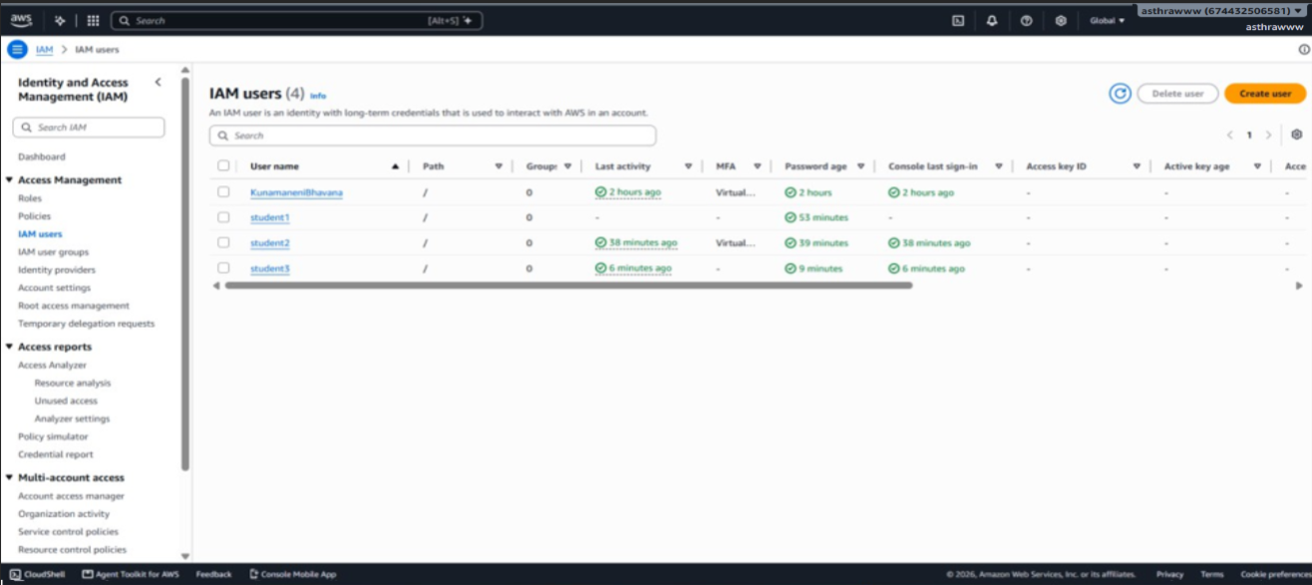

Output:


