

Department of CSE
B.Tech. CSE Trimester -5

2520030044
Asthra Pilla

Cloud Infrastructure and Services
25CS2206E

LAB RECORD 2026

Experiment -2

AIM: IAM User Creation, Access Key Generation and AWS Billing Alert Configuration

Description:
This experiment focuses on creating an IAM (Identity and Access Management) user in AWS, configuring appropriate permissions, and generating access keys for secure
programmatic access to AWS services. It also involves configuring AWS Billing Alerts using Amazon CloudWatch and AWS Budgets to monitor cloud usage and receive notifications
when spending reaches a specified threshold. This helps ensure secure access management, cost monitoring, and prevention of unexpected AWS charges.
Steps:

Part A: Create an IAM User with Programmatic Access Only
- Log in to the AWS Management Console using your root account credentials.
- In the search bar at the top of the AWS Console, search for IAM and select Identity and Access Management (IAM).
- From the left navigation panel, select Users.
- Click Create user.
- Enter a suitable username (e.g., Student-IAM-User).
- Do not enable AWS Management Console access, as the user requires programmatic access only.
- Click Next.
- Under Set permissions, select Attach policies directly.
- Select the required permissions policy based on the tasks to be performed. For example, select Administrative access based on the tasks.
- Click Next and review the configuration.
- Click Create user to complete the process.
- Verify that the newly created IAM user appears in the Users list.

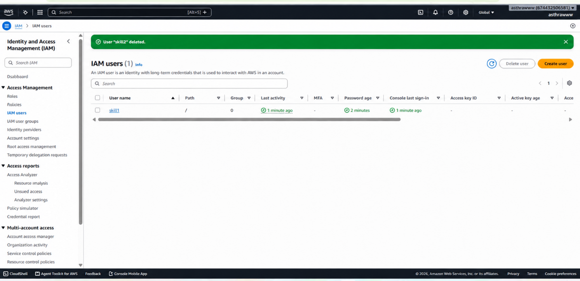

Part B: Generate and Download Access Keys
- In the IAM dashboard, select the newly created IAM user.
- Open the Security credentials tab.
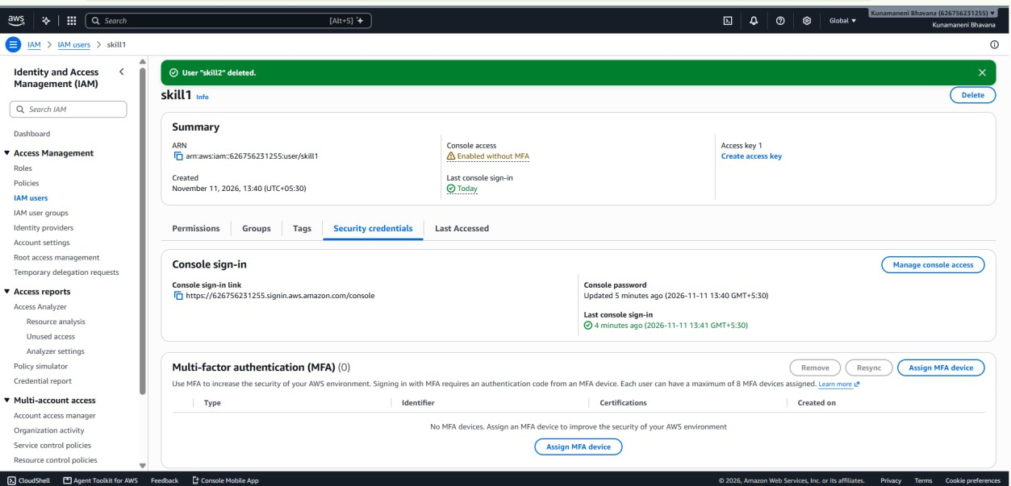
.
- Scroll down to the Access keys section.
- Click Create access key.

- 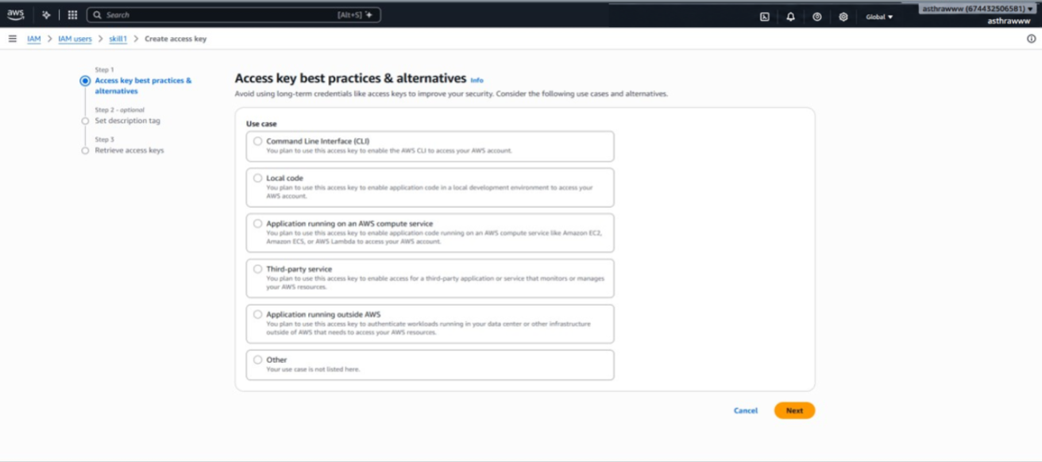Select the appropriate use case, such as Command Line Interface (CLI), if the key is intended for AWS CLI access.
- Acknowledge the recommendation and click Next.
- Optionally enter a description tag (e.g., Student-CLI-Access-Key).
- Click Create access key.
- The console displays the following credentials:
  - Access Key ID
  - Secret Access Key
- Click Download .csv file to download the credentials securely.
- 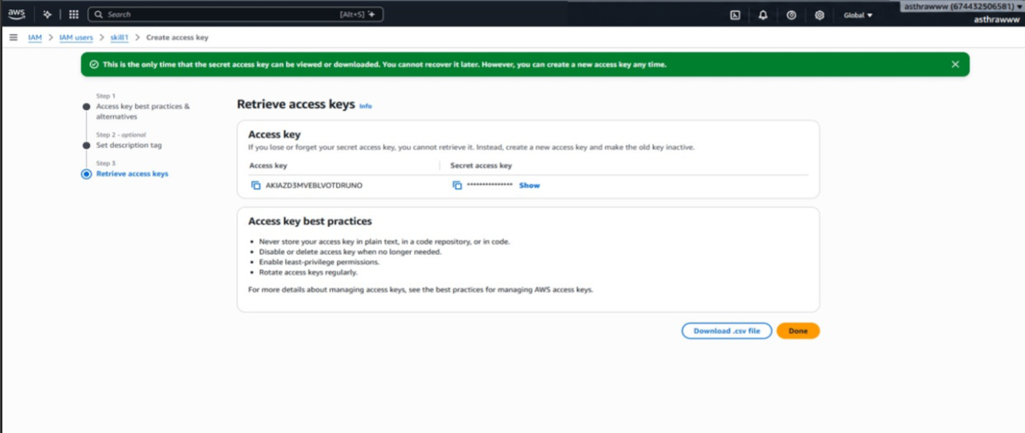
- Verify that the downloaded CSV file contains both the Access Key ID and Secret Access Key.

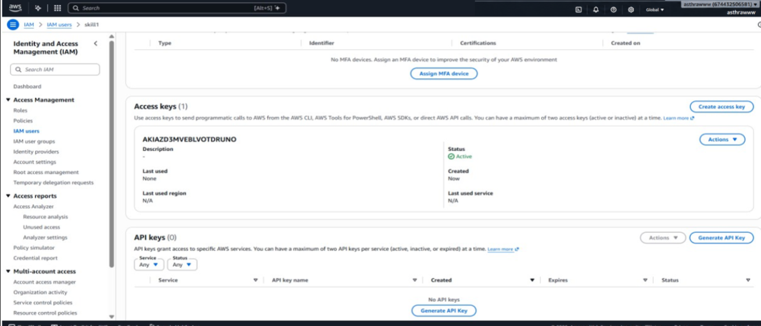

- Click Done.

Part C: Configure AWS Free Tier Usage Alerts
Configure alerts through Billing Preferences.
- Log in to the AWS Management Console using the Root User account.
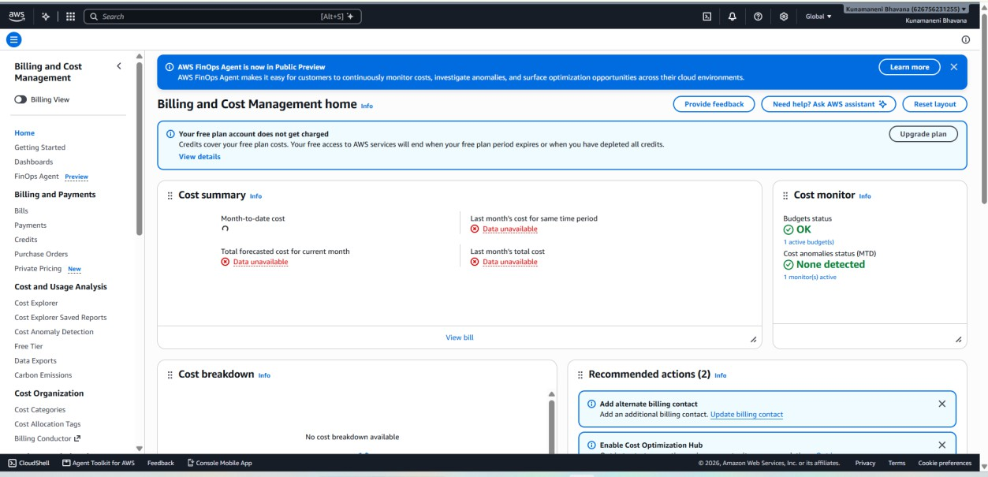
- Search for Billing and Cost Management in the AWS search bar and open it.

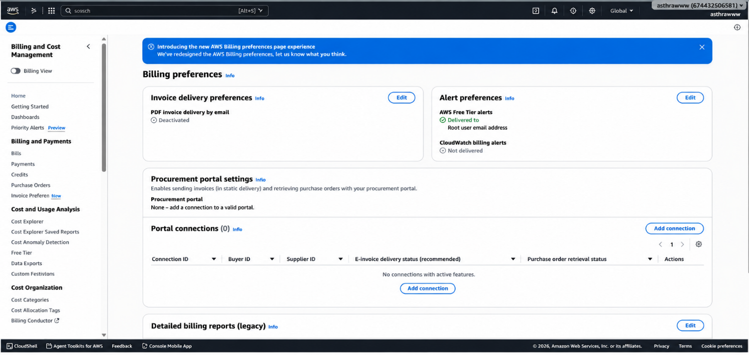
- In the left navigation panel, locate Preferences and select Billing preferences.

- Locate the Alert preferences section.
- Click Edit.
- Select the checkbox Receive AWS Free Tier usage alerts.
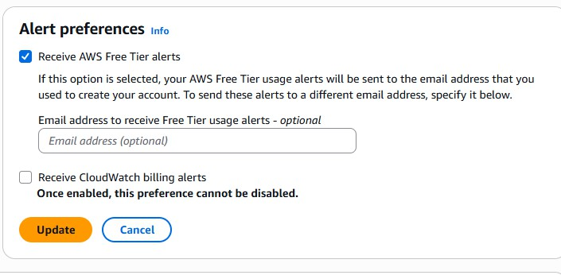

- Under Additional email address to receive alerts, enter the email address where notifications should be received (if required).
- Click Update to save the settings.
- Verify that the Free Tier usage alert option is enabled.

Part D: Configure AWS Billing Alerts Using the Custom Budget Option
- Log in to the AWS Management Console using the root account.
- Search for Billing and Cost Management and open it.
- From the left navigation panel, select Budgets under Budgets and Planning.

- Click Create budget.

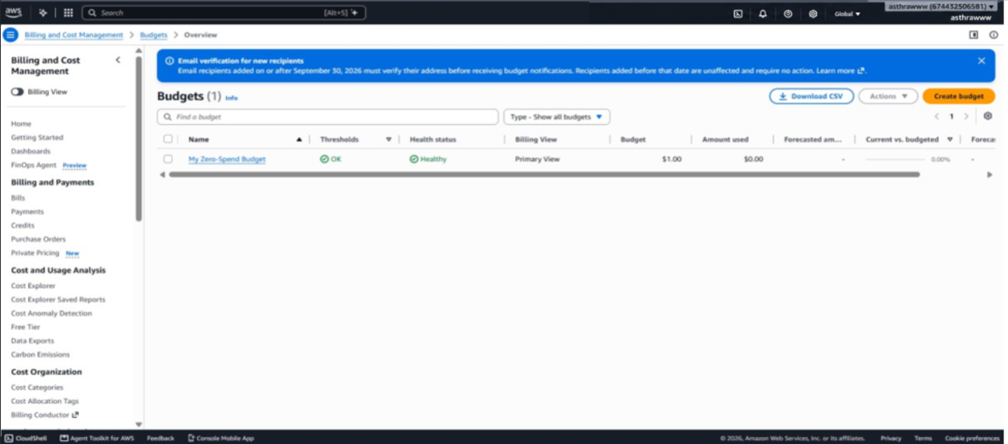

- Under Budget setup, select Use a template (simplified) which is set by default, In Templates – new select Zero spend budget (Create a budget that notifies you once your spending exceeds $0.01) which is set by default and then give the budget name and email id and goto step 17.
or Customize (advanced) instead of using a template.
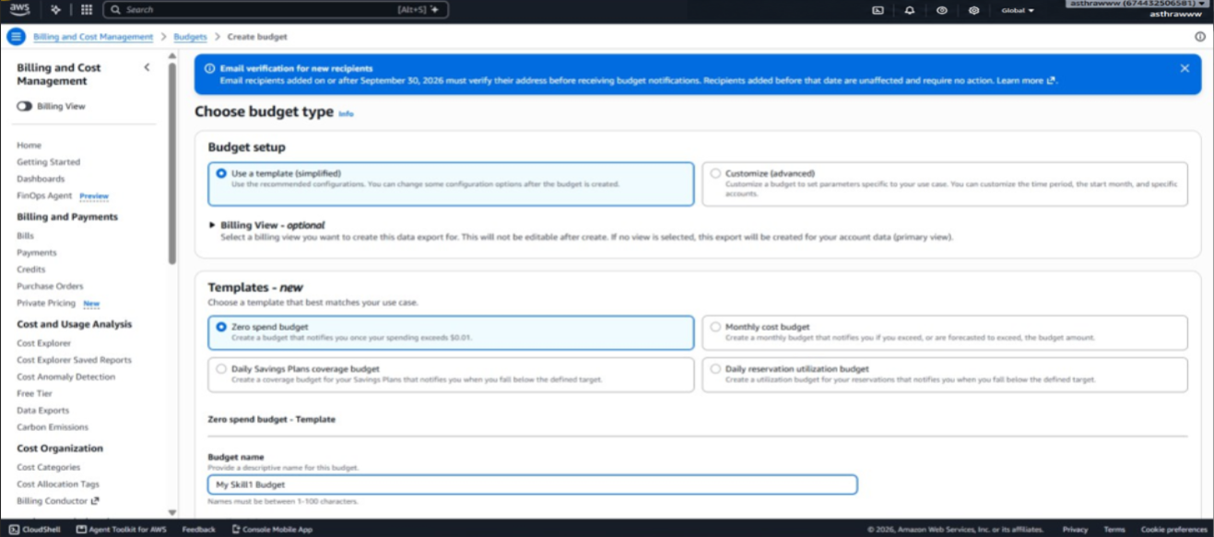

- Verify that the newly created budget appears in the AWS Budgets dashboard.
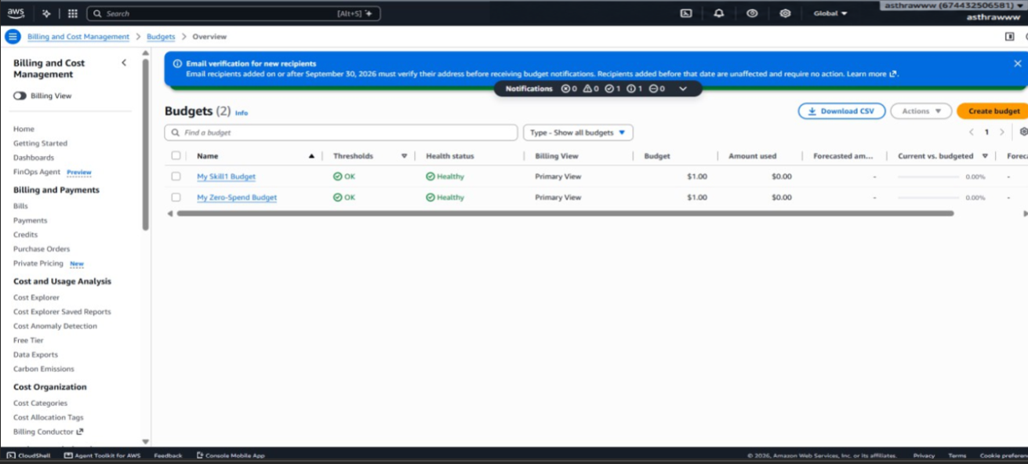0000000
- Check your email for AWS budget notifications when the configured thresholds are reached. Verify your email address if AWS requests confirmation.

Output:


