Traffic Accident Severity Prediction

Problem Id: 20

Student Name : DEVRAJ SINGH RAWAT
University Roll number: 2028707
Section : U

Student Name : ASTIK TRIPATHI
University Roll number: 2028678
Section : U

Student Name : MUKUL SINGH BHANDARI
University Roll number: 2028773
Section : U

- Problem Description:
Road traffic accidents are a major global concern, causing significant loss of life, injuries, and property damage every year. Predicting the severity of accidents is an important task that can help authorities, emergency services, and transportation planners take preventive measures and improve road safety. However, accident severity depends on multiple factors such as vehicle speed, weather conditions, road conditions, and vehicle type, making it difficult to determine the potential impact of an accident using traditional analysis methods.
The aim of the Traffic Accident Severity Prediction system is to use machine learning techniques to analyze historical accident data and predict the severity level of future accidents. By processing and analyzing relevant features from accident datasets, the system can identify patterns and relationships between different factors that contribute to accident outcomes. Data preprocessing is performed to clean the dataset by removing irrelevant or missing records, ensuring better model performance. Feature selection is used to identify the most influential variables affecting accident severity.
Machine learning algorithms such as Logistic Regression and Support Vector Machine (SVM) with different kernels are applied to build predictive models. The performance of these models is evaluated using metrics such as confusion matrix and recall score. This predictive approach can help in improving traffic management, enhancing road safety strategies, and supporting faster emergency response systems.

- Steps of Implementation:

- Collect Data
Use dataset with features like speed, weather, road condition, and vehicle type.
- Preprocess Data
Clean missing values, remove irrelevant records, encode categorical data, and scale features.
- Feature Selection
Keep only high-impact features (e.g., speed, weather).
- Train Models
Apply Logistic Regression and SVM (Linear, Polynomial, RBF kernels).
- Evaluate Models
Use confusion matrix and recall score to compare performance.
- Select Best Model
Choose the model with best evaluation results.
- Generate Output
Predict accident severity and prepare model for deployment.

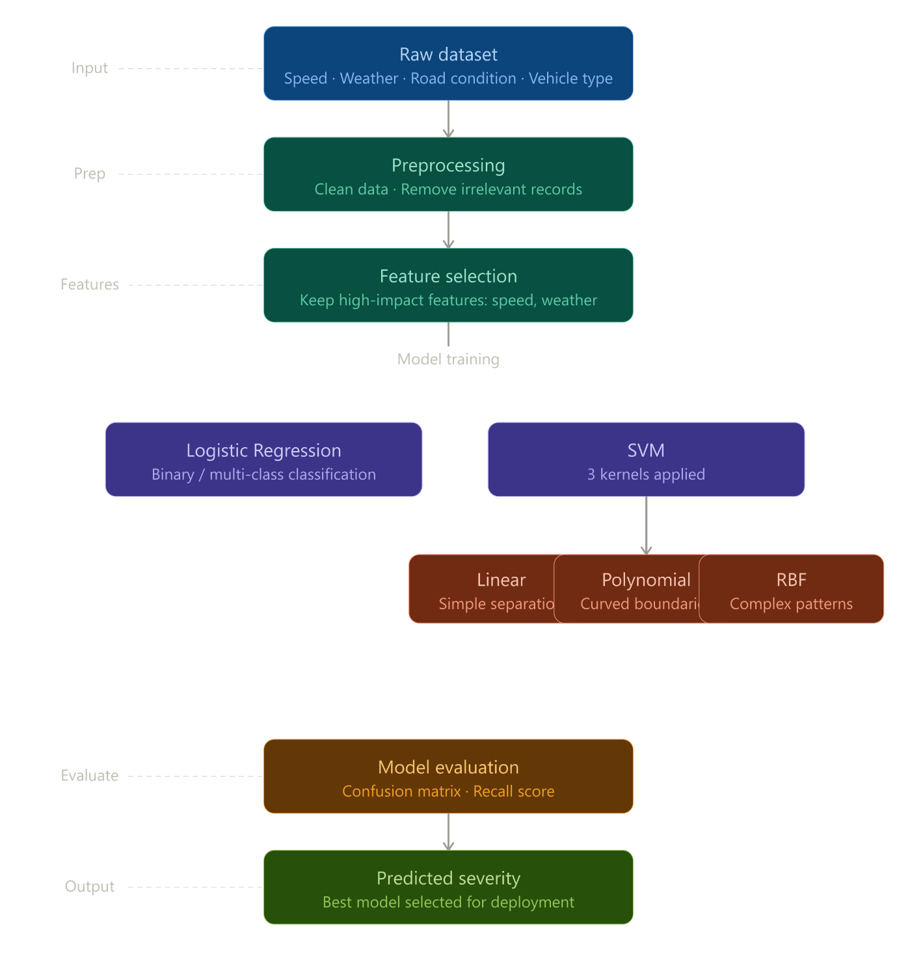

Expected Modules/ Libraries to be used:
1. NumPy (numpy)
NumPy is a library used for numerical computations in Python. It provides support for arrays and matrices, along with mathematical functions to operate on them efficiently. It is widely used for handling large datasets and performing fast calculations.

2. Matplotlib (matplotlib.pyplot)
Matplotlib is a plotting library used to create graphs and charts. The pyplot module allows us to generate visualizations such as line plots, bar charts, and histograms. It helps in understanding data through visual representation.

3. Seaborn (seaborn)
Seaborn is a data visualization library built on top of Matplotlib. It provides more attractive and informative statistical graphics. It is commonly used for plotting heatmaps, distribution plots, and relationships between variables.

4. LabelEncoder (sklearn.preprocessing.LabelEncoder)
LabelEncoder is used to convert categorical data (text values) into numerical form. Machine learning models cannot work with text directly, so this tool assigns a unique number to each category.

5. StandardScaler (sklearn.preprocessing.StandardScaler)
StandardScaler is used to scale numerical data so that it has a mean of 0 and a standard deviation of 1. This process is called standardization and is important for improving the performance of many machine learning algorithms.

- Expected Evaluation metrics and Plots to be used:
  - Class Distribution Plot
A count plot (bar graph) of accident severity is used to visualize imbalance in the dataset.
  - Feature Distribution Plots
Bar charts or histograms are used to understand how key features (such as weather conditions, road type, and driver attributes) are distributed.

- Required topics from the subject:
1.strings
Strings are used to handle textual data such as weather condition, road condition, and vehicle type in the dataset. These values are initially stored as strings and later converted into numerical form during preprocessing so that machine learning algorithms can process them.

2.Files
File handling is used to store and retrieve data from external files such as CSV datasets. In this project, file operations are used to read the accident dataset and load it into the program for preprocessing, training, and prediction.

- Platform Required:
Jupyter Notebook
Jupyter Notebook will be used for implementing the machine learning model because it allows writing code, visualizing results, and documenting the workflow in an interactive environment.

VS Code
Visual Studio Code (VS Code) is a lightweight and powerful source code editor developed by Microsoft. It is used for writing, editing, and debugging code in various programming languages.

GitHub
GitHub is an online platform used for storing, managing, and sharing code using version control (Git). It allows developers to collaborate on projects from anywhere.

- Books and Link Sources:
1.“NumPy Beginner’s Guide” – Ivan Idris
2.“Seaborn Statistical Data Visualization” – examples by Michael Waskom
3. Official Documentation of Python Libraries (NumPy, Pandas):
https://numpy.org/doc/
https://pandas.pydata.org/docs/
4.Preprocessing Guide (LabelEncoder, StandardScaler):
https://scikit-learn.org/stable/modules/preprocessing.html

