MOSAIC-ML
Evidence of Implementation and Results
Android Vulnerability and Intrusion Risk Analysis — Astik Sarkar
Every picture in this document is either a screenshot of the running system or notebook, or a graph generated by the project’s own scripts from executed results. No value was typed in by hand. The numbers behind each graph are saved as CSV/JSON in reports/results/ of the project folder.
Environment: Python 3.10, scikit-learn 1.6.1, NumPy 1.26.4, SciPy 1.15.3. Training record generated 2026-10-24T00:53:15Z.
Contents: 1. Model training (notebook) · 2. Model results · 3. Graphs · 4. Frontend dashboard · 5. Backend API · 6. Database · 7. Automated tests · 8. Not verified

1. Model Training — Notebook Run
The notebook notebooks/MOSAIC_ML_Model_Training.ipynb was executed end to end (951 seconds). It loads MH-100K, checks the matrix is not corrupted, removes duplicates, splits the data, trains all nine configurations of the three models, evaluates the selected model once on the test split, draws the graphs, and finally compares its numbers with the shipped results.
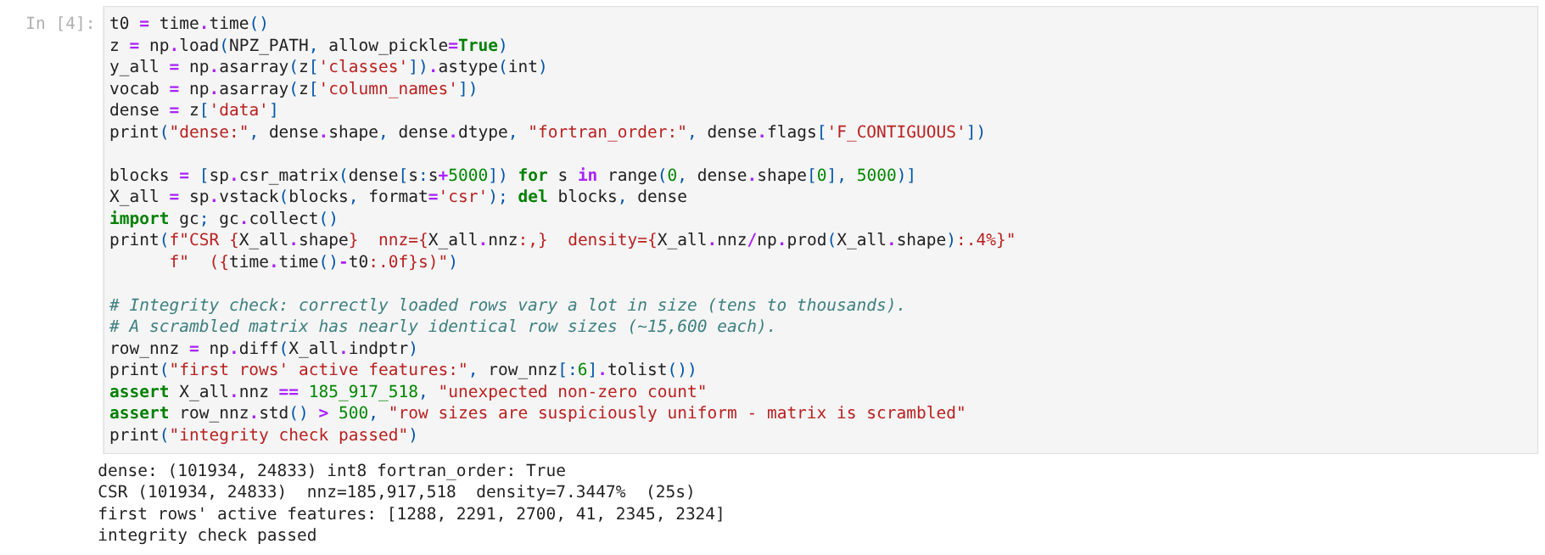
Evidence 1. Dataset loaded: 101,934 apps × 24,833 features. The integrity check confirms rows are not scrambled (first rows have 1,288, 2,291, 2,700 and 41 active features).
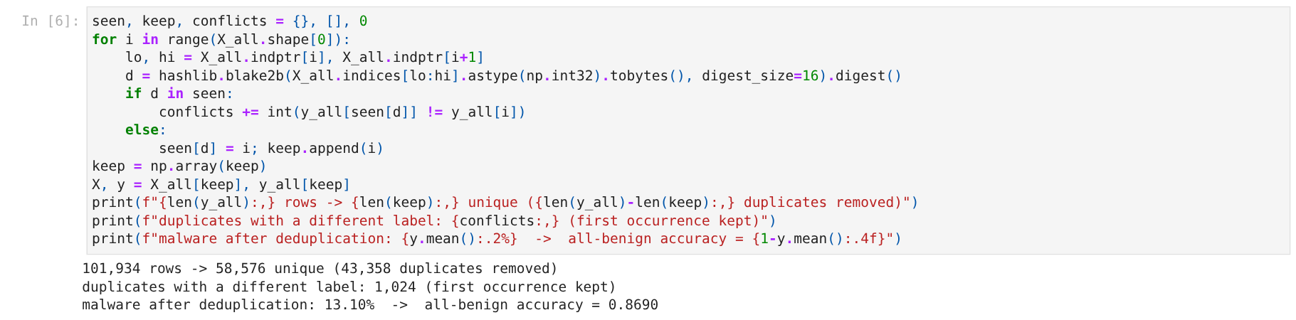
Evidence 2. Deduplication: 43,358 duplicate rows removed, 58,576 unique apps kept; malware becomes 13.10%, so an all-“benign” guess would score 0.8690 accuracy.
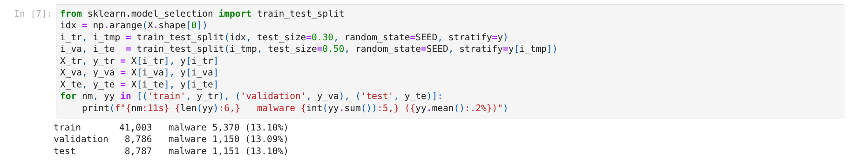
Evidence 3. Stratified 70/15/15 split with seed 42: train 41,003, validation 8,786, test 8,787.
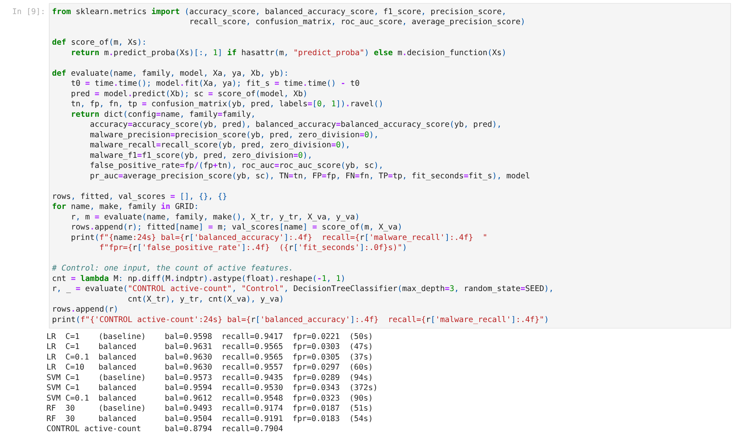
Evidence 4. All nine configurations trained and scored on the validation split, plus the count-only control.
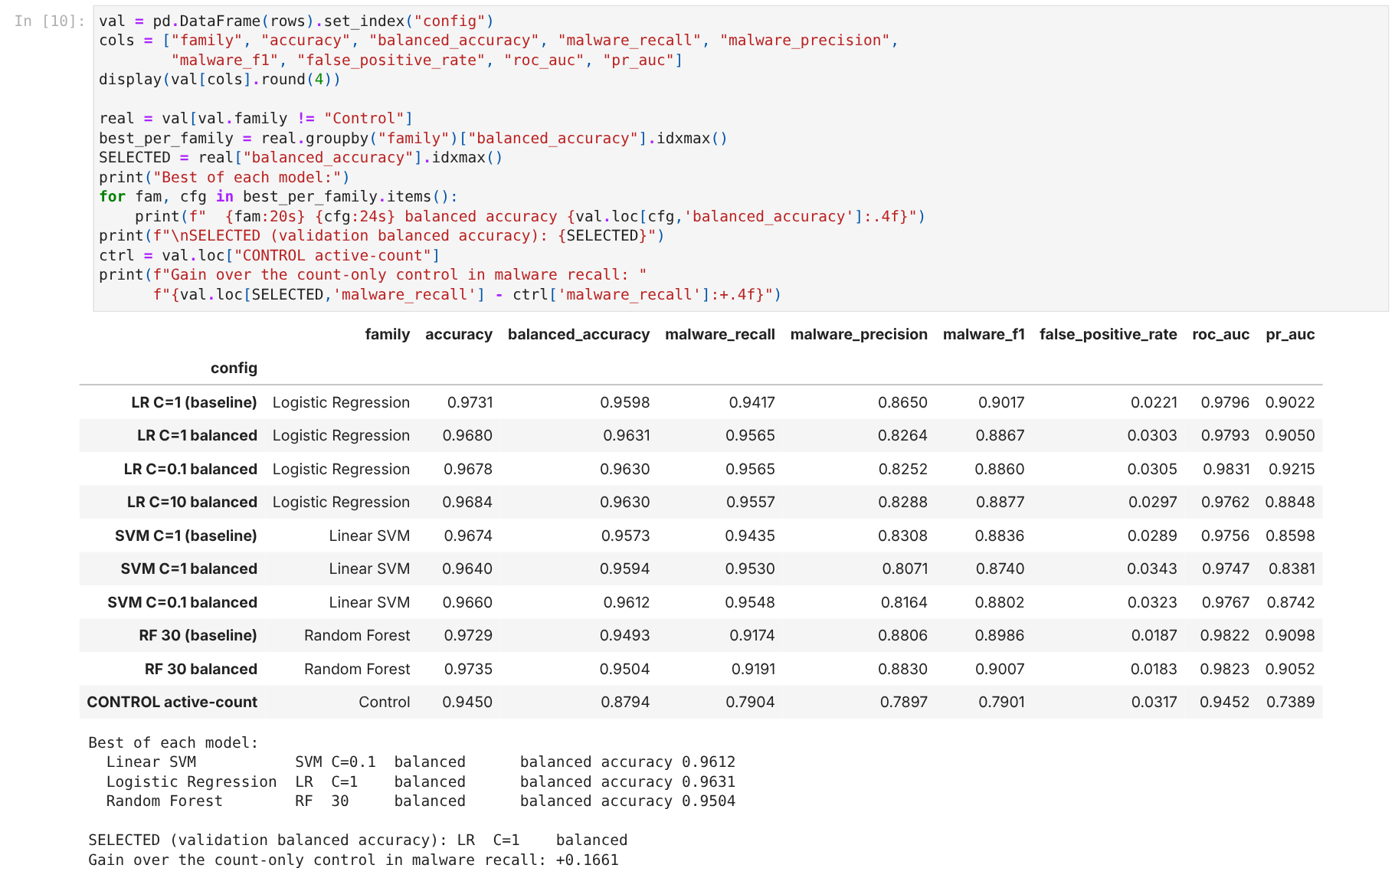
Evidence 5. Full validation results table and the selection: class-weighted Logistic Regression (balanced accuracy 0.9631).
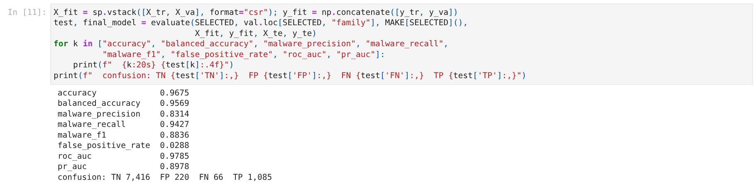
Evidence 6. The selected model refitted on train + validation and evaluated once on the test split.
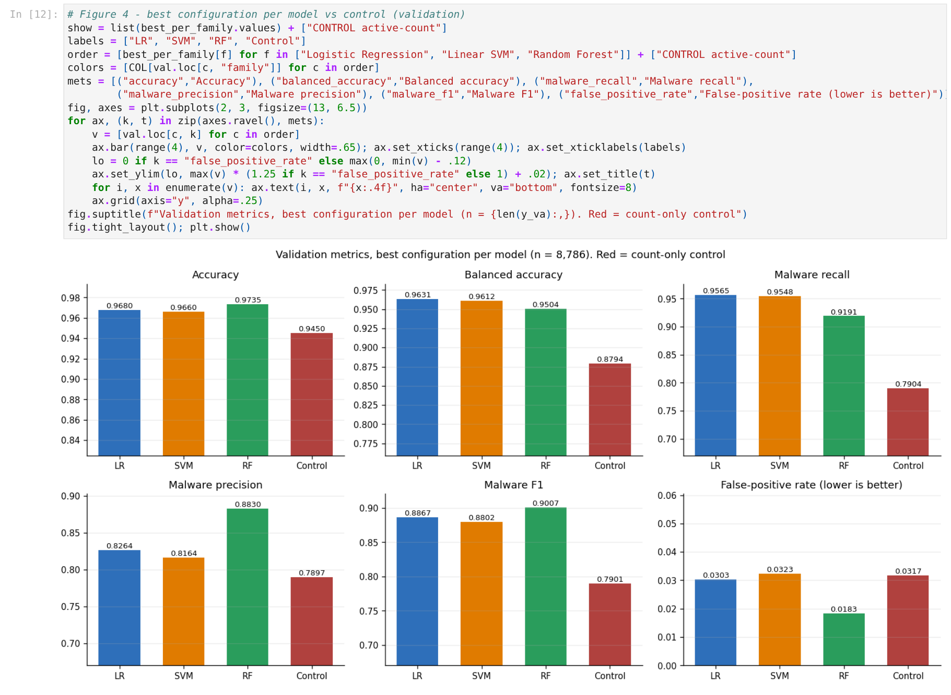
Evidence 7. Notebook graph: six metrics for the best configuration of each model and the control.
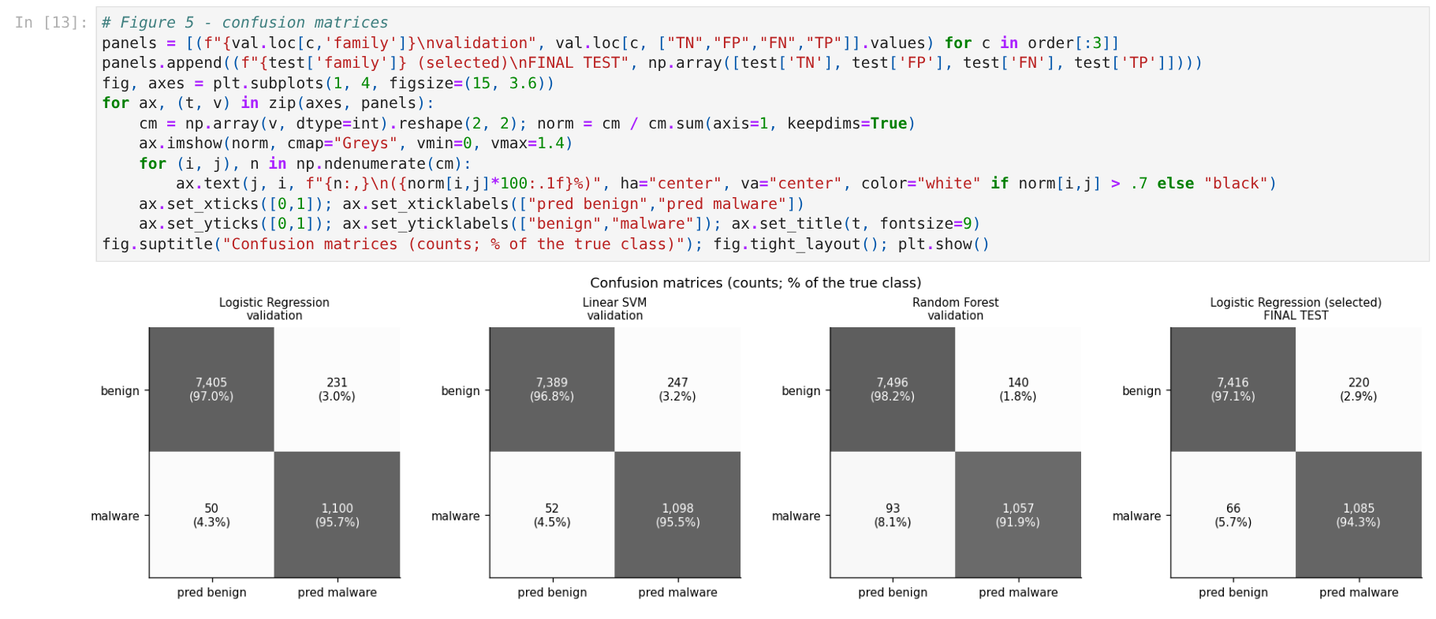
Evidence 8. Notebook graph: confusion matrices (validation for each model, final test for the selected one).
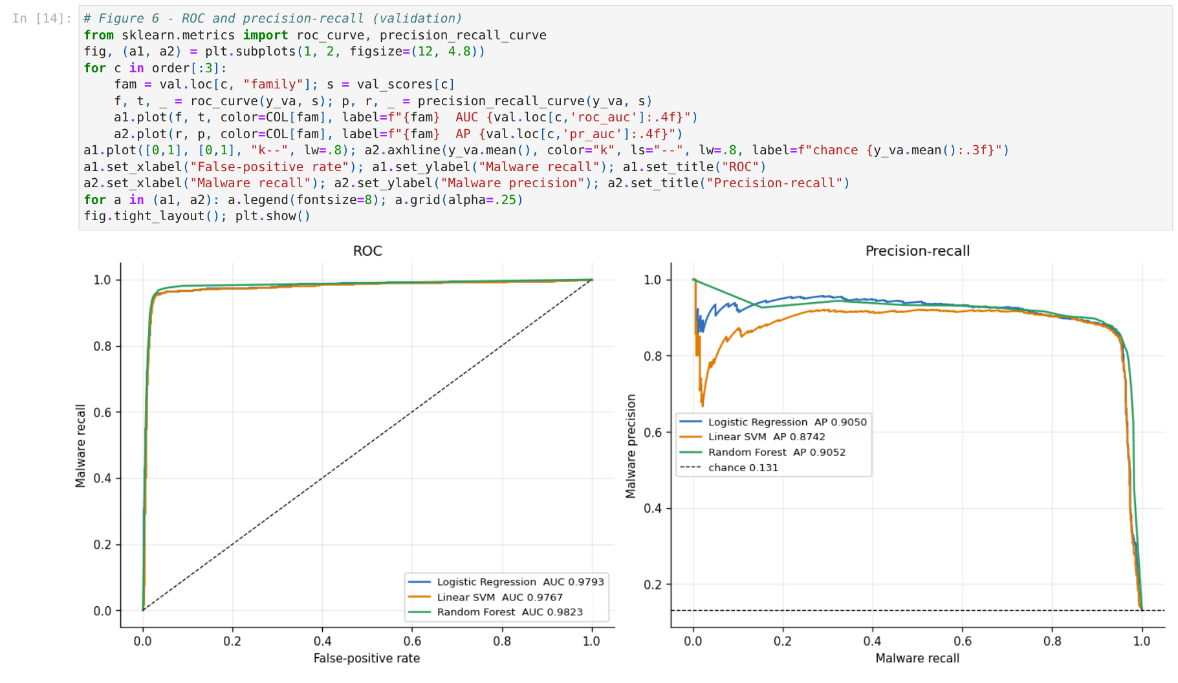
Evidence 9. Notebook graph: ROC and precision-recall curves.
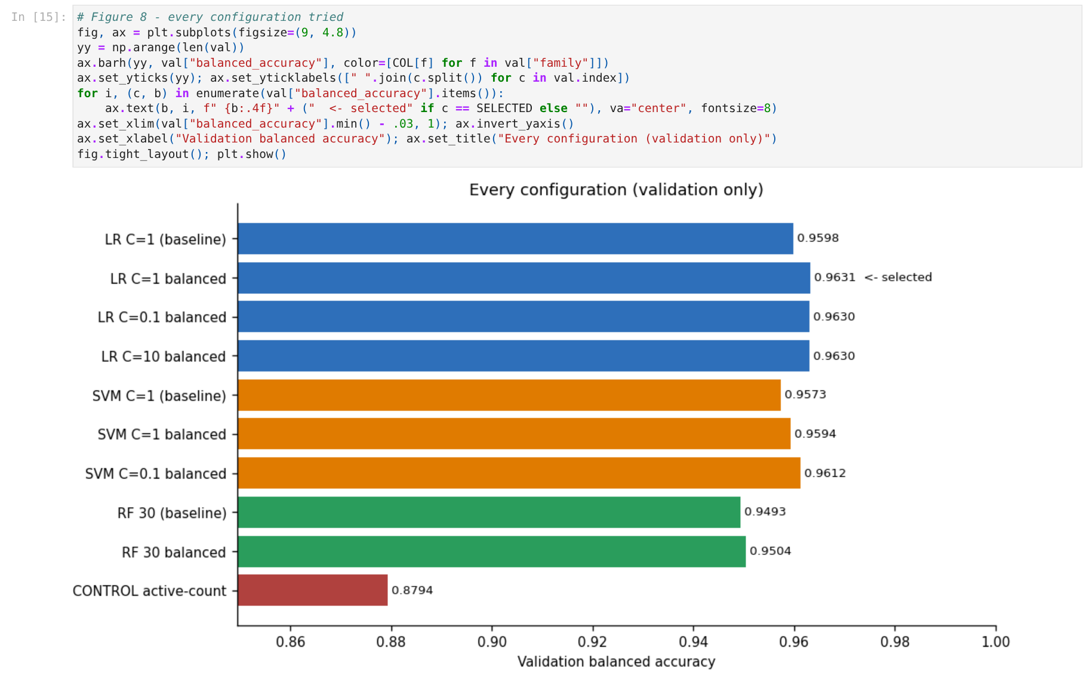
Evidence 10. Notebook graph: balanced accuracy of every configuration tried.
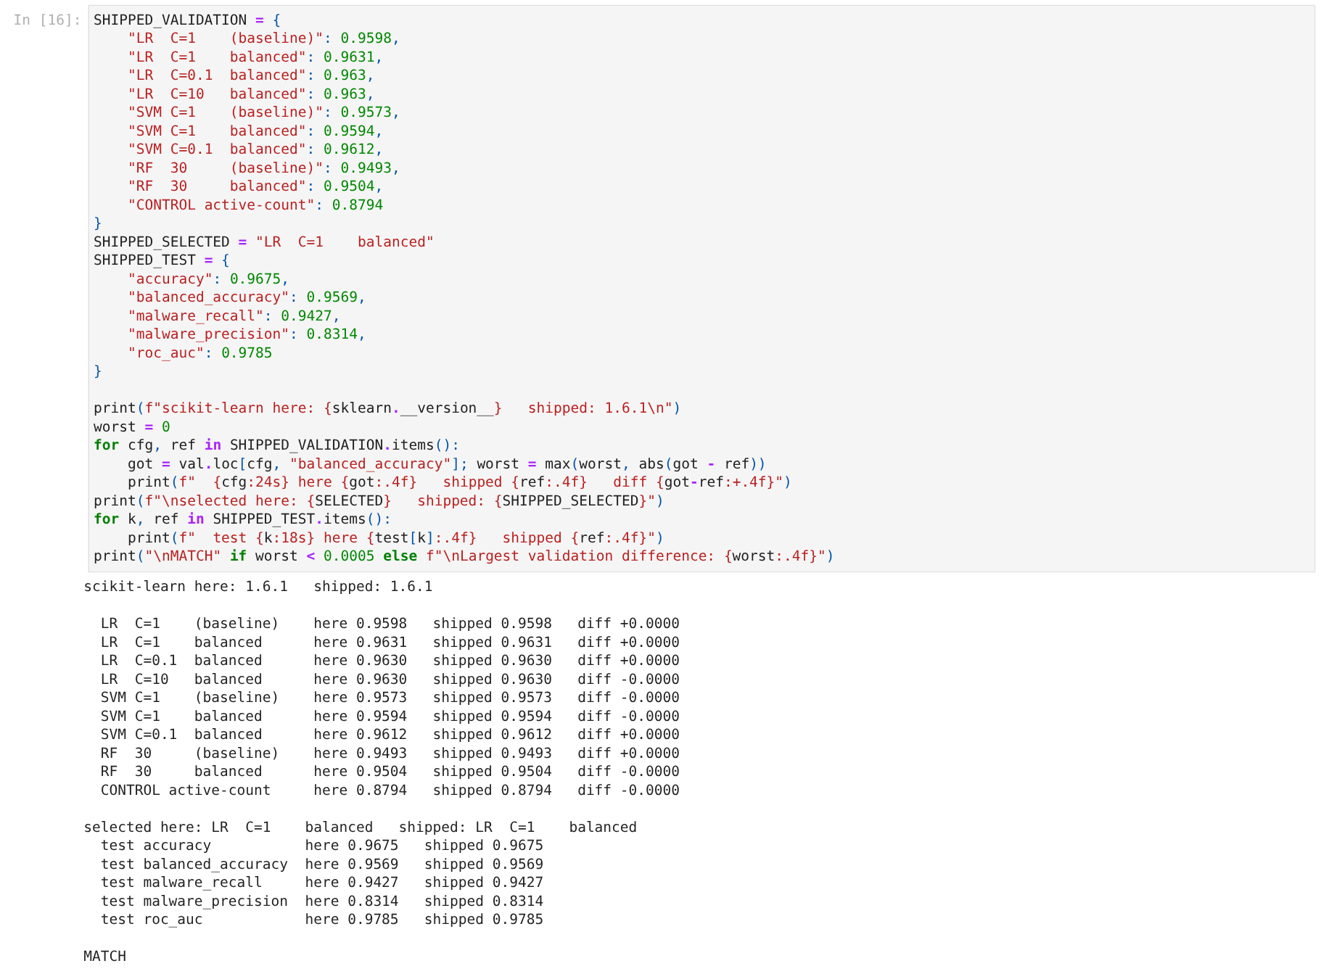
Evidence 11. Reproducibility check: every value from the notebook equals the value shipped with the project — the notebook prints MATCH.

2. Model Results

2.1 All nine configurations (validation split, n = 8,786)
Configuration | Accuracy | Balanced acc. | Malware recall | Malware F1 | False-pos. rate
LR C=1 (baseline) | 0.9731 | 0.9598 | 0.9417 | 0.9017 | 0.0221
LR C=1 balanced | 0.9680 | 0.9631 | 0.9565 | 0.8867 | 0.0303
LR C=0.1 balanced | 0.9678 | 0.9630 | 0.9565 | 0.8860 | 0.0305
LR C=10 balanced | 0.9684 | 0.9630 | 0.9557 | 0.8877 | 0.0297
SVM C=1 (baseline) | 0.9674 | 0.9573 | 0.9435 | 0.8836 | 0.0289
SVM C=1 balanced | 0.9640 | 0.9594 | 0.9530 | 0.8740 | 0.0343
SVM C=0.1 balanced | 0.9660 | 0.9612 | 0.9548 | 0.8802 | 0.0323
RF 30 (baseline) | 0.9729 | 0.9493 | 0.9174 | 0.8986 | 0.0187
RF 30 balanced | 0.9735 | 0.9504 | 0.9191 | 0.9007 | 0.0183
CONTROL active-count | 0.9450 | 0.8794 | 0.7904 | 0.7901 | 0.0317
Highlighted row: the selected configuration. Source: reports/results/model_evaluation.json.

2.2 Final test result (evaluated once)
Metric | LR C=1 balanced on test (n = 8,787)
Accuracy | 0.9675
Balanced accuracy | 0.9569
Malware precision | 0.8314
Malware recall | 0.9427
Malware F1 | 0.8836
False-positive rate | 0.0288
ROC-AUC | 0.9785
PR-AUC | 0.8978
Confusion matrix | TN 7,416 · FP 220 · FN 66 · TP 1,085
The test split was not used to choose anything in this run; it was evaluated once after selection.

3. Graphs
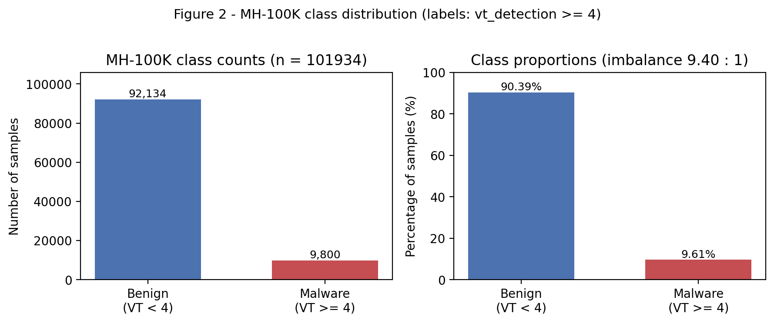
Evidence 12. Class distribution of the raw dataset (labels: vt_detection ≥ 4).
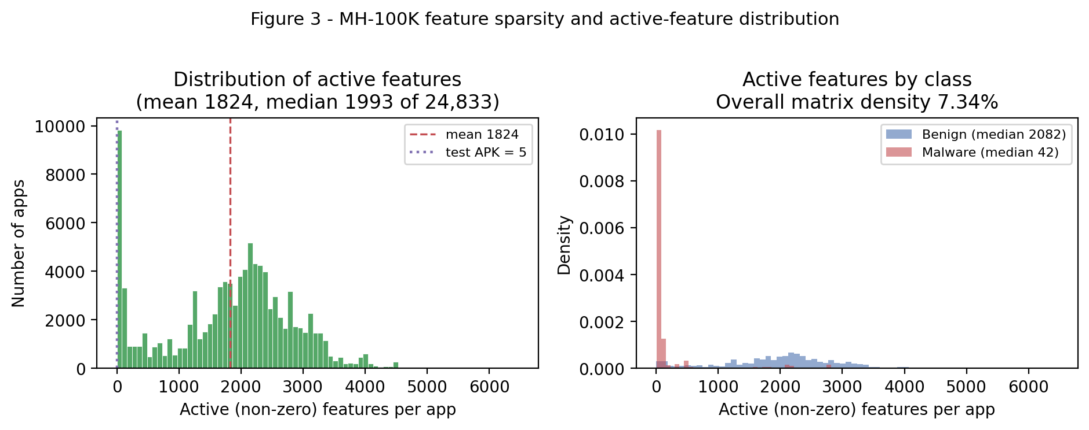
Evidence 13. Active features per app. Malware median 42 vs benign 2,082 — the shortcut the control model exploits.
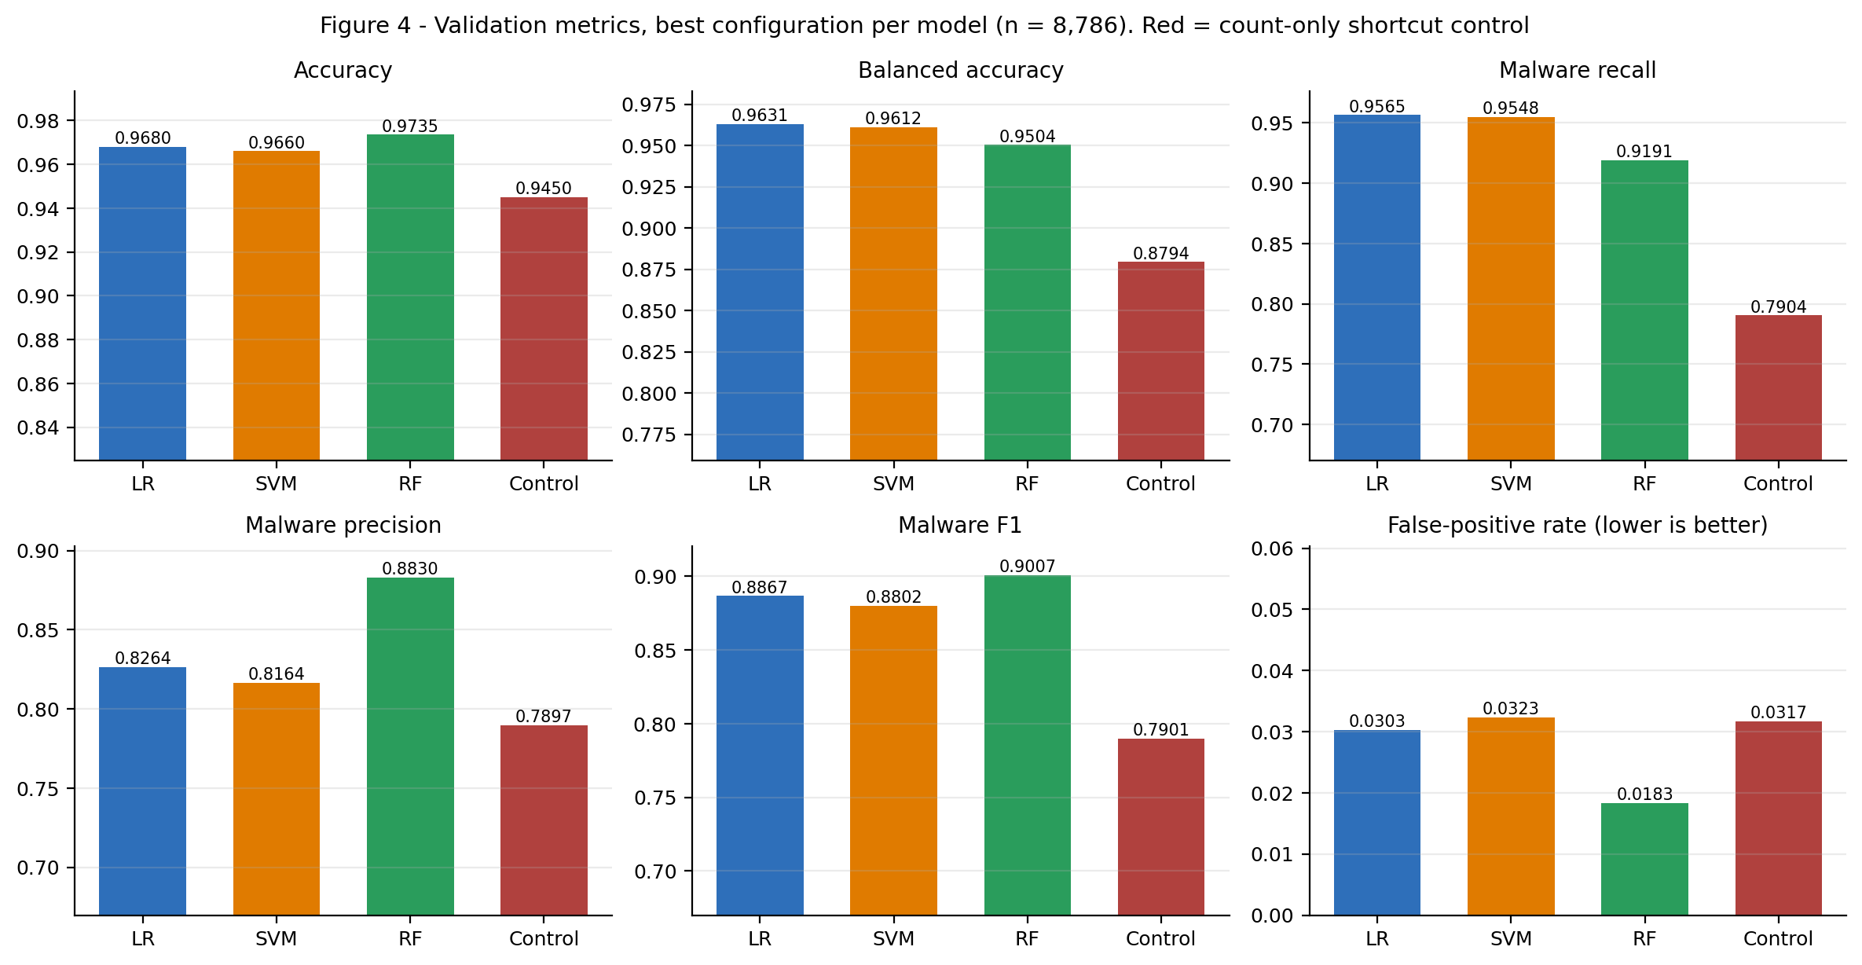
Evidence 14. Validation metrics, best configuration of each model, with the count-only control in red.
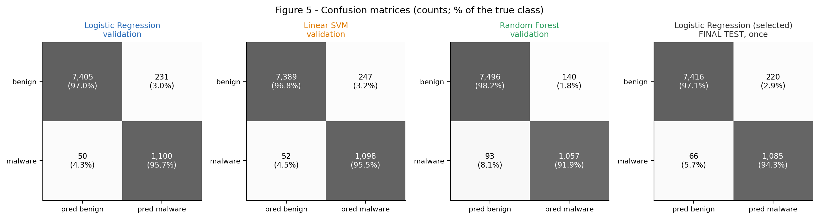
Evidence 15. Confusion matrices: validation for each model, and the final test result.
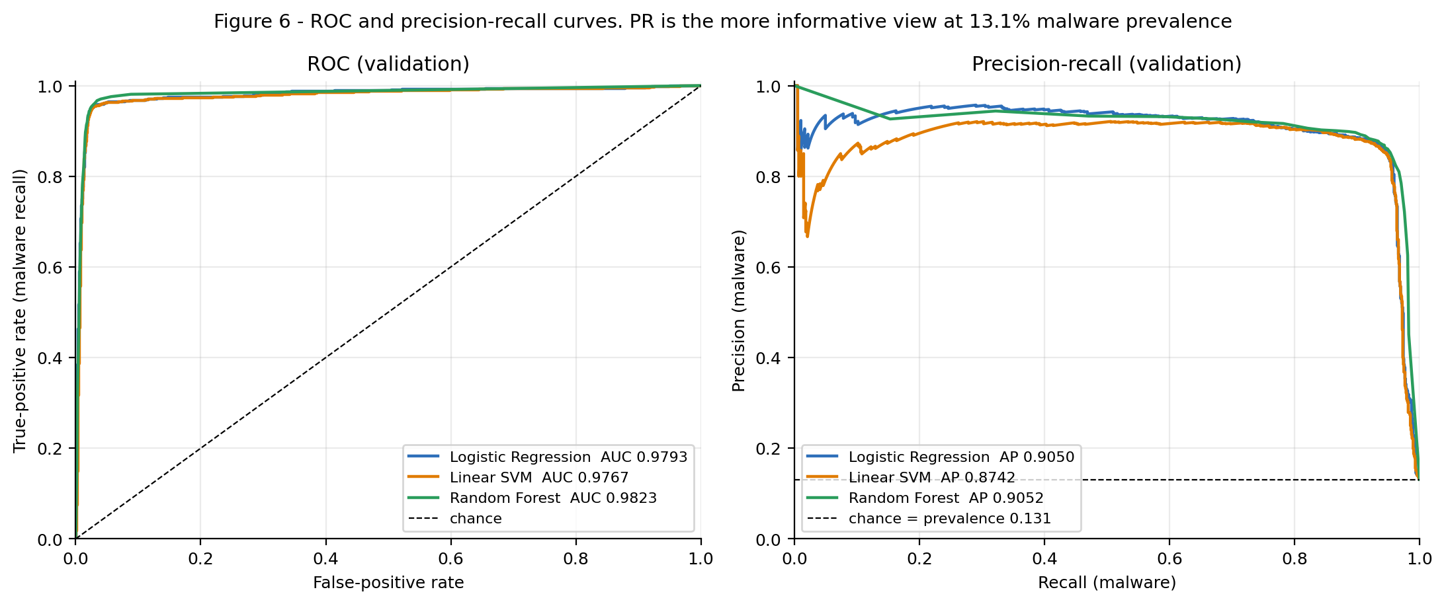
Evidence 16. ROC and precision-recall curves on validation.
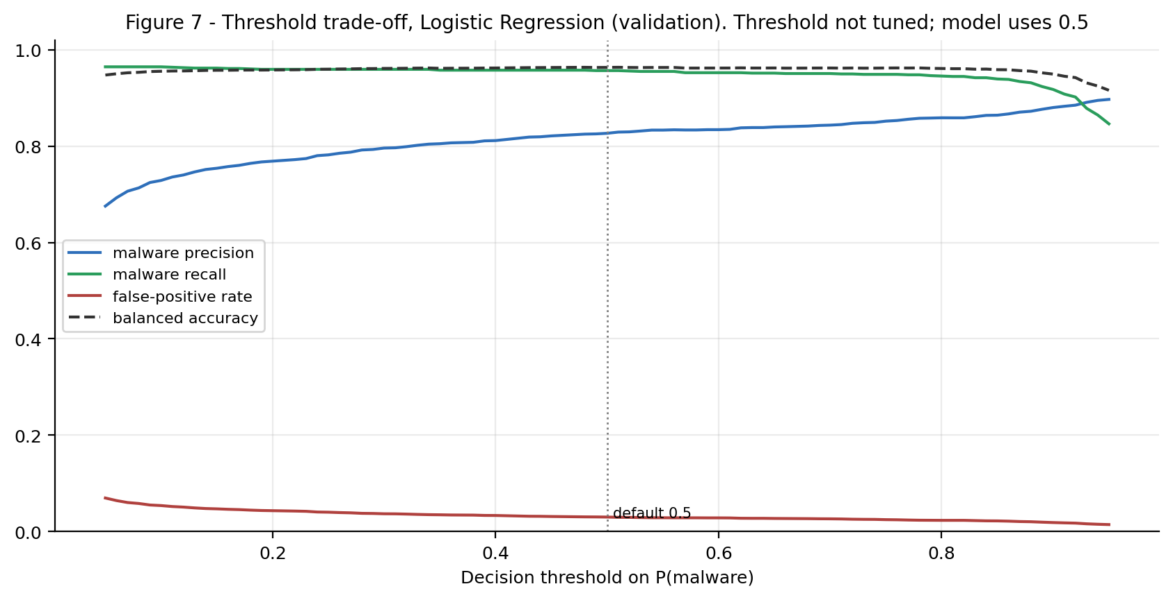
Evidence 17. Precision, recall, false-positive rate and balanced accuracy across decision thresholds (selected model).
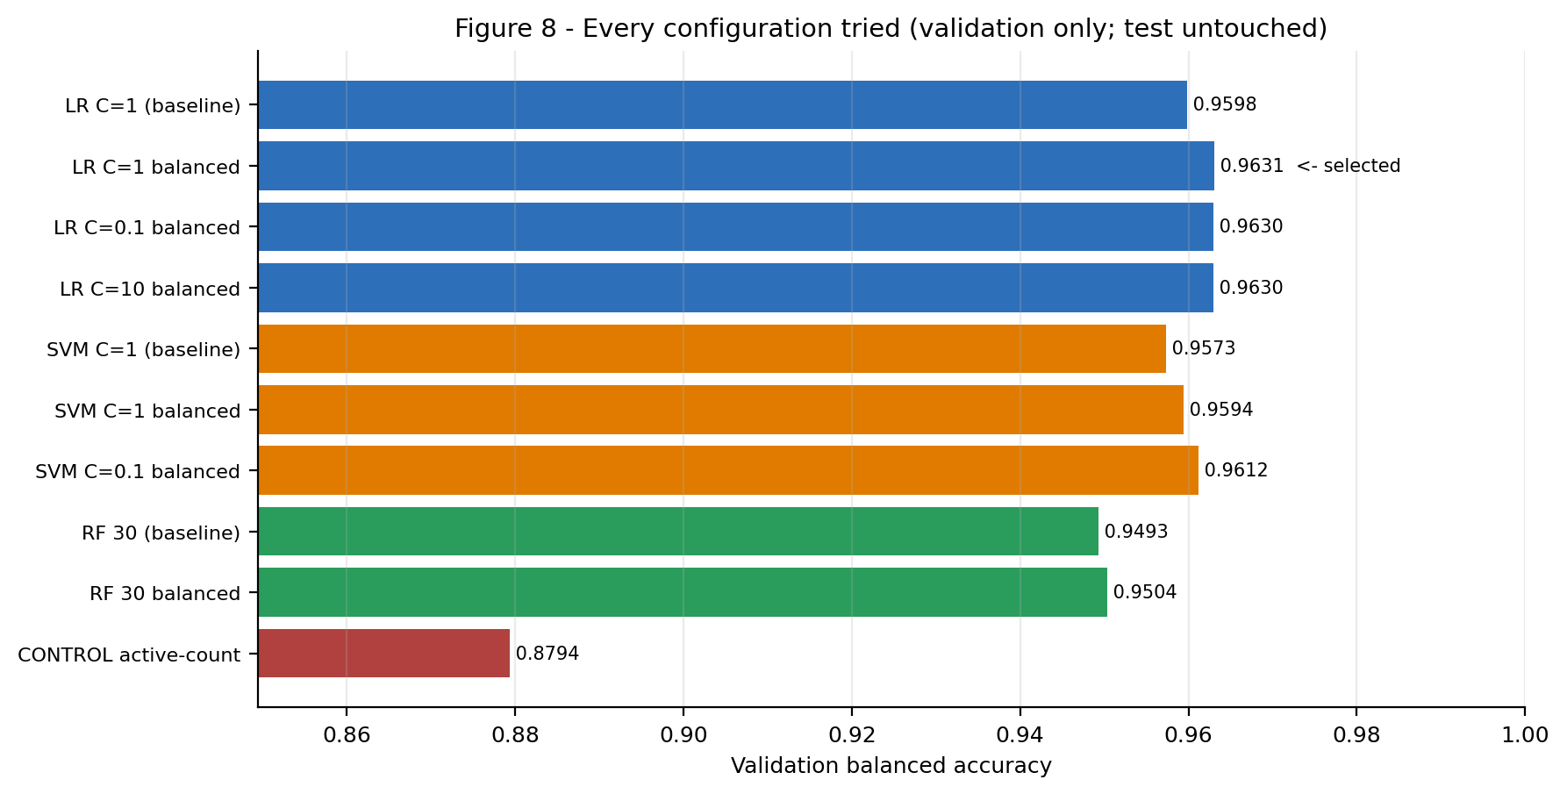
Evidence 18. Every configuration tried, validation balanced accuracy.
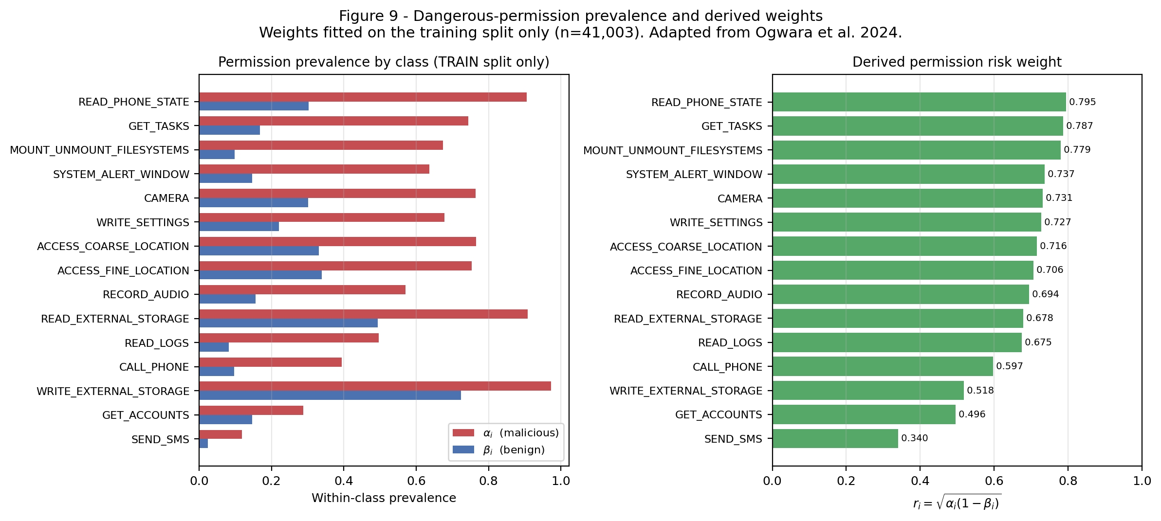
Evidence 19. Permission risk weights r = √(α(1−β)), fitted on the training split only.
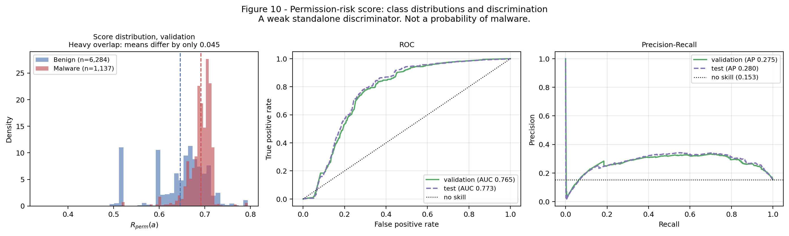
Evidence 20. Permission risk score evaluation (ROC-AUC 0.7734, PR-AUC 0.2804 on test).
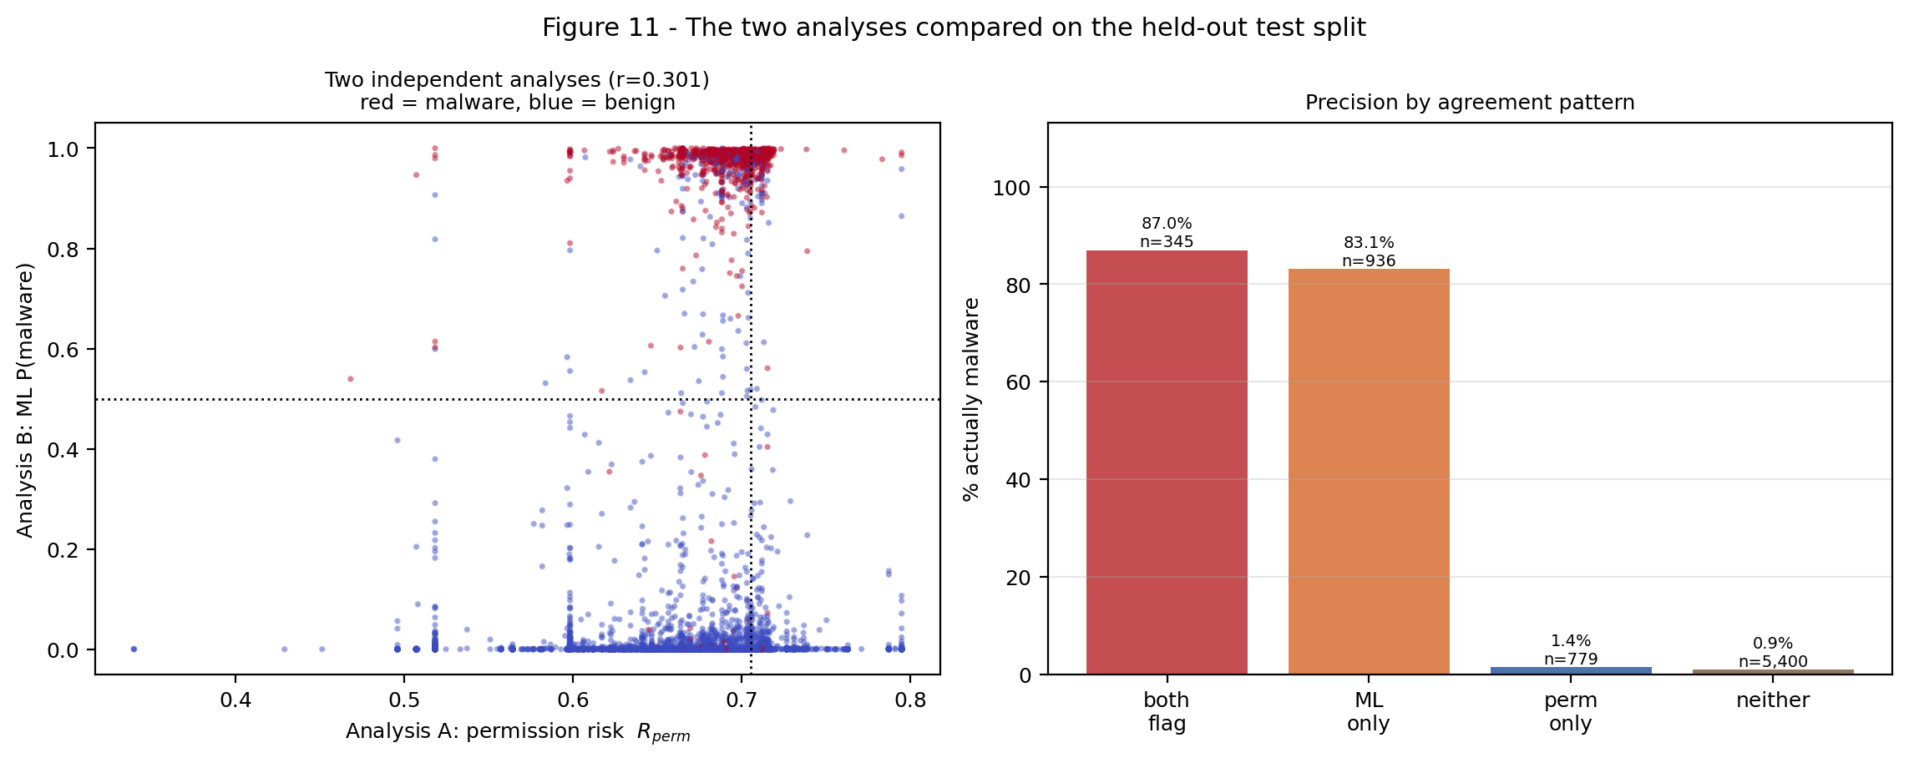
Evidence 21. Permission score vs ML model on the test split: correlation 0.30; precision by agreement pattern.
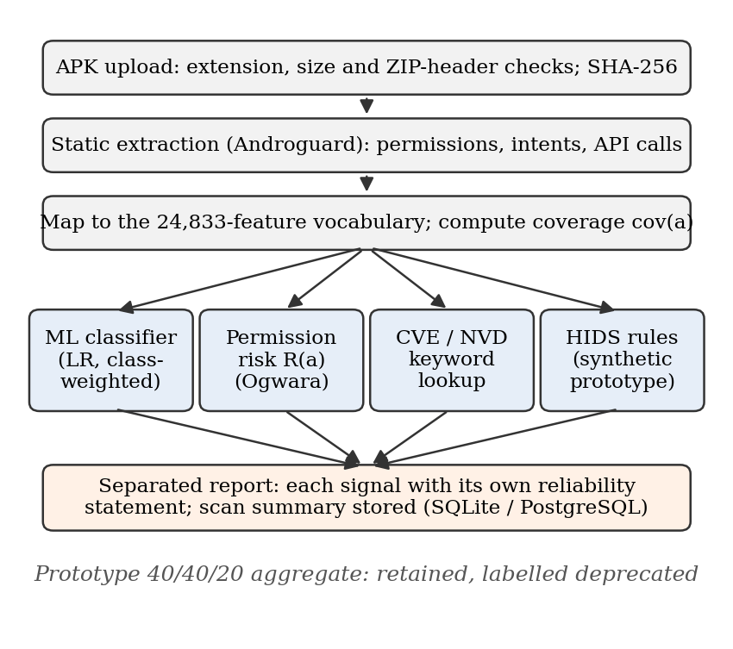
Evidence 22. System pipeline (Fig. 1 of the paper).

4. Frontend Dashboard
Screenshots of the React dashboard served by the backend at http://127.0.0.1:7860, taken from a fresh unzip of the final package. A real APK from test_apks/ was analysed.
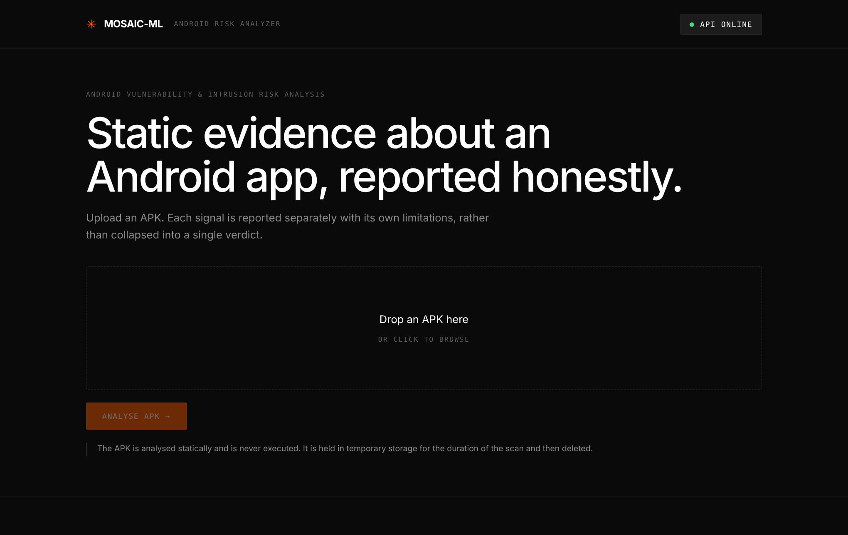
Evidence 23. Home screen. The header shows API ONLINE, confirming the frontend is connected to the backend.
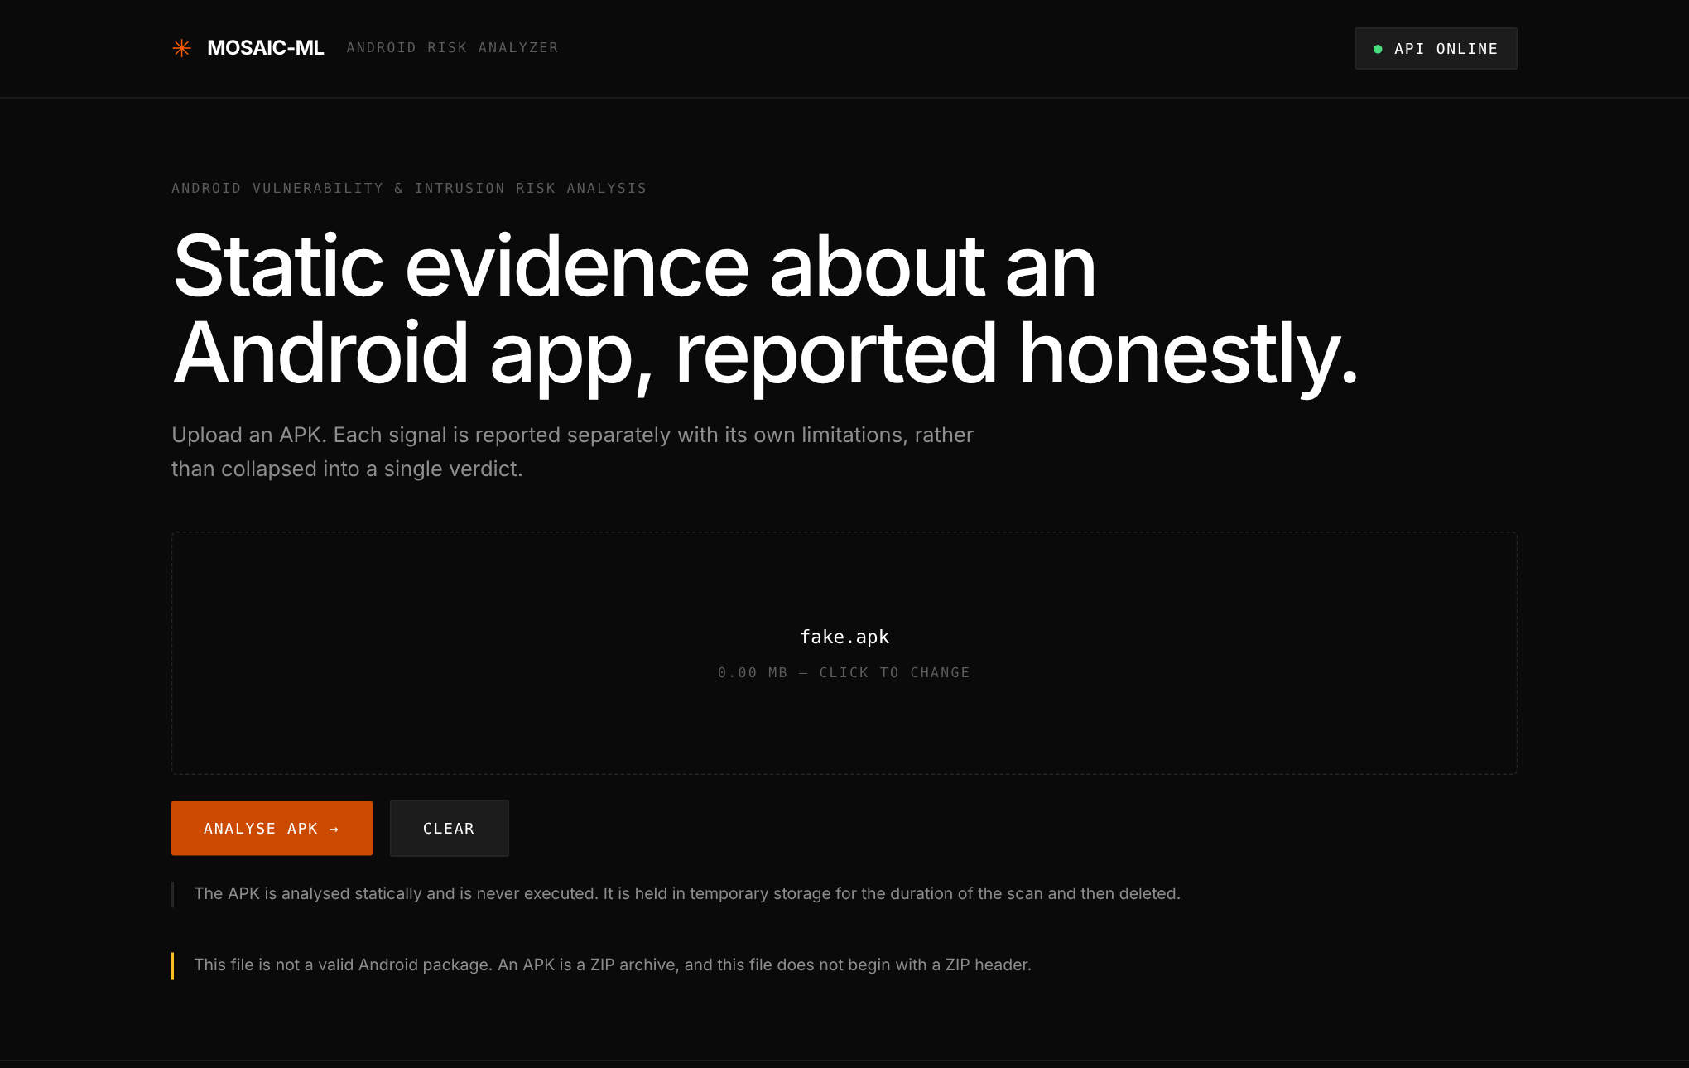
Evidence 24. Input validation: a text file renamed to .apk is rejected because it has no ZIP header.
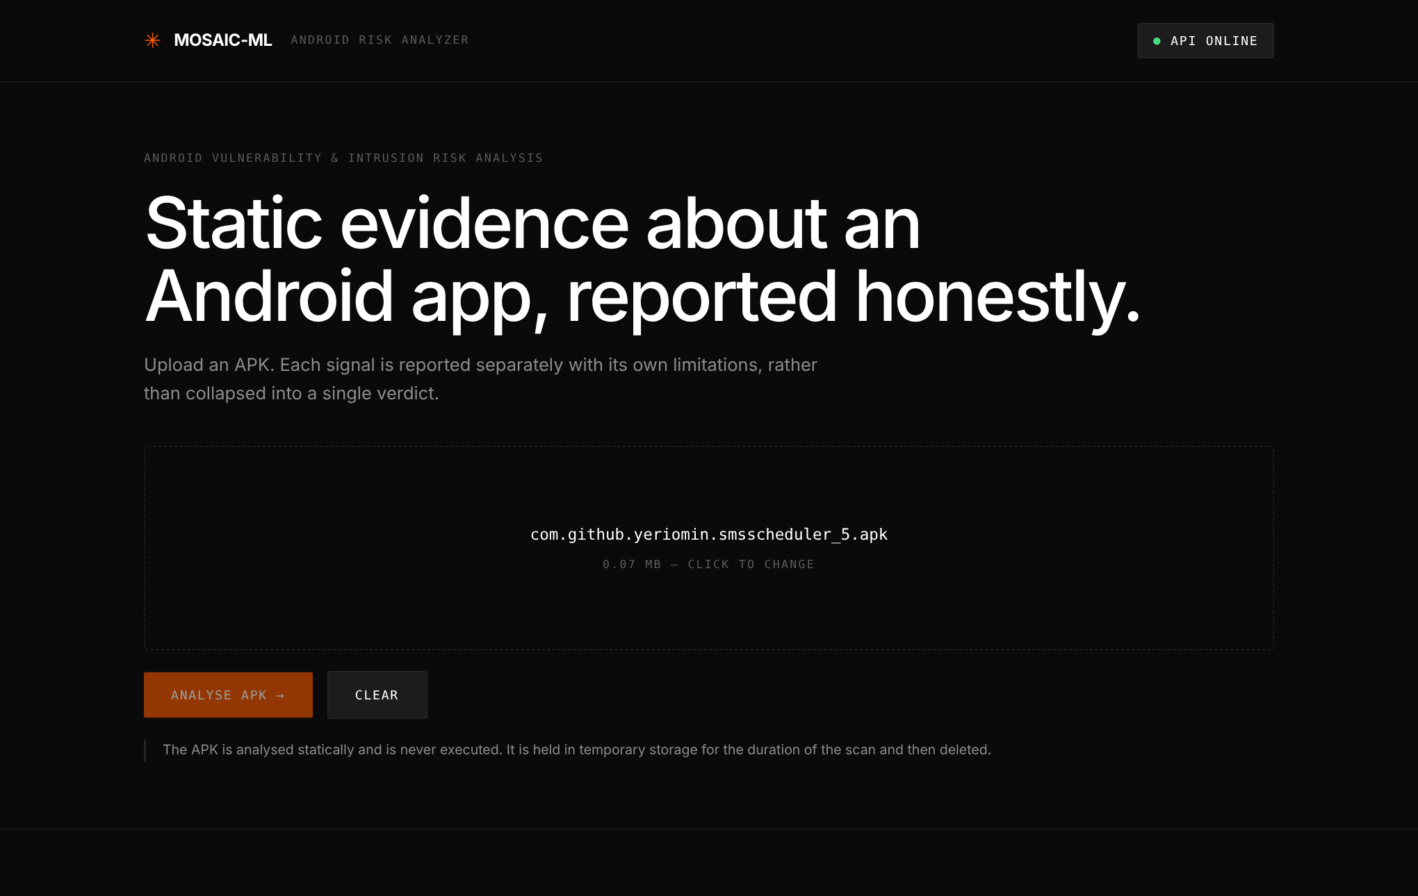
Evidence 25. A real APK selected for analysis.
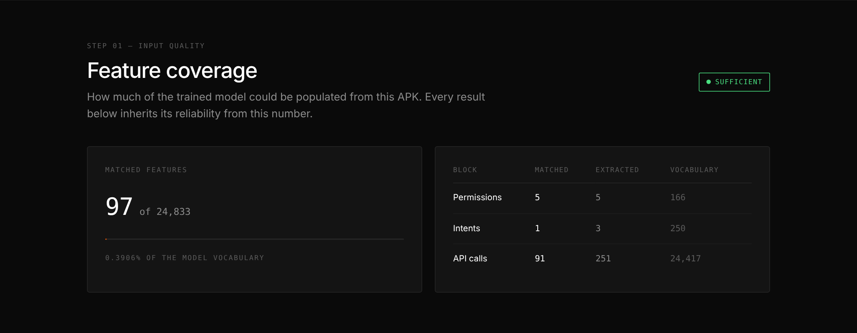
Evidence 26. Step 01 — feature coverage: 97 of 24,833 features matched (5 permissions, 1 intent, 91 API calls).
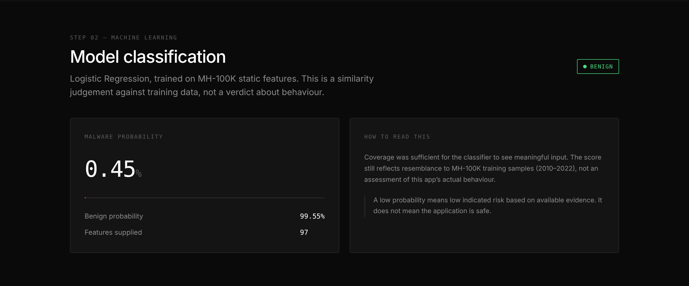
Evidence 27. Step 02 — ML classification by the loaded model (Logistic Regression): BENIGN, malware probability 0.45%.
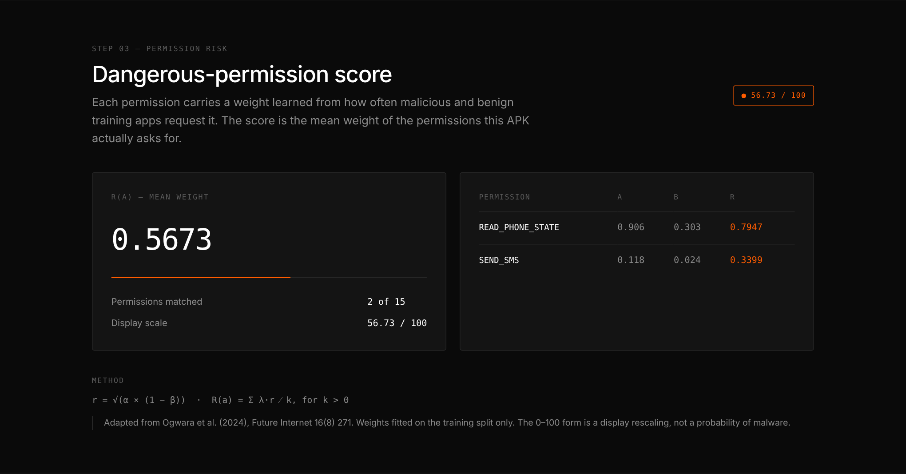
Evidence 28. Step 03 — permission risk score with the matched permissions and their weights.
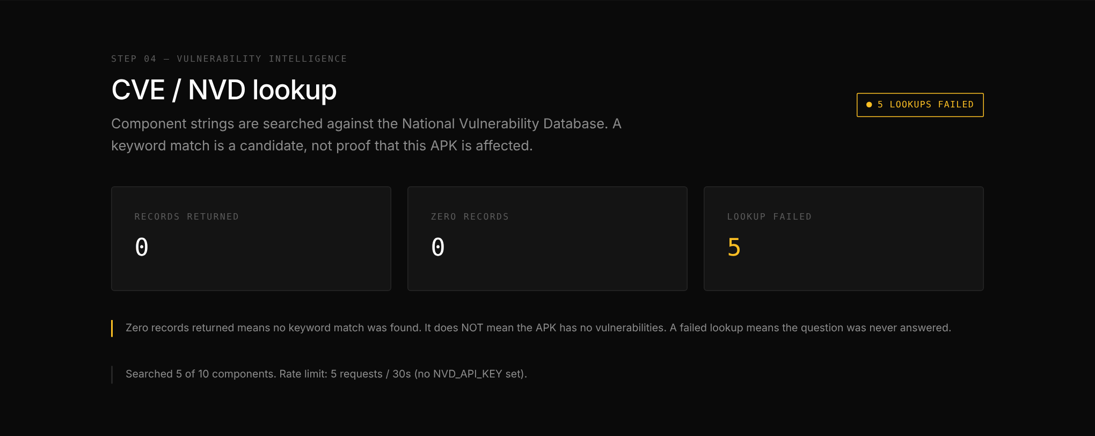
Evidence 29. Step 04 — CVE/NVD lookup. Lookups report FAILED here because the test environment had no internet access; the failure is reported honestly instead of as “0 vulnerabilities”.
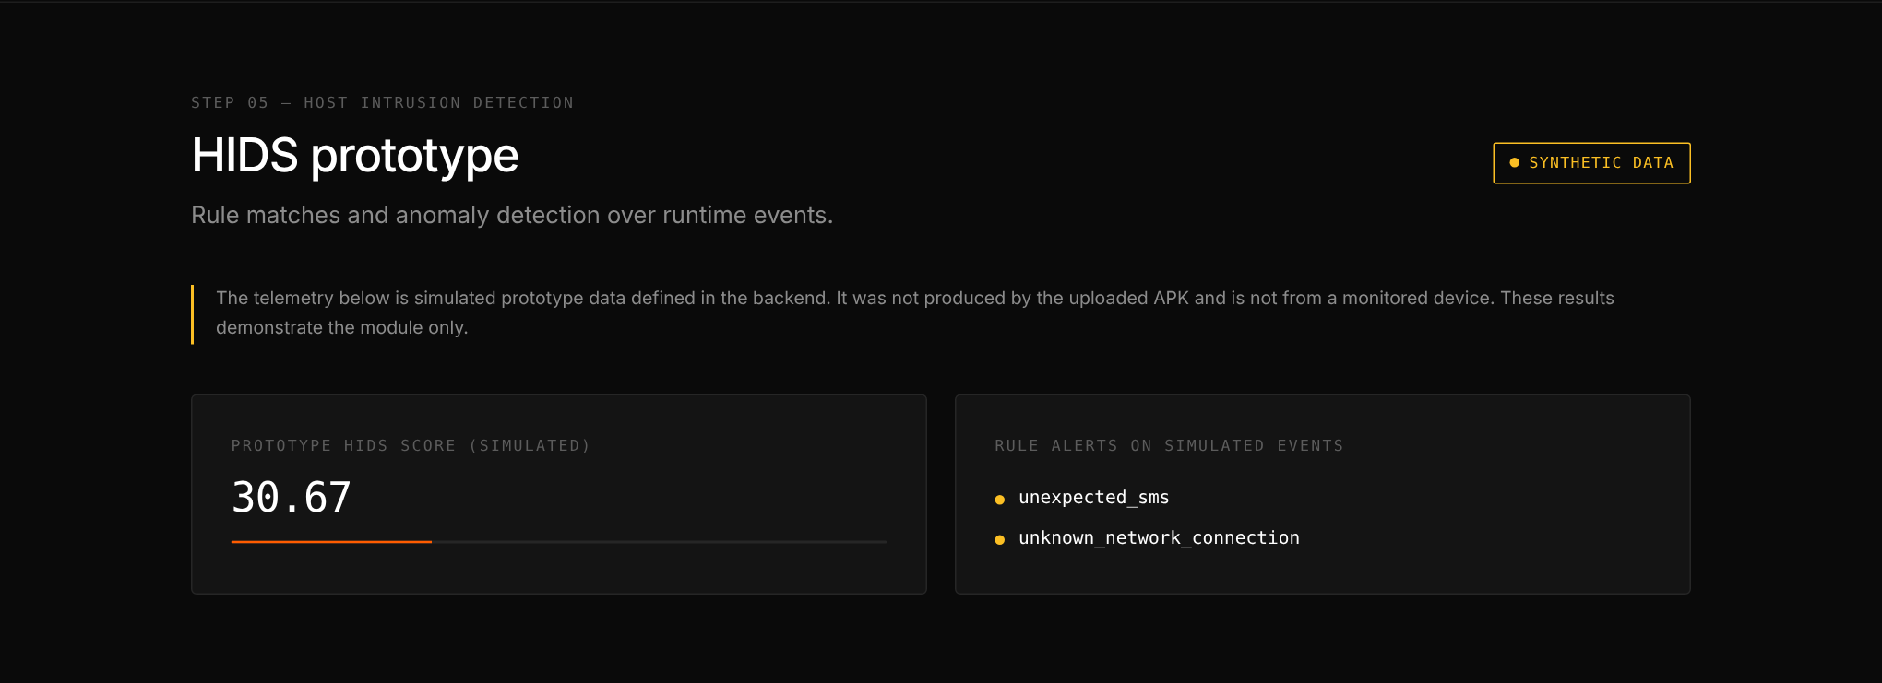
Evidence 30. Step 05 — HIDS prototype, clearly labelled as synthetic data.
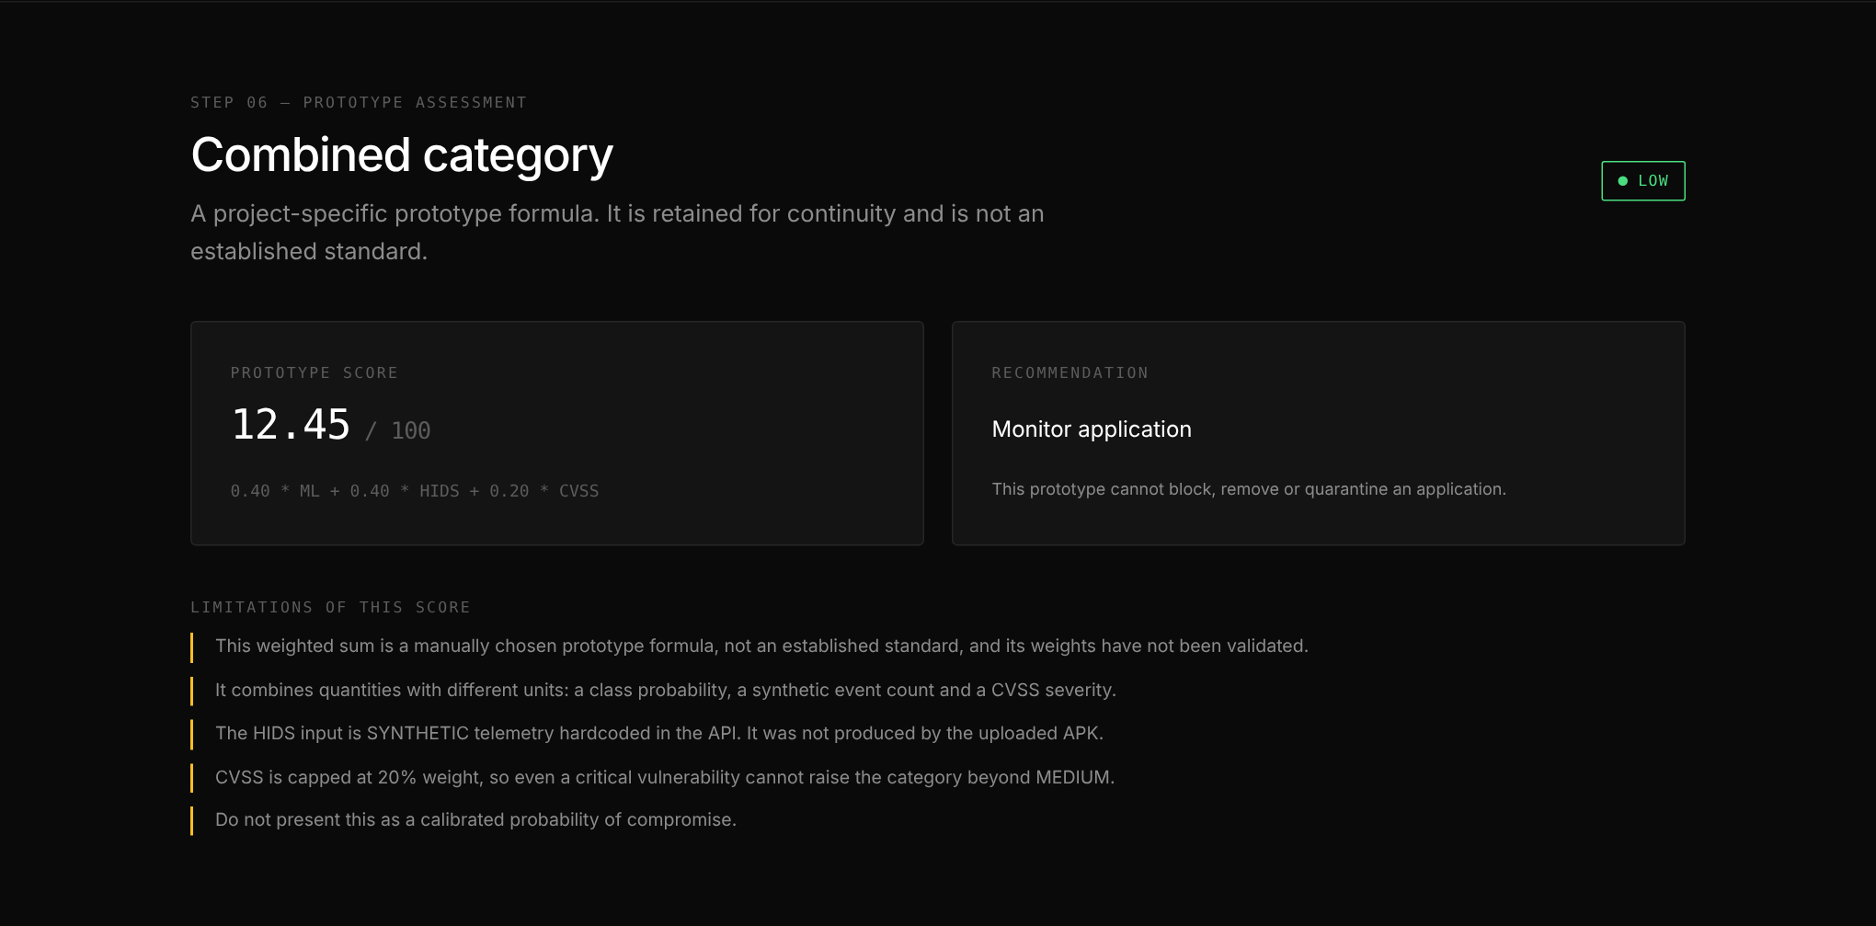
Evidence 31. Step 06 — prototype combined assessment, with its limitations listed.
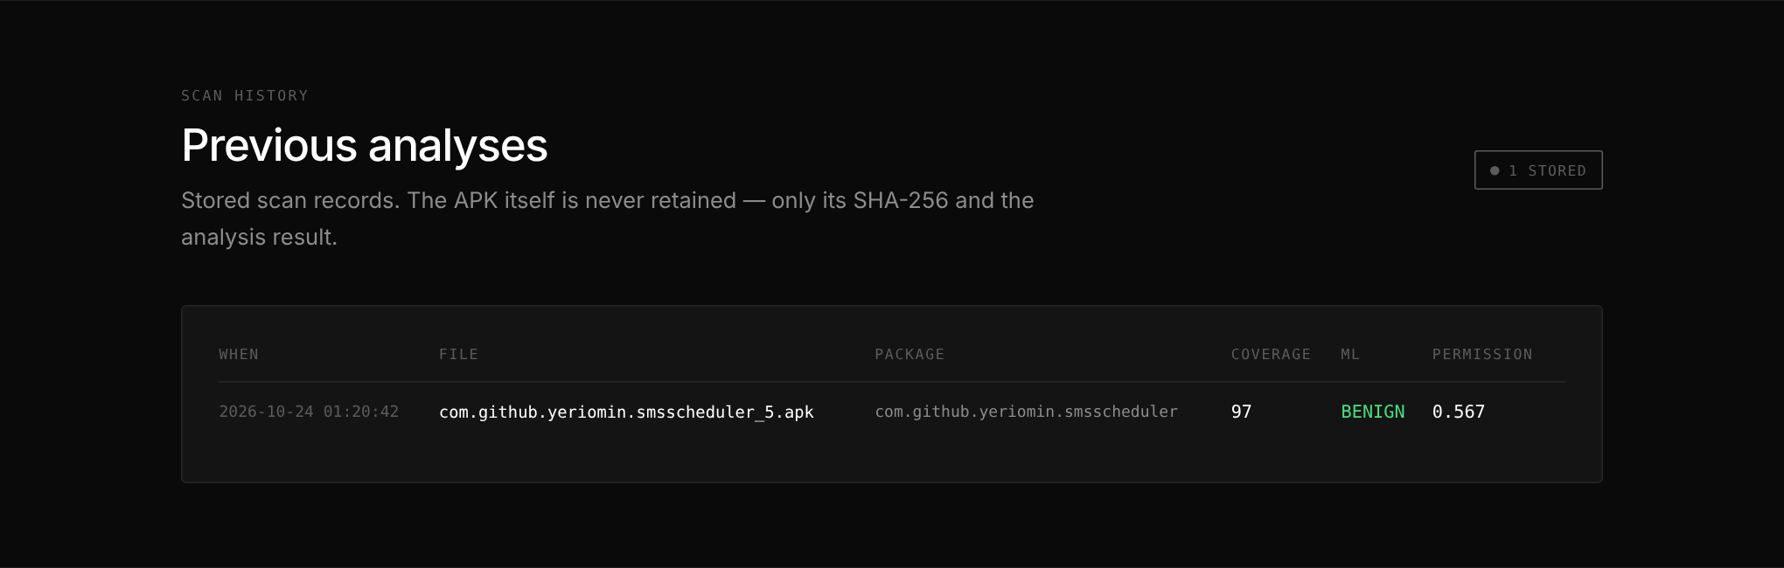
Evidence 32. Scan history read from the database.

5. Backend API
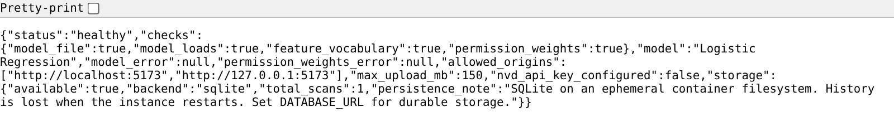
Evidence 33. GET /health in the browser: status healthy, model Logistic Regression loaded.
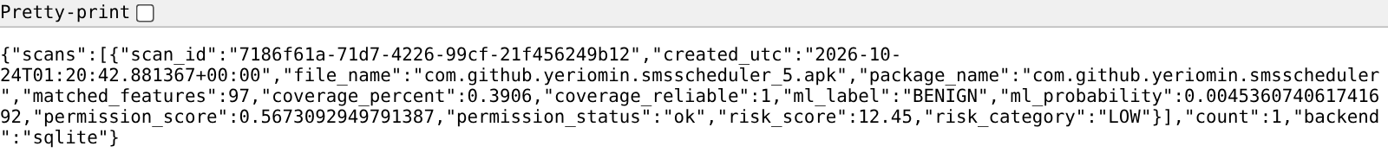
Evidence 34. GET /scans in the browser: stored scan history from the database.

5.1 /health response
{
"status": "healthy",
"checks": {
"model_file": true,
"model_loads": true,
"feature_vocabulary": true,
"permission_weights": true
},
"model": "Logistic Regression",
"model_error": null,
"permission_weights_error": null,
"allowed_origins": [
"http://localhost:5173",
"http://127.0.0.1:5173"
],
"max_upload_mb": 150,
"nvd_api_key_configured": false,
"storage": {
"available": true,
"backend": "sqlite",
"total_scans": 1,
"persistence_note": "SQLite on an ephemeral container filesystem. History is lost when the instance restarts. Set DATABASE_URL for durable storage."
}
}

5.2 POST /analyze-apk response (excerpt)
{
"filename": "com.github.yeriomin.smsscheduler_5.apk",
"apk_sha256": "b06f8cac3ef7f56af0e7b6da5e44cf773ed453a80c475f7e98c80342a6003af3",
"feature_coverage": {
"matched_features": 97,
"total_features": 24833,
"coverage_percent": 0.3906,
"candidates_generated": 259,
"candidates_not_in_vocabulary": 162,
"by_block": {
"permissions": {
"extracted": 5,
"matched": 5,
"vocabulary_size": 166
},
"intents": {
"extracted": 3,
"matched": 1,
"vocabulary_size": 250
},
"api_calls": {
"extracted": 251,
"matched": 91,
"vocabulary_size": 24417
}
},
"reliable": true,
"threshold": 50,
"warning": null,
"extraction_errors": {}
},
"ml_analysis": {
"matched_features": 97,
"prediction": 0,
"label": "BENIGN",
"malware_probability": 0.004536074061741692,
"benign_probability": 0.9954639259382583,
"model": "Logistic Regression"
},
"permission_risk": {
"score": 0.5673092949791387,
"status": "ok",
"matched": [
"READ_PHONE_STATE",
"SEND_SMS"
]
},
"storage": {
"stored": true,
"scan_id": "dead6e09-9b00-4813-8d3a-61a8a31c741b",
"backend": "sqlite",
"created_utc": "2026-10-24T01:38:24+00:00"
}
}
The full response (460 lines) is saved as reports/evidence/text/scan.json.

5.3 Rejecting an invalid file
{"detail":"This file is not a valid Android package. An APK is a ZIP archive, and this file does not begin with a ZIP header."}
HTTP 400

5.4 Server log for these requests
INFO: Started server process [408]
INFO: Waiting for application startup.
INFO: Application startup complete.
INFO: Uvicorn running on http://127.0.0.1:7860 (Press CTRL+C to quit)
INFO: 127.0.0.1:43030 - "GET /health HTTP/1.1" 200 OK
INFO: 127.0.0.1:43044 - "GET /health HTTP/1.1" 200 OK
INFO: 127.0.0.1:43056 - "POST /analyze-apk HTTP/1.1" 200 OK
INFO: 127.0.0.1:41792 - "POST /analyze-apk HTTP/1.1" 400 Bad Request
INFO: Shutting down
INFO: Waiting for application shutdown.
INFO: Application shutdown complete.
INFO: Finished server process [408]

6. Database
SQLite is used by default (PostgreSQL when DATABASE_URL is set). Only a summary and the APK’s SHA-256 are stored, never the APK itself. The query below was run directly on storage/mosaic.db after the server had been stopped and restarted: the earlier scan is still there, which shows history persists across restarts.
Table 'scans' columns: scan_id, created_utc, file_name, apk_sha256, package_name, matched_features, coverage_percent, coverage_reliable, ml_label, ml_probability, permission_score, permission_status, cve_records, cve_failed, risk_score, risk_category, report_json

2026-10-24T01:20:42.881367+00:00 | com.github.yeriomin.smsscheduler_5.apk | b06f8cac3ef7f56a... | BENIGN | 0.0045 | 0.5673 | LOW
2026-10-24T01:38:24.865631+00:00 | com.github.yeriomin.smsscheduler_5.apk | b06f8cac3ef7f56a... | BENIGN | 0.0045 | 0.5673 | LOW

Total rows: 2

7. Automated Tests
tests_permission_risk.py, run on the unzipped final package:
1. canonical_permission
PASS android.permission prefix
PASS Permission:: prefix
PASS bare name
PASS lowercase upcased

2. formula correctness on a hand-built dataset
PASS alpha_A
PASS beta_A
PASS r_A=1.0
PASS r_B=0.5
PASS r_C=0.0
PASS r in [0,1] for all

3. R_perm(a) averaging
PASS single perm -> r_A
PASS two perms -> mean
PASS three perms -> mean
PASS score in [0,1]
PASS 0-100 is rescale

4. k(a)=0 -> insufficient evidence, NOT zero
PASS score is None
PASS score is NOT 0.0
PASS status flag
PASS k==0
PASS unselected perms only -> None
PASS status flag (unselected)

5. absent / unknown permissions ignored
PASS unknown ignored, k=1
PASS denominator counts only matched

6. no leakage - weights depend only on data passed in
PASS different splits -> different weights

7. serialization round-trip
PASS round-trip preserves r
PASS metadata preserved
PASS stable scores after reload

8. vectorised scorer agrees with per-APK scorer
PASS vectorised == per-APK
PASS k vector matches

9. guards
PASS single-class rejected
PASS missing perm rejected
PASS row mismatch rejected

====================================================
PASSED 32 FAILED 0

Also verified by execution: the final zip unzipped into an empty folder and run with dependencies installed from requirements.txt alone (versions 1.6.1 / 1.26.4 / 1.15.3); the dashboard, /health, a real scan and history all worked. The saved models reproduce their recorded confusion matrices exactly when reloaded.

8. Not Verified — Stated Honestly
• The Docker image has not been built. Docker Hub was blocked in the build environment. Everything the image contains was assembled and run the way the container runs it, but the first docker build on a real machine is still to be done.
• NVD/CVE lookup has never returned a record, because every test ran without internet access. The success path is untested.
• HIDS telemetry is synthetic prototype data, labelled as such in the dashboard.
• Results come from a single data split; there are no confidence intervals and the probabilities are not calibrated.

