Software Requirements Specification

for

<Project>

Version 1.0 approved

Prepared by <Lam Hau Huong – Nguyen Thi Kim Hang >

<SE1410>

<26/10/2020>

Table of Contents

Table of Contents ii

Revision History ii

1. Introduction 2

1.1 Purpose 2

1.2 Document Conventions 2

1.3 Project Scope 2

2. Overall Description 2

2.1 Product Perspective 2

2.2 User Classes and Characteristics 2

2.3 Operating Environment 2

2.4 Design and Implementation Constraints 2

2.5 Assumptions and Dependencies 2

3. System Features 2

3.1 Major Features 2

3.2 Scope of Initial Release 2

3.3 UseCase 2

3.4 UseCase Detail 2

4. Data Requirements 2

4.1 Logical Data Model 2

4.2 Data Dictionary 2

4.3 Reports 2

4.4 Data Acquisition, Integrity, Retention, and Disposal 2

5. External Interface Requirements 2

5.1 User Interfaces 2

5.2 Software Interfaces 2

5.3 Hardware Interfaces 2

5.4 Communications Interfaces 2

6. Quality Attributes 2

6.1 Usability 2

6.2 Performance 2

6.3 Security 2

6.4 Safety 2

6.5 [Others as relevant] 2

7. Internationalization and Localization Requirements 2

8. Other Requirements 2

Appendix A: Glossary 2

Appendix B: Analysis Models 2

Revision History

|  |  |  |  |
| --- | --- | --- | --- |
| **Name** | **Date** | **Reason For Changes** | **Version** |
|  |  |  |  |
|  |  |  |  |

# Introduction

## Purpose

This SRS describes the functional and nonfunctional requirements for software release 1.0 of the The Toytailer’s System. This document is intended to be used by the members of the project team who will implement and verify the correct functioning of the system. Unless otherwise noted, all requirements specified here are committed for release 1.0.

## Document Conventions

No special typographical conventions are used in this SRS.

## Project Scope

## A. Business Objectives

BO-1: Increase 70% retailer’s service within 3 months following initial release.

* Depend on feedback of customers

BO-2: Reduce 40% time-consuming managing products within 6 months following initial release.

BO-3: Increate average effective work time by 30-minutes per staff per day within 7 months following initial release.

### b. Vision Statement

- For customers who want to order toys from toys’ retailer online,the Toytailer’s System is an Internet-based and smartphone-enabled application that will help customers order toys, process payments, receive online customer consultation, view and save information about favorite products without going to the store,track delivery progress of the ordered toys and register for member’s card. Unlike the current telephone and manual ordering processes, customers who use the Toytailer’s System will not have to go to the toy’s retailer to buy toys, which will save them time and will increase the toy choices available to them.

- For retailers who want to sell toys online from retailer’s stock, The Toytailer’s System is an Internet-based and smartphone-enabled application that will help retailer manage products and customer’s order easily, advertise new product, publish retailer’s event, statistics and view sales figures. Unlike the telephone and manual selling process, retailer who use the Toytailer’s System will not have to go to the storage to check for available product, send retailer’s announcement through leaflets and can communicate with many customers at the time, which will save them time and will increase retailer’s quality service.

### c. Business Risks

RI-1: The deal between customers and retailer is fake reflecting retailer’s hours of operation. ( Probability = 0.3, Impact = 6 ).

RI-2: Too few customers using Toytailer’s System ( Probability = 0.2, Impact = 9 ).

RI-3: Deviation in the statistics of the number of products on the system compared to the reality ( Probability = 0.2, Impact = 5 ).

# Overall Description

## Product Perspective

## 2.1.1 Background

Customers normally spend an average of 1-2 hours per shopping time finding and going to the retailer to select and purchase toys. In case that the favorite product which the customers want is out of stock, customers will waste more time on finding another retailer for that products. Towards the retailer, they will waste more money on leaflets’ advertisement which is not only inefficient but also harmful to environment, and spend many hours for storage’s checking.

## 2.1.2 Business Opportunity

Towards nowadays’ market, there are many online transactions on the network such as Food Delivery, Book Delivery, etc. Those online selling systems, similar to our system, help customers reduce time-consuming. Furthermore, Toytailer’s System support live-chat communication between retailer and customers, listing the most favorite products and quantities of products in stock for retailer to make a suitable business strategy of retailers, listing similar products base on those which customers have selected.

## User Classes and Characteristics

|  |  |
| --- | --- |
| Customer | A Customer is a user who wants to order products to be delivered from the retailers. There are about 400 potential Customers, of which 250 are expected to access the Toytailer’s System an average of 5 times per week each. Customers will sometimes order multiple orders for group events or guests. An estimated 75 percent of orders will be placed using the corporate Intranet, with 40 percent of orders being placed from home or by smartphone or tablet apps. |
| Staff | The Toytailer’s System employs about 10 Staff, who will receive orders from the Toytailer’s System, prepare order, package them for delivery, and request delivery. Most of the Staff will need training for more than 1 months in the use of the hardware and software for the Toytailer’s System. |
| Retailer’s Owner | The Retailer’s Owner is the one who manages Staffs, view statistics of retailer. |
|  |  |

## Operating Environment

OE-1: The Toytailer’s System shall operate correctly with the following web browsers: Windows Internet Explorer versions 7, 8, and 9; Firefox versions 12 through 26; Google Chrome (all versions); and Apple Safari versions 4.0 through 8.0; Opera ( all version );

OE-2: The Toytailer’s System shall operate on a server running the current corporate-approved versions of Red Hat Linux and Apache HTTP Server.

OE-3: The Toytailer’s System shall permit user access from the corporate Intranet, from a VPN Internet connection, and by Android, iOS, and Windows smartphones and tablets.

## Design and Implementation Constraints

CO-1: The system is designed and built by Java/C# Language.

CO-2: The system shall use the current corporate standard Microsoft SQL Server database engine.

CO-3: All HTML code shall conform to the HTML 5.0 standard.

## Assumptions and Dependencies

AS-1: The retailer is open for a whole day in which customers are expected to be on site.

DE-1: The operation of the Toytailer’s System depends on changes being made in the Payroll System to accept payment requests for meals ordered with the Toytailer’s System.

DE-2: The operation of the Toytailer’s System depends on changes being made in the Retailer Inventory System to update the availability of products as Toytailer’s System accepts orders.

# System Features

## 3.1. Major Features

Figure 3.1 Feature Tree of Toytailer’s System

FE-1: Order and pay for toys from retailer’s list of products to be picked and delivered.

FE-2: Create, view, modify, delete and archive retailer’s list of products.

FE-3: Provide system access through corporate intranet, smartphone, tablet, and outside Internet access by authorized staff.

FE-4: Create, view, modify, delete and archive retailer’s list of membership.

## Scope of Initial Release

|  |  |  |  |
| --- | --- | --- | --- |
| FEATURE | RELEASE 1 | RELEASE 2 | RELEASE 3 |
| FE-1: Order Toys | Orders can be paid for only by payroll deduction. | Implemented GPS tracking on orders in real-time. | Accept credit, debit card, e-wallet payments. |
| FE-2: Retailer’s list of products | Implemented if time permit | Fully implemented |  |
| FE-3: System access | Intranet and outside Internet access | iOS and Android and tablet apps |  |
| FE-4: Membership | Not implemented | Implemented if time permit | Fully implemented |

## Use Case

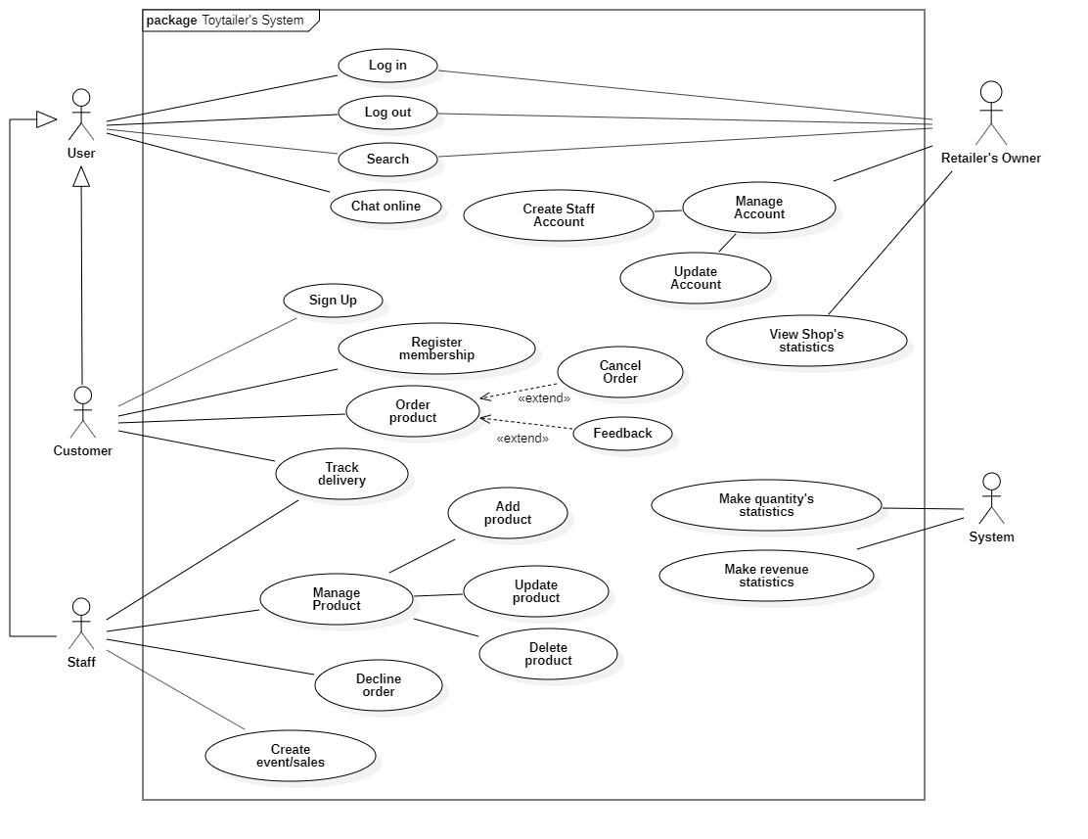

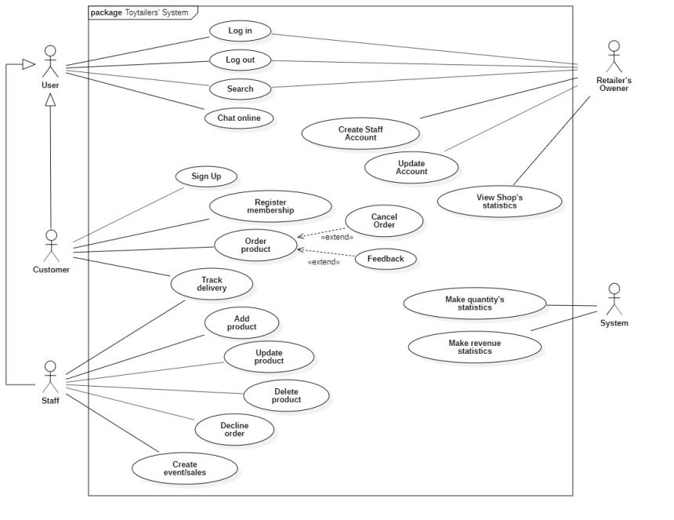

Figure 3.3 Toytailer’s System’s Usecase Diagram

## Use Case Detail

|  |  |  |  |
| --- | --- | --- | --- |
| UC ID and Name: | TS-01 Register Membership | | |
| Created By: | Lam Hau Huong | Date Created: | 9/10/2020 |
| Primary Actor: | Customer | Secondary Actors: |  |
| Trigger: | User has chosen to register membership | | |
| Description: | User registers for upgrading to membership account | | |
| Preconditions: | User has logged into system | | |
| Post-conditions: | User’s account is upgraded to membership account | | |
| Normal Flow: | System displays register membership page  User inputs his/her information  User checks on confirmation check box (Addition: Alternative flow 1.)  User clicks “Register” button (Addition: Alternative flow 2.)  System shows successful message  System change account’s status to membership  System displays account information page | | |
| Alternative Flows: | 1. User doesn’t check on confirmation check box  1.1. System asks user to tick on confirmation check box  1.2. Return to step 3 in normal flow  2. User clicks Cancel  2.1 System returns to account information page | | |
| Exceptions: | E01: Retailer doesn’t provide membership account anymore | | |
| Priority: | 2 | | |
| Frequency of Use: |  | | |
| Business Rules: | BR-1: Retailer is providing membership  BR-2: Customer must be given some promotion if they’re membership | | |
| Other Information: |  | | |
| Assumptions: |  | | |

|  |  |  |  |
| --- | --- | --- | --- |
| UC ID and Name: | TS-02 Track delivery | | |
| Created By: | Lam Hau Huong | Date Created: | 11/10/2020 |
| Primary Actor: | Customer, Staff | Secondary Actors: |  |
| Trigger: | User has chosen to track delivery | | |
| Description: | User want to view delivery’s tracking process | | |
| Preconditions: | 1. User has logged into system | | |
| Post-conditions: | 1. Delivery’s tracking process show on user’s screen | | |
| Normal Flow: | 1. User clicks “Tracking delivery”  2. System gets information about delivery  3. System show delivery process on user’s screen (Addition: Alternative flow 1.) | | |
| Alternative Flows: | 1. Delivery has been done  1.1. System only show order’s information | | |
| Exceptions: | E01: Delivery has been canceled in the middle | | |
| Priority: | 3 | | |
| Frequency of Use: |  | | |
| Business Rules: | BR-1: Delivery must be done in 10 days  BR-2: Delivery must be paid when it’s arrived or through e-wallet while ordering | | |
| Other Information: |  | | |
| Assumptions: |  | | |

|  |  |  |  |
| --- | --- | --- | --- |
| UC ID and Name: | TS-03 Manage Product | | |
| Created By: | Lam Hau Huong | Date Created: | 11/10/2020 |
| Primary Actor: | Staff | Secondary Actors: |  |
| Trigger: | User has chosen to manage product | | |
| Description: | User want to manage product of retailer | | |
| Preconditions: | 1. User has logged into system | | |
| Post-conditions: | 1. Product is added to system / deleted from system / updated | | |
| Normal Flow: | 1. User clicks Manage product. (Additional Alternative flow 1. /2. /3.) | | |
| Alternative Flows: | 1. User clicks “Add product”  1.1 User inputs information  1.2 User checks confirmation box  1.3 User clicks “Create”  1.4 New product is added to system  1.5 System shows successful message  1.6 System returns to product page  2. User clicks “Delete product”  2.1 System asks user to confirm action  2.2 User clicks “Confirm”  2.3 System removes product  2.4 System shows successful message  2.5 System returns to product page  3. User clicks “Update product”  3.1 User inputs information  3.2 User checks confirmation box  3.3 User clicks “Update”  3.4 System updates product information  3.5 System shows successful message  3.6 System returns to product page | | |
| Exceptions: | E01: Product has been deleted while it’s being updated  E02: Product has been deleted but still show on product screen | | |
| Priority: | 5 | | |
| Frequency of Use: |  | | |
| Business Rules: | BR-1: Product must be in system while being updated or deleted  BR-2: Which product is updated will notified “Product [xxx] has been updated” to staff and admin | | |
| Other Information: |  | | |
| Assumptions: |  | | |

|  |  |  |  |
| --- | --- | --- | --- |
| UC ID and Name: | TS-04 Decline Order | | |
| Created By: | Lam Hau Huong | Date Created: | 11/10/2020 |
| Primary Actor: | Staff | Secondary Actors: |  |
| Trigger: | User has chosen to decline order | | |
| Description: | User want to decline order from customer | | |
| Preconditions: | 1. User has logged into system | | |
| Post-conditions: | 1. Order is declined | | |
| Normal Flow: | 1. User clicks on “Requested Order”  2. User clicks “Decline”  3. System asks user to confirm action  4. User clicks “Confirm” (Addition: Alternative flow 1.)  5. System removes order from Requested Order  6. System notifies to customer that their order is declined  7. System shows successful message  8. System returns to main page | | |
| Alternative Flows: | 1. User clicks “Cancel”  1.1 System returns to product page. | | |
| Exceptions: | E01: Customer cancels order before user declines order | | |
| Priority: | 4 | | |
| Frequency of Use: |  | | |
| Business Rules: | BR-1: Order must be waiting for being accepted while staff decline order  BR-2: Customer must be notified “Order is declined” if order is declined | | |
| Other Information: |  | | |
| Assumptions: |  | | |

|  |  |  |  |
| --- | --- | --- | --- |
| UC ID and Name: | TS-05 Create event/sales | | |
| Created By: | Lam Hau Huong | Date Created: | 11/10/2020 |
| Primary Actor: | Staff | Secondary Actors: |  |
| Trigger: | User has chosen to create event/sales | | |
| Description: | User want to create promotion event for customers | | |
| Preconditions: | 1. User has logged into system | | |
| Post-conditions: | 1. System shows Event information on banner of main page | | |
| Normal Flow: | 1. User clicks “Create Event”  2. User inputs information  3. User checks on confirmation box (Addition: Alternative flow 1 )  4. User clicks “Create”  5. System shows successful message  6. System returns to main page  7. System shows Event Information on main page | | |
| Alternative Flows: | 1. User doesn’t check on confirmation box  1.1 System asks user to confirm before create new event  1.2 Returns to Normal flow 3. | | |
| Exceptions: | E01: Ending date of event is before current date.  E02: Customer is ordering while event is being created. | | |
| Priority: | 4 | | |
| Frequency of Use: |  | | |
| Business Rules: | BR-1: Date Start of event must after current day in real-time and Date End of event must be greater than Date Start.  BR-2: After event is created, all customers who have account will be notified “There is an event [xxx] start from [dd/MM/yyyy] to [dd/MM/yyyy]” via email. | | |
| Other Information: |  | | |
| Assumptions: |  | | |

|  |  |  |  |
| --- | --- | --- | --- |
| UC ID and Name: | TS-06 Make quantity statistics | | |
| Created By: | Lam Hau Huong | Date Created: | 11/10/2020 |
| Primary Actor: | System | Secondary Actors: |  |
| Trigger: | There’s some change on quantity of products | | |
| Description: | System automatically make quantity statistics | | |
| Preconditions: | 1. System must be connected to internet continuously | | |
| Post-conditions: | 1. Quantities of products statistics is counted automatically | | |
| Normal Flow: | 1. Customer orders product.  2. System automatically reduces product’s quantities  3. Staff adds new product.  4. System automatically make new statistics of that product  5. Staff updates/deletes product.  6. System automatically reduces or increases product’s quantities base on action | | |
| Alternative Flows: |  | | |
| Exceptions: | E01: System is disconnected from Internet | | |
| Priority: | 5 | | |
| Frequency of Use: |  | | |
| Business Rules: | BR-1: System will generate a excel file of quantity statistics and send to staff after one day.  BR-2: System will track user’s buying quantities to increase membership of that user for promotion in next order  BR-3: Statistics must be ordered by date / product for better view. | | |
| Other Information: |  | | |
| Assumptions: |  | | |

|  |  |  |  |
| --- | --- | --- | --- |
| UC ID and Name: | TS-07 Make revenue statistics | | |
| Created By: | Lam Hau Huong | Date Created: | 11/10/2020 |
| Primary Actor: | System | Secondary Actors: |  |
| Trigger: | Orders are done | | |
| Description: | System automatically make revenue statistics for retailer | | |
| Preconditions: | 1. System must be connected to electricity continuously | | |
| Postconditions: | 1. Revenue statistics is updated after orders are done | | |
| Normal Flow: | 1. Customer orders products  2. Customer confirms “Delivery received” (Addition: Alternative flow 1.)  3. System added orders to “Successful Order”  4. System makes revenue statistics base on total of all “Successful Order”. | | |
| Alternative Flows: | 1. Shipper confirms “Delivery completed”  1.1 Returns to Normal flow 3. | | |
| Exceptions: | E01: System isn’t supplied power/electricity | | |
| Priority: | 5 | | |
| Frequency of Use: |  | | |
| Business Rules: | BR-1: System will generate an excel file of revenue statistics and send to staff after one day.  BR-2: System only makes revenue statistics if order is set to “Successful Order” status.  BR-3: Statistics must be ordered by date / product for better view. | | |
| Other Information: |  | | |
| Assumptions: |  | | |

|  |  |  |  |
| --- | --- | --- | --- |
| UC ID and Name: | TS-08 Order toys | | |
| Created By: | Nguyen Thi Kim Hang-SE140651 | Date Created: | 09/10/2020 |
| Primary Actor: | Customer | Secondary Actors: |  |
| Trigger: | Customer has chosen to order toys. | | |
| Description: | This use case allows customer to order toys. | | |
| Preconditions: | 1. User must connect to Internet 2. User must login into as the Customer | | |
| Post-conditions: | 1. User receives order’s information | | |
| Normal Flow: | 1. System shows list toys for the customer 2. User chooses the toy and quantity 3. User clicks to “Choose” button 4. System adds toy to shopping cart 5. User clicks to view shopping cart (see 1.1) 6. User clicks to “Order” button 7. System requires information from user:   + Address: free text input,required,length 5-100  + Phone: free text input,required,length 8-15,number  + Payment: drop down list,required   1. User inputs information (see 1.0.E1) 2. User click to confirm button 3. System asks user to confirm their information 4. User confirms “Yes” 5. System stores order’s information 6. Systems shows order’s information to user | | |
| Alternative Flows: | * 1. Order multiple toys   1.User requests to order another toy  2.Return to step 1 of normal flow | | |
| Exceptions: | 1. E1 Customer don’t input required information   1. System shows error message to ask user input missing required fields. | | |
| Priority: | High | | |
| Frequency of Use: |  | | |
| Business Rules: | BR-1: When customer order is success, order’s status changes “Delivery”.  BR-2: When customer receives toy successfully, order’s status changes “Completed”  BR-3: List toy load from database from tblToy which quantity > 0  BR-4: Delivery time windows are 3 days (except Sunday)  BR-5: Deliveries must be completed between 8:00 A.M. and 17:00 P.M. local time  BR-6: System offers any toys that are similar to user’s buying toys after user submits order | | |
| Other Information: |  | | |
| Assumptions: |  | | |

|  |  |  |  |
| --- | --- | --- | --- |
| UC ID and Name: | TS-09 Cancel order | | |
| Created By: | Nguyen Thi Kim Hang-SE140651 | Date Created: | 11/10/2020 |
| Primary Actor: | Customer | Secondary Actors: |  |
| Trigger: | Customer has chosen to delete order. | | |
| Description: | This use case allows customer to delete order. | | |
| Preconditions: | 1.User must connect to Internet  2.User must login into as the Customer  3.User must order toy success | | |
| Post-conditions: | User’s order has been deleted. | | |
| Normal Flow: | 1. User clicks button “My Order” 2. System shows information about user’s order 3. User clicks button “Cancel Order” 4. System shows notification “Do you really want to delete this order?” 5. User clicks button ”Yes” 6. System displays new view require user input some information:   -Reason to cancel this order,required: can be optional selected from these values:  +User orders wrong toy  +Delivery time is too long  +Other reason: free text input,required   1. User inputs information (see 1.0.E1) 2. User clicks to button ”Submit” 3. System shows notification “Delete success” | | |
| Alternative Flows: |  | | |
| Exceptions: | 1. E1 Customer don’t input required information   1. System shows error message to ask user input missing required fields. | | |
| Priority: | Normal | | |
| Frequency of Use: |  | | |
| Business Rules: | BR-1: When user cancels order, system removes that order from “Requested order” beside retailer’s screen.  BR-2: Products selected after being deleted still stays in the Shopping Cart if user cancels Order.  BR-3: Product is only removed from Shopping Cart if user clicks “Remove” of that product in “Shopping Cart” screen.  BR-4:Order’s status changes to “Delete” | | |
| Other Information: |  | | |
| Assumptions: |  | | |

|  |  |  |  |
| --- | --- | --- | --- |
| UC ID and Name: | TS-10 Feedback | | |
| Created By: | Nguyen Thi Kim Hang-SE140651 | Date Created: | 11/10/2020 |
| Primary Actor: | Customer | Secondary Actors: |  |
| Trigger: | Customer has chosen to feedback. | | |
| Description: | This use case allows customer to feedback. | | |
| Preconditions: | 1.User must connect to Internet  2.User must login into as the Customer  3.User must order toy success | | |
| Post-conditions: | 1. Save feedback information 2. Send feedback to retailer’s owner | | |
| Normal Flow: | 1. System shows notification “Successful receipt” 2. System shows view for user to feedback   -Rate toy  -Other: free text input  3. User inputs information (see 1.1)  4. User clicks to button “Submit”  5. System sends feedback to retailer’s owner  6. System shows notification “Thank you for your purchase” | | |
| Alternative Flows: | * 1. User doesn’t want to feedback  1. User clicks to button “Exit” 2. Return to step 6 of normal flow | | |
| Exceptions: |  | | |
| Priority: | Normal | | |
| Frequency of Use: |  | | |
| Business Rules: | BR-1: User can give feedback on that product only if they’ve bought that product recently.  BR-2: User feedback must be validated that it doesn’t contain any words, which violated traditional customs ( bad words / insulting words ).  BR-3: After user submit feedback, retailer must be notified about that feedback | | |
| Other Information: |  | | |
| Assumptions: |  | | |

|  |  |  |  |
| --- | --- | --- | --- |
| UC ID and Name: | TS-11 Sign Up | | |
| Created By: | Nguyen Thi Kim Hang-SE140651 | Date Created: | 11/10/2020 |
| Primary Actor: | Customer | Secondary Actors: |  |
| Trigger: | Customer has chosen to sign up. | | |
| Description: | This use case allows customer to sign up. | | |
| Preconditions: | User must connect to Internet | | |
| Post-conditions: | User has a registered account and can log in to the system. | | |
| Normal Flow: | 1. User clicks “Sign up” button 2. System shows view with input fields:   + Phone number: phone input, required, length 10  + Password: free text input, required, length 5-100  + Re-type password: must match Password  + Full name: free text input, required, length 1-100  + Address: : free text input, length 0-100  + Birthdate: date input   1. User inputs information (see 1.0.E1,1.0.E2) 2. User clicks button “Submit” (see 1.1.E1) 3. System shows notification success | | |
| Alternative Flows: |  | | |
| Exceptions: | 1.0.E1 Customer don’t input required information  1.System shows error message to ask user input missing required fields.  1.0.E2 Customer inputs wrong format  1.System shows error message to ask user input right format.  1.1.E1 Customer inputs phone number existence  1.System shows error message to ask user input again phone number. | | |
| Priority: | Normal | | |
| Frequency of Use: |  | | |
| Business Rules: | BR-1: User’s account will use to store their order, count their order to give them promotion and allow user to feedback on product after buying that product.  BR-2: Account’s status will be “New”. | | |
| Other Information: |  | | |
| Assumptions: |  | | |

|  |  |  |  |
| --- | --- | --- | --- |
| UC ID and Name: | TS-12 Search | | |
| Created By: | Nguyen Thi Kim Hang-SE140651 | Date Created: | 11/10/2020 |
| Primary Actor: | User | Secondary Actors: |  |
| Trigger: | User has chosen to search. | | |
| Description: | This use case allows user to search. | | |
| Preconditions: | User must connect to Internet | | |
| Post-conditions: | System shows list toys depends on what user search | | |
| Normal Flow: | 1. User inputs what they want to search (see 1.1) 2. Users clicks to button “Search” (see 1.0.E.1) 3. System shows list toys and information of the toy :   + Name  + Price  + Status (Active or Out of stock) | | |
| Alternative Flows: | * 1. User search depends on Category  1. Users click to Category they want to search 2. Return to step 2 of normal flow | | |
| Exceptions: | 1.0.E1 User input blank text  1.System will not respond | | |
| Priority: | Normal | | |
| Frequency of Use: |  | | |
| Business Rules: | BR-1: List toy load from database from tblToy which quantity > 0  BR-2:When customer search blank content, nothing will happen. | | |
| Other Information: |  | | |
| Assumptions: |  | | |

|  |  |  |  |
| --- | --- | --- | --- |
| UC ID and Name: | TS-13 Manage account | | |
| Created By: | Nguyen Thi Kim Hang-SE140651 | Date Created: | 11/10/2020 |
| Primary Actor: | Retailer’s owner | Secondary Actors: |  |
| Trigger: | Retailer’s owner can manage account | | |
| Description: | This use case allows retailer’s owner can manage account. | | |
| Preconditions: | 1.Retailer’s owner must connect to Internet  2.Role must be admin | | |
| Post-conditions: | Retailer’s owner manage account:   1. Add staff’s account 2. Update account’s information 3. Delete account | | |
| Normal Flow: | 1. Retailer’s owner clicks to “Manage account” button 2. System shows list action Retailer’s owner can do   -Add staff’s account  -Update account  3.Click to “Add staff’s account” (see 1.1, 1.2)  4. System shows view with input fields:  + Phone number: phone input, required, length 10  + Password: free text input, required, length 5-100  + Re-type password: must match Password  + Full name: free text input, required, length 1-10  + Birthdate: date input  5.Retailer’s owner input information (see 1.0.E1,1.0.E2)  6.Retailer’s owner click button “Submit” (see 1.1.E1)  7.System stores account in database with role “Staff” and send notification success | | |
| Alternative Flows: | * 1. Click to “Update account”  1. System shows list account of staff and customer 2. Retailer’s owner chooses account want to update information 3. System shows information about this account (except phone number and password) 4. Retailer’s owner input information wants to update (except phone number and password) 5. Retailer’s owner clicks button “Update” 6. System updates information and,show notification success and send notification to account which Retailer’s owner updates | | |
| Exceptions: | 1.0.E1 Retailer’s owner don’t input required information  1.System shows error message to ask user input missing required fields.  1.0.E2 Retailer’s owner inputs wrong format  1.System shows error message to ask user input right format.  1.1.E1 Retailer’s owner inputs phone number existence  1.System shows error message to ask user input again phone number. | | |
| Priority: | Normal | | |
| Frequency of Use: |  | | |
| Business Rules: | BR-1: The owner of the account that is updated must be notified via email / phone which information is updated.  BR-2: If staff’s account is created, system notifies to that staff via their email / phone.  BR-3: : If staff’s account is created with,account’s role will be “Staff”. | | |
| Other Information: |  | | |
| Assumptions: |  | | |

|  |  |  |  |
| --- | --- | --- | --- |
| UC ID and Name: | TS-14 View shop’s statistics | | |
| Created By: | Nguyen Thi Kim Hang-SE140651 | Date Created: | 11/10/2020 |
| Primary Actor: | Retailer’s owner | Secondary Actors: |  |
| Trigger: | Retailer’s owner can view shop’s statistics | | |
| Description: | This use case allows retailer’s owner can view shop’s statistics. | | |
| Preconditions: | 1.Retailer’s owner must connect to Internet  2.Role must be admin | | |
| Post-conditions: | Retailer’s owner view shop’s statistics | | |
| Normal Flow: | 1. Retailer’s owner clicks to “Statistics” 2. Systems shows sales chart | | |
| Alternative Flows: |  | | |
| Exceptions: |  | | |
| Priority: | Normal | | |
| Frequency of Use: |  | | |
| Business Rules: | BR-1: System saves last accessed time to statistics for later user knows.  BR-2: System notifies to all user whose role is admin that statistics are being accessed. | | |
| Other Information: |  | | |
| Assumptions: |  | | |

# Data Requirements

## Logical Data Model

Figure 4.1 Data Model for Toytailer’s System’s System

## Data Dictionary

|  |  |  |  |  |
| --- | --- | --- | --- | --- |
| **Data Element** | **Description** | **Composition or Data type** | **Length** | **Value** |
| Staff | Details about a staff of retailers | - Staff ID  - Staff Name |  |  |
| Staff ID | Unique ID that retailers assigns to each staff | Integer | 7 | Initial Value is 1 |
| Staff Name | Name of the staff of retailers | Alphabetic | 50 |  |
| Product | Details about a product of retailers | - Product ID  - Product Name  - Product Quantity  - Product Price  - Product Image |  |  |
| Product ID | Unique ID that retailers assigns to each Product | Integer | 7 | Initial Value is 1 |
| Product Name | Name of the product | Alphabetic | 50 |  |
| Product Quantity | Quantity of the product | Integer | 7 | Initial Value is 1 |
| Product Price | Price of the product | Money |  |  |
| Product Image | Image of the product | Alphabetic | 50 | Value ends with “.jpg” or “.png” |
| Order Product | Details of product that customer orders | - Order ID  - Product ID  - Number of products |  |  |
| Number of Products | Quantity of products that customer orders | Integer | 7 | Default is 1;  Maximum = Product quantity |
| Order | Details of the order | - Order ID  - Order Address  - Payment |  |  |
| Order ID | Unique ID that systems assign to each Order | Integer | 7 | Initial value is 1 |
| Order Address | Address that order will be delivered to | Alphabetic | 50 | hyphens and commas permitted |
| Payment | Information about a payment Toytailer’s System accepted for an order | - Payment amount  - Payment method  - Transaction number |  |  |
| Payment amount | Total price of an order | Money |  |  |
| Payment method | How the customer is paying for an order | Alphabetic | 20 | payroll deduction, cash, credit card, debit card |
| Transaction number | Unique sequence number that Toytailer’s System assigns to each payment transaction | Integer | 12 |  |
| Category | Details of category of products | - Category ID  - Category Name |  |  |
| Category ID | Unique ID that Toytailer’s System assign to each Category | Integer | 7 | Initial Value is 1 |
| Category Name | Name of the category | Alphabetic | 50 |  |
| Sub Category | Details of sub category of category | - Sub Category ID  - Sub Category Name |  |  |
| Sub Category ID | Unique ID that Toytailer’s System assign to each Sub Category | Integer | 7 | Initial Value is 1 |
| Sub Category Name | Name of the sub category | Alphabetic | 50 |  |
| Customer | Details of customer of retailers | Customer ID  Customer Name  Password  Email  Customer Address |  |  |
| Customer ID | Unique ID that Toytailer’s System assigns to each Customer | Integer | 7 | Initial Value is 1 |
| Customer Name | Name of the customer | Alphabetic | 50 |  |
| Password | Must be encrypted by SHA-256 | String | 100 |  |
| Email | Email of the customer | String | 100 | A string with an extension of an email (@gmail.com, @fpt.edu.vn, …) |
| Customer Address | Address of the customer | String | 50 | hyphens and commas permitted |
| Delivery Time | Time of the order completed | Time | hh:mm | Local time; hh = 0-23 inclusive; mm = 00, 15, 30 or 45 |

# External Interface Requirements

## User Interfaces

UI-1: The system shall provide a help link from each displayed webpage to explain how to use that page.

UI-2: The webpages shall permit complete navigation and food item selection by using the keyboard alone, in addition to using mouse and keyboard combinations.

## Software Interfaces

SI-1: E-Wallet System

The Toytailer’s System shall communicate with the E-Wallet System through a programmatic interface for the following operations:

- SI-1.1: To allow customer to pay order online.

- SI-1.2: To reverse all or part of a previous charge because the product was not delivered per the confirmed delivery instructions.

## Hardware Interfaces

No hardware interfaces have been identified.

## Communications Interfaces

CI-1: The Toytailer’s System shall send an email or text message (based on user account settings) to the Customer to confirm acceptance of an order, price, and delivery instructions.

CI-2: The Toytailer’s System shall send an email or text message (based on user account settings) to the Customer to report any problems with the order or delivery.

# Quality Attributes

## Usability

USE-1: The Toytailer’s System shall allow a Customer to retrieve the previous order with a single interaction.

USE-2: 90% of new users shall be able to successfully order a product without errors on their first try.

## Performance

PER-1: The system shall accommodate a total of 400 users and a maximum of 100 concurrent users during the peak usage time window of 9:00 A.M. to 10:00 A.M. local time, with an estimated average session duration of 8 minutes.

PER-2: 95% of webpages generated by the Toytailer’s System shall download completely within 4 seconds from the time the user requests the page over a 20Mbps or faster Internet connection.

PER-3: The system shall display confirmation messages to users within an average of 3 seconds and a maximum of 6 seconds after the user submits information to the system.

## Security

SEC-1: All network transactions that involve financial information or personally identifiable information shall be encrypted.

SEC-2: Only authorized Staff shall be permitted to work with products.

SEC-3: The system shall permit Customer to view only orders that they placed.

## Safety

SAF-1: The user shall be able to see whether this product/toy is suitable for which age of user.

## [Others as relevant]

AVL-1: The Toytailer’s System shall be available at least 98% of the time between 5:00 A.M. and midnight local time and at least 90% of the time between midnight and 5:00 A.M. local time, excluding scheduled maintenance windows.