## Activity File: Interview Questions

- This first project covers a wide range of topics including cloud, network security, and logging and monitoring.

- When networking and talking to potential employers, you should be able to reference the work done on this project to answer specific interview questions or demonstrate your skills within a specific domain.

- You will choose a domain that you're interested in pursuing as a career and answer mock questions based on the suggested response format.
​
### Instructions

1. Choose one question below from each of the following domains:
- Network security-Answered Question 2-Unsecured Web Server
- Cloud security- Question 1: Cloud Access Control
- Logging and monitoring-Question 2: Challenges of Collecting Large Amounts of Log Data

3. Write a response that answers the question using specific examples from your work on Project 1. Your response should flow and read like a presentation while keeping the general structure of the technical question response guidelines.

You will submit this one-page response.

#### Reminder: Response Guidelines
As a reminder, good responses do the following.
​
1. Restate the problem.
2. Provide a concrete example scenario.
3. Explain the solution requirements.
4. Explain the solution details.
5. Identify advantages and disadvantages of the solution​.
​
Including each of these components will ensure you prove your competency of subject matter and critical thinking.
​
### Interview Questions by Domain

Below you will find a list of questions, grouped by specific domains. Select one question to answer.

For each question, where appropriate, we have provided you with specific prompts to consider as you structure each section of your response. Feel free to use these prompts or your own examples.

#### Domain: Network Security

**Question 2: Unsecured Web Server**
Suppose you find a server running HTTP on port 80, despite compliance guidelines requiring encryption in motion. What do you do?
1. Restate the Problem
2. Provide a Concrete Example Scenario
- In Project 1, did you have servers running HTTP on port `80`? If so, why was it permissible to do so?
- In a real deployment, which specific machine would you configure differently? How, and why?
3. Explain the Solution Requirements
- Why is running HTTP on port `80` a potential problem?
- How would you reconfigure a server to serve HTTP traffic safely?
- How does this solution fix the problem?
4. Explain the Solution Details
- Which tools and technologies would you use to implement this solution in Project 1?
- How, specifically, would you use these tools to harden your deployment?
5. Identify Advantages and Disadvantages of the Solution
- Will your solution break clients that used to communicate with the server over port `80`?
- Do you have to do any work to keep this solution running longterm? Or can you simply "set it and forget it?”

After configuring different virtual machines, I created Network Security Groups to define Inbound & Outbound security rules based on Priority, Name, Port, Protocol, Source, Destination, & Action. Port_80 is available in my RedTeamSecurityGroup although I am not sure if a VM is using it now.
Running a server on Port_80 is permissible, despite compliance guidelines because this is a testing environment. Running http on Port 80 may be a potential problem because of it’s lack of security since it’s not encrypted & thus not secure. In order make the HTTP server secure, I would reconfigure it to make it HTTPS & putting it on port 443. This fixes the problem by encrypting the traffic. I would add a SSL Certificate to secure my http into https. These tools would encrypt the traffic on a larger scale. Thus, I would add a license and certificate to the URL.
Clients will need to use port 443 from now going forward. In order to keep this solution running long term, the SSL certificate needs to be renewed before it expires.

#### Domain: Cloud Security
**Question 1: Cloud Access Control**
How would you control access to a cloud network?
1. Restate the Problem
2. Provide a Concrete Example Scenario
- In Project 1, did you deploy an on-premises or cloud network?
- Did you have to configure access controls to this network?
- What kinds of access controls did you configure, and why were they necessary?
- How do these details relate to the interview question?
3. Explain the Solution Requirements
- In Project 1, what kinds of access controls did you have to implement? Consider:
- NSGs around the VNet? Around the VMs?
- Local firewalls (ufw, etc.) on each VM?
- Protocol allow/deny lists?
- What did each access control achieve, and why was this restriction necessary for the project?
4. Explain the Solution Details
- Which rules do you set for each NSG in the network?
- How does access to the jump box work?
- How does access from the jump box to the web servers work
5. Identify Advantages/Disadvantages of the Solution
- Does your solution scale?
- Is there a better solution than a jump box?
- What are the disadvantages of implementing a VPN that kept you from doing it this time?
- What are the advantages of a VPN?
- When is it appropriate to use a VPN?

In order to set up Cloud Access Controls, certain protocols must be followed in order to secure a network, particularly in the cloud environment. In Project 1, I deployed a cloud network. In order to configure access controls around this network, I allowed my public ip to the network as it was necessary for me to gain access & necessary to limit other people’s access to my network. In my project, there are different Network Security Group rules for different things. For example, there are network security groups including one for the virtual machines, one for ELK, one for load balancers, & around the virtual machines are the load balancers.
Access from the jump box to the web servers works through the public ip. In order to achieve this, all traffic must be denied with only the necessary ports allowed in. One mush ssh into Jumpbox & use the public key to access web servers.
This solution can scale as several virtual machines can be added in the load balancer tool. Perhaps a better solution to jumpbox is to secure remote desktop access through a SSH proxy. A disadvantage of implementing a VPN that kept me from doing it this time is that it’s slower. Advantages of a VPN include that it’s more secure. It’s appropriate to use a VPN when traffic is not high.

**Question 2: Challenges of Collecting Large Amounts of Log Data**

What are the challenges of collecting huge amounts of log data? How do security analysts deal with them?

1. Restate the Problem
2. Provide a Concrete Example Scenario
- In Project 1, when did you deal with log data?
- What kind(s) of data did you investigate?
- How much data were you dealing with?
- What were you looking for?
3. Explain the Solution Requirements
- What information did you need to find what you were looking for?
- What does an analyst need to analyze large amounts of log data to find this information?
- In Project 1, what tools did you use to analyze log data?
4. Explain the Solution Details
- How did you use these tools to find the log data? E.g., which charts, graphs, etc. were useful for parsing the logs?
5. Identify Advantages and Disadvantages of the Solution
- What kinds of data did you not inspect during Project 1?
- Would having access to this additional data have changed your process or conclusions? If so, how?

Some of the challenges in collecting huge amounts of log data include the large amount of memory it consumes. Security analysts deal with them by using ELK to filter data under a time range. In project 1, I dealt with log data when I reviewed the Kibana logs. I dealt with logs. Specifically, thousands of logs were filtered through (3946). In my review, I searched for any suspicious activity.

In order to find what I was looking for, I used the filter, time range and relevant graphs & charts.
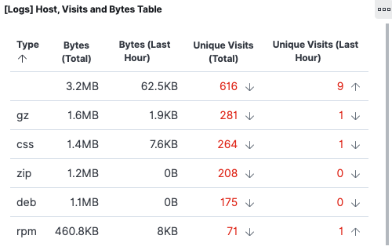
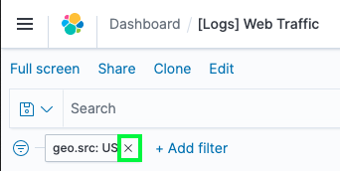
---

I did not inspect any Nmap data. However, this would not have likely changed the results.

© 2020 Trilogy Education Services, a 2U, Inc. brand. All Rights Reserved.

