Chocolate Bar Recognition II: Upgrading the A1 Pipeline with DINOv2, SAM 2 and SigLIP
Mirzhan Myssyrgaliyev · SE-2414 · Astana IT University · Instructor: Nurym Kaiyrkhan · 22 October 2026
Summary. On the A1 chocolate-bar dataset, a DINOv2 backbone and SAM 2 synthetic data do not beat a re-tuned MobileNetV2 on accuracy: every trained model reaches 98.8–99.0% averaged over four unseen locations. The upgrade shows elsewhere. DINOv2 gives cleaner, object-focused explanations and better retrieval (P@5 0.991 vs 0.981). Synthetic data halves the spread between locations. A zero-shot SigLIP model without our data reaches only 80%.

1. Introduction
Assignment 1 built a dataset of 800 frames of four chocolate bars (Kazakhstan, KitKat, Milky Way, Snickers) from 16 phone videos filmed at four locations. MobileNetV2 with transfer learning reached 97.0% accuracy on a location it never saw; an SVM on HOG (23%) and a small CNN (50%) did not generalise.
A1 left three weaknesses: a single test location, most errors on frames where the bar is partly out of view, and no explanation of what the model looks at. A2 keeps the same data and adds a SOTA backbone (DINOv2 with registers), SOTA data synthesis (SAM 2), a zero-shot reference (SigLIP), leave-one-location-out and stress testing, explainability, one ablation and a demo app.

2. Dataset update
The real data is unchanged from A1: 800 frames, 200 per class, 256×256, the sharpest frame from each of 50 windows per video. No new photos were taken. What changed is how the data is split and what is added for training.
Split by location. Each class has four videos, one per location, so a location is a natural test domain. The A1 split (test = location 4) is kept for direct comparison. In addition, every model is trained four times, each time holding out a different location (leave-one-location-out, LOLO). The remaining 600 frames are split 85/15 into training and validation; validation is used only for early stopping.
Set (A1 split) | Kazakhstan | KitKat | Milky Way | Snickers | Total
Train (real) | 127 | 128 | 127 | 128 | 510
Validation | 23 | 22 | 23 | 22 | 90
Test (location 4) | 50 | 50 | 50 | 50 | 200
Synthetic (train only) | — | — | — | — | 123
Synthetic data. SAM 2.1 segmented the bar in every frame (Section 3). A mask was accepted only if it looked like a bar, which 202 of 800 frames passed (25%). Each accepted bar was pasted once onto a random texture from the Describable Textures Dataset (DTD, 300 textures), at a random scale and position. Composites are used only for training and only from frames of training locations, so no test location leaks in. On the A1 split this adds 123 synthetic images, a 19.4% synthetic share of the training set.
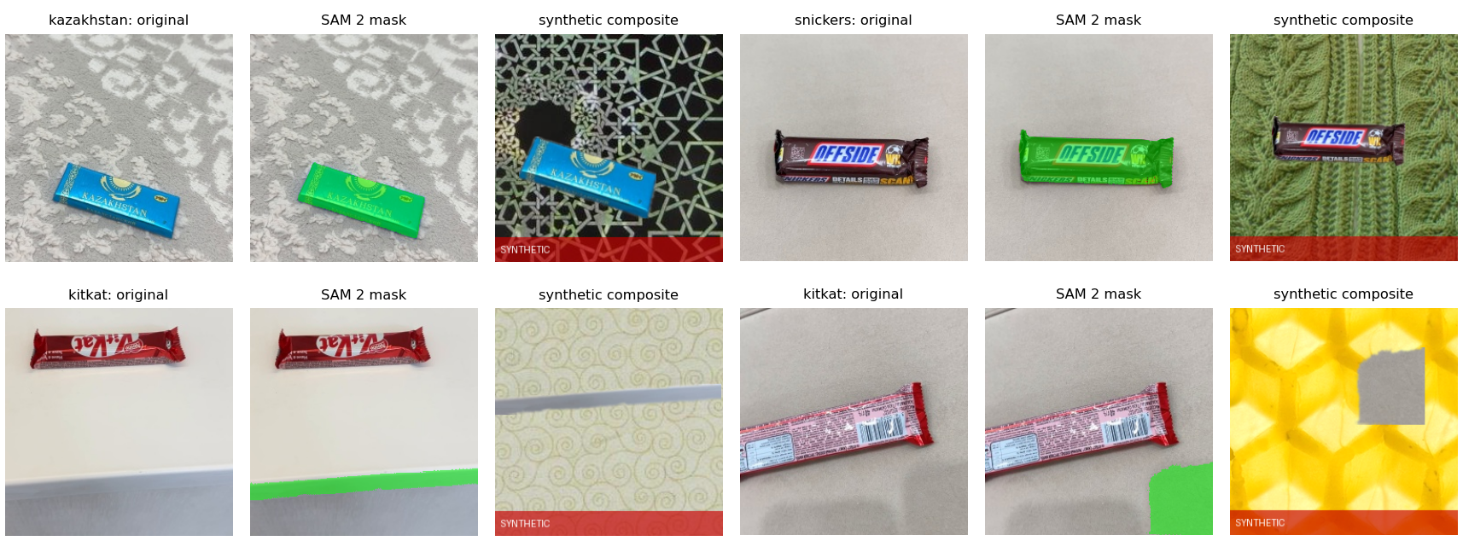
Figure 1. Original frame, accepted SAM 2 mask (green) and the SYNTHETIC composite. Top: two correct cut-outs. Bottom: the remaining failure — a strip of table edge and a patch of floor passed the filter.
Augmentation is the same as in A1, applied on the fly to training images only: horizontal flip, rotation ±15°, translation ±10%, scale 0.85–1.15, brightness and contrast ±20%. Images are resized to 224×224 and normalised with ImageNet statistics.

3. SOTA methods
Two SOTA components are added and one SOTA model serves as a reference. Everything else stays as in A1, so any change in the results comes from them.
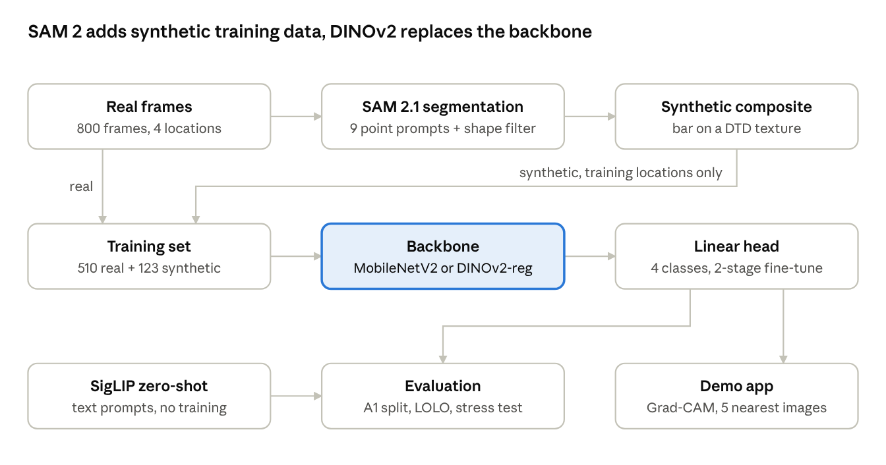
A2 pipeline · synthetic data, two backbones, zero-shot reference

3.1 DINOv2 with registers (backbone)
What it is. DINOv2 (Meta AI, 2023) is a Vision Transformer trained without labels on 142 million curated images. It continues the DINO line covered by Neurohive: a student network learns to match a teacher network (an exponential moving average of the student) on different crops of the same image. The result is a general feature extractor that works with a simple linear classifier on top.
Registers. Plain ViTs reuse some background patches as "scratch space" for global information. These high-norm artifact tokens make feature maps and heatmaps noisy. Darcet et al. (ICLR 2024) add four extra learnable register tokens that take over this role. We saw the problem ourselves: with plain DINOv2, Grad-CAM was spread over the background; with registers it sits on the bar (Section 5).
How it is used. ViT-S/14 with registers (22.1 M parameters, 224×224 input, 256 patches). The image feature is the CLS token joined with the mean of the patch tokens (768 values). Training follows the A1 recipe: stage 1 trains only a linear head (learning rate 1e-3, up to 10 epochs) on the frozen backbone; stage 2 unfreezes the last 2 transformer blocks (1e-5, up to 8 epochs). Early stopping on validation loss restores the best weights.
Why it should help. Self-supervised features describe objects and their parts rather than the surface they lie on, which should transfer better to an unseen location. The same embedding gives a nearest-neighbour gallery for the app and a retrieval metric.

3.2 SAM 2.1 (synthetic data)
What it is. Segment Anything Model 2 (Meta AI, 2024) cuts out any object from a prompt such as a click or a box. A Hiera image encoder computes features once; a light mask decoder then returns three candidate masks with a predicted quality score for each prompt. MedSAM2 from the assignment's list is SAM 2.1 fine-tuned for medical scans; our objects are not medical, so we use the general SAM 2.1 (hiera-small).
How it is used. Each frame gets 9 single-point prompts on a 3×3 grid, giving 27 candidate masks. A candidate is accepted only if it looks like a chocolate bar:
- covers 3–60% of the image and at most 15% of the image border;
- SAM quality score ≥ 0.6;
- one compact blob (largest part ≥ 95% of the mask);
- almost rectangular: mask area / area of its minimum rotated rectangle ≥ 0.85.
The most rectangular accepted mask wins. The filter rejects masks of the table, the carpet and the hand, which a first, looser version let through. The bar is then pasted onto a random DTD texture at scale 0.7–1.1 with a softened edge. Segmenting 800 frames took 215 s on a T4 GPU.
Why it should help. In the real data every bar of a location shares the same background. Pasting the same bar onto many new backgrounds breaks that link, so the model should rely on the wrapper, not the surface.

3.3 SigLIP (zero-shot reference)
SigLIP (Google, 2023) is an image–text model like CLIP, trained with a sigmoid loss on image–caption pairs. It classifies with no training: the image is compared with four prompts such as "a photo of a Snickers chocolate bar", and the closest prompt wins. We use siglip-base-patch16-224. It shows how far a foundation model gets without our dataset.

4. Experiments
On this dataset the upgrade does not raise accuracy: all four trained models stay at 98.8–99.0% averaged over four unseen locations, a difference of 2 images in 800. The differences that matter are in spread across locations, robustness and speed.

4.1 Setup
All runs used one notebook on Google Colab (Tesla T4 GPU, PyTorch, batch 32, Adam, mixed precision, seed 42). MobileNetV2 was re-implemented in PyTorch with ImageNet weights and the A1 two-stage recipe (head first, then the last 4 blocks at 1e-5, batch-norm statistics frozen). Four configurations — 2 backbones × with/without synthetic data — were each trained on the 4 location folds: 16 runs of 65–90 s each.

4.2 Results on the A1 split (test = location 4)
Model | Accuracy | Macro-F1 | Top-2 | Retrieval P@5 | Train images | Train time (s)
A1: SVM (HOG) | 0.230 | 0.231 |  |  | 600 | 9
A1: simple CNN | 0.500 | 0.333 |  |  | 510 | 18
A1: MobileNetV2 (Keras) | 0.970 | 0.970 |  |  | 510 | 47
MobileNetV2 (A2 baseline) | 0.995 | 0.995 | 1.000 | 0.981 | 510 | 65
MobileNetV2 + SAM 2 synthetic | 0.985 | 0.985 | 1.000 | 0.983 | 633 | 73
DINOv2-reg | 0.995 | 0.995 | 1.000 | 0.991 | 510 | 70
DINOv2-reg + SAM 2 synthetic | 0.995 | 0.995 | 1.000 | 0.992 | 633 | 71
SigLIP zero-shot | 0.860 | 0.856 | 0.930 |  | 0 | 0
The PyTorch re-implementation of the A1 model already reaches 99.5% (1 error in 200 instead of 6), so the A2 baseline is stronger than the A1 result. DINOv2 matches it but cannot improve on 1 error. DINOv2 embeddings retrieve the right class more often: 99.1–99.2% of the 5 nearest training images share the query's class, against 98.1–98.3% for MobileNetV2. SigLIP without training confuses the two blue wrappers: 18 of 50 Milky Way images are called Kazakhstan, a local brand it has never seen named.
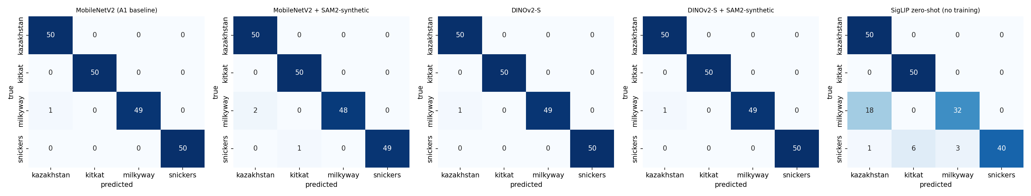
Figure 2. Confusion matrices on location 4 (50 images per class). Rows are true classes.
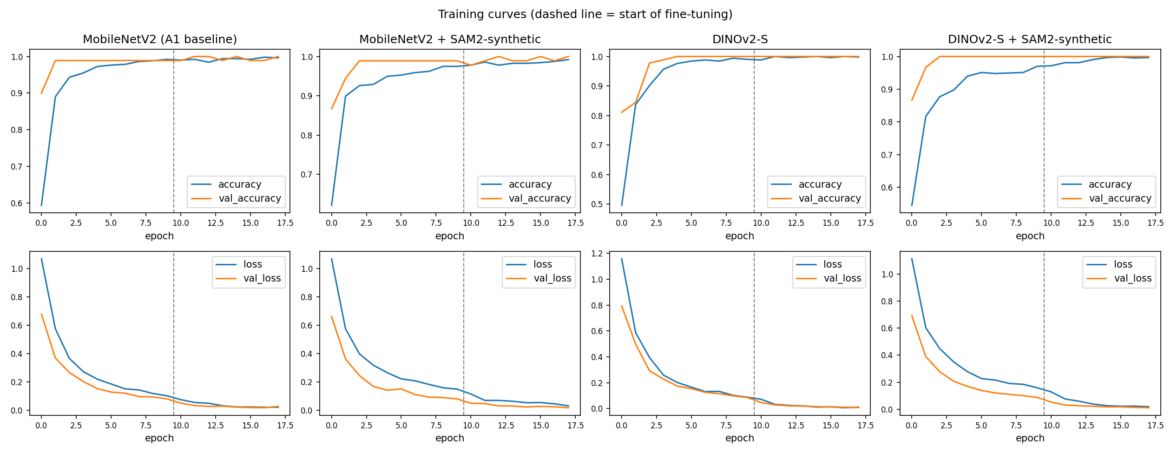
Figure 3. Training and validation accuracy and loss on the A1 split. The dashed line marks the start of fine-tuning.
All curves converge within 18 epochs, and training and validation curves stay close: no model overfits the way the A1 simple CNN did. DINOv2 reaches 100% validation accuracy after 2–4 epochs of head training alone, which shows how separable its frozen features already are.

4.3 Leave-one-location-out
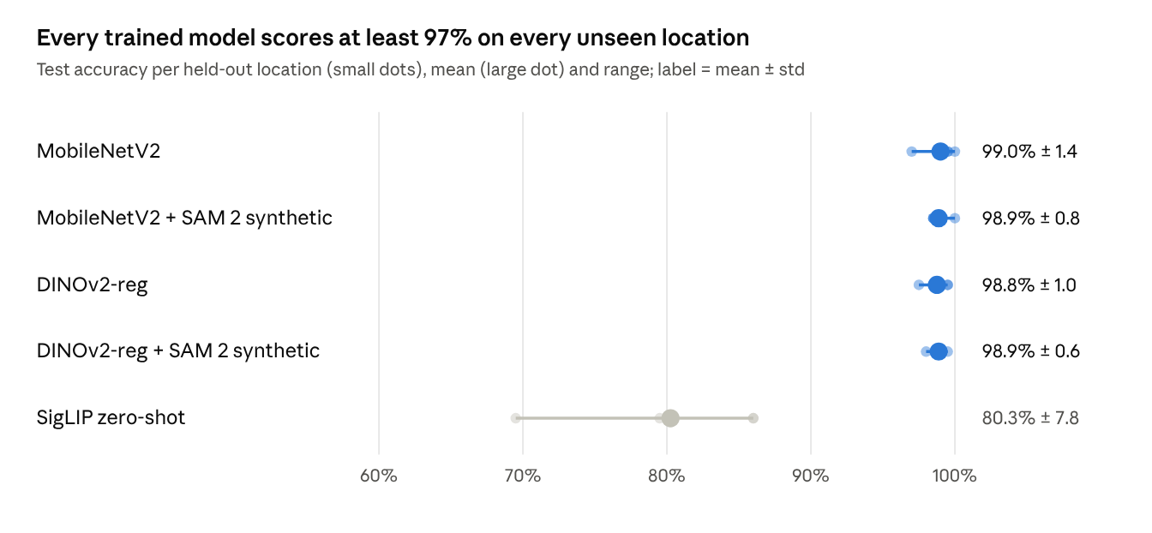
results.json from the A2 notebook · 4 held-out locations × 200 test images
All four trained models are within 0.3 percentage points of each other on average, and none drops below 97% on any location. Location 2 is the hardest for every trained model. SigLIP without training scores 69.5–86%, so our own data is still what makes the task solvable.

4.4 Ablation: with vs without SAM 2 synthetic data
Backbone | Macro-F1 without | Macro-F1 with | Δ F1 | Spread (std) without | Spread (std) with
MobileNetV2 | 0.990 | 0.989 | −0.001 | 0.013 | 0.007
DINOv2-reg | 0.987 | 0.989 | +0.001 | 0.010 | 0.006
Mean and standard deviation over the 4 held-out locations.
Synthetic data does not change the mean, but it roughly halves the spread across locations for both backbones. The worst location rises from 97.0% to 98.5% (MobileNetV2) and from 97.5% to 98.0% (DINOv2). This matches the purpose of the method: it targets the location shift, not the average case. The effect is small because only 19% of the training set is synthetic and the baseline has almost no room left.

4.5 Stress test
The A1 test images were corrupted in five ways that match the A1 error analysis: Gaussian blur, low light, a partial view (a 55% corner crop, the bar half out of frame), a grey square over 45% of the image, and sensor noise.
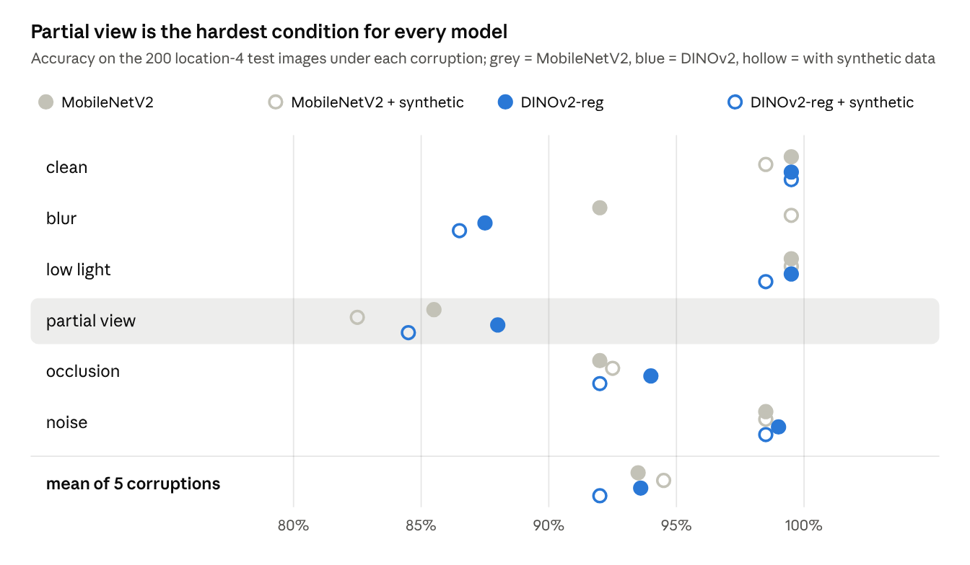
results.json from the A2 notebook · 6 conditions × 4 models, location 4
A bar half out of frame costs every model 11–17 points, which confirms the main A1 error type. DINOv2 handles it best (88.0% vs 85.5%) and also handles occlusion best (94.0% vs 92.0%), because it reads many small wrapper details rather than one global shape. It is clearly worse under blur (87.5% vs 92.0%): its 14-pixel patches lose the fine print that blur removes. Synthetic data makes MobileNetV2 almost immune to blur (99.5%), probably because the composites add softened edges and new textures. No configuration wins every condition.

4.6 Latency
Model | Parameters | GPU, T4 (ms / image) | CPU, Colab 1 thread (ms / image)
MobileNetV2 | 2.2 M | 5.7 | 29
DINOv2-reg (ViT-S/14) | 22.1 M | 9.5 | 169
Batch of 1, mean of 30 runs. DINOv2 is 10× larger and 6× slower on a CPU. In the demo app on a 2-thread CPU it needs about 75 ms per photo plus about 40 ms for Grad-CAM, which is fast enough for an interactive demo but not for a phone.

5. Explainability
Grad-CAM shows that both models base correct predictions on the wrapper, and that DINOv2 with registers localises it more tightly than MobileNetV2.
Grad-CAM (Selvaraju et al., 2017) weights a layer's activations by the gradient of the predicted class and keeps the positive part. For MobileNetV2 the layer is the last convolution block (7×7 grid). For DINOv2 it is the patch tokens before the last attention block (16×16 grid); CLS and register tokens are dropped.
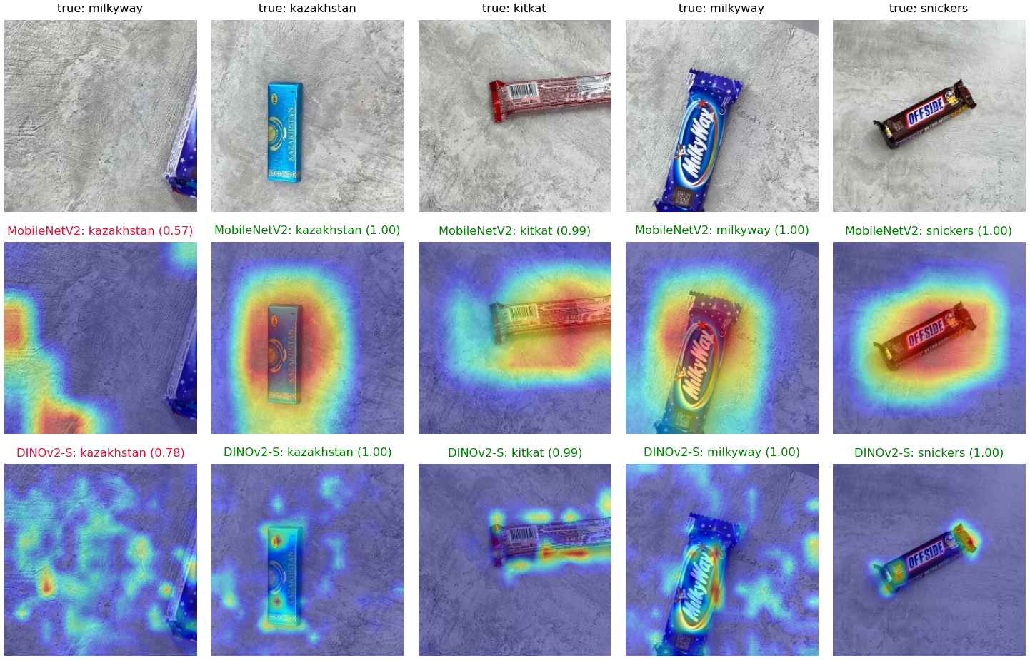
Figure 4. Grad-CAM on held-out test images (location 4). Top: input. Middle: MobileNetV2. Bottom: DINOv2-reg + synthetic data. Green = correct, red = wrong.
- MobileNetV2 maps are coarse blobs that cover the bar and some of the surface around it.
- DINOv2 maps follow the wrapper: the logo of Milky Way, the barcode and edge of KitKat, the end of Snickers. With plain DINOv2 (first run, no registers) the same maps were scattered over the concrete background, the artifact effect that registers remove.
- The first column is the only test error of both models: a Milky Way bar almost fully out of frame. Both predict Kazakhstan, the other blue wrapper, and both heatmaps sit on the empty floor. The models have no evidence and say so with low confidence (0.57 and 0.78).
Nearest neighbours. For each query the app and Figure 5 show the 5 most similar training images by cosine similarity of the DINOv2 embedding. A query with a clearly visible bar finds 5 images of the same bar at similarities 0.65–0.81, on all three training surfaces. That shows the embedding groups by wrapper, not by background.
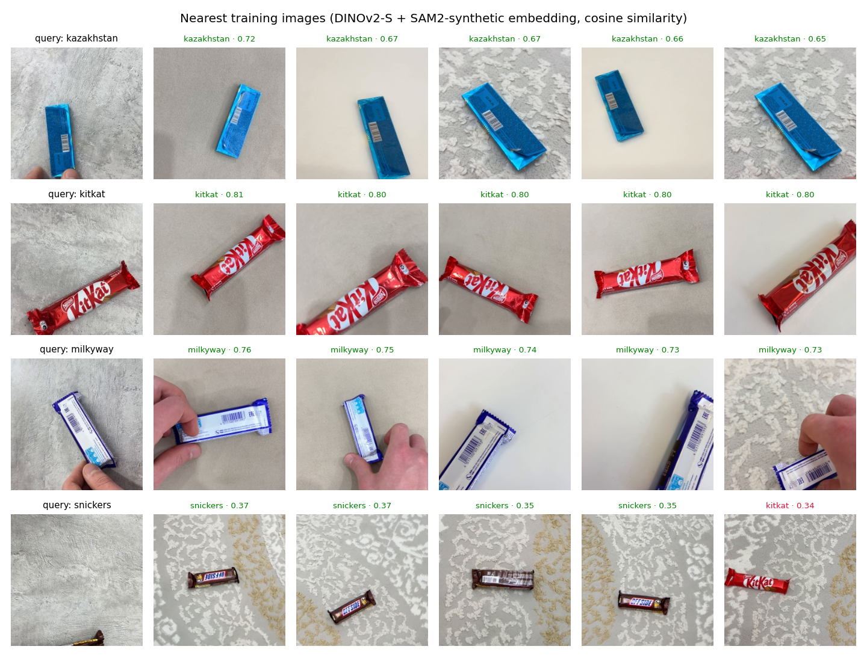
Figure 5. Queries from location 4 (left) and their 5 nearest training images with class and cosine similarity.
The Snickers query in the last row shows only a sliver of the bar. Its neighbours have similarity 0.34–0.37, about half the usual value, and one is a KitKat. The app uses exactly this signal: when the top similarity falls below the 2nd percentile of the test set (0.56), it warns that the photo may not show one of the four bars.

6. Demo application
The demo is a web app built with Gradio that runs the best DINOv2 model (DINOv2-reg + synthetic data) on a CPU. The flow is the one the assignment asks for: upload or camera → prediction → visual explanation.
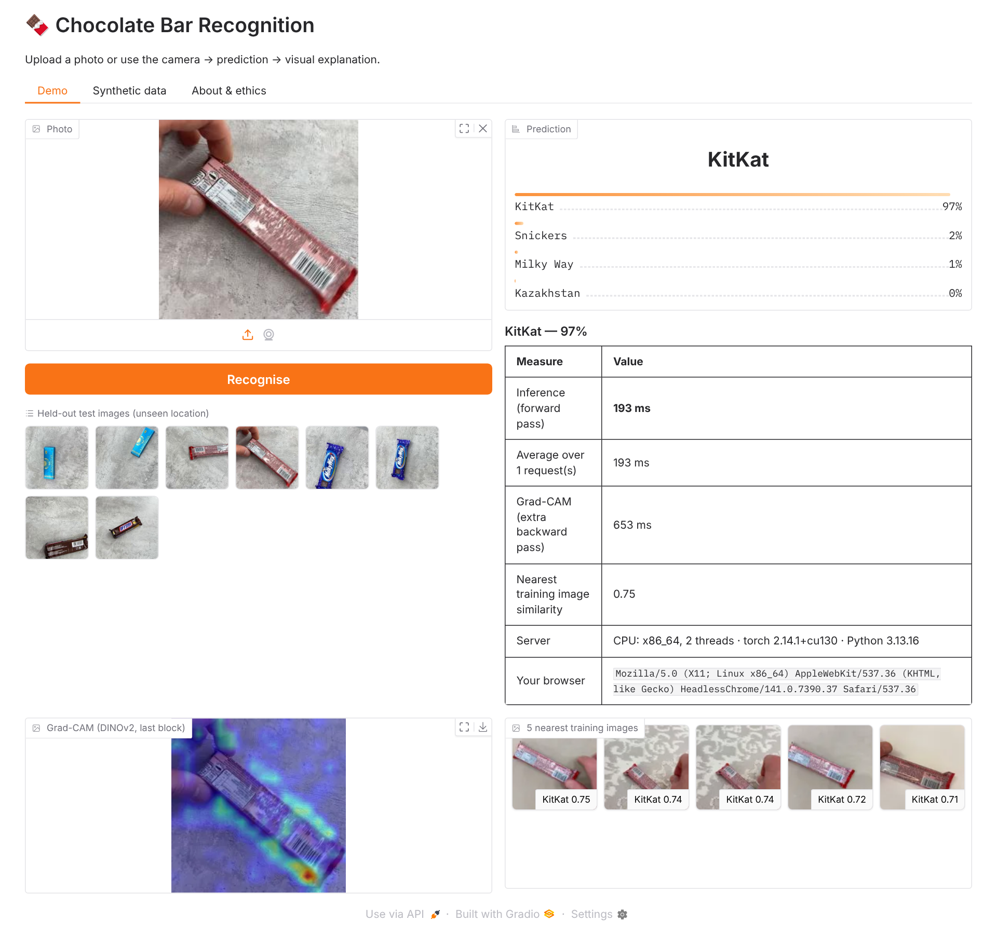
Figure 6. The demo app on a held-out KitKat image. Timings in this screenshot come from a small 2-thread test machine that was also running the browser.
- Input: upload or webcam, plus 8 held-out test images to click; photos are centre-cropped like the training frames.
- Output: probabilities for the 4 classes, a Grad-CAM heatmap and the 5 nearest training images with their similarity.
- Latency and environment: time of this request, session average, Grad-CAM time, server CPU and library versions, visitor's browser.
- Low-confidence warning when the top probability is below 60% or the nearest training image is less similar than 0.56, since the model always picks one of four classes.
- Extra tabs: labelled SYNTHETIC examples, and the model, metrics and ethics notes.
Free Gradio hosting on Hugging Face Spaces now requires a paid plan, so the app is submitted with a local run guide (Section 8). For a demonstration, python app.py --share creates a temporary public link.

7. Ethics and limitations
Consent and people. All 16 videos were filmed by the author. The only person visible is the author's hand, used with consent. No faces appear in the data. The app processes uploaded photos in memory and does not store them, and its About tab asks users not to upload photos of other people without consent.
Synthetic media. Synthetic composites are used only for training and never for validation or testing. Every synthetic image shown in this report (Figure 1) and in the app carries a visible SYNTHETIC label. No generative model invents new wrappers: each composite contains a real photographed bar on a real texture photograph.
Brands. Kazakhstan, KitKat, Milky Way and Snickers are trademarks of their owners. This is a non-commercial student project.
Misuse. The potential is low; the realistic risk is over-trust, because the app always names one of four classes. The low-confidence warning reduces this but does not reject inputs.
Bias and limitations.
- One physical bar per class, one phone, one person, four indoor surfaces. Other packaging versions, lighting or cameras may fail.
- Accuracy is at the ceiling (one error in 200), so differences of 0.5% between models are a single image and not significant.
- The SAM 2 filter is strict: it accepted only 25% of frames, and some accepted masks are still wrong (Figure 1, bottom row). 2 of the 14 composites inspected by eye show no bar, so part of the synthetic set carries a wrong label.
- SigLIP prompts were written once and not tuned; better prompts would likely raise its score.
- The stress test uses synthetic corruptions of one location, not real blurred or dark photos.

8. Reproducibility
Training and evaluation. Open A2_chocolate_sota.ipynb in Google Colab, choose a T4 GPU and select Run all (about 40 minutes). The only input is the A1 data folder on Google Drive (DRIVE_PATH, one sub-folder of videos per class). The notebook re-creates the A1 frames, installs SAM 2, downloads DTD and the pretrained models, trains all 16 configurations and saves figures.zip (tables, figures, results.json) and app_model.zip (model for the app). Seed 42; RUN_LOLO = False runs only the A1 split in about 10 minutes.
Component | Version / weights
DINOv2 | facebook/dinov2-with-registers-small (Hugging Face)
SAM 2 | facebook/sam2.1-hiera-small, official repo
SigLIP | google/siglip-base-patch16-224
MobileNetV2 | torchvision IMAGENET1K_V1
Backgrounds | Describable Textures Dataset (torchvision)
Run environment | Colab, Tesla T4, PyTorch 2.11, Python 3.13
Demo app. Python 3.10 or newer is required. In the app folder:
uv venv --python 3.12 && source .venv/bin/activate
uv pip install gradio==5.50.0 -r requirements.txt
python app.py # http://127.0.0.1:7860
python app.py --share # optional temporary public link
The app folder holds app.py, the trained weights (model/dino_classifier.pt, 44 MB), the nearest-neighbour gallery (model/gallery.npz), the configuration and the example images. The full step-by-step guide is in RUN_LOCALLY.md.

9. Conclusion
On a small, clean dataset a well-tuned MobileNetV2 is already at the ceiling, and SOTA components do not raise accuracy: every trained model reaches 98.8–99.0% across four unseen locations, while a zero-shot SigLIP reaches 80%. The SOTA components pay off elsewhere:
- DINOv2 with registers gives the clearest explanations, the best retrieval (P@5 0.991) and the best robustness to partial views and occlusion, at 6× the CPU latency and worse robustness to blur.
- SAM 2 synthetic data roughly halves the spread across locations and makes MobileNetV2 robust to blur, but its masks need a strict filter and still let some errors through.
- Leave-one-location-out and stress testing were more informative than the single A1 test split: they show where the models differ when accuracy alone does not.
For a phone app MobileNetV2 + synthetic data is the better choice; for explanations and image search DINOv2 is. The next step is harder data rather than a bigger model: more bars per class, outdoor and low-light photos, and real partial views, so that the remaining differences become measurable.

References
- Oquab M. et al. DINOv2: Learning Robust Visual Features without Supervision. 2023.
- Darcet T. et al. Vision Transformers Need Registers. ICLR 2024.
- Ravi N. et al. SAM 2: Segment Anything in Images and Videos. 2024.
- Zhai X. et al. Sigmoid Loss for Language Image Pre-Training (SigLIP). ICCV 2023.
- Selvaraju R. R. et al. Grad-CAM: Visual Explanations from Deep Networks. ICCV 2017.
- Sandler M. et al. MobileNetV2: Inverted Residuals and Linear Bottlenecks. CVPR 2018.
- Cimpoi M. et al. Describable Textures Dataset (DTD). CVPR 2014.
- Neurohive. FAIR developed DINO architecture for self-supervised image analysis. 2021.
- Neurohive. MedSAM2: Open Source SOTA 3D Medical Image and Video Segmentation Model. 2025.
- Myssyrgaliyev M. Chocolate Bar Recognition with a Self-Collected Image Dataset. CV Assignment 1 report, AITU, 2026.

