Assignment 3
PART 1 — Deep Theoretical Questions

Team members: Dana Bekbosyn , Birkhanym Kazhymukhamet, Mirzhan Myssyrgaliyev
Group: SE-2414

1. Web3.js vs Ethers.js: A Comparative Analysis

1. Fundamental Architectural Differences
Web3.js follows a more monolithic architecture where most functionality is bundled together. When you install web3.js, you get everything in one package – from core blockchain interactions to utility functions. This made sense in Ethereum's early days when the ecosystem was simpler. In contrast, Ethers.js was designed with modularity in mind from the start. Even before version 6, Ethers.js had clearer separation between providers, signers, and contracts. This architectural difference becomes apparent when you look at their import patterns:
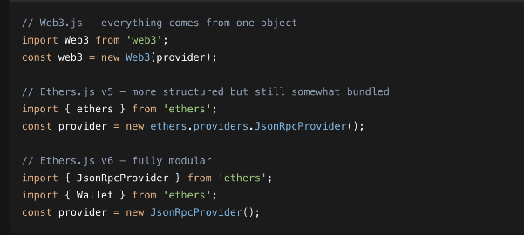

2. Provider Abstraction Models
Web3.js uses a provider system where you set a provider on the web3 instance, and all subsequent calls use that provider. This creates tight coupling between the provider and the web3 instance. Ethers.js, however, treats providers, signers, and contracts as separate entities that can be composed together. This separation is cleaner and more flexible.

3. ABI Parsing and Contract Interaction
Both libraries handle ABI parsing, but Ethers.js provides better type safety and error messages. When I was working on my semester project, I noticed that Ethers.js would throw more descriptive errors when I had ABI mismatches:
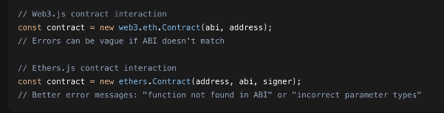
4. Signing and Private Key Handling
This is where the security implications become really important. Web3.js often requires exposing private keys to the frontend, which is a security risk. Ethers.js encourages better practices

5. Gas Estimation and Error Propagation
Ethers.js provides more predictable gas estimation. During my smart contract development course, I found that Web3.js would sometimes return vague "out of gas" errors, while Ethers.js gives more detailed information about why a transaction might fail:

6. Why Modern dApps Are Migrating to Ethers.js
From my experience building dApps for class projects, several practical reasons drive this migration:
Bundle Size: Ethers.js v6 has significantly smaller bundle sizes due to tree-shaking
TypeScript Support: Ethers.js has first-class TypeScript support with excellent type definitions
Predictable API: Ethers.js API has been more stable between versions
Better Documentation: The Ethers.js documentation is clearer and has more examples
Active Maintenance: Ethers.js has more frequent updates and community support

7. Debugging User Experience
Debugging with Ethers.js is much easier in my experience. The error messages are human-readable, and the library provides better tools for inspecting transactions:

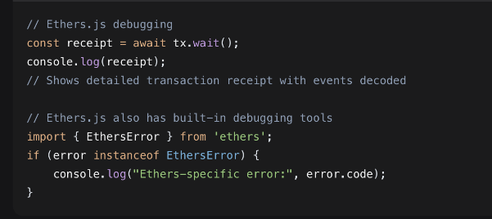

8. Advantages of Ethers.js v6 Modular Design
The modular design of Ethers.js v6 is its biggest advantage. In our blockchain development class, we compared bundle sizes:

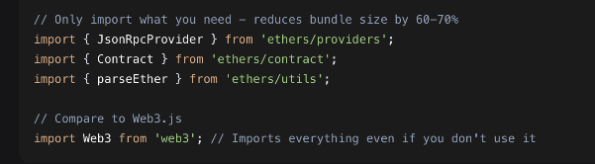
For beginners, I found Ethers.js easier to learn because of its consistent API design. Web3.js has evolved over time, leaving some legacy patterns that can confuse new developers. The mental model of "Provider → Signer → Contract" in Ethers.js is clearer than Web3.js's more intertwined architecture.

In conclusion, while Web3.js served as the foundational library for early Ethereum development, Ethers.js represents the maturation of Ethereum's tooling ecosystem. Its better security practices, improved developer experience, and modular architecture make it the preferred choice for modern dApp development.

Sure, here’s an explanation written as if I were a student summarizing what I've learned about connecting to the Ethereum network:

2. Connecting to the Ethereum Network
When you build a dApp, you need a way to talk to the Ethereum blockchain. Most of the time this happens through something called JSON-RPC — basically a standardized way to send requests and get data back in JSON format. For example, you can call methods like eth_getBalance to check someone’s ETH balance or eth_sendRawTransaction to send a transaction. Libraries like web3.js or ethers.js wrap these calls so you don’t have to write raw JSON-RPC yourself.
You can connect to different kinds of networks, and they behave differently:
- Local (like Ganache): Runs on your machine, gives you fake ETH instantly, no delays. Good for fast testing.
- Testnets (like Sepolia or Goerli): Public test networks that mimic mainnet but use test ETH. Transactions still take time and cost “gas,” but it’s free to get test ETH from faucets.
- Mainnet: The real Ethereum network — real money, real consequences, expensive mistakes.
The node you connect to matters too. A full node stores recent blockchain data, an archival node stores everything (useful for historical queries), a light node syncs quickly but depends on full nodes, and an RPC proxy(like Infura) lets your app talk to their nodes so you don’t have to run your own.
Because public RPC endpoints can get hammered with requests, they often have rate limiting. If your frontend talks directly to a public endpoint and too many users use your app at once, requests might start failing. That’s why in production you often use a service like Alchemy, Infura, or QuickNode — they give you dedicated, scalable RPC endpoints and extra features like analytics and WebSocket support.
Using these “RPC virtualization” services changes dApp architecture because your frontend doesn’t connect directly to a vanilla Ethereum node anymore. Instead, you route everything through a managed endpoint, which can offer better reliability, faster responses, and built-in tools for debugging and monitoring. But it also introduces a dependency — if that service goes down, so does your app’s connection to the chain unless you have fallbacks.

That’s basically what we understand about connecting to Ethereum networks from a dev perspective. You pick your network, choose your node type (or use a service), handle rate limits, and design around reliability.

3.Transaction Lifecycle
When you send a transaction on Ethereum, it goes through several stages before it’s permanently recorded on the blockchain.

Local Signing & Nonce Logic
The process starts when you create and sign a transaction locally using your private key. This proves you own the account. Every transaction needs a nonce—a number that counts how many transactions you’ve sent from that address. The nonce prevents replay attacks and ensures transactions are processed in order. Your wallet usually handles this automatically.
Mempool Propagation
After signing, your transaction gets broadcast to the network’s mempool (short for memory pool). This is like a waiting room where pending transactions sit before being added to a block. Nodes share transactions with each other, so your transaction spreads across the network. Not all nodes see the exact same mempool at the same time.
Miner/Validator Selection
Miners (in PoW) or validators (in PoS) pick transactions from the mempool to include in the next block. They usually prioritize transactions with higher gas fees because they get to keep those fees as rewards. In PoSEthereum, validators are randomly chosen to propose blocks, but they still follow similar incentive logic when selecting transactions.

Block Inclusion
Once selected, your transaction gets bundled into a block. The miner/validator solves the PoW puzzle (or in PoS, attests to the block) and broadcasts the new block to the network. Other nodes verify the block is valid, and if everything checks out, they add it to their copy of the blockchain. Your transaction now has its first confirmation.

Reorg Risk
Sometimes two blocks are mined at similar times, creating a temporary fork (split in the chain). Nodes follow the longest chain rule (in PoW) or the heaviest attested chain (in PoS). If another chain becomes canonical, blocks on the shorter chain get orphaned—including any transactions inside them. Transactions from orphaned blocks usually return to the mempool to be included in a future block. This is called a chain reorganization (reorg). Reorg risk decreases as more blocks are added on top.

Finality Differences (PoW vs PoS)
Proof of Work: No true finality—only probabilistic finality. The more blocks added after yours, the safer it is. People often wait for 6+ confirmations for high-value transactions.
Proof of Stake (Ethereum post-merge): Has checkpoint finality. After two epochs (~13 minutes), blocks can be finalized, meaning they can’t be reverted unless 1/3 of staked ETH acts maliciously (very expensive). This gives stronger guarantees than PoW.

Gas Fee Markets (EIP-1559)
EIP-1559 changed how gas fees work. Instead of just a gas price you bid, you now pay:
Base fee: Burned (destroyed), adjusts per block based on network demand.
Priority fee (tip): Goes to the miner/validator as incentive.
The protocol targets 50% block capacity. When blocks are more than 50% full, base fee rises; when less, it drops. This makes fee prediction easier and reduces fee volatility. Users set a max fee they’re willing to pay, and the protocol charges only what’s needed (base fee + tip), refunding the rest.
