Assignment 3 (Blockchain)
Part 2 Report
Part 2A - Minimal dApp (Ethers.js + MetaMask)

Goal
Build a minimal web page that connects to MetaMask and reads data from a deployed smart contract. The UI must display the connected wallet address and the read results. Error handling is required.

Implementation summary
- Wallet connection via window.ethereum (MetaMask).
- Provider and signer created using ethers.js (BrowserProvider).
- Contract instance created with contract address + ERC-20 ABI.
- Read functions: name(), symbol(), decimals(), totalSupply(), balanceOf(user).
- Basic validation: address format check + network (chainId) check.
- Error handling: user rejection, wrong network, invalid address, call failures.

How to run (local)
- Start local Hardhat network: npx hardhat node
- Deploy contract to localhost: npx hardhat run scripts/deploy.js --network localhost
- Open the web page via a local server (e.g., npm http-server) to avoid browser module restrictions.
- In MetaMask select Localhost 8545 (chainId 31337) and connect wallet.
- Paste deployed contract address into the input field and click Read.
Screenshot 1 - Wallet connected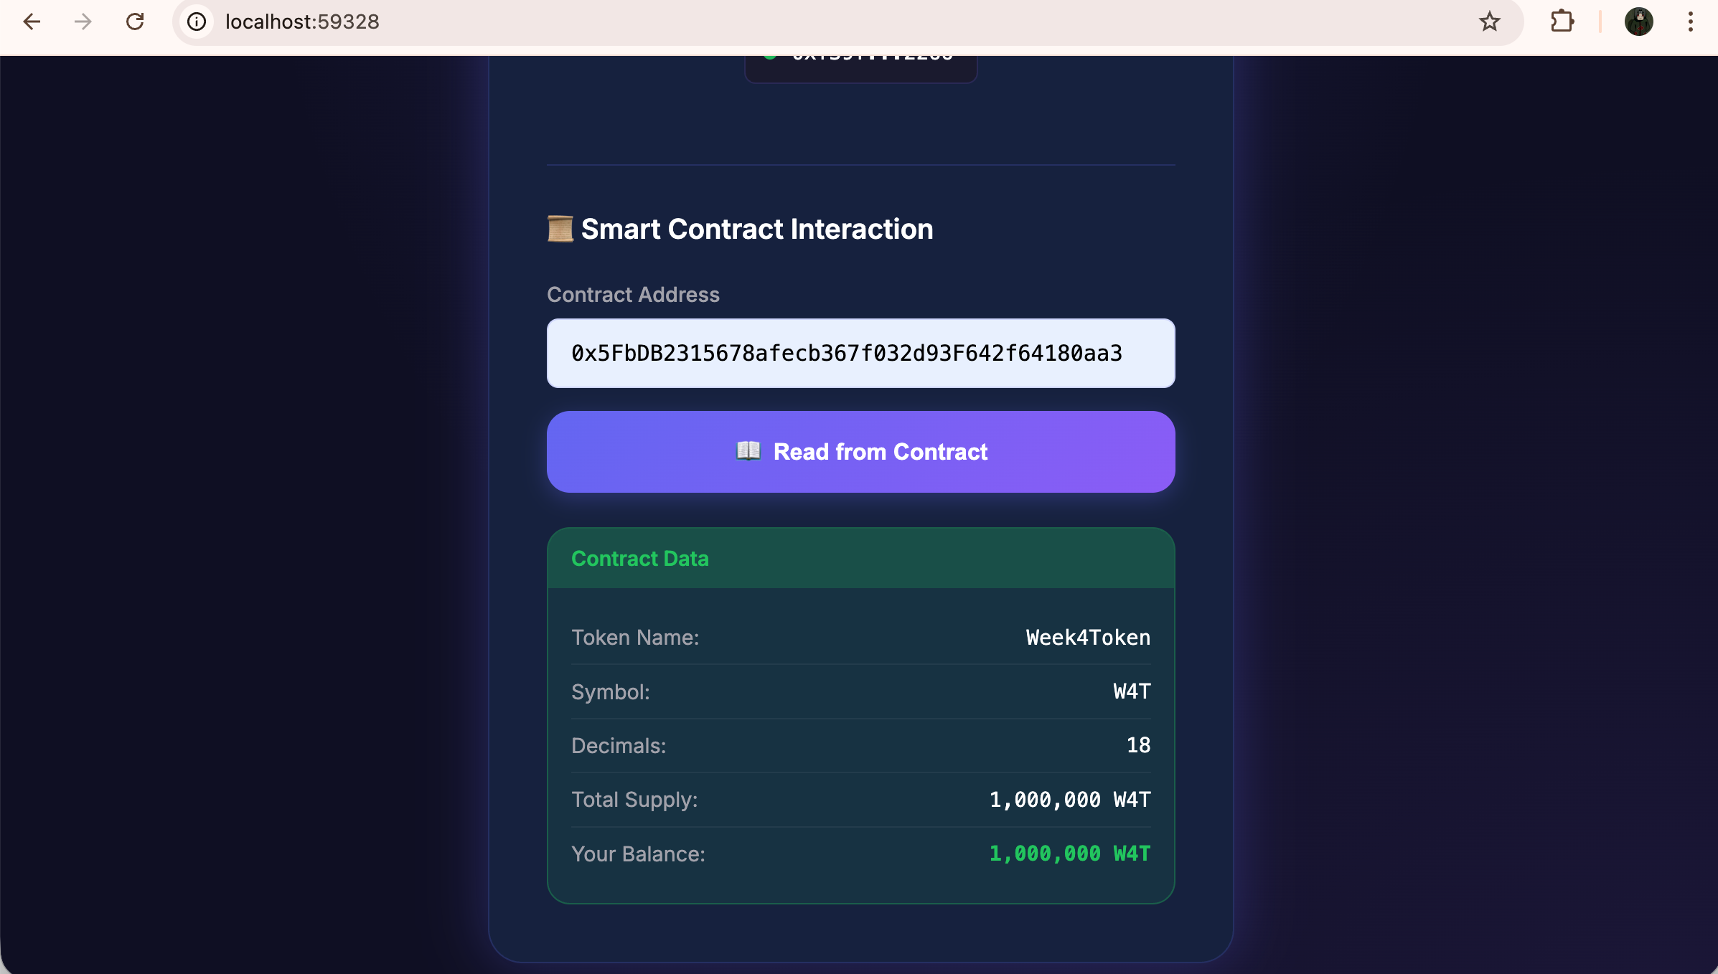

Screenshot 2 - Successful read from contract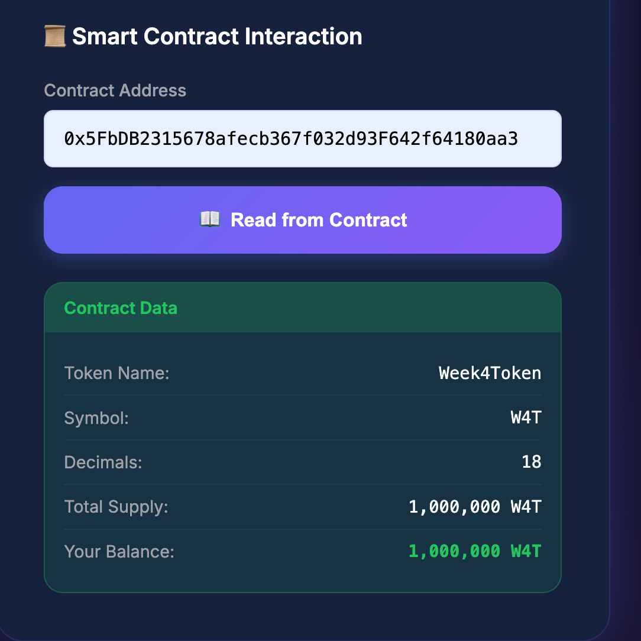

Screenshot 3 - Error handling
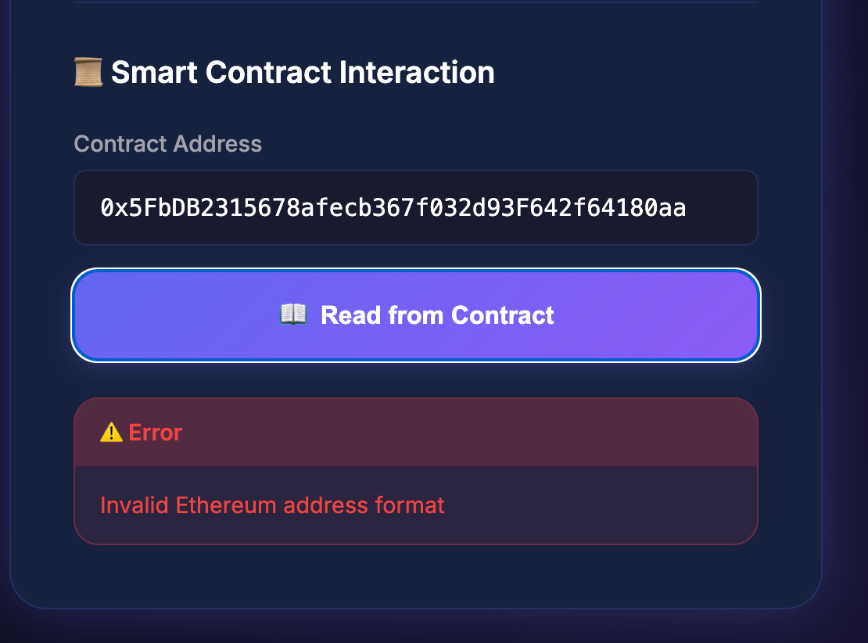

Part 2B - Security Discussion (2-3 pages)

1. Context and scope
This report discusses key security risks for a minimal decentralized application (dApp) built with Ethers.js and MetaMask. The dApp connects a user wallet, reads data from a deployed smart contract (e.g., ERC-20 token metadata and balances), and displays results in the UI. Even a read-only dApp can expose users to serious security and privacy risks if the front-end, wallet connection flow, and RPC usage are handled incorrectly.

2. RPC exposure risks (API keys, endpoints, privacy)
Most dApps use an RPC provider (Infura, Alchemy, QuickNode, etc.) to query blockchain state. RPC endpoints can be public or protected by API keys. Key risks include leakage of RPC API keys, user privacy leakage through RPC logs, and endpoint tampering (malicious RPC returning misleading data). Mitigations: never store secrets in client-side code; use backend proxy + rate limiting for protected endpoints; rotate keys; minimize unnecessary calls; validate chainId and display contract address + network clearly to users.

3. Cross-Site Scripting (XSS) in a dApp front-end
XSS occurs when untrusted input is inserted into the page as executable HTML/JS. In dApps, XSS can be used to manipulate wallet interactions and trick users into signing actions. Common vectors: writing untrusted strings into innerHTML, rendering user input without sanitization, loading third-party scripts from untrusted CDNs. Mitigations: use textContent instead of innerHTML; sanitize any dynamic HTML; apply a strict Content Security Policy (CSP); pin dependency versions and avoid untrusted scripts.

4. Replay attacks on signatures (message signing risks)
If a dApp requests message signatures (e.g., login), replay attacks happen when a valid signature is reused elsewhere. Risks increase when using static messages and personal_sign without nonce/domain/chainId. Mitigations: use EIP-712 typed data signing; include nonce + timestamp + chainId + explicit purpose; enforce one-time nonce usage server-side; clearly show users what they sign.

5. Malicious Web3 injection and wallet phishing
Users can install malicious extensions that tamper with window.ethereum, or visit phishing clones of a legitimate dApp. Threats include fake prompts, UI overlays hiding details, and social engineering. Mitigations: display network + contract address prominently; educate users to verify domain and MetaMask confirmation screens; minimize permissions; use HTTPS and domain protection.

6. How wallets (MetaMask) reduce risk
Wallets isolate private keys from websites, require explicit user consent, and show transaction details (destination, approvals, gas). This provides a security boundary, but cannot fully prevent user mistakes or social engineering. Users can still sign malicious approvals or deceptive messages.

7. Practical checklist for a safer minimal dApp
Validate and display chainId; validate contract addresses and verify bytecode with getCode; avoid innerHTML; keep dependencies pinned; avoid exposing RPC secrets; provide clear error messages for rejections and wrong networks; show contract, account, and network in the UI.

8. Conclusion
Even a minimal Ethers.js dApp can be abused via front-end vulnerabilities (XSS), unsafe RPC usage (privacy leakage, key exposure), and wallet-related social engineering. The strongest practical defenses are secure UI practices, strict address/network validation, minimal permissions, careful RPC handling, and relying on wallet confirmation screens as a final safety boundary.

