Part 4 - Professional Hardhat Development Environment
Hardhat project with ERC-20 + ERC-721 contracts, tests, deploy scripts, gas reporting, dotenv, and console usage

1. Overview
This document is the report for Part 4. It provides evidence of a full professional Hardhat environment: contract compilation, deployment scripts, local test network, automated tests, Hardhat console usage, gas reporting, and environment variable management (dotenv).

2. Requirements Checklist (Part 4)
- Contract compilation (Hardhat compile)
- Deployment scripts for ERC-20 and ERC-721
- Local test network (Hardhat node / localhost)
- Automated tests (Mocha/Chai)
- Hardhat console usage (interactive contract calls)
- Gas reporting plugin (hardhat-gas-reporter)
- dotenv secret management (.env not submitted; .env.example included)
- Submission: full project folder WITHOUT node_modules

3. Installation
Install dependencies and prepare environment variables:
npm install
cp .env.example .env
# edit .env only if deploying to testnet (optional)

4. Project Structure
Project folder structure:
Part4/
├── contracts/
│ ├── MyToken.sol # ERC-20 token
│ └── MyNFT.sol # ERC-721 NFT
├── scripts/
│ ├── deploy-token.ts # ERC-20 deploy
│ └── deploy-nft.ts # ERC-721 deploy
├── test/
│ ├── MyToken.test.ts # ERC-20 tests
│ └── MyNFT.test.ts # ERC-721 tests
├── docs/
│ └── ERC_STANDARDS_ANALYSIS.md
├── hardhat.config.ts
├── .env.example
└── package.json

5. Commands

5.1 Compile
npm run compile
# or
npx hardhat compile

5.2 Test
npm run test
# or
npx hardhat test

5.3 Gas Report
npm run test:gas
# or
REPORT_GAS=true npx hardhat test

5.4 Local Network
npm run node
# or
npx hardhat node

5.5 Deploy
# local deploy
npm run deploy:token:local
npm run deploy:nft:local
# testnet (requires .env)
npm run deploy:token -- --network sepolia
npm run deploy:nft -- --network sepolia

6. Smart Contracts

6.1 MyToken (ERC-20)
- ERC-20 standard token (OpenZeppelin ERC20)
- Ownable access control (mint restricted to owner)
- Burnable extension (holders can burn their tokens)
- Batch transfer function (multiple recipients)
- Custom decimals() override

6.2 MyNFT (ERC-721)
- ERC-721 NFT collection (OpenZeppelin ERC721)
- URI Storage for per-token metadata (ERC721URIStorage)
- Enumerable extension for token enumeration (ERC721Enumerable)
- Public mint with payment and supply cap
- Owner mint (free minting for any address)
- Minting controls (toggle minting, set mint price, set base URI)
- Withdraw function for collected funds

7. Testing
Automated tests are implemented using Mocha/Chai via Hardhat Toolbox. All tests pass.
Observed result: 39 passing.
Screenshot 1 - Test run (npx hardhat test)
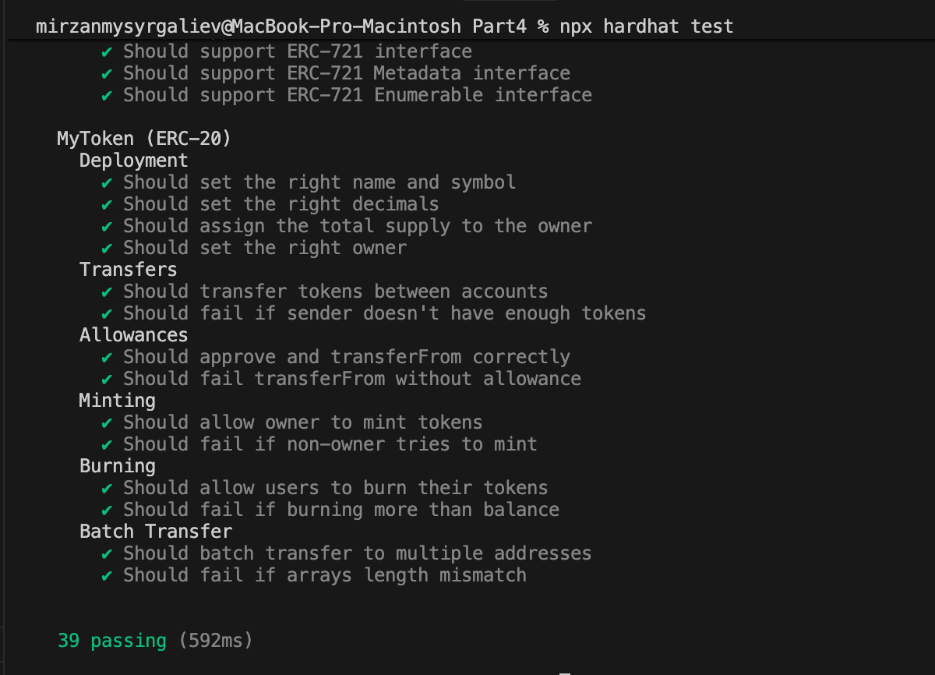

8. Gas Report
Gas reporting is enabled via hardhat-gas-reporter. Run tests with REPORT_GAS=true to produce the gas table (methods + deployments).
Screenshot 2 - Gas report table (REPORT_GAS=true npx hardhat test)
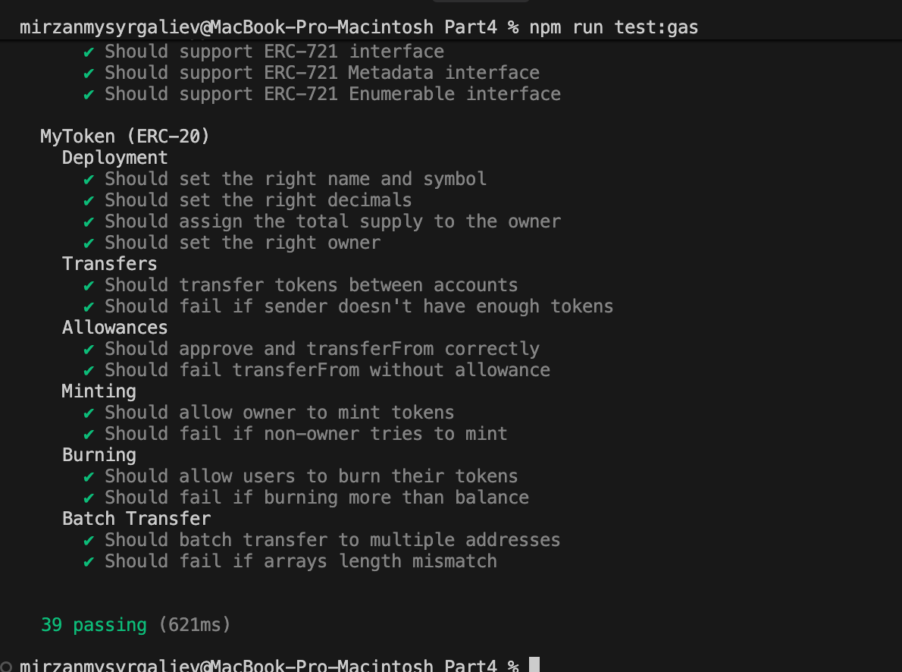

9. Deployment (Localhost)
Local deployment was executed on Hardhat node (localhost).
Deployed contract addresses (localhost):
- MyToken: 0x5FbDB2315678afecb367f032d93F642f64180aa3
- MyNFT: 0xe7f1725E7734CE288F8367e1Bb143E90bb3F0512

Screenshot 3 - Deploy output (deploy-token.ts and deploy-nft.ts)
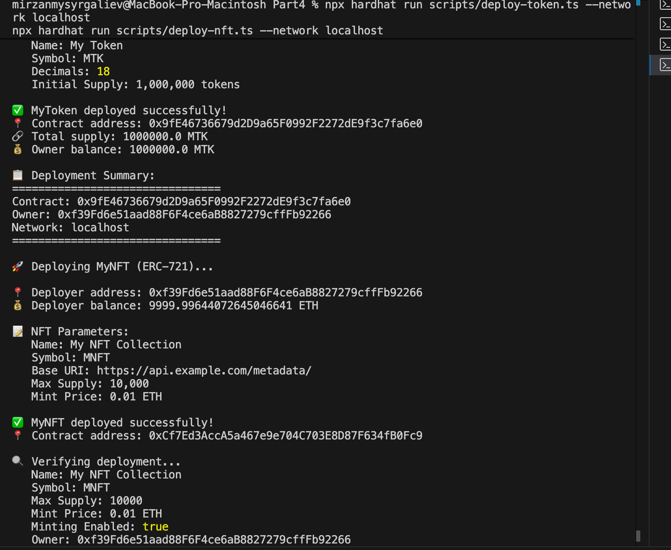

10. Hardhat Console
Hardhat console provides an interactive environment to call deployed contract methods and verify state.
Commands:
npx hardhat console --network localhost
Example console session (replace addresses if re-deployed):
const t = await ethers.getContractAt('MyToken', '0x5FbDB2315678afecb367f032d93F642f64180aa3')
await t.name()
await t.symbol()
await t.totalSupply()
const n = await ethers.getContractAt('MyNFT', '0xe7f1725E7734CE288F8367e1Bb143E90bb3F0512')
await n.name()
await n.symbol()
await n.maxSupply()
await n.mintPrice()
await n.mintingEnabled()
Screenshot 4 - Hardhat console usage
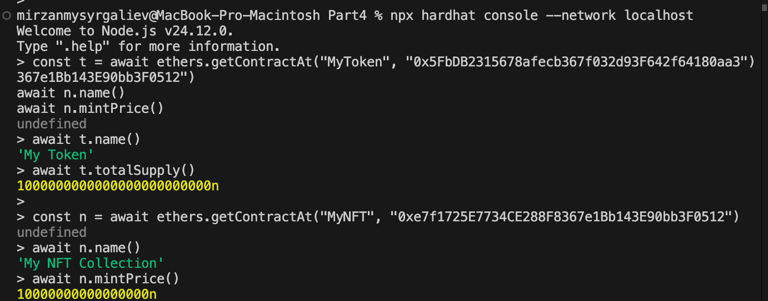

11. Configuration

11.1 Environment Variables (.env)
The project uses dotenv. The .env file is NOT included in submission; only .env.example is provided.
SEPOLIA_RPC_URL=
PRIVATE_KEY=
ETHERSCAN_API_KEY=
COINMARKETCAP_API_KEY=
REPORT_GAS=true

11.2 Networks
Network | Chain ID | Description
hardhat | 31337 | Built-in Hardhat network
localhost | 31337 | Local Hardhat node
sepolia | 11155111 | Ethereum testnet (optional)

12. Security Notes
- OpenZeppelin implementations used for ERC-20 and ERC-721 standards.
- Access control via Ownable (restricted minting/admin actions).
- Input validation for minting/payment and array length checks in batchTransfer.
- Withdraw uses call pattern and checks success.

13. ERC Standards Analysis
See: docs/ERC_STANDARDS_ANALYSIS.md (ERC-20 vs ERC-721 analysis).

14. Submission Notes
- Remove node_modules before zipping the project.
- Do not include .env in the submission archive; include .env.example instead.
- Include this report document and required screenshots.

