Assignment 3 - Blockchain
Part 5 - Token Contract Unit Tests (Hardhat)

1. Objective
Implement and run unit tests for the ERC-20 token contract in Hardhat. The test suite covers basic balances, successful transfers, failing transfers, edge cases, gas estimation, event emission, storage verification, and negative tests.

2. Environment
- Framework: Hardhat + ethers
- Language: Solidity + JavaScript
- Command used: npx hardhat test
- Token contract under test: MyToken (ERC-20)

3. Implementation Summary
A dedicated test file was created (test/token.test.js). The deploy helper deploys the token contract and provides test accounts (owner, alice, bob). Each test validates expected state changes or reverts.

4. Test Coverage
Requirement | Test name | Expected result | Screenshot
Basic balance checks | Basic balance checks | Owner has initial supply (>0); new account has 0 balance | S2
Transfer tests | Transfer tests: updates balances | Balances updated correctly after transfer | S3
Failing transfer tests | Failing transfer: insufficient balance reverts | Transaction reverts when balance is insufficient | S4
Edge case: transfer to yourself | Edge case: transfer to yourself | Transaction succeeds and net balance unchanged | S5
Gas estimation tests | Gas estimation tests: success vs fail | estimateGas succeeds for valid transfer and reverts for failing case | S6
Event emission tests | Event emission tests: Transfer emitted | Transfer event emitted with correct args | S7
Storage verification | Storage verification: final balances consistent | Storage/balances reflect expected final state | S8
Negative tests | Negative tests: bad params (0 amount / zero address) revert | Invalid params revert | S9

5. Commands and Results
Run tests:
npx hardhat test
S1. Terminal output showing all Part 5 tests passing ("Part 5 — Token tests" and overall passing count).
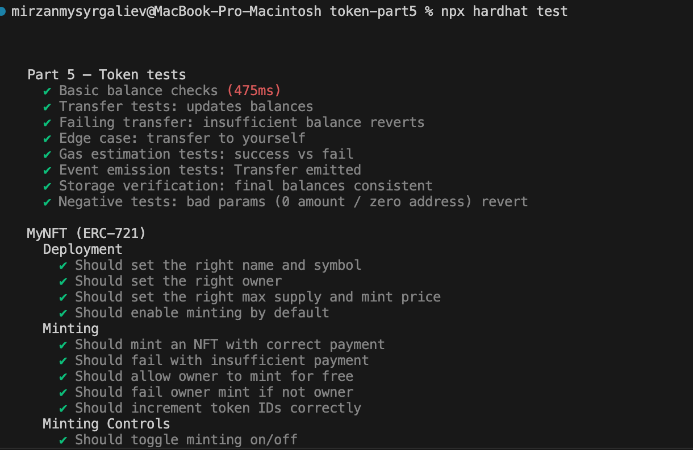

6. Evidence Screenshots
S2. Basic balance checks - test output or code snippet evidence.
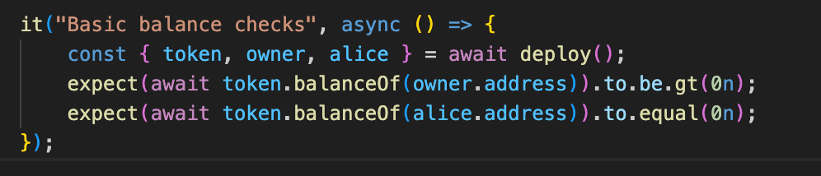

S3. Transfer success - test output (balances updated).
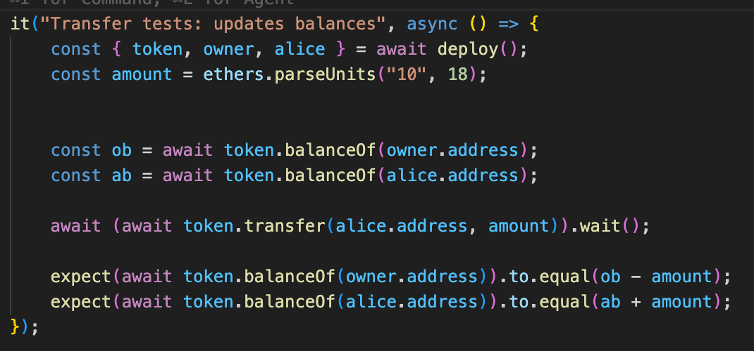

S4. Failing transfer - revert evidence.
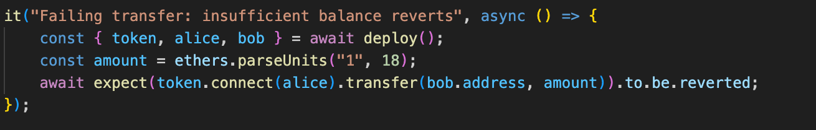

S5. Transfer to self - evidence.
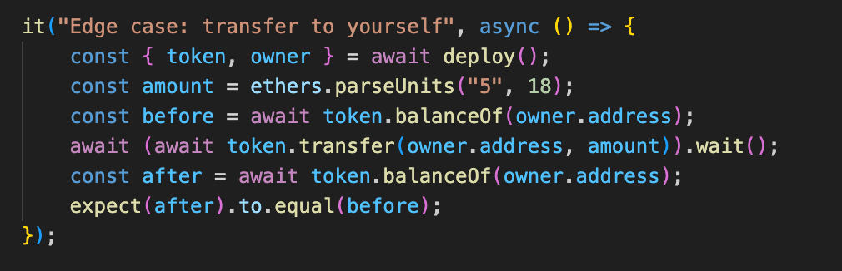

S6. Gas estimation - success vs fail evidence.
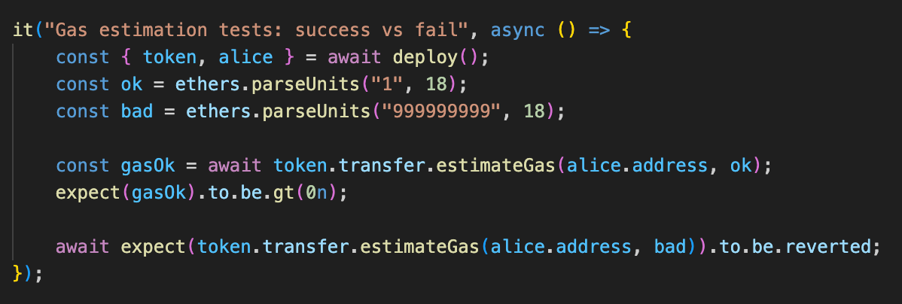

S7. Transfer event emission - evidence.
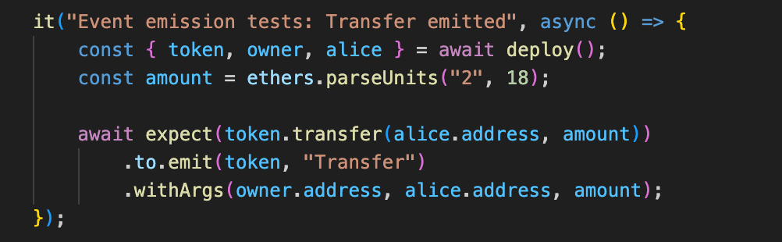

S8. Storage verification - evidence.
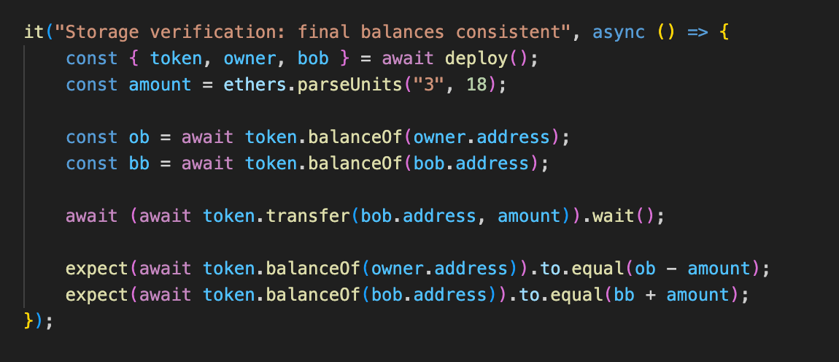

S9. Negative tests (0 amount / zero address) - revert evidence.
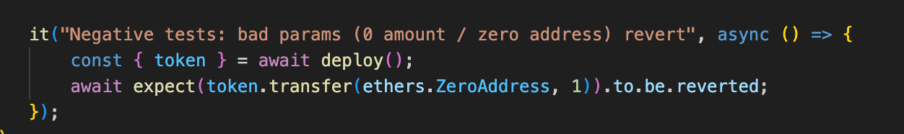

6. Conclusion
All Part 5 unit tests pass successfully. The test suite validates correct token behavior for successful and failing transactions, events, gas estimation, and storage updates.

