PART 7 — Blockchain Architecture & Consensus
SECTION A — Deep Architecture Exploration
Team members: Dana Bekbosyn , Birkhanym Kazhymukhamet, Mirzhan Myssyrgaliyev
Group: SE-2414

1. Blockchain Block Structure
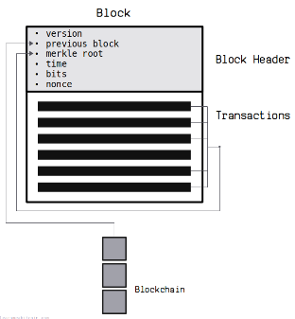
A blockchain is composed of a continuously growing sequence of blocks, where each block acts as a cryptographically secured container for a set of transactions. The block structure is fundamental to ensuring data integrity, transparency, and immutability.
A block can be divided into two major components: the block header and the block body.
The block header contains metadata that uniquely identifies the block and links it to the previous block in the chain. In most blockchain systems (such as Bitcoin and Ethereum), the block header includes:
- The hash of the previous block (parent hash)
- A timestamp indicating when the block was created
- The Merkle root of all transactions in the block
- Difficulty or target value
- Nonce (in Proof of Work systems)
The block body contains the actual list of transactions and, in more advanced blockchains like Ethereum, additional structures such as receipts and state changes.
In Ethereum, transactions are organized using a transaction trie, which is a specialized Merkle Patricia Trie. This structure allows efficient verification, insertion, and retrieval of transactions while maintainingcryptographic integrity. Each transaction is indexed, hashed, and included in the trie, whose root hash is stored in the block header. Any modification to a transaction changes the trie root, immediately invalidating the block.
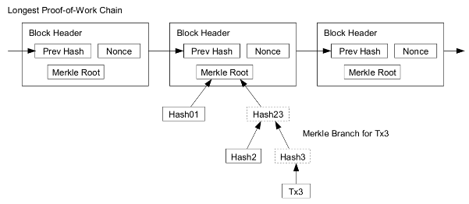

2. Merkle Trees: Proof Generation and Verification
A Merkle Tree is a binary tree structure used to efficiently summarize and verify large sets of data. Each leaf node represents the hash of a transaction, while each internal node represents the hash of the concatenation of its child nodes.
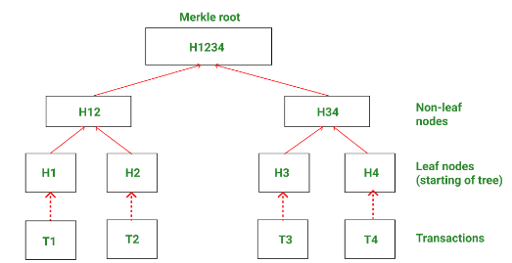
The top hash of the tree is called the Merkle Root, which is stored in the block header.
Proof generation works by providing a minimal set of sibling hashes required to reconstruct the Merkle root from a specific transaction. This proof is called a Merkle Proof.
Verification is performed by:
- Hashing the target transaction
- Iteratively hashing it with the provided sibling hashes
- Recomputing the Merkle root
- Comparing the result with the root stored in the block header
If the roots match, the transaction is proven to be part of the block without revealing all other transactions. This mechanism enables light clients to verify transactions securely without downloading the entire blockchain.
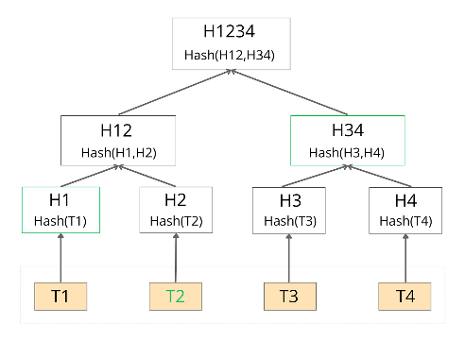

3. Link Structures Forming the Blockchain
Blocks are linked together through cryptographic hashes. Each block contains the hash of its parent block, forming a linear, append-only chain. This linkage creates immutability, because altering any block would require recomputing all subsequent blocks.
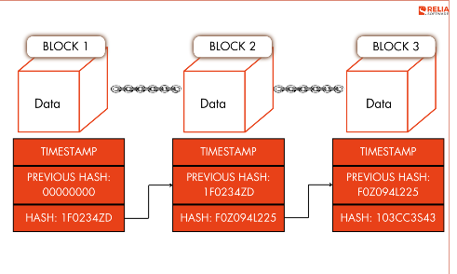
This structure ensures that:
- Historical data cannot be modified without detection
- The chain with the most accumulated work or stake is considered valid
- Trust is distributed across the network rather than centralized

4. Networking and Node Discovery
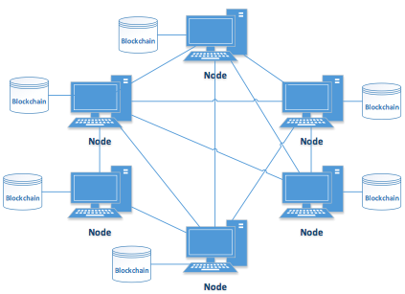
Blockchain networks operate on a peer-to-peer (P2P) architecture. There is no central server; instead, nodes communicate directly with each other.
Node discovery is achieved using:
- Bootnodes (initial contact points)
- Peer exchange protocols
- Distributed hash tables (DHT)
Once connected, nodes share information using gossip protocols, where data is propagated randomly but efficiently across the network.
Different node types include:
- Full nodes (store and validate the full blockchain)
- Light nodes (verify data using Merkle proofs)
- Validator or miner nodes (participate in consensus)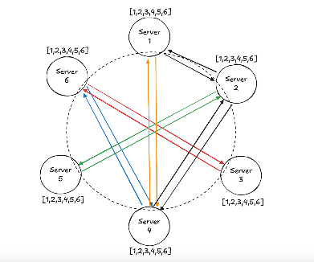

5. Transaction Propagation Model
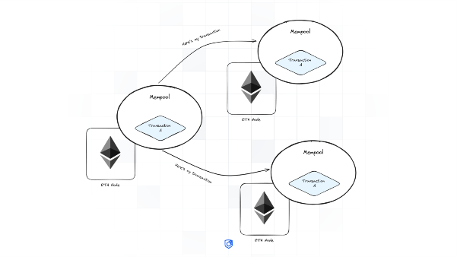
When a user creates a transaction, it is first signed locally and then broadcast to the network. The transaction enters the mempool, a temporary storage for unconfirmed transactions.
Transactions are propagated using gossip protocols. Nodes validate transactions before relaying them further. Miners or validators select transactions from the mempool based on priority rules such as transaction fees.

6. Mining Process in Proof of Work (PoW)
In Proof of Work systems, miners compete to solve a cryptographic puzzle by finding a nonce that produces a block hash below a target value.
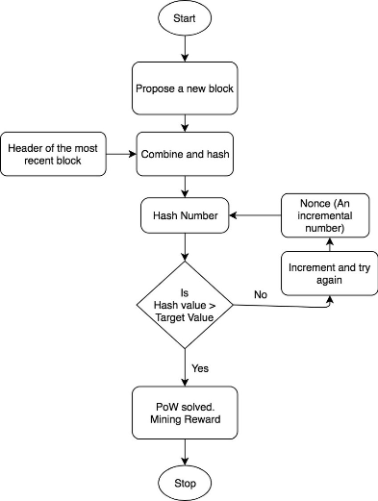
This process:
- Requires significant computational effort
- Is probabilistic in nature
- Provides security through economic cost
Once a miner finds a valid solution, the block is broadcast to the network and verified by other nodes. The miner receives a block reward and transaction fees.

7. Validation and Finality in Proof of Stake (PoS)
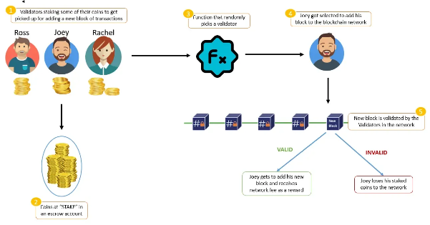
In Proof of Stake systems, validators replace miners. Validators are selected based on the amount of cryptocurrency they have staked.
In Ethereum post-Merge:
- Time is divided into slots and epochs
- Validators propose and attest to blocks
- Finality is achieved through economic penalties (slashing)
Once a block is finalized, reverting it would require destroying a large portion of the staked assets, making attacks economically irrational.

8. Fork Choice Rules
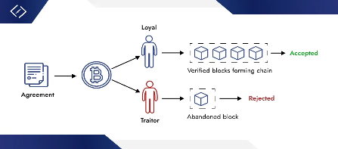
Nakamoto Consensus selects the longest (most work) chain as the valid one.
LMD-GHOST chooses the chain with the greatest weight of validator votes.
Gasper, used by Ethereum, combines LMD-GHOST for fork choice with Casper FFG for finality, providing both safety and liveness.
Text Diagram (Fork Choice):
Block A
├─ Block B1 ─ Block C1
└─ Block B2 ─ Block C2 (more votes → chosen)

SECTION B — Practice: Consensus Analysis
Proof of Work (PoW)
PoW provides strong security through computational difficulty. Attacks such as 51% attacks are expensive and visible. However, PoW consumes significant energy and requires specialized hardware.
Finality in PoW is probabilistic; blocks become more secure as more blocks are added.

Proof of Stake (PoS)
PoS relies on economic stake rather than computation. Validators are incentivized to behave honestly through rewards and penalties.
Ethereum PoS provides economic finality, while Cardano’s Ouroboros uses mathematically proven slot leadership.
PoS significantly reduces energy consumption but introduces risks such as stake centralization.

Delegated Proof of Stake (DPoS)
DPoS systems elect a small number of validators. This improves performance and throughput but reduces decentralization.
While DPoS achieves fast finality, it is more vulnerable to governance capture and cartel formation.

Comparative Summary
Model | Security | Finality | Decentralization | Energy | Hardware
PoW | Very High | Probabilistic | High | Very High | ASIC/GPU
PoS | High | Economic | Medium–High | Low | Standard
DPoS | Medium | Fast | Lower | Very Low | Standard

Conclusion
There is no universally perfect consensus model. Proof of Work prioritizes maximum security and decentralization through computational cost, but at the expense of energy efficiency and hardware centralization. Proof of Stake introduces economic finality and sustainability, while carefully shifting trust assumptions from computation to cryptoeconomic incentives. Delegated Proof of Stake optimizes performance and governance efficiency, but sacrifices decentralization and censorship resistance. The optimal consensus mechanism depends on the blockchain’s primary goals: security, scalability, decentralization, or governance efficiency.

EXPANDED ANALYSIS — SECURITY, ATTACKS, AND INCENTIVES

Security Guarantees Across Consensus Models
Proof of Work systems derive security from real-world physical costs. An attacker must acquire and operate a majority of the network’s total hash power, which requires enormous capital investment, energy consumption, and logistical coordination. This makes large-scale attacks economically irrational for mature networks such as Bitcoin.
Proof of Stake systems secure the network through economic bonding. Validators lock capital as stake, which can be destroyed through slashing if malicious behavior is detected. This creates direct financial consequences for attacks, enabling faster finality and lower operational costs. However, PoS security depends on correct protocol design and honest majority assumptions.
Delegated Proof of Stake relies on social consensus and governance mechanisms. Security is partially enforced through reputation and voting, which introduces human and political risk into the protocol layer.

Attack Surfaces and Threat Models
In PoW, the dominant threat is the 51% attack, where an attacker controls the majority of hash power. While theoretically possible, this attack is highly visible and costly. Selfish mining and mining pool centralization are additional concerns.
In PoS, attack vectors include nothing-at-stake, long-range attacks, and stake centralization. Modern PoS designs mitigate these through checkpointing, slashing, and weak subjectivity assumptions.
DPoS systems are vulnerable to cartel formation, vote buying, and governance capture, as a small number of validators can collude to censor transactions or manipulate protocol upgrades.

Finality Models
PoW provides probabilistic finality, meaning that transaction confidence increases over time but is never absolute.
PoS introduces economic finality, where finalized blocks cannot be reverted without destroying a significant amount of staked capital.
DPoS often achieves instant or near-instant finality, but this comes from trusted validator sets rather than decentralized consensus.

Decentralization Tradeoffs
PoW favors decentralization at the protocol level but often results in hardware and geographic concentration.
PoS lowers participation barriers but risks wealth concentration.
DPoS intentionally limits validator count, trading decentralization for performance and governance simplicity.

Economic Incentives
PoW miners are rewarded for expending resources.
PoS validators are rewarded for honest participation and punished for misbehavior.
DPoS validators are incentivized through governance rewards and political legitimacy.

Hardware Requirements
PoW requires specialized hardware (ASICs or GPUs).
PoS and DPoS can run on commodity hardware, improving accessibility.

