Restful

优雅的uri表达方式

资源的状态和状态转移

Get /seckill/list

Post /seckill/execute/{seckillid} 不好

Post /seckill/{seckillid}/execution

Get /seckill/delete/{id} 不好

Delete /seckill/{id}/delete

restful规范

Get->查询操作

Post->添加/修改操作

Put->修改操作

Delete ->删除操作

/user/{uid}/friends ->好友列表

/user/{uid}/followers->

Get /seckill/list->秒杀列表

Get /seckill/{id}/detail->详情页

Get /seckill/time/now ->系统时间

Post /seckill/{id}/exposer ->暴露秒杀

Post /seckill/{id}/{md5}/execution->执行秒杀

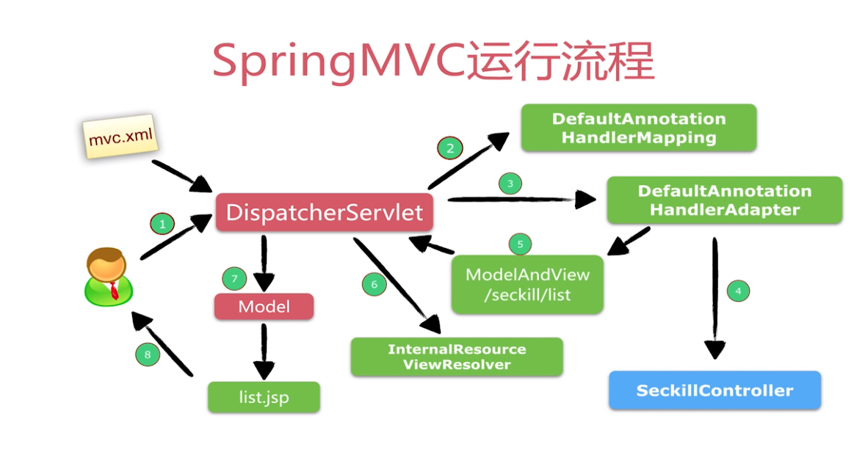

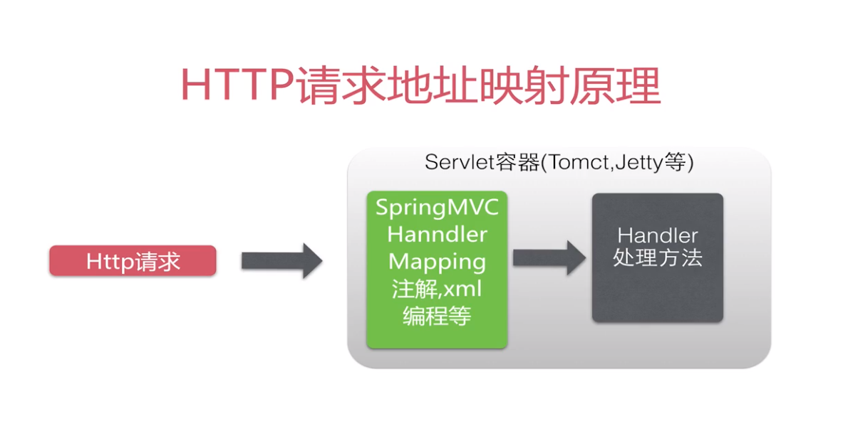

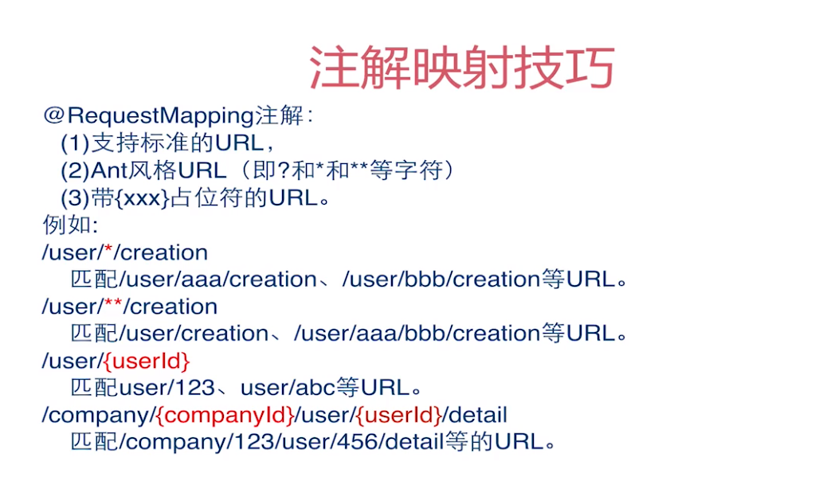

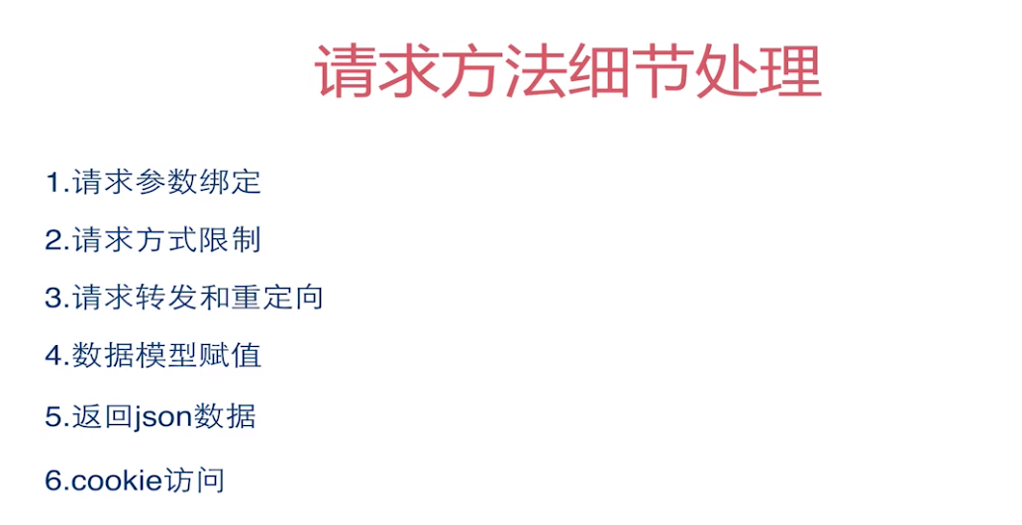

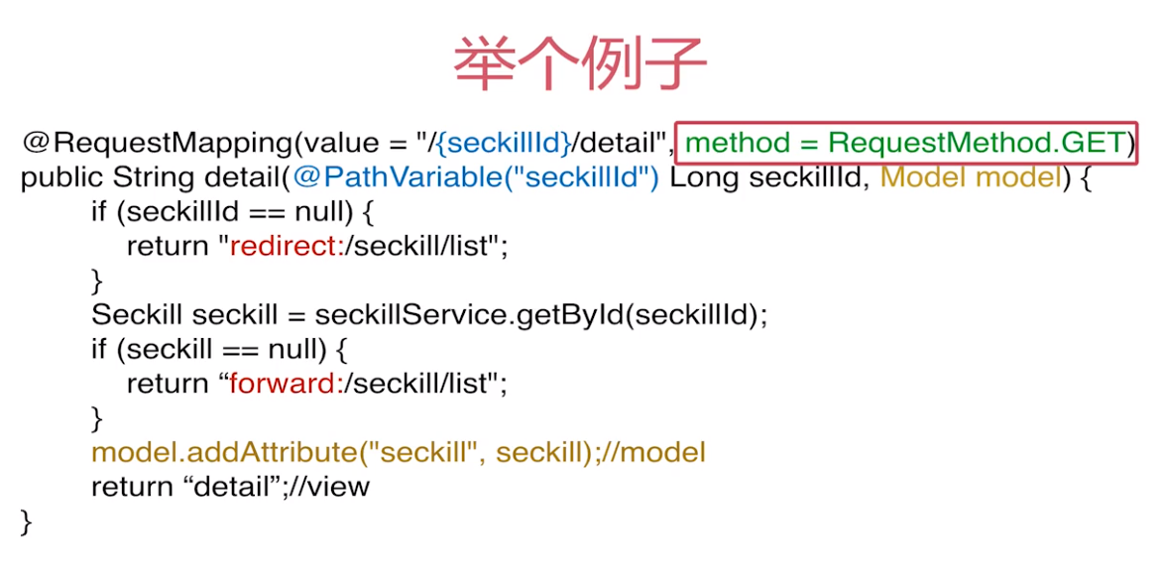

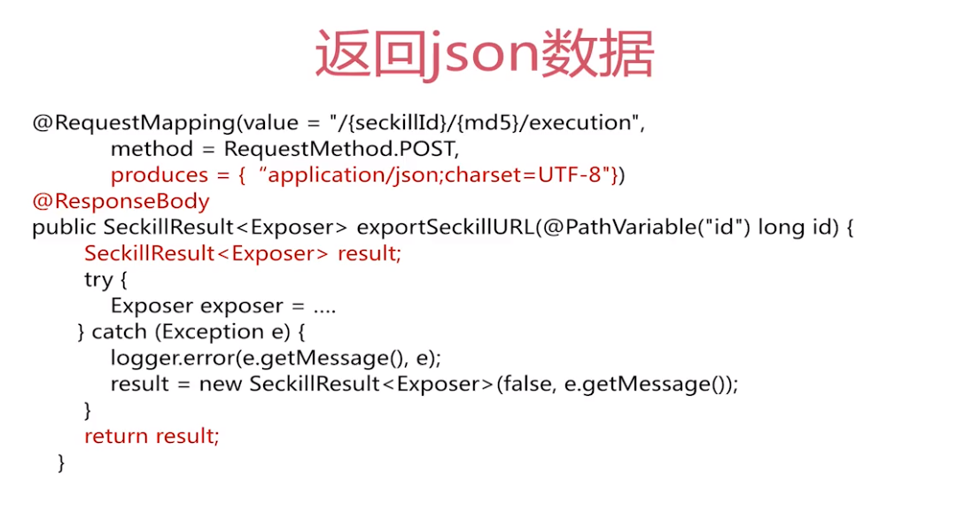

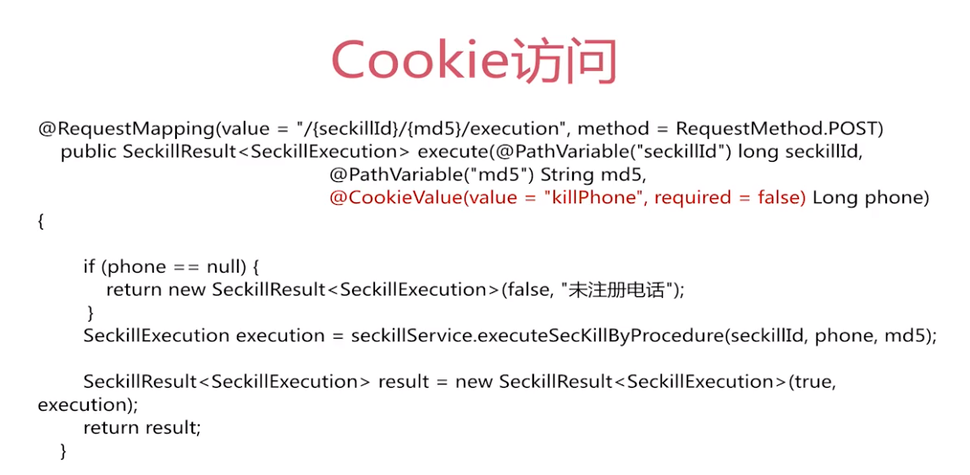

jsp静态引用

<%@include file=””%>

CDN 获取jquery插件 countdown，cookie操作插件

Js分模块

