Get start

Set up

<https://ci.apache.org/projects/flink/flink-docs-release-1.8/tutorials/local_setup.html>

<https://www.elastic.co/cn/blog/building-real-time-dashboard-applications-with-apache-flink-elasticsearch-and-kibana>

开启Flink

#./bin/start-cluster.sh

检查flink是否起来，有两种方法：

<http://localhost:8081>

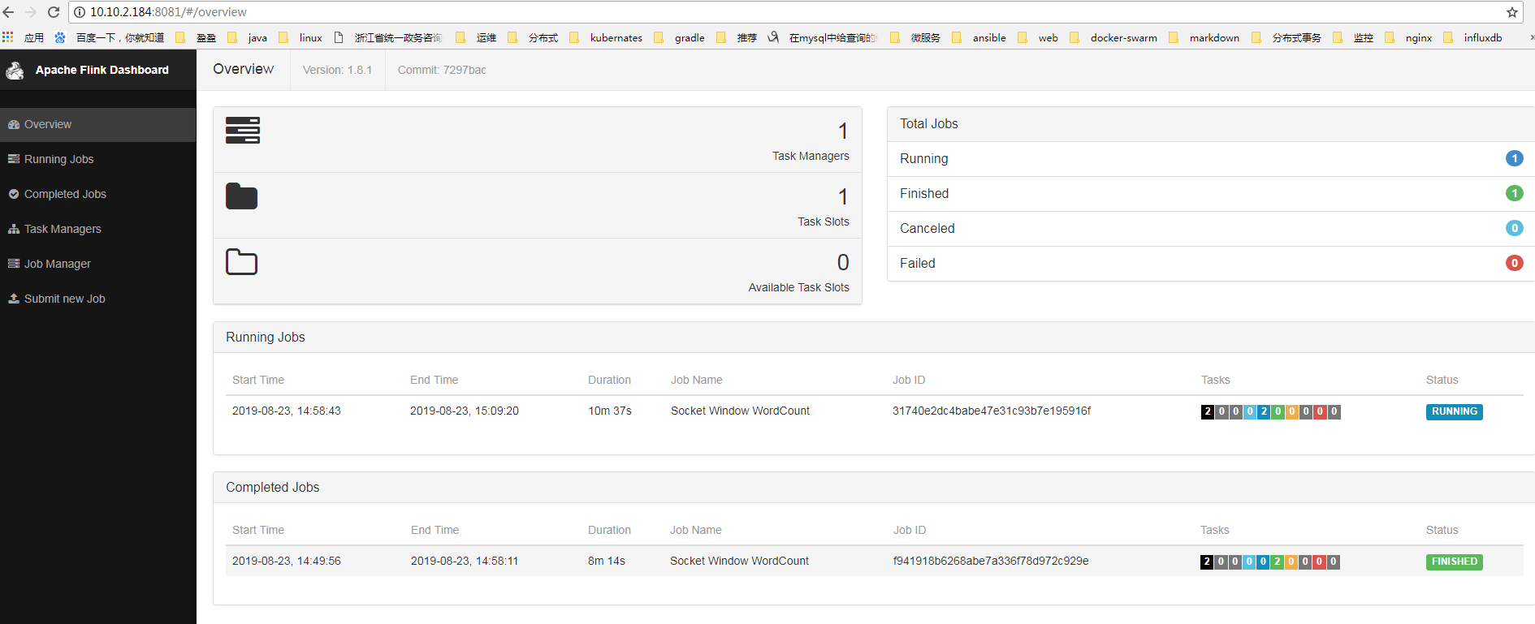

也可以查看日志 tail log/flink-*-standalonesession-*.log

用nc –l 9000 开启服务端口

./bin/flink run examples/streaming/SocketWindowWordCount.jar --port 9000

Starting execution of program

程序监听9000端口

当我们在nc –l 9000的界面输入，单词计数器就能获取到信息

$ nc -l 9000

lorem ipsum

ipsum ipsum ipsum

bye

单词统计结果会输出到日志文件中

$ tail -f log/flink-*-taskexecutor-*.out

lorem : 1

bye : 1

ipsum : 4

停止flink服务

$ ./bin/stop-cluster.sh

当log/flink-root-taskexecutor-3-localhost.localdomain.out日志文件出现下面的信息

Java HotSpot(TM) 64-Bit Server VM warning: INFO: os::commit_memory(0x00000000c6600000, 966787072, 0) failed; error='Cannot allocate memory' (errno=12)

#

# There is insufficient memory for the Java Runtime Environment to continue.

# Native memory allocation (mmap) failed to map 966787072 bytes for committing reserved memory.

# An error report file with more information is saved as:

# /home/soft/flink-1.8.1/hs_err_pid32445.log

查看cat /home/soft/flink-1.8.1/hs_err_pid32445.log

需要停止flink

#ulimit -c unlimited

启动flink。