yum install etcd -y

vim /etc/etcd/etcd.conf

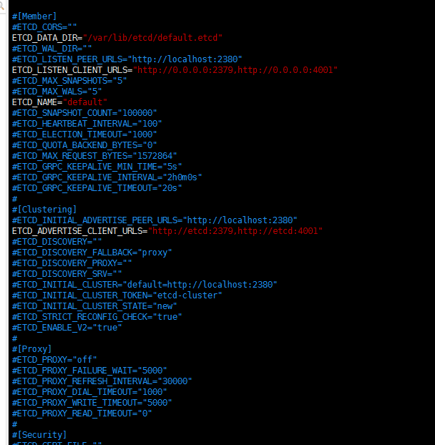

Systemctl start etcd

etcdctl cluster-health

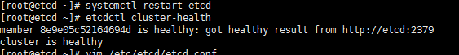

查看集群成员

