依赖jetcache-starter-redis就好了

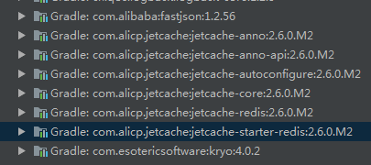

|  |
| --- |
| jetcache:  statIntervalMinutes: 15  areaInCacheName: false  local:  default:  type: linkedhashmap  keyConvertor: fastjson  expireAfterWriteInMillis: 100000  remote:  default:  type: redis  keyConvertor: fastjson  valueEncoder: kryo  valueDecoder: kryo  poolConfig:  minIdle: 5  maxIdle: 20  maxTotal: 50  host: 10.100.2.41  port: 6379  password: yinghuo |