这次安装是基于单机的，简单的部署。操作方法是按照rocketmq官方网站来处理。

<http://rocketmq.apache.org/docs/quick-start/>

需要注意的点：

1、rocket启动需要java8，高版本的java舍弃了一些参数，比如UseCMSCompactAtFullCollection

2、启动broker的时候，报错如下，原因是内存需求设置太大。

OpenJDK 64-Bit Server VM warning: If the number of processors is expected to increase from one, then you should configure the number of parallel GC threads appropriately using -XX:ParallelGCThreads=N

OpenJDK 64-Bit Server VM warning: INFO: os::commit_memory(0x00000005c0000000, 8589934592, 0) failed; error='Cannot allocate memory' (errno=12)

#

# There is insufficient memory for the Java Runtime Environment to continue.

# Native memory allocation (mmap) failed to map 8589934592 bytes for committing reserved memory.

# An error report file with more information is saved as:

# /home/software_install/rocketmq-all-4.7.0-source-release/distribution/target/rocketmq-4.7.0/rocketmq-4.7.0/hs_err_pid1391.log

解决办法：调整runbroker.sh脚本中的配置

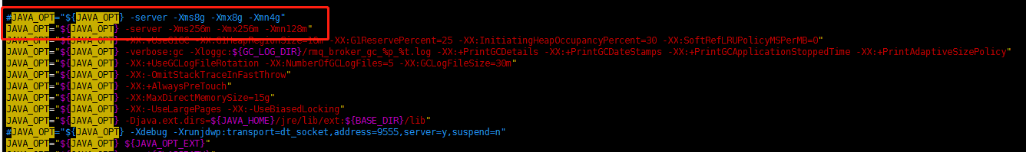

测试消息：

ConsumeMessageThread_8 Receive New Messages: [MessageExt [brokerName=localhost.localdomain, queueId=1,

storeSize=179, queueOffset=4, sysFlag=0, bornTimestamp=1590214676465, bornHost=/10.0.92.150:58780, storeTimestamp=1590214676467, storeHost=/10.0.92.150:10911, msgId=0A005C9600002A9F0000000000000C8C,

commitLogOffset=3212, bodyCRC=89962020, reconsumeTimes=0, preparedTransactionOffset=0, toString()=Message{topic='TopicTest', flag=0, properties={MIN_OFFSET=0, MAX_OFFSET=197,

CONSUME_START_TIME=1590214691242, UNIQ_KEY=0A005C9606656BC7C054745D5FF10012, WAIT=true, TAGS=TagA}, body=[72, 101, 108, 108, 111, 32, 82, 111, 99, 107, 101, 116, 77, 81, 32, 49, 56], transactionId='null'}]]