参考文档：spring-cloud-中文文档

<https://www.springcloud.cc/spring-cloud-greenwich.html#spring-cloud-consul-install>

我写的demo工程

git@gitee.com:astorage/spring-cloud-consul-config.git

git@gitee.com:astorage/consul-discovery.git

服务注册：

引入依赖

<dependency>  
 <groupId>org.springframework.cloud</groupId>  
 <artifactId>spring-cloud-starter-consul-discovery</artifactId>  
</dependency>

配置：

spring:  
 cloud:  
 consul:  
 host: 10.0.92.111  
 port: 8500  
*# discovery:  
# health-check-url: http://10.0.92.85:8080/actuator/health* application:  
 name: consul-config-center

说明：spring.application.name需要配置的。不配置程序不能正常启动。

一个应用可以对应注册中心多个服务名。不同的服务名，只要端口号和ip相同，就会映射到同一个应用上。

问题：健康检查*http://10.0.92.85:8080/actuator/health*报错404

解决办法：引入依赖

<dependency>  
 <groupId>org.springframework.boot</groupId>  
 <artifactId>spring-boot-starter-actuator</artifactId>  
</dependency>

到此，服务能正常注册到consul上面

consul数据配置

引入依赖

<dependency>  
 <groupId>org.springframework.cloud</groupId>  
 <artifactId>spring-cloud-starter-consul-config</artifactId>  
</dependency>

添加配置：

spring:  
 cloud:  
 consul:  
 host: 10.0.92.111  
 port: 8500  
*# discovery:  
# health-check-url: http://10.0.92.85:8080/actuator/health* config:  
 enabled: true  
 watch:  
 enabled: true  
 format: *yaml* prefix: config-1  
 data-key: config-test  
 default-context: consul-config-center  
 profile-separator: ','  
 application:  
 name: consul-config-center  
*# profiles:  
# active: test*

consul配置具有实时更新配置的功能。

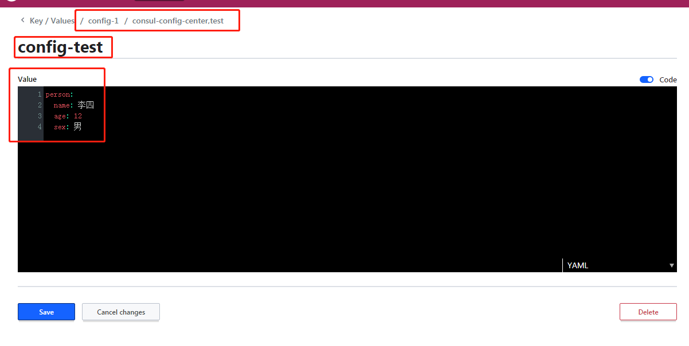

结合consul配置，说明consul-config配置参数：

prefix: config-1

default-context: consul-config-center

data-key: config-test

profile-separator: ','

prefix的默认值 config

default-context的默认值 application

profile-separator 的默认值 ','

配置匹配

没有配置default-context

/${prefix}/${application}${profile-separator}${profile.active}/${data-key}

/${prefix}/${application}/${data-key}

/${prefix}/${default-context}${profile-separator}${profile.active}/${data-key}

/${prefix}/${default-context}/${data-key}

例如：

Located property source:

[BootstrapPropertySource {name='bootstrapProperties-config-1/consul-config-center,test/'}, BootstrapPropertySource {name='bootstrapProperties-config-1/consul-config-center/'},

BootstrapPropertySource {name='bootstrapProperties-config-1/application,test/'}, BootstrapPropertySource {name='bootstrapProperties-config-1/application/'}]

服务发现

引入依赖：

<!-- 服务注册，发现 -->  
<dependency>  
 <groupId>org.springframework.cloud</groupId>  
 <artifactId>spring-cloud-starter-consul-discovery</artifactId>  
</dependency>

<!-- feign 包 http声明式调用-->  
<dependency>  
 <groupId>org.springframework.cloud</groupId>  
 <artifactId>spring-cloud-starter-openfeign</artifactId>  
</dependency>

配置

spring:  
 cloud:  
 consul:  
 host: 10.0.92.111  
 port: 8500

使用

@EnableFeignClients

使@FeignClient注解接口，生成spring 的bean

spring自动加载的两个对象

@Resource  
private LoadBalancerClient loadBalancerClient;  
  
@Resource  
private DiscoveryClient discoveryClient;

问题：@FeignClient注解的value，在一个程序中不能出现两个相同的value属性值。

The bean 'consul-config-center.FeignClientSpecification' could not be registered. A bean with that name has already been defined and overriding is disabled.

Action:

Consider renaming one of the beans or enabling overriding by setting spring.main.allow-bean-definition-overriding=true

解决：就是下面的action，配置spring.main.allow-bean-definition-overriding=true

@EnableFeignClients

不用这个注解，@FeignClient注解的接口不能自动转为spring bean

A component required a bean of type 'com.java.consuldiscovery.feign.FeignCTestFF' that could not be found.

Action:

Consider defining a bean of type 'com.java.consuldiscovery.feign.FeignCTestFF' in your configuration.