ASTORASOC
Incident Response Platform
A
AstoraSOC
Security Operations and Incident Response Manual
Architecture | Administration | SOC Workflows | Integrations | Operations

PUBLISHER  Astora Lab | WEBSITE  www.astoralab.com | REPOSITORY  github.com/astoralab/astorasoc

About Astora Lab
Astora Labs is an open-source cybersecurity lab dedicated to building modern tools for security operations, incident response, digital forensics, and threat intelligence. The name reflects our mission to guide organizations through complex cyber threats with intelligent, research-driven solutions.

Manual Edition 1.0 | Generated 02 July 2026 | Internal and open-source project reference

Manual Front Matter
Field | Value
Product | AstoraSOC
Company | Astora Lab
Website | www.astoralab.com
Repository | github.com/astoralab/astorasoc
Document Type | Full product and operations manual
Prepared For | AstoraSOC administrators, Lead Analysts, Analysts, Junior Analysts, and incident-response operators
Generated On | 02 July 2026
Design Preset | compact_reference_guide: US Letter, Calibri 11 pt, 1.0 in margins, fixed 6.5 in tables
Confidentiality | Internal use. Contains operational and security architecture details.

Document Control
Version | Date | Owner | Description
AstoraSOC v1.0 | 02 July 2026 | AstoraSOC Platform Team | Professional product manual covering provider-neutral alert normalization, asset intelligence, case-type playbooks, AI-assisted reporting, and enterprise SOC reporting workflow.

Document Purpose
This document provides comprehensive technical, administrative, and operational guidance for AstoraSOC v1.0, the Astora Lab SOC & Incident Response Platform. It describes platform architecture, security controls, alert management workflows, incident response processes, case management, IOC intelligence, containment operations, asset management, reporting capabilities, integrations, and role-based responsibilities.
The document is intended for system administrators, SOC leads, analysts, incident responders, and security operations personnel responsible for deploying, managing, and operating the AstoraSOC platform within an organizational security environment.
This documentation serves as the primary reference for platform configuration, day-to-day operations, workflow governance, and security management.

About Astora Lab
Astora Labs is an open-source cybersecurity lab dedicated to building modern tools for security operations, incident response, digital forensics, and threat intelligence. The name reflects our mission to guide organizations through complex cyber threats with intelligent, research-driven solutions.
Organization | Website | Repository
Astora Lab | www.astoralab.com | github.com/astoralab/astorasoc

Audience
- Administrators: Configure AstoraSOC, manage users, SMTP/email delivery, assets, playbooks, audit logs, and platform settings.
- Lead Analysts: Review alerts and closure requests, assign cases, approve containment, and maintain SOC governance.
- Analysts: Investigate assigned cases, collect evidence, manage IOCs, request containment, complete tasks, and submit closure review.
- Junior Analysts: Triage incoming alerts, identify false positives, and send valid alerts to Lead review.
- Security Engineers: Integrate AstoraSOC with SIEM, SOAR, EDR, firewall, and custom API sources through webhook and future provider models.

Scope
This document covers AstoraSOC application behavior, operational workflows, role restrictions, security controls, integrations, deployment practices, data model, troubleshooting, and recommended SOC runbooks. The public project reference is github.com/astoralab/astorasoc, and organizational information is available at www.astoralab.com. This document does not replace organization-specific incident response policy, legal guidance, or production hardening review.

Manual Table of Contents
Section No. | Section Title | Purpose
1 | Executive Overview | Introduces AstoraSOC positioning, operational value, and core SOC capabilities.
2 | Product Goals and Design Principles | Defines design goals, workflow principles, platform scope, IR governance, and response quality controls.
3 | System Architecture | Describes application layers, data flow, and core platform components.
4 | Deployment and Configuration | Explains installation, environment configuration, and operational setup.
5 | Authentication, Sessions, and Security Controls | Documents login security, API keys, retention controls, uploads, and secure settings.
6 | RBAC and Role-Based Workflows | Defines Admin, Lead, Analyst, Junior Analyst, Viewer, and custom role behavior.
7 | Dashboard and Operations Posture View | Explains SOC workload, case analytics, asset intelligence, IOC activity, and dashboard filters.
8 | Alerts and SIEM Intake | Documents provider-neutral alert ingestion, normalization, triage, and raw payload handling.
9 | Review Queue | Explains Lead/Admin review decisions for alerts, closures, containment, and false positives.
10 | Case Investigation Workspace | Describes investigation fields, tasks, notes, evidence, IOCs, timeline, containment, and closure workflow.
11 | Asset Management | Covers asset intelligence, criticality, risk scoring, business function, and alert/case linkage.
12 | Playbook Engine and Tasks | Explains playbook matching, case-type templates, task generation, and investigation checklists.
13 | IOC Intelligence | Documents IOC extraction, classification, normalization, correlation, and analyst actions.
14 | Evidence Management | Explains evidence uploads, hashing, metadata, previews, and report usage.
15 | Containment Queue and IR Workflow | Defines approved containment lifecycle, execution states, rollback, and auditability.
16 | Email and In-App Notifications | Documents notification delivery, SMTP settings, and workflow messaging.
17 | Reports | Explains enterprise DOCX/PDF reports, AI fallback, remediation details, charts, and closure constraints.
18 | Audit Logs | Defines audit scope for authentication, workflows, settings, retention, and response actions.
19 | Chat and Collaboration | Documents secure team collaboration, mentions, reactions, attachments, and profile context.
20 | API and Webhook Reference | Provides webhook authentication, accepted fields, and sample JSON payloads.
21 | SIEM and SOAR Integration Guide | Explains direct webhook, bridge script, SOAR relay, and polling integration patterns.
22 | Operational Runbooks | Provides repeatable operating procedures for daily SOC use.
23 | Troubleshooting | Lists common symptoms, causes, and corrective actions.
24 | Maintenance and Roadmap | Covers operational maintenance and planned enhancement areas.
25 | Appendices | Provides status definitions, severity/criticality guidance, and operational checklists.

1. Executive Overview
AstoraSOC is a modern SOC and incident-response workflow platform built by Astora Lab for security teams that need fast triage, governed investigation, asset-aware response, IOC intelligence, and professional reporting without the operational weight of a large enterprise SOAR deployment. The platform sits beside SIEM, SOAR, EDR, vulnerability, and monitoring tools and converts security signals into structured review, investigation, containment, closure, and audit workflows.
The product is intentionally provider-neutral. Wazuh is supported as an integration example, but AstoraSOC is designed for alerts from Splunk, Microsoft Sentinel, Elastic Security, QRadar, Security Onion, Graylog, Chronicle/SecOps, LogRhythm, ArcSight, AlienVault/USM, Shuffle, custom API clients, and future detection sources that can send normalized JSON.
Operational Positioning
Detection platforms identify signals; AstoraSOC normalizes them, preserves context, routes review, manages investigation, records response, and produces executive-ready reports.

Core Capabilities
- SOC-focused dashboard with open cases, review queue health, workload, MTTD, MTTR, severity/status distribution, asset risk, IOC activity, containment readiness, most affected assets, analyst workload, and recent incident activity.
- Provider-neutral alert intake through a protected API/webhook, with normalization for different SIEM/SOAR/EDR field names and preservation of original raw payloads.
- Role-aware alert triage and Lead review before promotion to cases.
- Case investigation workspace with incident type, business impact, root cause, resolution summary, MTTR, IOCs, evidence, notes, timeline, tasks, related activity, containment queue, linked assets, and reports.
- Asset Intelligence for hostname/IP matching, asset owner, department, business function, OS, status, criticality, risk score, linked alerts, linked cases, and investigation context.
- Playbook Engine that auto-generates tasks based on SIEM rule ID, source category, MITRE tactic, alert type, case type, or generic fallback.
- Containment workflow with approval, execution, rollback, execution history, timeline entries, and audit logs.
- Professional DOCX/PDF report generation with case-type aware executive summaries, remediation details, evidence register, reviewer approval, timeline highlights, charts, and optional AI enhancement.
- Professional HTML email notifications and in-app notification records for important workflow events.
- Audit logs, secure file upload validation, CSRF protection, password hashing, protected API keys, and RBAC restrictions.

2. Product Goals and Design Principles
Principle | Implementation in AstoraSOC
SOC-first workflow | Screens prioritize cases, review, investigations, affected assets, IOC context, containment, and response timelines.
Lightweight by design | AstoraSOC avoids unnecessary enterprise clutter while still providing structured SOC triage, investigation, review, asset context, reporting, and auditability.
Governed investigation | Junior Analysts triage, Leads review and assign, Analysts investigate, and containment requires approval.
Auditability | Important workflow changes are stored in audit logs and/or case timelines.
Secure defaults | CSRF, session timeout, password hashing, upload validation, API key protection, role checks, encrypted secrets, and delivery logs are built in.
Provider-neutral integrations | Webhook intake, normalized alert fields, and modular containment concepts allow SIEMs, SOAR tools, EDR, firewall APIs, SSH, PowerShell, active response, and playbooks to connect without redesign.

Platform Features Overview
Capability | Purpose
Alert Management | Ingest, normalize, filter, and triage alerts from SIEM, SOAR, EDR, monitoring platforms, and custom webhook clients.
Review Workflow | Route analyst-triaged alerts and closure requests through Lead/Admin review before promotion, closure, or false-positive disposition.
Case Management | Track investigations with unified AstoraSOC IDs, ownership, severity, workflow status, tasks, evidence, notes, and timelines.
IOC Intelligence | Extract, sanitize, classify, normalize, correlate, and export indicators across alerts, cases, evidence, raw logs, and analyst notes.
Asset Management | Maintain business and technical asset intelligence for hostnames, IPs, owners, departments, business functions, risk, and investigation context.
Playbooks | Apply reusable investigation task templates based on SIEM rule ID, source category, MITRE tactic, alert type, case type, or generic fallback.
Containment | Record and govern response actions such as block, isolate, disable, quarantine, firewall, and custom script workflows.
Reporting | Generate professional DOCX/PDF investigation reports with executive impact, remediation details, evidence register, charts, timeline highlights, reviewer approval, and AI-assisted narrative when configured.
Audit Logs | Preserve security-relevant actions, configuration changes, authentication events, workflow decisions, and retention operations.
Notifications | Deliver in-app and email notifications for assignments, reviews, messages, case updates, and SOC workflow events.

Incident Response Lifecycle
AstoraSOC v1.0 follows a governed incident response lifecycle that supports both provider-driven alerts and manually created investigations. Each phase is designed to preserve accountability, reduce analyst ambiguity, and produce evidence-backed closure.
Phase | AstoraSOC Practice
Detection | External SIEM, SOAR, EDR, vulnerability, monitoring, or manual sources identify security-relevant activity.
Alert Normalization | AstoraSOC maps provider-specific fields into consistent alert fields while preserving the original raw payload.
Junior Analyst Triage | Junior Analysts review normalized alerts, asset context, severity, IOCs, and raw data before sending valid items to review or closing clear false positives.
Lead Review | Lead Analysts validate promoted alerts, assign analysts, create cases, or mark false positives with required rationale.
Case Creation | Validated alerts or manual investigations become cases with unified AST tracking IDs and linked context.
Playbook Assignment | The Playbook Engine applies the best matching SIEM rule, source category, MITRE tactic, alert type, case type, or generic playbook.
Investigation | Assigned Analysts work the case using summary fields, tasks, timeline, related activity, notes, and asset intelligence.
Evidence Collection | Analysts upload relevant artifacts, preserve SHA256 hashes, and document evidence purpose for reviewer and report use.
IOC Analysis | Indicators are extracted, sanitized, classified, correlated, and reviewed across alerts and cases.
Containment Request | Analysts request controlled response actions from within an active case, including reason, target, risk, and notes.
Lead Approval | Leads approve, reject, or request more information for containment and closure decisions.
Manual / Provider-Based Execution | Authorized operators record manual execution or future provider-backed response results with audit history.
Remediation | Teams document patching, configuration changes, account actions, isolation, quarantine, or other response activities.
Validation | Analysts validate remediation through evidence, scans, logs, follow-up monitoring, or reviewer-confirmed checks.
Closure Review | Assigned Analysts submit closure review; Leads approve closure or request more work.
Final Report | Approved closed cases can generate professional DOCX/PDF reports with standard or AI-enhanced narrative.
Lessons Learned | Teams retain findings, recommendations, and audit history for process improvement and recurrence prevention.

Investigation Governance
- Junior Analysts triage incoming alerts and document false-positive or review decisions.
- Lead Analysts review promoted alerts, create cases, assign one or more Analysts, and govern closure decisions.
- Analysts investigate only cases they are assigned to, complete tasks, add notes, upload evidence, review IOCs, and request closure review.
- Containment actions require approval before execution unless explicitly configured as low-risk manual documentation.
- Closure requires Lead approval and should be supported by evidence, notes, root cause, resolution summary, task completion, and final disposition.
- Reports are generated only after approved closure so management and auditors receive final, reviewed records.
- Audit logs and case timelines preserve accountability for configuration changes, workflow actions, approvals, evidence, containment, and reporting.

Response Quality Controls
- Evidence should be attached or the reason for missing evidence should be documented before closure.
- Root cause must be documented for confirmed incidents, vulnerabilities, and security operations tasks that require remediation.
- Resolution summary must describe the actual remediation, validation, or final disposition.
- Containment records must include reason, target, risk, approval status, execution result, rollback status, and analyst notes where applicable.
- Reports must hide empty optional fields and avoid database-dump formatting.
- Playbooks must match the case type, alert source, MITRE context, or detection logic rather than inserting unrelated tasks.
- AI-generated reports must never invent facts, indicators, vulnerabilities, evidence, or remediation actions.

Case Closure Readiness Checklist
Check | Closure Expectation
Alert validated | The alert or manual case reason has been reviewed and confirmed.
Asset linked or documented as unknown | Known affected assets are linked; unavailable asset context is explained.
IOC reviewed | Indicators have been reviewed, classified, and correlated where relevant.
Evidence uploaded | Supporting artifacts are uploaded or absence of evidence is documented.
Analyst notes added | Investigation findings and decisions are recorded in the journal.
Root cause documented | The underlying cause or best-supported cause assessment is recorded.
Resolution summary documented | Remediation, validation, false-positive rationale, or final action is summarized.
Containment actions reviewed | Any requested response action includes approval, execution, and rollback status.
Playbook tasks completed or marked not applicable | Assigned checklist work is complete or justified.
Lead closure approval completed | Lead decision is recorded before final closure.
Final report generated | Approved closed cases can generate DOCX/PDF reports for management and audit records.

What AstoraSOC Is Not
- Not a SIEM replacement. Detection and log correlation remain in SIEM platforms such as Wazuh, Splunk, Sentinel, Elastic, QRadar, or Chronicle.
- Not a full CMDB. Asset Management focuses on security context, business impact, and investigation correlation rather than full IT asset lifecycle governance.
- Not an uncontrolled response executor. Containment is case-driven, approval-aware, audited, and designed for safe provider integrations.
- Not a legal evidence vault. Evidence storage supports SOC investigations, hashing, and reports, but formal legal chain-of-custody policy must be defined separately.

3. System Architecture
AstoraSOC uses a Flask web application with SQLAlchemy persistence, Jinja templates, WTForms, Flask-Login, CSRF protection, Flask-Limiter, Bootstrap-style UI components, Lucide icons, and custom JavaScript/CSS for the SOC interface. It is deployable through Docker Compose with a web service and relational database.
Layer | Primary Components | Responsibility
Frontend | Jinja templates, static CSS, main.js, Lucide icons | SOC screens, filters, role-aware controls, theme behavior, sidebar behavior, notification bell, date filters, modals, and interactive queue cards.
Application | Flask routes under app/routes | Authentication, dashboard, alerts, cases, assets, playbooks, settings, reports, chats, live state, and webhook endpoints.
Domain Services | utils.py, playbooks.py, email_notifications.py, ioc_intel.py, docx_reports.py | Task generation, notifications, encryption helpers, IOC extraction/labels, report generation, upload validation, audit logging, timeline entries.
Persistence | SQLAlchemy models and migrations | Users, assets, alerts, cases, IOCs, evidence, tasks, playbooks, containment actions, reports, audit logs, settings, notifications, chats.
Integration Edge | /api/webhook/alert, SIEM/SOAR webhooks, and optional source-specific bridge scripts | Receives security alerts using X-API-Key and normalizes them into AstoraSOC alert records.
Runtime | Docker Compose, Flask app container, database container | Local or server deployment with configurable environment variables and mounted upload storage.

High-Level Data Flow
- A SIEM, SOAR, EDR, monitoring platform, or bridge script sends an alert to POST /api/webhook/alert using the X-API-Key header.
- AstoraSOC validates the API key, parses fields, assigns a tracking ID, extracts IOCs, links known assets where possible, stores raw JSON, and notifies the alert queue.
- A Junior Analyst or authorized triage user reviews the alert and either marks it false positive or sends it to Lead review.
- A Lead reviews the alert and promotes it to a case or requests more work.
- When a case is created, AstoraSOC applies the best matching playbook template and generates investigation tasks.
- Analysts investigate assigned cases, add notes, upload evidence, manage IOCs, request containment, and submit closure review.
- Leads approve closure or request more work. Containment actions follow request, approval, execution, rollback, timeline, and audit workflows.
- Reports are generated from case data, including alert metadata, IOCs, evidence, timeline, tasks, containment actions, and closure details.

Core Data Model
Model | Purpose | Important Fields
User | Authenticated platform identity and role holder. | username, email, pending_email, notification_preference, password_hash, role, active state, profile fields, session state.
Asset | Security asset intelligence for impact and correlation. | asset name, hostname, IP address, asset owner, department, business function, OS, asset type, criticality, status, risk score, linked alerts/cases.
Alert | Incoming normalized security event before or during case promotion. | tracking ID, source, event ID, detection name, rule ID, severity, status, host, user, IPs, MITRE, raw JSON, normalized debug fields, asset, case.
Case | Primary investigation container. | tracking ID, title, incident type, description, severity, status, source, business impact, root cause, resolution summary, rule/MITRE, affected host/user/IPs, asset, assignments, due date, closure metadata.
IOC | Indicator record tied to alerts and/or cases. | type, value, normalized value, confidence, source, tags, first/last seen, notes.
Evidence | Uploaded investigation file with hash and report context. | original filename, evidence type, stored filename, SHA256, uploader, upload time, purpose/description inferred from investigation context.
Task | Investigation checklist item. | title, complete state, source Auto/Analyst, playbook template, completion metadata, deletion/edit history where audited.
PlaybookTemplate | Central task template managed by Admins. | name, category, match type, match value, priority, active flag, tasks text.
ContainmentAction | Controlled response action record. | CA ID, action type, target, host, status, risk, approvals, execution result, rollback result, provider.
TimelineEvent | Case-specific chronology. | event type, description, actor, timestamp.
AuditLog | Platform-level accountability trail. | actor, action, details, IP address, timestamp.
Notification / EmailDeliveryLog | In-app and email notification tracking. | recipient, type/category, message/subject, status, errors, timestamps.

4. Deployment and Configuration
AstoraSOC supports lab, LAN, and production-style deployments on Windows or Linux. The platform can run directly from Docker for simple internal use, or behind Apache, Nginx, Traefik, Cloudflare Tunnel, or the included host proxy for production-style access, HTTPS, and real client IP logging.

Quick Start
Step | Command / Action
1 | cd Raven
2 | copy .env.example .env
3 | docker compose up --build -d web
4 | docker compose exec web flask --app run.py init-db
5 | docker compose exec web flask --app run.py upgrade-db
6 | docker compose exec web flask --app run.py seed-admin
7 | For direct Docker access, open the mapped Docker port. For proxy access, start the proxy or configure Apache/Nginx as described below.

Port Models
AstoraSOC does not require both 5000 and 5001. The application listens on port 5000 inside the container. Port 5001 is used only when the container is kept private and a proxy owns the public port.
Mode | Host Port | When to Use
Direct Docker | 0.0.0.0:5000 -> container 5000 | Simple lab or internal Linux deployment without Apache/Nginx. Users open http://SERVER-IP:5000.
Private Docker backend | 127.0.0.1:5001 -> container 5000 | Recommended when Apache, Nginx, host proxy, Traefik, or Cloudflare Tunnel is the public entrypoint.
Production HTTPS | 80/443 -> 127.0.0.1:5001 | Recommended for domains, TLS certificates, security headers, and reliable real client IP headers.
Database | db:3306 | MySQL service inside Docker Compose. Keep database access restricted.
Why 5001 Exists
Port 5001 is a private host-only backend used by proxy deployments. It avoids exposing the Flask container directly and allows the public proxy on port 5000, 80, or 443 to inject real client IP headers. If you do not need a proxy, Docker can expose AstoraSOC directly on port 5000.

Windows Docker Desktop Deployment
Windows deployments should be written for Docker Desktop users. The simplest local setup uses Docker Desktop and opens AstoraSOC from the Windows host. For LAN sharing with accurate Audit Log IP addresses, use the included host proxy.
Step | Command / Action
1 | Install and start Docker Desktop. Confirm Docker Engine is running.
2 | Open PowerShell in the AstoraSOC project folder: cd Raven
3 | Copy .env.example to .env and edit secrets before production use.
4 | Run: docker compose up --build -d web
5 | Initialize/update the database with the init-db, upgrade-db, and seed-admin commands if this is the first deployment.
6 | For local-only access, open http://localhost:5001 when using the default private backend mapping.
7 | For LAN access on http://WINDOWS-IP:5000, start the included host proxy: powershell -ExecutionPolicy Bypass -File .\deployment\host_proxy\start-astorasoc-proxy.ps1
8 | Allow Windows Firewall port 5000 for trusted networks: netsh advfirewall firewall add rule name="AstoraSOC 5000" dir=in action=allow protocol=TCP localport=5000

Linux Docker-Only Deployment without Web Server
Many open-source platforms run this way for labs, internal tools, and small SOC environments. Apache or Nginx is not mandatory. In this mode Docker exposes AstoraSOC directly on port 5000.
Step | Command / Action
1 | Install Docker Engine and Docker Compose plugin.
2 | Clone or copy AstoraSOC, then run: cd Raven
3 | Copy .env.example to .env and set SECRET_KEY, database credentials, webhook key, and upload limits.
4 | For direct access, map web as 0.0.0.0:5000:5000 in docker-compose.yml ports.
5 | Run: docker compose up --build -d web
6 | Initialize/update database: docker compose exec web flask --app run.py init-db && docker compose exec web flask --app run.py upgrade-db && docker compose exec web flask --app run.py seed-admin
7 | Allow firewall access from trusted networks only: sudo ufw allow 5000/tcp or equivalent firewall rule.
8 | Users open http://SERVER-IP:5000.
Docker-Only Tradeoff
Docker-only deployment is valid and simple. The tradeoff is that HTTPS, domain routing, security headers, and real client IP handling are weaker unless another network device or proxy provides them.

Linux Docker Deployment with Nginx
Step | Command / Action
1 | cd Raven && docker compose up --build -d web
2 | Copy deployment/nginx/astorasoc.conf to /etc/nginx/sites-available/astorasoc.conf.
3 | Enable the site with a symlink into /etc/nginx/sites-enabled/.
4 | Run sudo nginx -t && sudo systemctl reload nginx.
5 | Allow firewall ports 80/tcp and 443/tcp.
6 | For HTTPS production deployments, set SESSION_COOKIE_SECURE=true and keep TRUST_PROXY_HEADERS=true.

Linux Docker Deployment with Apache
Apache can be used instead of Nginx when the organization already standardizes on Apache HTTP Server. Apache listens on 80/443 and proxies traffic to the private Docker backend on 127.0.0.1:5001.
Step | Command / Action
1 | Keep docker-compose.yml mapped as 127.0.0.1:5001:5000.
2 | Install Apache and modules: sudo apt install apache2 && sudo a2enmod proxy proxy_http headers ssl rewrite
3 | Copy deployment/apache/astorasoc.conf to /etc/apache2/sites-available/astorasoc.conf.
4 | Enable site: sudo a2ensite astorasoc.conf && sudo apachectl configtest && sudo systemctl reload apache2
5 | Allow firewall ports 80/tcp and 443/tcp.
6 | For HTTPS production deployments, enable TLS certificates and set SESSION_COOKIE_SECURE=true and TRUST_PROXY_HEADERS=true.

Linux Host Proxy without Nginx or Apache
For lab or temporary Linux deployments without Apache/Nginx, the lightweight Python proxy can listen on 0.0.0.0:5000 and forward to the private Docker backend on 127.0.0.1:5001. For production, Apache, Nginx, Traefik, or Cloudflare Tunnel is preferred.
Use Case | Command / Guidance
Start proxy | python3 deployment/host_proxy/astorasoc_proxy.py --listen-host 0.0.0.0 --listen-port 5000 --backend-host 127.0.0.1 --backend-port 5001
Persist process | Run through systemd, tmux, screen, or a process supervisor.
Firewall | Allow TCP 5000 from trusted networks only.

Reverse Proxy Header Compatibility
Deployment | Required / Supported Headers | Notes
Windows host proxy | X-Forwarded-For, X-Real-IP, X-Forwarded-Proto, X-Forwarded-Host | Recommended for Docker Desktop LAN sharing when no enterprise proxy is present.
Nginx | X-Forwarded-For, X-Real-IP, X-Forwarded-Proto, X-Forwarded-Host, X-Forwarded-Port | Use the provided deployment/nginx/astorasoc.conf sample.
Apache | X-Forwarded-For, X-Real-IP, X-Forwarded-Proto, X-Forwarded-Host, X-Forwarded-Port | Use the provided deployment/apache/astorasoc.conf sample.
Traefik | X-Forwarded-For, X-Forwarded-Proto, X-Forwarded-Host | Usually added automatically by Traefik routers.
Cloudflare | CF-Connecting-IP | AstoraSOC gives this header highest priority.
Generic proxy | Forwarded, X-Client-IP, X-Cluster-Client-IP, True-Client-IP | AstoraSOC parses common provider and proxy variants.

Real IP Troubleshooting
- If Audit Logs show 'Real IP unavailable - configure proxy headers', AstoraSOC did not receive a usable real-client IP header.
- Confirm users connect to the proxy entrypoint on port 5000, not directly to the Docker backend.
- For proxy deployments, confirm Docker Compose exposes the web container on 127.0.0.1:5001 rather than public 5000.
- For Docker-only deployments, real IP logging may depend on Docker network mode and host firewall behavior.
- Confirm Windows Firewall or Linux firewall allows the public proxy port.
- Confirm TRUST_PROXY_HEADERS=true and that the proxy sends X-Forwarded-For or X-Real-IP.
- Old Audit Log records are not rewritten; verify with a new login after proxy changes.

Default Login
Field | Value
Username | admin
Password | ChangeMeNow123!
First Login | Default admin is forced to change password after first login.

Update and Maintenance Workflow
- Use Admin Settings -> Update System for backup-first update checks.
- AstoraSOC creates a backup of database data, uploads, evidence files, and system settings before update actions.
- For Docker deployments, update commands may need to be executed from the host so containers can be rebuilt and restarted safely.
- Run database migrations after updating: docker compose exec web flask --app run.py db upgrade or docker compose exec web flask --app run.py upgrade-db.
- Run docker compose ps and verify the web service is reachable through the public proxy entrypoint.

Backup Scope
- Database volume and SQLAlchemy application data.
- Uploads volume, including evidence, report templates, profile images, and media.
- System settings stored in the application settings table.
- .env should be backed up separately into a secure secrets vault and never exposed in logs or screenshots.
- Update operations must stop if backup verification fails.

Deployment Files
Path | Purpose
docker-compose.yml | Defines the web and database services. The recommended shared deployment maps 127.0.0.1:5001 to container port 5000.
deployment/host_proxy/astorasoc_proxy.py | Small Windows/Linux-compatible Python host proxy that forwards real client IP headers.
deployment/host_proxy/start-astorasoc-proxy.ps1 | Windows helper script for starting the host proxy on port 5000.
deployment/nginx/astorasoc.conf | Nginx reverse proxy sample for Linux deployments.
deployment/apache/astorasoc.conf | Apache reverse proxy sample for Linux deployments.
deployment/README.md | Operational deployment guide covering Windows, Linux, proxies, ports, real IPs, firewall, updates, and troubleshooting.

Environment Variables
Variable | Purpose | Recommended Production Guidance
SECRET_KEY | Flask secret and encryption source for encrypted app values. | Use a long random value. Rotate carefully because encrypted settings/chat content depend on it.
DATABASE_URL | SQLAlchemy database connection string. | Use a managed relational database or protected container volume.
WEBHOOK_API_KEY | Fallback API key for alert webhook before generated settings key exists. | Set a long random value and rotate through Admin Settings when needed.
MAX_CONTENT_LENGTH | Maximum request/upload size. Default is 25 MB. | Keep aligned with evidence upload policy.
UPLOAD_FOLDER | Location for uploaded profiles, evidence, templates, chat files, and custom assets. | Persist this path outside ephemeral containers. Back it up.
SESSION_COOKIE_SECURE | Controls Secure flag for cookies. | Set true behind HTTPS.
RATELIMIT_STORAGE_URI | Flask-Limiter backend. Default memory://. | Use Redis or another shared backend for multi-instance production.
RATELIMIT_DEFAULT | Default request limit. Current default is 300 per minute. | Tune for user population and reverse proxy behavior.
TRUST_PROXY_HEADERS | Enables ProxyFix and proxy-aware client IP handling. Default is true. | Keep true when behind Nginx, Traefik, Cloudflare, host proxy, or any reverse proxy.

Production Hardening Checklist
- Run behind HTTPS and set SESSION_COOKIE_SECURE=true.
- Use a strong SECRET_KEY and protect .env from source control and broad filesystem permissions.
- Persist the database volume and UPLOAD_FOLDER, then schedule backups.
- Move rate-limit storage from memory:// to Redis or another central backend for multiple web instances.
- Rotate default admin password immediately and disable or rename seed credentials if deploying beyond development.
- Configure SMTP only from Admin Settings and test delivery before relying on email notifications.
- Restrict webhook exposure to SIEM networks when possible.

5. Authentication, Sessions, and Security Controls

Authentication
- Users authenticate with username and password through Flask-Login.
- Passwords are stored using Werkzeug password hashing, not plaintext.
- New and changed passwords require at least 12 characters in current forms.
- The seeded admin account is forced to change password at first login.
- Inactive users cannot pass role checks and should be disabled or deleted according to policy.

Session Behavior
- Session timeout is configurable in Admin Settings, commonly 5 to 1440 minutes depending on policy.
- Active browser polling updates user presence only when the AstoraSOC tab is visible and active.
- Passive state checks for notifications and counters do not extend the authenticated session.
- Cookie settings use HttpOnly and SameSite=Lax; Secure should be enabled in HTTPS production deployments.

Application Security Controls
Control | Current AstoraSOC Behavior | Operator Notes
CSRF | Form-based state changes include CSRF tokens through Flask-WTF. The webhook endpoint is API-key protected instead of browser CSRF protected. | Do not expose administrative POST routes through unauthenticated reverse proxy rules.
Password hashing | Passwords are hashed with Werkzeug generate_password_hash/check_password_hash. | Enforce organization password policy externally if stronger requirements are needed.
File upload validation | Uploads are restricted by subdirectory-specific extension lists and max byte sizes. Evidence files are hashed with SHA256. | Allowed evidence: pdf, txt, log, csv, json, png, jpg, jpeg, zip.
API key protection | Webhook uses X-API-Key and rejects insecure default keys. Generated keys use rvn_ plus strong random token material. | Rotate the key if exposed and update SIEM integrations immediately.
Audit logs | Important actions add AuditLog records with actor, action, details, IP address, and timestamp. | Audit logs should be retained according to SOC policy.
Encryption helpers | Chat and stored SMTP passwords use Fernet derived from SECRET_KEY. | Rotating SECRET_KEY requires a migration strategy for encrypted values.

Upload Rules
Upload Area | Allowed Extensions | Maximum Size
Evidence | pdf, txt, log, csv, json, png, jpg, jpeg, zip | 25 MB
Profile pictures | jpg, jpeg, png, webp | 5 MB
Role icons | jpg, jpeg, png, webp | 2 MB
Chat emojis | jpg, jpeg, png, webp, gif | 1 MB
Report templates | docx | 5 MB

6. RBAC and Role-Based Workflows
AstoraSOC uses role presets with support for custom roles that inherit a base preset. Access decisions are evaluated through role_allows, so custom roles can be mapped to Admin, Lead, Analyst, Junior Analyst, or Viewer behavior.
Role | Primary Responsibilities | Restrictions
Admin | System settings, users, SMTP, assets, playbooks, audit logs, integrations, platform oversight, and view access across alerts/cases/reviews. | Admin can view alert, review, and case information but should not perform Lead review decisions or Analyst investigation edits inside cases.
Lead | Alert review, case assignment, closure review, containment approval/rejection, review queue governance, and SOC workload control. | Lead can view case work and perform review/approval workflows, but should not edit Analyst investigation content inside cases.
Analyst | Assigned case investigation, notes, tasks, evidence, IOCs, containment requests, and closure submission. | Analysts modify assigned investigations but do not approve closure or approve containment.
Junior Analyst | Alert triage, false-positive handling, and sending alerts for Lead review. | Junior Analysts do not own case investigation approval or containment execution.
Viewer | Dashboard-level visibility. | Viewer is read-oriented and should not change operational records.

RBAC Matrix
Capability | Admin | Lead | Analyst | Junior Analyst | Viewer
Dashboard | View | View | View | View | View
Alerts list/detail | View | View/Review | View where allowed | Triage | Limited
Send alert to review | No | No | No | Yes | No
Promote alert to case | No | Yes | No | No | No
Case detail | View only | View/review only | Investigate assigned cases | Limited | No
Case notes/evidence/IOCs/tasks | View only | View only | Create/edit/delete as investigator | No | No
Closure review | View only | Approve/reject/request more work | Request closure review | No | No
Containment request | No case edits | Approve/reject and execute when allowed | Request only | No | No
Assets | Manage | View/use context | View/use context | View context | Limited
Playbooks | Manage templates | View outcomes | Use generated tasks | Limited | No
Settings/email/API key | Manage | No | No | No | No
Audit logs | Manage/view/export/cleanup | Policy-based | No | No | No
Case Workspace Rule
The case investigation workspace is Analyst-owned working space. Admin and Lead users may inspect case content for oversight and review, but operational edits such as notes, evidence uploads, IOC creation, task edits, containment requests, and closure submission are reserved for Analysts.

7. Dashboard and Operations Posture View
The AstoraSOC dashboard answers SOC operating questions: what needs review, what is assigned, what is actively investigating, what is closed, which cases are false positives, how fast detection and response are moving, and which rules, assets, IOCs, and containment actions need attention.
Metric | Meaning | Recommended Use
Open Cases | All active non-closed cases. | SOC workload and backlog visibility.
Pending Review | Cases or alerts waiting for Lead review. | Lead queue focus and aging control.
Assigned | Cases currently assigned to analysts. | Workload balancing.
Investigating | Cases in active investigation status. | Active incident health.
Closed Cases | Completed cases. | Throughput and reporting.
False Positives | Cases or alerts closed as false positive. | Detection tuning and quality feedback.
MTTD | Mean Time To Detect. | Detection pipeline health and alert latency analysis.
MTTR | Mean Time To Respond. | Response effectiveness and process maturity.

Dashboard Visuals
- Case Severity Distribution reflects incident impact more directly than alert-only severity charts.
- Case Status Distribution shows New, Assigned, Investigating, Pending Review, Closed, and False Positive posture.
- Top Triggered Detections shows detection name, source platform, and count instead of raw rule IDs only.
- Most Affected Assets shows asset name, criticality, open alerts, open cases, and calculated risk score.
- Analyst Workload shows assigned, investigating, and pending-review load per analyst.
- IOC Intelligence Overview highlights IOC volume, type, correlation, and repeated indicators.
- Containment Queue metrics show approval and execution health.
- Recent Incident Activity records case creation, review requests, containment events, and closures.
Signal | Meaning | SOC Use
Critical / Red | Immediate business or security impact. | Prioritize investigation, containment approval, and executive visibility.
High / Orange | Material risk or likely incident. | Assign quickly and confirm affected assets.
Medium / Yellow | Requires analyst validation. | Investigate with normal queue urgency.
Low / Blue | Informational or low impact. | Track, correlate, and close if benign.
Closed / Green | Resolved or false positive. | Available for reporting and audit.
Investigating / Purple | Active case work is underway. | Monitor analyst workload and aging.
Pending Review / Amber | Waiting on Lead decision. | Focus Lead queue and closure governance.

Date Filtering
Dashboard filters support all-time, daily, weekly, monthly, yearly, and calendar-driven selection. When a date or period is selected, AstoraSOC queries backend case and alert data for that period. If the selected date has no records, widgets correctly show zero or an empty state. Refresh-free background updates should preserve selected filters, open UI state, and scroll position.
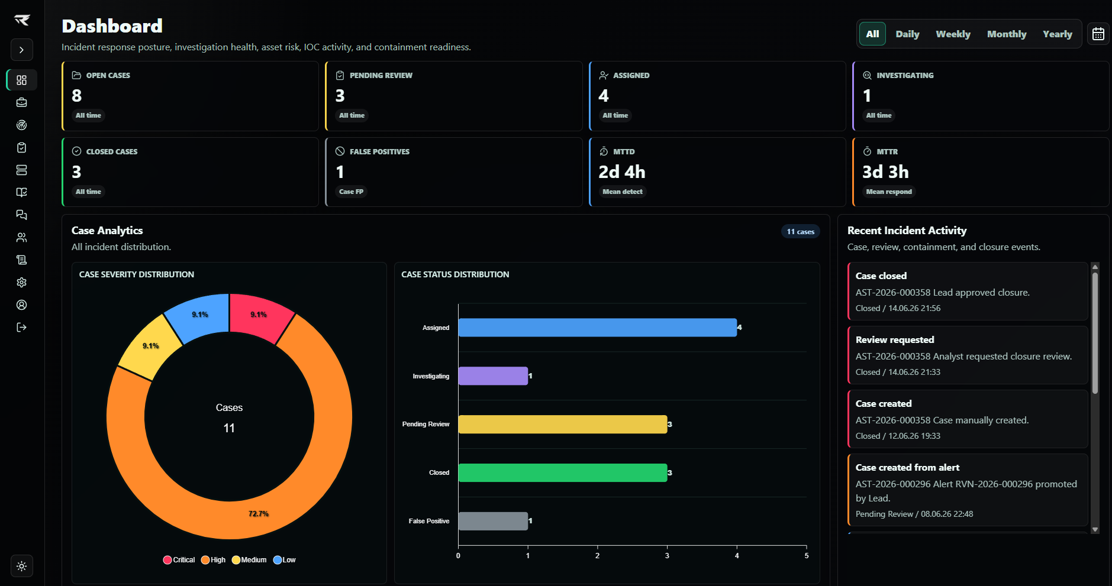
Figure 1: AstoraSOC dashboard showing SOC workload, case analytics, incident activity, and operational response posture.
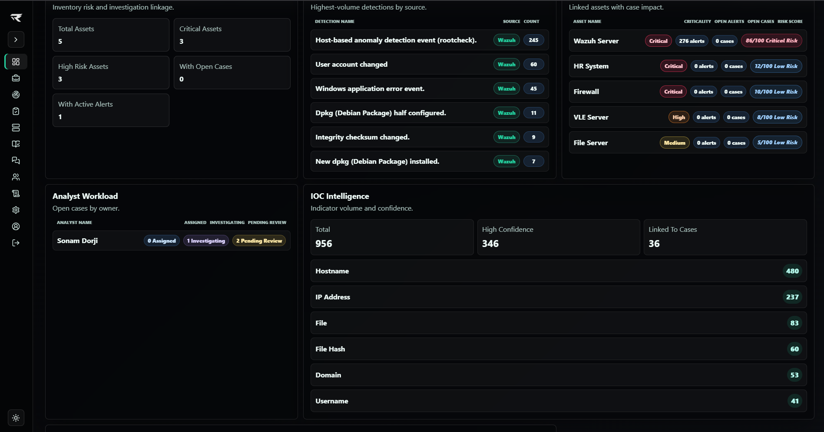
Figure 2: AstoraSOC dashboard intelligence panels showing triggered detections, affected assets, analyst workload, and IOC activity.

8. Alerts and SIEM Intake
Alerts are the first normalized AstoraSOC object created from external detections. The alert queue is provider-neutral and should display clean fields even when different SIEMs use different payload names. The alert queue is not intended to be the final record of response; validated alerts move through review and become cases for investigation.
Field | Purpose
Tracking ID | Human-readable AstoraSOC identifier such as AST-2026-000124.
Detection Name | Readable detection, signature, rule name, or event action derived from the source payload.
Title/Description | Readable summary and detail of the detection.
Severity | Security severity: Critical, High, Medium, Low.
Status | Workflow status such as New, Pending Review, Promoted, or False Positive.
Source | Alert source such as SIEM Webhook, Wazuh, Splunk, Sentinel, QRadar, Elastic, Security Onion, Shuffle, API, or manual source.
Event ID | External SIEM identifier for de-duplication and traceability.
Rule ID | Optional SIEM rule/signature identifier used by dashboard, playbooks, and reporting when present.
Host/User/IPs | Normalized affected host, hostname, agent name, username, source IP, and destination IP from provider-specific fields.
MITRE tactic/technique | ATT&CK mapping when provided by source.
Raw JSON | Original payload retained for later review and report context.
Asset link | Linked asset when hostname, agent name, or IP matches known Asset records.

Alert Normalization
Normalized Field | Typical Source Field Examples
Source IP | source_ip, src_ip, srcip, source.ip, data.srcip, event.source_ip, SourceIP, id.orig_h.
Destination IP | destination_ip, dst_ip, destination.ip, data.dstip, event.dst_ip, DestinationIP, id.resp_h.
Username | username, user.name, data.dstuser, data.srcuser, TargetUserName, SubjectUserName, account_name.
Host | host, hostname, host.name, agent.name, computer, computer_name, winlog.computer_name.
Detection Name | rule.description, rule.name, title, alert.title, event.action, signature, detection.name.
Raw Alert | Original JSON payload retained separately for forensic review and integration debugging.
Admin users may use normalized-field debug views to troubleshoot integration payloads. Analyst-facing cards should hide empty optional fields instead of displaying repeated placeholder values.
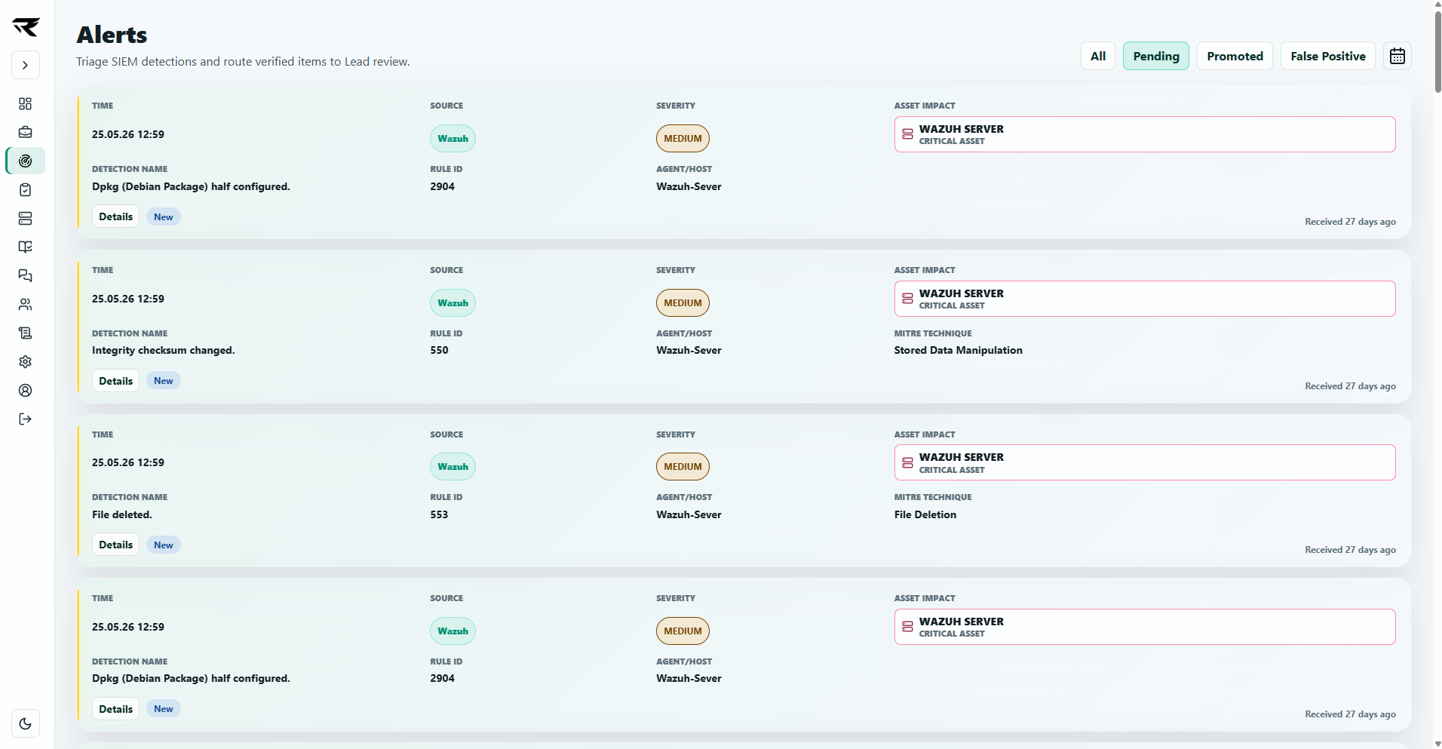
Figure 3: Alert queue showing provider-neutral alert normalization, detection metadata, linked asset impact, and triage actions.

Junior Analyst Triage Flow
- Review the alert summary, severity, asset context, rule ID, and raw event details.
- Check whether the affected asset is known and whether criticality changes priority.
- Review extracted IOCs and related activity.
- Mark the alert false positive if it is clearly benign and document rationale.
- Send the alert for Lead review when it appears valid or requires case creation.

9. Review Queue
The Review module is the governance point between triage, investigation, and closure. Reviews should feel like reviews, not ordinary case editing. Leads are responsible for forward movement and review decisions; Admins may see review content for oversight but should not perform review actions.
Review Type | Submitted By | Decision Owner | Possible Outcomes
Alert Review | Junior Analyst or authorized triage role | Lead Analyst | Promote to case, request more work, or close as false positive.
Closure Review | Assigned Analyst | Lead Analyst | Approve closure, request more work, escalate, or mark false positive if appropriate.
Containment Approval | Assigned Analyst | Lead Analyst | Approve, reject, or cancel depending on risk and evidence.
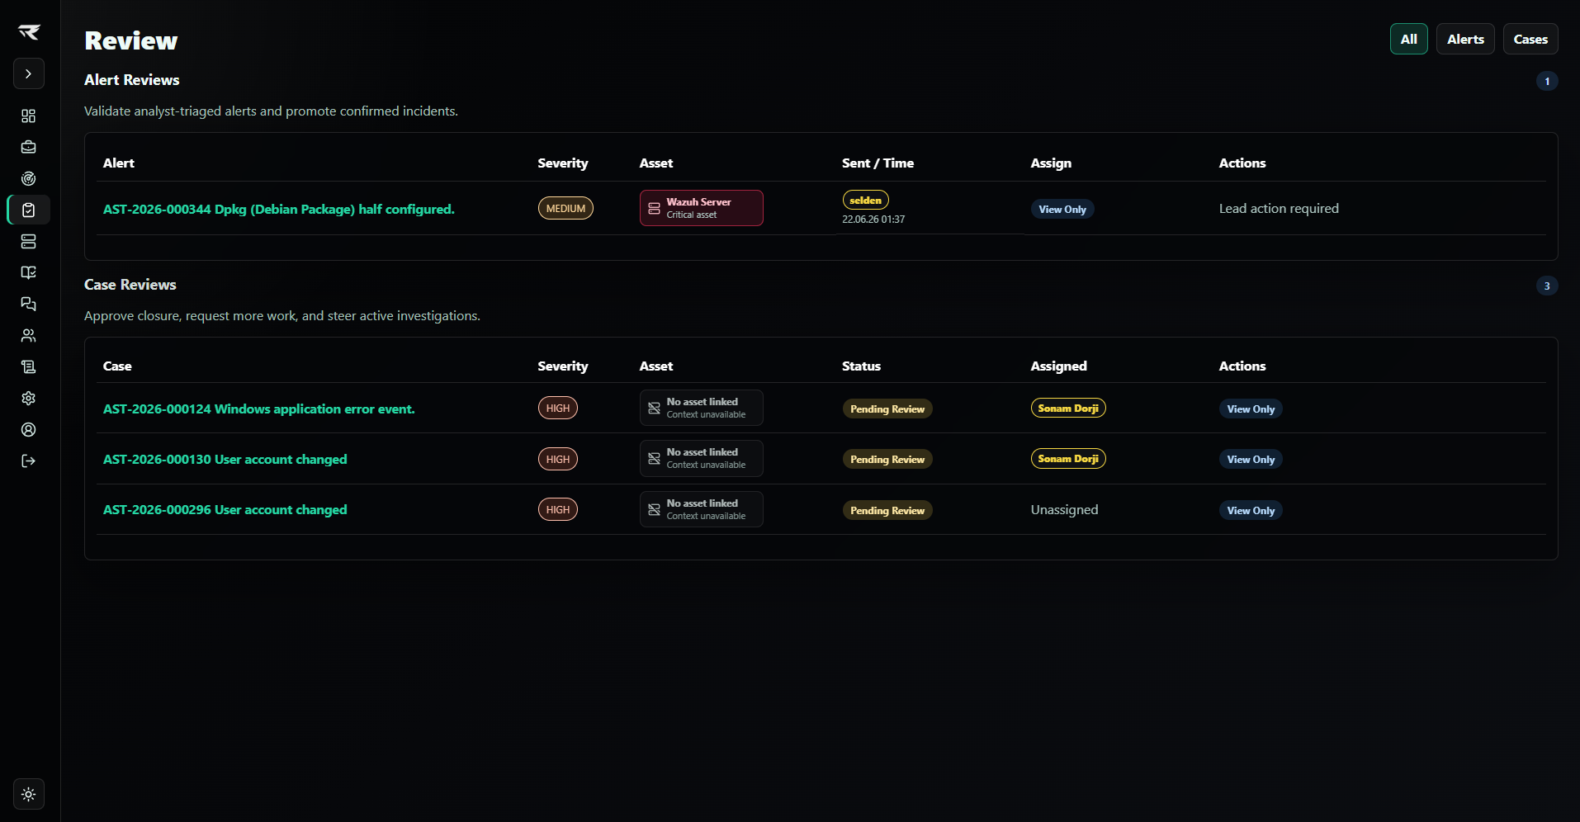
Figure 4: Review Queue showing alert reviews, case closure reviews, Lead decision points, assignment visibility, and review status controls.

10. Case Investigation Workspace
Cases are the central operational unit in AstoraSOC. All incident response work should converge into the case: summary fields, incident type, business impact, root cause, resolution summary, tasks, notes, evidence, IOCs, linked assets, timeline, containment requests, review state, and reports.
Section | Purpose | Primary Editor
Review Decision | Closure readiness, evidence, reviewer action, and summary context. | Lead decision / Analyst submission
Review Summary | Core case metadata snapshot for reviewers. | System-generated from case fields
Case Summary | Incident type, business impact, root cause, resolution summary, created/assigned/closed time, MTTR, host/user/IP context, and linked asset. | System plus authorized case editors
Timeline | Chronological incident and workflow events. | System plus workflow actions
Related Activity | Lightweight correlation hints by IOC, rule ID, and host. | System-generated
IOC Intelligence | Indicators tied to case and alert context. | Assigned Analyst
Evidence | Uploaded files, hashes, previews, and downloads. | Assigned Analyst
Tasks | Auto-generated and analyst-created checklist items. | Assigned Analyst
Investigation Journal | Searchable notes and findings. | Assigned Analyst
Containment Queue | Response action request, approval, execution, rollback, and history. | Analyst request; Lead/Admin execution depending on policy
Reports | DOCX/PDF case reporting. | Authorized users by role and assignment
- Every case should identify affected asset, user, host, severity, asset criticality, rule ID, source, and timestamps where available.
- Empty optional fields should be hidden in operational views and reports instead of rendered as repeated placeholder text.
- Vulnerability cases should record CVE ID, CVSS score, affected software/version, fixed version, patch status, remediation owner, validation performed, and final resolution summary where known.
- Every significant analyst decision should be captured in notes, timeline, audit logs, or containment history.
- Evidence uploads should be purposeful, named clearly, and referenced in closure notes when relevant.
- Closure requests should state finding, impact, action taken, evidence reviewed, and recommended final disposition.
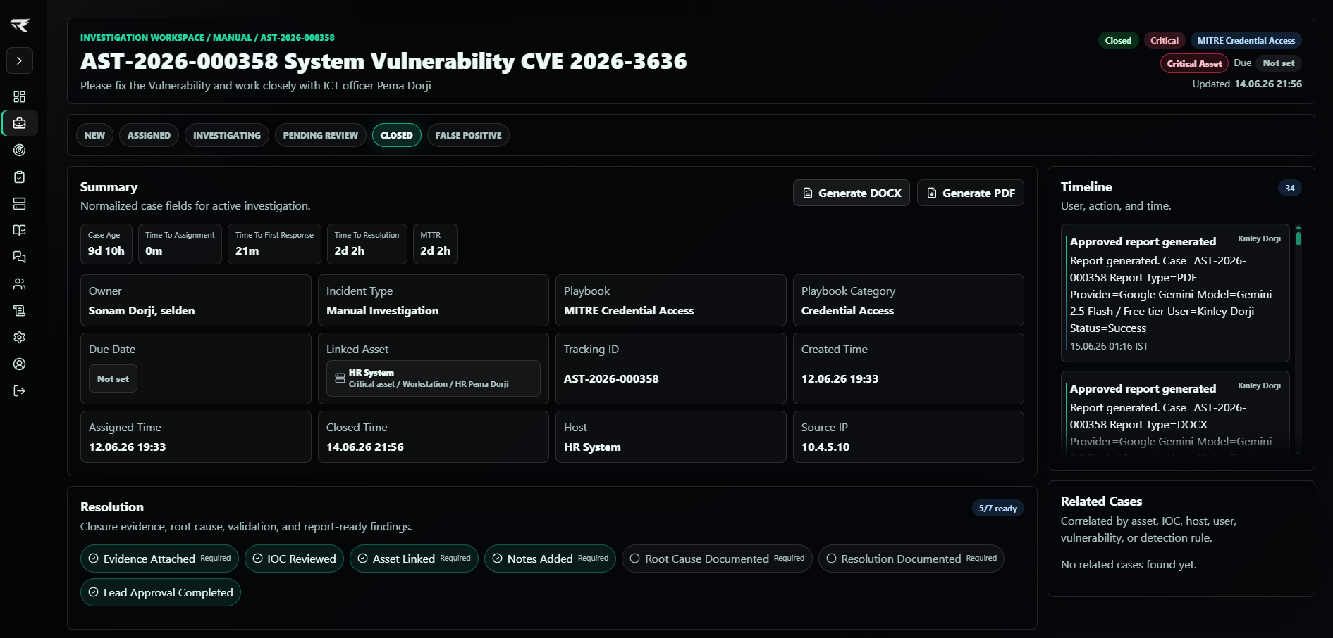
Figure 5: Investigation workspace showing case summary, workflow status, closure readiness, timeline, and report generation controls.
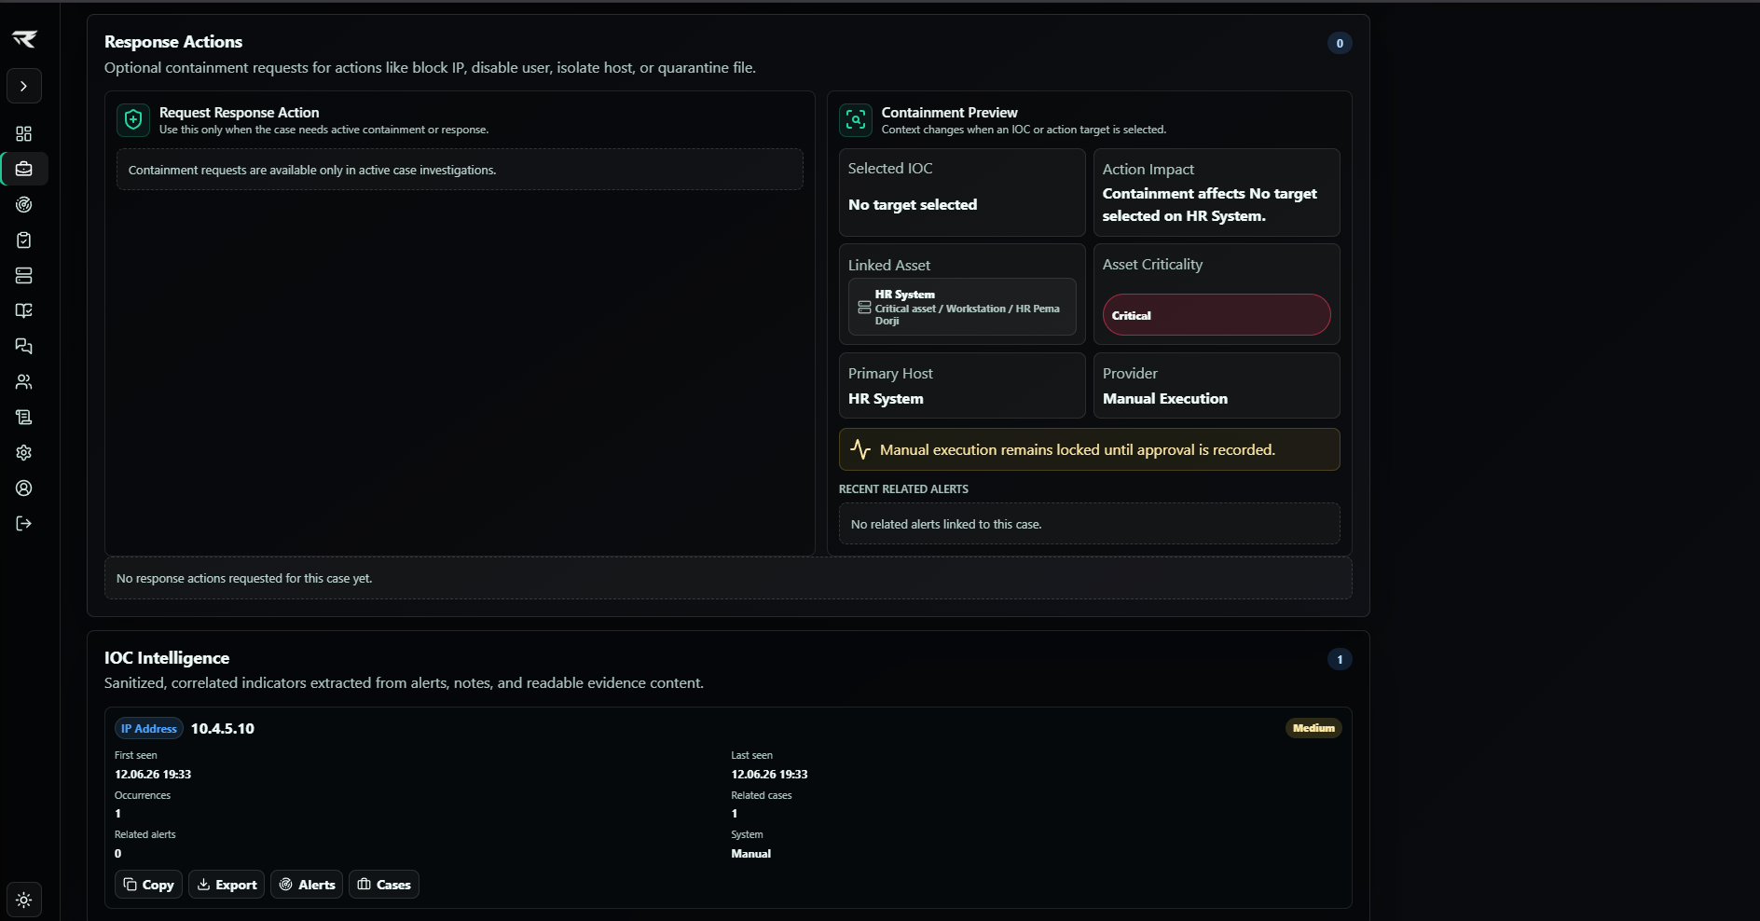
Figure 6: Investigation workspace response section showing containment readiness, linked asset context, and IOC intelligence actions.
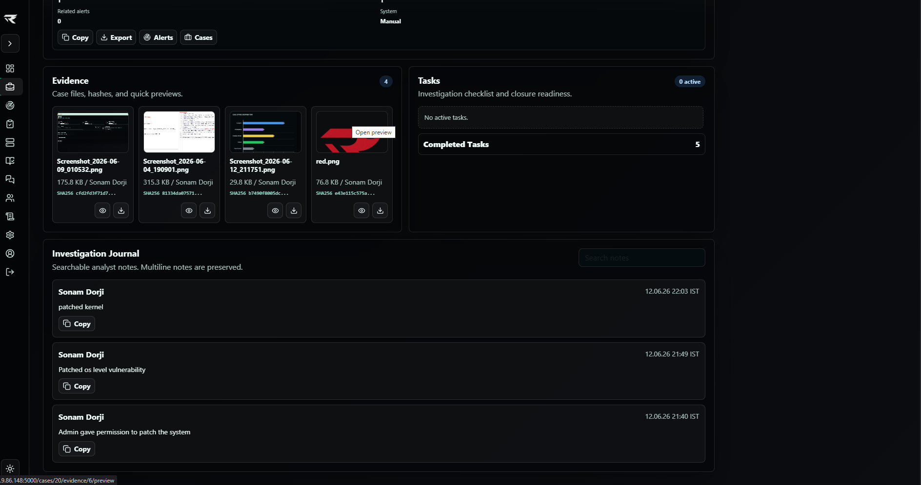
Figure 7: Investigation workspace evidence, task, and journal panels showing case artifacts, completed work, and analyst notes.

11. Asset Management
AstoraSOC Asset Management provides security-focused asset intelligence for investigations, vulnerability response, threat hunting, and reporting. It is not intended to replace an enterprise CMDB, but it gives SOC teams the business and technical context needed to prioritize alerts and cases.
Asset Field | Usage
Asset Name | Human-readable name shown in asset tables, case summaries, and reports.
Hostname | Primary matching key for agent name, host name, and case affected host.
IP Address | Secondary matching key for source/destination or host IPs.
Asset Owner | Business or technical owner for escalation and context.
Department | Standardized department value; tables may show short names such as ICT, HR, SOC, or R&D while details and reports preserve the full name.
Business Function | Operational purpose such as SIEM Platform, Active Directory, Payroll System, Email Gateway, Web Server, or custom value.
Operating System | Investigation context and containment planning.
Asset Type | Workstation, server, domain controller, network device, cloud resource, or other lightweight type.
Criticality | Business importance: Critical, High, Medium, or Low. This is separate from current security risk.
Status | Online, Offline, or Unknown. Status may be updated from network checks, telemetry, or future integrations.
Risk Score | Current security exposure from open alerts, open cases, IOC associations, vulnerabilities, and recent security activity.

Automatic Asset Linking
AstoraSOC attempts to link alerts and cases to assets when hostname, agent name, affected host, source IP, destination IP, or related host/IP fields match an existing Asset. Linked asset information is displayed directly in alerts, reviews, and cases so analysts can combine technical severity with business criticality.
Criticality | Definition | Response Impact
Critical | Business-critical service, privileged infrastructure, identity platform, regulated data, or executive asset. | Escalate quickly; containment may be justified even for medium technical severity.
High | Important production system, sensitive business process, or high-value user/host. | Prioritize investigation and Lead visibility.
Medium | Standard business asset with normal user or service impact. | Use normal SOC workflow.
Low | Low-impact endpoint, lab asset, or informational context. | Correlate, document, and avoid unnecessary escalation.

Asset Risk Score
Risk Rating | Score Range | Meaning
Low Risk | 0-24 | Low current security exposure, even if the asset is business critical.
Medium Risk | 25-49 | Some active exposure such as recent alerts, related IOCs, or unresolved investigation context.
High Risk | 50-74 | Material exposure from open cases, active alerts, high-value indicators, or vulnerable business context.
Critical Risk | 75-100 | High likelihood or impact requiring immediate SOC attention.
Asset Criticality represents business importance. Asset Risk Score represents current security exposure. A critical asset with no current alerts may have low risk, while a medium asset with active malware activity may have high or critical risk.
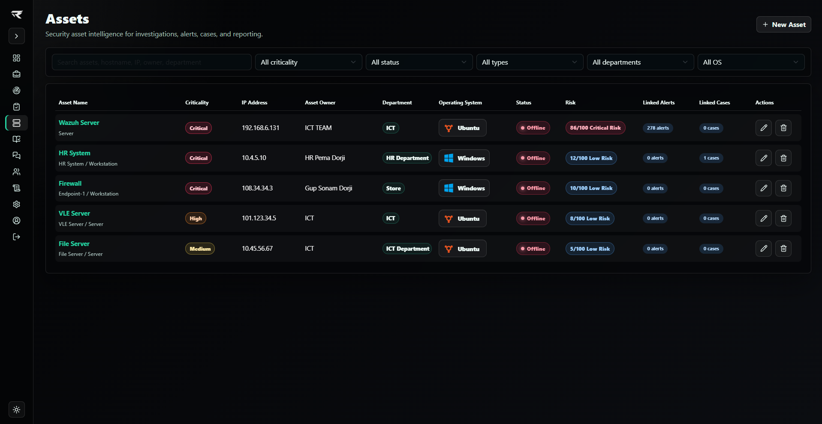
Figure 8: Asset Management inventory showing criticality, asset owner, department, operating system, status, risk score, and linked alert/case counts.

12. Playbook Engine and Tasks
The Playbook Engine automatically creates investigation tasks when a case is created from an alert or manually opened by a Lead/Admin. Administrators manage central templates, while Analysts retain the ability to add, edit, delete, and complete tasks during the investigation.
- SIEM Rule ID playbooks match the normalized detection rule/signature ID when an exact or contained match is found.
- Source Category playbooks match alert category, decoder, rule groups, or provider category fields when provided.
- MITRE Tactic playbooks match the alert MITRE tactic field.
- Alert Type playbooks match alert type, event type, title, or description keywords.
- Case Type playbooks match manually created cases such as Vulnerability Remediation, Malware Incident, Credential Access, Threat Hunt, Compliance Investigation, Asset Investigation, Security Request, or Manual Investigation.
- Generic fallback playbook is used when no more specific playbook matches.
Template Field | Meaning
Name | Human-readable playbook name.
Description | Short explanation of the scenario.
Category | Operational category such as Vulnerability, Malware, Phishing, Credential Access, Threat Hunting, Compliance, Operations, or Generic.
Match Type | SIEM_RULE_ID, SOURCE_CATEGORY, MITRE_TACTIC, ALERT_TYPE, CASE_TYPE, or GENERIC.
Match Value | Rule/category/tactic/type value used for matching; generic uses *.
Priority | Lower numbers win when multiple templates could match.
Active Flag | Disabled templates are ignored.
Tasks Text | One investigation step per line.
Playbook | Match | Example Tasks
Generic SOC Triage | GENERIC * | Validate alert fidelity; review raw event; collect evidence; identify IOCs; assess containment; prepare summary.
Vulnerability Remediation | CASE_TYPE Vulnerability Remediation | Validate vulnerability; confirm affected asset; assess business impact; apply remediation; verify remediation; request closure review.
Authentication Failure Investigation | CATEGORY authentication | Confirm login pattern; review source IP; check successful logins; validate MFA/password reset indicators.
Malware / File Execution Investigation | ALERT_TYPE malware | Identify process/file/hash; check recurrence; collect process tree; assess isolation or quarantine.
MITRE Credential Access | MITRE_TACTIC Credential Access | Validate tactic; identify impacted users; review auth/lateral movement; determine reset/session revocation.
Threat Hunting | CASE_TYPE Threat Hunt | Define hunt objective; collect telemetry; search indicators; analyze findings; document outcome; escalate if threats are identified.
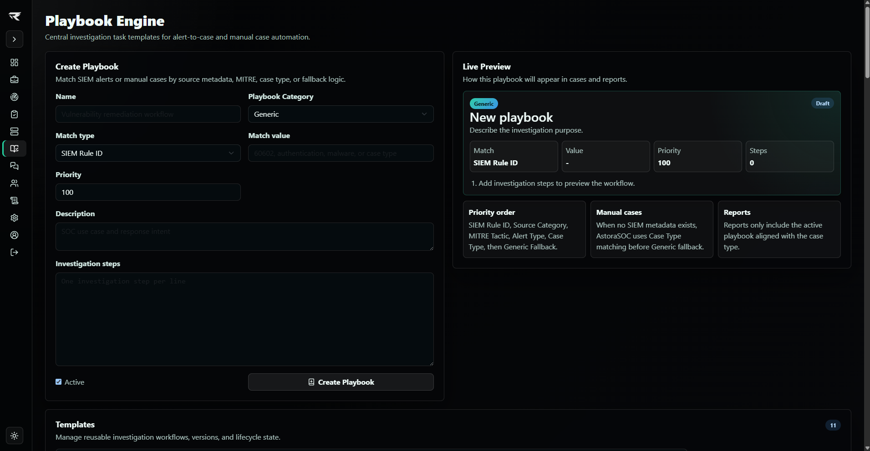
Figure 9: Playbook Engine showing SIEM and manual case matching, category selection, priority control, live preview, and reusable workflow templates.

13. IOC Intelligence
IOC Intelligence records indicators from alerts and cases, normalizes values for correlation, and presents analyst-friendly type labels such as IP Address, Domain, Hostname, URL, Username, Email, Process, File, Registry Key, File Hash, and Service.
IOC Type | Examples | Investigation Use
IP Address | 192.168.1.10, 8.8.8.8 | Network source/destination, firewall blocks, reputation checks.
Domain / URL | example.com, https://site/path | Phishing, malware callback, web proxy checks.
Hostname | WIN-01, server01 | Asset linking, host triage, case correlation.
Username / Email | jdoe, user@example.com | Account compromise, disable user containment, identity review.
Process / File | powershell.exe, C:\Temp\evil.exe | Endpoint triage, kill process, quarantine file.
File Hash | SHA256/MD5/SHA1 where provided | Malware lookup and cross-case recurrence.
Registry Key / Service | Run keys, service names | Persistence analysis.
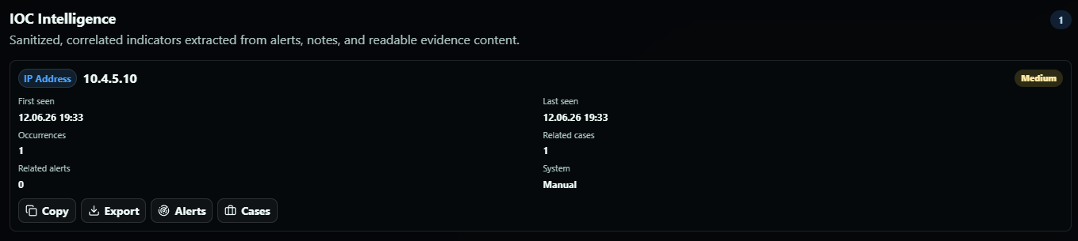
Figure 10: IOC Intelligence panel showing sanitized indicator classification, confidence, first and last seen timestamps, correlation counts, source system, and quick investigation actions.

14. Evidence Management
Evidence uploads support investigation documentation, report generation, and reviewer confidence. Each evidence record stores the original filename, randomized stored filename, SHA256 hash, uploader, and timestamp.
- Upload only files that support the investigation or closure decision.
- Prefer text, logs, PDFs, JSON, CSV, screenshots, and zipped evidence bundles when appropriate.
- Avoid uploading secrets, credentials, private keys, or unnecessary personal data.
- Reference important evidence in notes or closure summaries.
- Use SHA256 values for verification and tamper-evidence, not as a substitute for formal legal chain-of-custody.
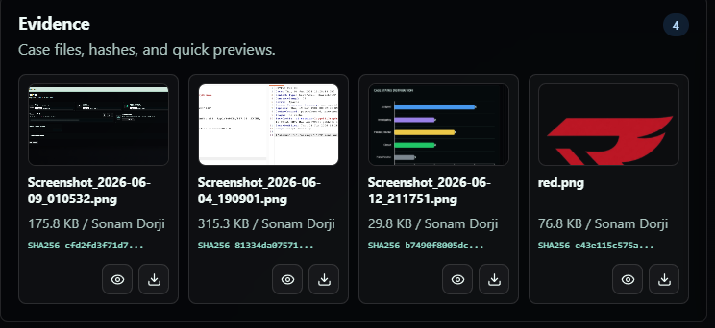
Figure 11: Evidence Management panel showing compact evidence cards, file previews, SHA256 hashes, uploader metadata, and quick preview/download actions.

15. Containment Queue and IR Workflow
Containment in AstoraSOC is case-only. Actions originate from the investigation workflow and are never automatically executed directly from alerts. This keeps response actions governed, auditable, and tied to a case record.
Action Type | Typical Target | Risk Notes
Block IP | Source or destination IP | May disrupt legitimate traffic if shared IP or NAT is involved.
Disable User | Username or email | High-risk identity action; confirm user and business impact.
Kill Process | Process name or PID | Can disrupt running workloads; confirm host and process context.
Isolate Host | Hostname or asset | High operational impact; confirm criticality and business owner.
Add Firewall Rule | IP, port, protocol, direction | Coordinate with network/security owners and document rollback.
Quarantine File | File path or hash | Confirm file identity and endpoint scope.
Future Integration | Provider-specific target | Reserved for SIEM/SOAR relays, Wazuh Active Response, Shuffle, PowerShell, SSH, firewall APIs, EDR, and SOAR.
Status | Meaning
Draft | Action has been prepared but not submitted.
Pending Approval | Analyst requested action and Lead/Admin approval is required.
Approved | Authorized by Lead or authorized approver.
Rejected | Approver declined the request.
Queued | Approved action is waiting for execution.
Executing | Authorized operator is performing manual or provider-backed execution.
Executed | Action completed successfully.
Failed | Execution attempt failed and error/result is recorded.
Cancelled | Action was cancelled before completion.
Rolled Back | Rollback was performed and result was recorded.

Required Containment Fields
- Unique Containment Action ID in CA-000001 format.
- Action Type, Target, Asset/Host, Risk Level, Approval Requirement, Reason, Analyst Notes.
- Requested By, Approved By, Rejected By, Executed By, Cancelled By, Rolled Back By where applicable.
- Created, approved, rejected, started, completed, cancelled, and rolled back timestamps as applicable.
- Execution Provider, Execution Result, Execution History, Rollback Supported, Rollback Status, and Rollback Result.

SOC Workflow
- Analyst selects an IOC or enters a target in the case containment request panel.
- AstoraSOC shows containment preview: selected IOC, affected asset, primary host, asset criticality, provider, related alerts, and impact summary.
- Analyst submits the request with reason, risk level, approval requirement, and notes.
- AstoraSOC creates a containment record, writes timeline/audit entries, and notifies Leads/Admins if approval is required.
- Lead approves, rejects, or cancels. Decision is written to timeline and audit logs.
- After approval, authorized Admin or Lead manually executes the action and records result, notes, and success/failure details.
- If rollback is supported and needed, authorized operator records rollback result and AstoraSOC preserves the history.
- Reports include containment action history, approvals, execution results, rollback records, and timestamps.
Future Provider | Integration Pattern
SIEM/SOAR Relay | Dispatch approved provider-neutral response payloads to connected SIEM/SOAR workflows.
Wazuh Active Response | Map approved actions to active-response commands with host/agent scope and return execution output when Wazuh is used.
Shuffle | Trigger workflow webhook with case/action payload and store playbook response.
PowerShell | Execute approved Windows response commands through a controlled runner.
SSH | Run approved Linux/network commands through credential-safe executor.
Firewall APIs | Create or remove block rules through vendor API adapters.
EDR Platforms | Isolate host, kill process, quarantine file, or collect telemetry through EDR APIs.
SOAR Playbooks | Dispatch provider-neutral action payloads into enterprise orchestration tooling.

16. Email and In-App Notifications
AstoraSOC combines in-app notification bell records with optional HTML email notifications. Email destinations use the email stored in each user profile, with pending email changes requiring administrator approval before delivery uses the new address.
Setting | Purpose
SMTP Host | Mail server hostname.
SMTP Port | Mail server port, commonly 587 for STARTTLS or 465 for SSL.
SMTP Username | Authentication username when required.
SMTP Password | Encrypted at rest with AstoraSOC encryption helper.
TLS/SSL Options | STARTTLS or SSL transport security modes.
From Name | Display name for AstoraSOC emails.
From Email | Sender address for notifications.
Test Email | Recipient for validation through Send Test Email.
Event | Recipients | Email Title | Action Button
Junior Analyst sends alert for review | All Lead Analysts | Alert Review Required | Review Alert
Lead assigns case to Analyst | Assigned Analyst | Case Assigned | Open Case
Analyst requests closure review | Assigned Lead/Lead group | Closure Review Requested | View Investigation
Containment approval requested | Leads and Administrators | Containment Approval Required | Approve Request
Containment approved or rejected | Requesting Analyst | Containment Approved / Rejected | View Investigation
Case closed | Assigned Analyst and Lead | Case Closed | View Investigation
- Email + In-App: user receives an in-app notification and email where workflow supports email.
- In-App Only: user receives AstoraSOC bell notifications only.
- Disabled: AstoraSOC suppresses notifications for that user where preference checks apply.
- EmailDeliveryLog records recipient, notification type, subject, status, errors, created timestamp, and delivered timestamp.

17. Reports
AstoraSOC supports professional case report generation to DOCX and PDF-oriented output. Reports are intended for management review, audit support, closure evidence, and post-incident documentation. Reports are generated only after the case is closed and Lead review has approved closure.
- Case identifiers, title, severity, status, source, timestamps, assignee, reviewer, and closure metadata.
- Executive impact summary explaining what happened, affected systems, asset criticality, business impact, downtime or data exposure when recorded, before/after risk, residual risk, and recommended follow-up.
- Alert metadata including detection name, source, optional rule ID, MITRE tactic/technique, affected host/user/IPs, and raw event context where appropriate.
- Linked asset context including hostname, IP, owner, department, OS, type, and criticality.
- IOC intelligence with analyst-friendly IOC labels.
- Evidence register with preview status, filename, evidence type, file size, uploader, upload time, SHA256 hash, and purpose or description.
- Evidence image previews embedded directly into generated reports when image artifacts are attached and available.
- Task completion status and playbook-generated/analyst-created task source.
- Timeline highlights with major milestones only, avoiding report-generation noise and repeated internal activity.
- Containment actions, approval history, execution results, rollback records, and operator notes.
- MITRE ATT&CK mapping with tactic ID/name, technique ID/name, procedure, and detection source when available from the case or linked alert.
- Technical remediation summary with CVE, affected product, affected version, fixed version, patch status, remediation owner, installed patch/update, commands, verification command, and verification result where available.
- Risk metrics showing initial risk, residual risk, risk reduction percentage, and confidence based on evidence, task completion, root cause, resolution, validation, and reviewer approval.
- Professional report charts generated only from real case data, such as Risk Reduction, Remediation Progress, Timeline Activity, Task Completion, IOC Distribution, Evidence Summary, MITRE Technique Distribution, Severity Distribution, or Containment Status when the data is meaningful.
Report routes enforce role and assignment visibility so Analysts cannot generate or access reports for cases outside their allowed scope. If AI report generation is enabled and configured, AstoraSOC automatically uses AI to enhance the report narrative; if AI is disabled, missing, or fails, the standard report generator is used as a safe fallback.

Enterprise Report Engine Behavior
Capability | Enterprise Behavior
Real-data charts | Charts are created from stored case data only. AstoraSOC does not generate random or placeholder graph values. If there is not enough data for a useful chart, the chart is hidden.
Technical remediation | Exact CVEs, affected/fixed versions, KB/RPM/APT/package details, commands, service restarts, and verification results are shown only when recorded in case fields, notes, tasks, evidence metadata, or timeline entries.
Evidence intelligence | Reports show evidence metadata and include image previews where supported so reviewers can inspect screenshots without relying only on filenames.
Risk measurement | Risk sections use calculated initial and residual scores, risk reduction percentage, and confidence. Scores are derived from severity, closure state, remediation status, evidence, tasks, and reviewer approval.
MITRE mapping | ATT&CK data is split into tactic ID/name and technique ID/name where possible, with procedure and detection source retained for technical traceability.
Timeline compression | Reports emphasize major milestones such as case creation, investigation, evidence collection, remediation, review, approval, and closure while excluding report-generation noise.
Page footer | DOCX/PDF reports include AstoraSOC version, case ID, classification, generated time, page number, and Generated by AstoraSOC footer metadata.

AI Report Configuration
Setting | Operational Guidance
Enable AI Report Generation | When enabled, Generate DOCX/PDF automatically attempts AI-enhanced report generation for approved closed cases.
AI Provider | Supported provider families include OpenAI-compatible APIs, OpenRouter, DeepSeek routes, Google Gemini, Anthropic Claude, Azure OpenAI, Ollama local models, and custom OpenAI-compatible endpoints where configured.
AI Model | Administrators select from provider-approved model options. Free, local, or low-cost routes should be labelled clearly in the UI.
API Key | Stored encrypted and never displayed after saving. Replacing the key should be audited.
Custom Endpoint | Used only for Azure OpenAI, Ollama, or custom OpenAI-compatible services.
Test AI Connection | Validates endpoint connectivity, authentication, model availability, and response latency before relying on report generation.
AI-enhanced reports must never invent facts. AI should transform verified case data into executive and technical narrative, omit empty fields, avoid generic language, and fall back to the standard deterministic report generator if the AI call or rendering fails.

Report Quality Rules
- Reports must not look like raw database exports.
- Reports must never invent patches, versions, CVEs, commands, indicators, evidence, or remediation actions.
- If a required technical field is unavailable, the report displays Not Available; optional empty sections are omitted where they do not help the reader.
- Recommendations, findings, and remediation text must align with the case type and verified case data.
- Vulnerability reports must not include unrelated credential, malware, or phishing playbook language.
- Evidence, timeline, tasks, notes, and closure information should be summarized for executive readability, with technical detail preserved in appendices where useful.
- Charts are generated only when meaningful data exists and should remain compact, print-friendly, and limited to a maximum of three per report.

18. Audit Logs
Audit logs provide platform-level accountability. They complement case timelines: timelines explain case chronology, while audit logs explain who changed platform or workflow state and from what IP address.
Audit Area | Examples
Authentication and users | Login state, password changes, user creation/edit/delete, email approval/rejection.
Alerts and cases | Alert review, case promotion, assignment, workflow transitions, closure decisions.
Playbooks | Template changes and automatic playbook application.
Containment | Request, approval, rejection, execution, failure, cancellation, rollback.
Settings | Webhook API key rotation, email settings updates, timeout changes.
Evidence and uploads | Upload, delete, and validation outcomes where implemented.

19. Chat and Collaboration
AstoraSOC includes SOC chat for lightweight collaboration. Chat content is encrypted using the application encryption helper, supports mentions, reactions, attachments, reply context, and configurable custom emojis.
Feature | Purpose
Encrypted message body | Protects stored chat content using Fernet derived from SECRET_KEY.
Mentions | Allows users or roles to be referenced with profile-card context.
Reactions | Lightweight acknowledgment and collaboration.
Attachments | Supports controlled file sharing with upload validation.
Custom emojis | Admin-configurable visual collaboration assets.

20. API and Webhook Reference
Property | Value
Method | POST
Path | /api/webhook/alert
Authentication | Header X-API-Key: <WEBHOOK_API_KEY>
Content Type | application/json
Primary Source | Any SIEM/SOAR webhook, bridge script, Wazuh custom integration, EDR/security tool, or API client.
Field | Type | Description
event_id | string | Unique source event ID for duplicate tracking.
title | string | Readable alert title.
description | string | Detailed event text.
severity | string | Critical, High, Medium, Low, or source value mapped by AstoraSOC.
source | string | Source platform such as SIEM Webhook, Wazuh, Splunk, Sentinel, Elastic, QRadar, Security Onion, Shuffle, or API.
rule_id | string | Detection rule identifier.
affected_host | string | Host or agent name.
affected_user | string | User account involved.
source_ip | string | Source IP address.
destination_ip | string | Destination IP address.
mitre_tactic | string | MITRE ATT&CK tactic when available.
mitre_technique | string | MITRE ATT&CK technique when available.
raw_alert | object | Original source payload for analyst review.

Example Payload
{
"event_id": "siem-1700000000.123",
"title": "Suspicious authentication activity",
"description": "Multiple failed logins followed by a successful login.",
"severity": "High",
"source": "SIEM Webhook",
"rule_id": "AUTH-001",
"affected_host": "workstation-01",
"affected_user": "jdoe",
"source_ip": "192.168.1.50",
"destination_ip": "10.0.0.20",
"mitre_tactic": "Credential Access",
"mitre_technique": "T1110",
"raw_alert": {"provider": "example-siem", "rule": {"id": "AUTH-001", "groups": ["authentication"]}}
}

21. SIEM and SOAR Integration Guide
AstoraSOC is designed as a SIEM/SOAR-agnostic incident response intake layer. Any security platform that can send JSON over HTTP, run a bridge script, or relay through a SOAR workflow can send alerts to AstoraSOC using the same webhook architecture. Wazuh is included as one ready-to-use integration example, not the only supported source.
- Use /api/webhook/alert as the common intake endpoint for all SIEM/SOAR sources.
- Send X-API-Key with an AstoraSOC-generated webhook key and JSON payload fields such as event_id, title, severity, source, rule_id, host, user, IPs, MITRE, and raw_alert.
- Use direct webhooks when the source supports custom headers and JSON bodies.
- Use bridge scripts when a source cannot directly format AstoraSOC payloads.
- AstoraSOC includes SIEM Integrations/Wazuh/custom-astorasoc.py as a dependency-free Wazuh example for minimal Wazuh Docker environments.
Platform | Recommended Pattern
Splunk Enterprise / Splunk ES | Use alert actions or webhook integrations to POST normalized JSON to AstoraSOC.
Microsoft Sentinel | Use Logic Apps or automation rules to call AstoraSOC webhook.
Elastic Security | Use connectors, webhooks, or rule actions to send alerts.
IBM QRadar | Use custom action scripts or SOAR bridge to call AstoraSOC.
Google Chronicle / SecOps | Use integration webhook or cloud function bridge.
Graylog | Use event notification HTTP callbacks.
LogRhythm | Use SmartResponse or webhook bridge.
ArcSight | Use connector/action bridge to normalize events.
Security Onion | Forward detections through webhook/script bridge.
AlienVault / USM | Use alarm webhook or API polling bridge.
Pattern | When to Use | Notes
Direct webhook | SIEM supports outbound HTTP POST with custom header. | Simplest and preferred pattern.
Bridge script | SIEM can run a script but cannot format AstoraSOC payload directly. | Normalize fields and send X-API-Key.
SOAR relay | Existing SOAR orchestrates detection workflow. | SOAR can enrich alert before AstoraSOC case creation.
Scheduled API polling | SIEM lacks alert webhooks but has query API. | Use a small service to poll, de-duplicate, and post to AstoraSOC.
Email parser | Legacy systems only send email. | Use only as fallback; less structured and harder to secure.
CSV/manual import | Backfill or testing. | Useful for migration, not real-time SOC workflow.

22. Operational Runbooks
- Open Dashboard and review open cases, pending review, investigating cases, MTTD, MTTR, top rules, affected assets, IOC overview, and containment metrics.
- Leads clear pending review queue first, especially high severity or critical asset cases.
- Junior Analysts triage new alerts and submit valid alerts for Lead review.
- Leads assign promoted cases to Analysts based on workload and skill.
- Analysts work assigned cases, complete playbook tasks, add IOCs, upload evidence, and maintain notes.
- Containment requests are submitted only from case investigations with clear reason and risk level.
- Leads approve/reject containment and closure requests with documented rationale.
- Admins review audit logs, email delivery logs, platform health, API key status, and user activity.

New Alert Handling Runbook
- Validate source, rule ID, event timestamp, affected host/user, and severity.
- Check linked asset and criticality.
- Review raw JSON and extracted IOCs.
- Mark false positive if confirmed benign; otherwise send to review.
- Lead promotes alert to case if investigation is required.

Case Investigation Runbook
- Review case summary, linked alert, asset criticality, MITRE mapping, and playbook tasks.
- Confirm scope: affected host, user, IPs, and related IOCs.
- Collect and upload evidence with meaningful filenames.
- Document findings in the Investigation Journal.
- Request containment if risk and evidence justify it.
- Complete tasks or explain why a task is not applicable.
- Submit closure review with final finding, evidence summary, response actions, and recommended closure reason.

Containment Approval Runbook
- Confirm action originated from a case and has a documented reason.
- Validate target, asset, IOC, affected host/user/process/file, and risk level.
- Confirm business impact, especially for Critical or High asset criticality.
- Approve only when expected security benefit outweighs operational risk.
- Reject or request more context when evidence is weak or target is ambiguous.
- Record manual execution result and rollback plan/result if applicable.

Backup and Restore Runbook
- Back up the database on a schedule aligned with incident record retention requirements.
- Back up UPLOAD_FOLDER, including evidence, profile images, report templates, chat attachments, and custom assets.
- Document SECRET_KEY handling because encrypted values depend on it.
- Test restore in a non-production environment before relying on backups.

23. Troubleshooting
Symptom | Likely Cause | Resolution
No alerts arriving | Wrong webhook URL, invalid X-API-Key, network block, SIEM script error. | Test POST manually, verify API key in Admin Settings, inspect SIEM logs, confirm AstoraSOC container reachable.
Webhook unauthorized | Key mismatch or insecure default key rejected. | Regenerate/copy AstoraSOC webhook key and update SIEM configuration.
Emails not delivered | SMTP incomplete, TLS/SSL mismatch, auth failure, blocked relay. | Use Send Test Email, review Email Delivery Logs, confirm host/port/from email and credentials.
Dashboard date filter returns no data | Selected date period has no matching cases or filter not applied. | Choose period above calendar, click Apply, clear filter to validate baseline.
User remains online too long | Browser active heartbeat still updating session or timeout setting high. | Verify session timeout value and that passive polling does not update activity in hidden tabs.
Admin/Lead can edit case content | Route or template control still exposing investigation actions. | Ensure case_investigation_required protects notes, evidence, IOCs, tasks, containment requests, and closure submission.
Evidence upload rejected | Unsupported extension or size over limit. | Use allowed evidence types and stay under configured max bytes.
Report formatting issue | Long IOC/hash/string or unsupported content layout. | Use report wrapping and inspect generated DOCX/PDF output.
Assets not linking | Hostname/IP mismatch or asset not created. | Normalize hostname/IP values and create/update asset record.
Playbook tasks missing | No active template or match context insufficient. | Verify active generic fallback and match values in Admin Playbooks.

24. Maintenance and Roadmap
- Review user roles and remove inactive users.
- Rotate webhook API key on exposure, staff change, or periodic security schedule.
- Review audit logs and email delivery failures.
- Update playbook templates when rule IDs, detection logic, or SOC procedures change.
- Update asset criticality as business impact changes.
- Archive old evidence and reports according to retention policy.
- Rebuild/redeploy containers after dependency or security updates.
Area | Recommended Enhancement
Containment providers | Implement provider adapters for SIEM/SOAR relay, EDR, firewall, PowerShell, SSH, Shuffle, Wazuh Active Response, and other response tools behind the existing lifecycle.
SIEM connectors | Add native payload mappers for Splunk, Sentinel, Elastic, QRadar, Chronicle, and Graylog.
Asset sync | Optional import from CSV, AD, cloud inventory, or EDR without becoming a full CMDB.
Metrics | Trend baselines, SLA aging, workload forecasting, and detection quality scorecards.
Reports | Custom report template builder and scheduled report packs.
Security | MFA, SSO/SAML/OIDC, per-route permission policy, and secrets manager integration.

25. Appendices

Appendix A - Status Definitions
Object | Statuses / Values
Case | New, Assigned, Investigating, Pending Review, Closed, False Positive, and workflow-specific submitted/review states.
Alert | New, Pending Review, Promoted, False Positive, and source/triage states.
Containment | Draft, Pending Approval, Approved, Rejected, Queued, Executing, Executed, Failed, Cancelled, Rolled Back.
Task | Active or completed; source Auto or Analyst.
Email Delivery | Queued, Delivered, Failed, or SMTP-specific failure state.

Appendix B - Severity and Criticality
Level | Severity Meaning | Criticality Meaning
Critical | Immediate or confirmed severe security incident. | Mission-critical asset or business process.
High | Likely incident or high-risk activity. | Important system or sensitive business area.
Medium | Needs investigation but not immediately severe. | Normal business asset.
Low | Informational or low-risk signal. | Low-impact asset or lab/noncritical scope.

Appendix C - Administrator Checklist
- Change default admin password.
- Configure session timeout and cookie security for environment.
- Generate and secure webhook API key.
- Configure SMTP and send a test email.
- Create users and validate role assignments.
- Create critical assets and verify automatic linking with sample alerts.
- Review and customize default playbook templates.
- Verify audit logs and report generation.
- Back up database and upload folder.

Appendix D - Analyst Case Closure Checklist
- Affected host/user/IPs confirmed.
- Asset criticality reviewed.
- All relevant IOCs recorded and labeled correctly.
- Evidence uploaded and referenced in notes.
- Playbook tasks completed or documented as not applicable.
- Containment actions requested/executed/rolled back where needed.
- Final summary explains finding, impact, response, and closure reason.
- Closure review submitted to Lead.

Appendix E - Design Preset Audit
Preset Token | Applied Value
Preset | compact_reference_guide
Page | US Letter portrait, 1.0 in margins, 0.492 in header/footer, 6.5 in content width
Base font | Calibri 11 pt
Body spacing | 0 pt before, 6 pt after, 1.25 line spacing
Heading 1 | 16 pt #2E74B5, 18 pt before, 10 pt after
Heading 2 | 13 pt #2E74B5, 14 pt before, 7 pt after
Heading 3 | 12 pt #1F4D78, 10 pt before, 5 pt after
Tables | 9360 DXA width, 120 DXA indent, fixed grid, 80/120/80/120 cell margins
Header fill | #E8EEF5

