**--1. List the following details of each employee: employee number, last name, first name, gender, and salary.**

SELECT employees.emp_no, employees.last_name, employees.first_name, employees.gender, salaries.salary

FROM employees, salaries

WHERE salaries.emp_no = employees.emp_no;

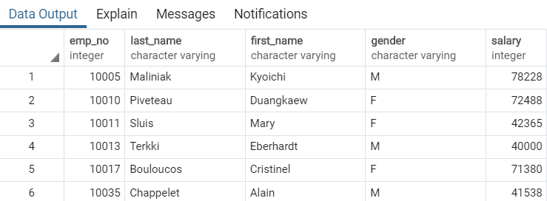

**-- 2. List employees who were hired in 1986.**

SELECT employees.last_name, employees.first_name, employees.hire_date

FROM employees

WHERE hire_date between '1985-12-31' and '1987-01-01';

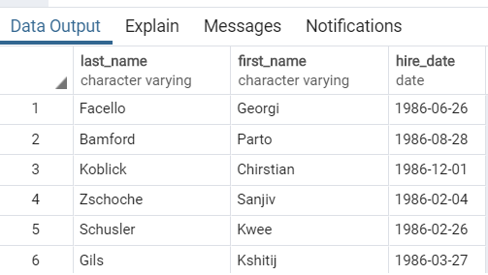

-- 3. List the manager of each department with the following information:

-- department number, department name, the manager's employee number,

-- last name, first name, and start and end employment dates.

SELECT dept_manager.dept_no, departments.dept_name,

dept_manager.emp_no, employees.last_name, employees.first_name,

dept_manager.from_date,dept_manager.to_date

FROM dept_manager, departments, employees

WHERE dept_manager.dept_no = departments.dept_no AND

dept_manager.emp_no = employees.emp_no;

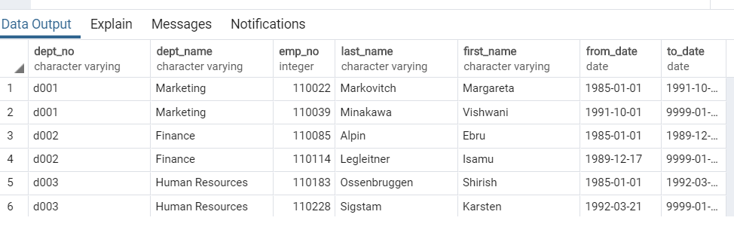

-- 4. List the department of each employee with the following information:

-- employee number, last name, first name, and department name.

Select dept_emp.emp_no, employees.last_name, employees.first_name, departments.dept_name

From dept_emp

Left Join Employees ON dept_emp.emp_no = employees.emp_no

Left Join departments ON dept_emp.dept_no = departments.dept_no;

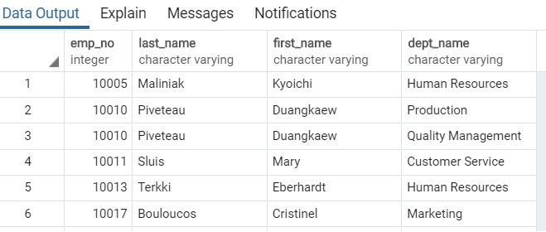

-- 5. List all employees whose first name is "Hercules" and last names begin with "B."

Select emp_no, first_name, last_name

From employees

Where first_name = 'Hercules' AND last_name Like 'B%'

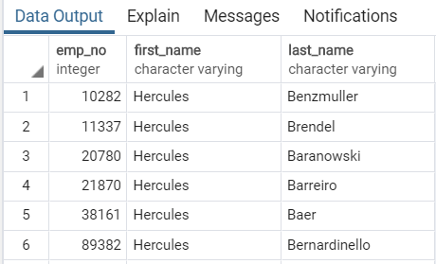

-- 6. List all employees in the Sales department, including their

-- employee number, last name, first name, and department name.

SELECT employees.emp_no, departments.dept_name, employees.last_name, employees.first_name

FROM departments, employees

Where dept_name = 'Sales'

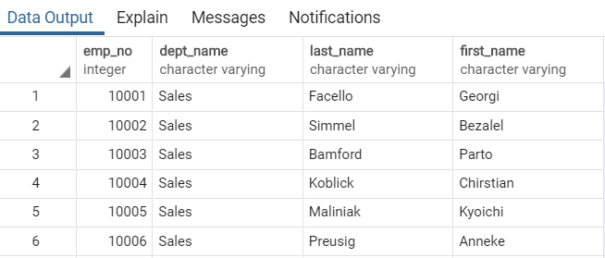

-- 7. List all employees in the Sales and Development departments,

-- including their employee number, last name, first name, and department name.

SELECT dept_emp.emp_no, employees.last_name, employees.first_name, departments.dept_name

FROM dept_emp

LEFT JOIN employees ON dept_emp.emp_no = employees.emp_no

LEFT JOIN departments ON dept_emp.dept_no = departments.dept_no

WHERE dept_name = 'Sales' OR dept_name = 'Development';

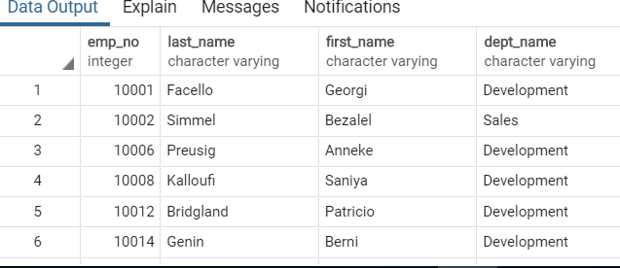

-- 8. In descending order, list the frequency count of

-- employee last names, i.e., how many employees share each last name.

SELECT last_name, COUNT(*)

FROM employees

GROUP BY last_name

ORDER BY count(*) DESC;

