Master for an Hour
System Design Package
UML diagram, database schema, and submission-ready UI mockups

Project: Call Control System for Minor Repairs
Platform: Web application
Suggested stack: Django + Supabase
This package is aligned with the uploaded project brief: customers submit repair requests, operators assign masters, masters update task progress, and the system tracks status, history, and reporting.

1. UML Diagram
The class diagram below models the main business entities and their relationships in the repair service system.
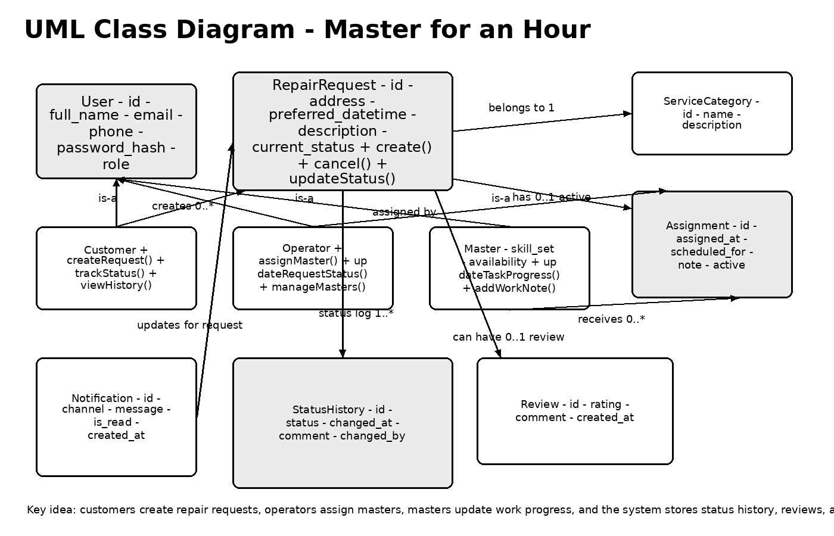
Figure 1. Core domain model for request handling, assignment, work execution, and notifications.

Main relationships
- A Customer creates one or more RepairRequest records.
- An Operator assigns a Master to a request through the Assignment entity.
- RepairRequest status changes are stored in StatusHistory for auditing.
- A request can optionally receive a Review after completion.
- Notifications can be sent to customers, operators, or masters when status changes.

2. Database Schema for Django + Supabase
The schema below fits a Django backend with Supabase PostgreSQL. In Django, the custom user model can extend AbstractUser; in Supabase, the same logical tables can be stored in PostgreSQL and connected to auth users via UUID keys.
accounts_user
Column | Type | Constraints | Description
id | UUID / BIGINT PK | Primary key | Application user identifier
full_name | VARCHAR(150) | NOT NULL | Display name
email | VARCHAR(255) | UNIQUE, NOT NULL | Login and contact email
phone | VARCHAR(30) | NULL | Optional phone number
role | VARCHAR(20) | CHECK customer/operator/master | Role in the system
is_active | BOOLEAN | DEFAULT TRUE | User status
created_at | TIMESTAMP | DEFAULT now() | Creation time

service_category
Column | Type | Constraints | Description
id | BIGSERIAL PK | Primary key | Category identifier
name | VARCHAR(100) | UNIQUE, NOT NULL | Service name
description | TEXT | NULL | Category details

master_profile
Column | Type | Constraints | Description
id | BIGSERIAL PK | Primary key | Profile identifier
user_id | FK -> accounts_user.id | UNIQUE, NOT NULL | Linked master user
skill_summary | TEXT | NOT NULL | Short description of skills
availability_status | VARCHAR(20) | DEFAULT available | Current availability
rating_avg | NUMERIC(3,2) | DEFAULT 0 | Average review score

repair_request
Column | Type | Constraints | Description
id | BIGSERIAL PK | Primary key | Request identifier
customer_id | FK -> accounts_user.id | NOT NULL | Customer who submitted request
service_category_id | FK -> service_category.id | NOT NULL | Requested service type
title | VARCHAR(120) | NOT NULL | Short issue title
description | TEXT | NOT NULL | Detailed repair description
address | TEXT | NOT NULL | Service address
preferred_datetime | TIMESTAMP | NOT NULL | Requested visit time
current_status | VARCHAR(20) | DEFAULT new | new/assigned/in_progress/completed/cancelled
created_at | TIMESTAMP | DEFAULT now() | Submission time
updated_at | TIMESTAMP | DEFAULT now() | Last update time

assignment
Column | Type | Constraints | Description
id | BIGSERIAL PK | Primary key | Assignment identifier
request_id | FK -> repair_request.id | NOT NULL | Linked request
master_id | FK -> accounts_user.id | NOT NULL | Assigned master
operator_id | FK -> accounts_user.id | NOT NULL | Operator who assigned
assigned_at | TIMESTAMP | DEFAULT now() | Assignment time
scheduled_for | TIMESTAMP | NULL | Confirmed service time
note | TEXT | NULL | Dispatch note
is_active | BOOLEAN | DEFAULT TRUE | Current active assignment flag

status_history
Column | Type | Constraints | Description
id | BIGSERIAL PK | Primary key | Status log identifier
request_id | FK -> repair_request.id | NOT NULL | Linked request
status | VARCHAR(20) | NOT NULL | Recorded status value
changed_by | FK -> accounts_user.id | NOT NULL | User who made the change
comment | TEXT | NULL | Optional note
changed_at | TIMESTAMP | DEFAULT now() | Change timestamp

work_note
Column | Type | Constraints | Description
id | BIGSERIAL PK | Primary key | Work note identifier
request_id | FK -> repair_request.id | NOT NULL | Linked request
master_id | FK -> accounts_user.id | NOT NULL | Authoring master
note_text | TEXT | NOT NULL | Work progress or issue note
created_at | TIMESTAMP | DEFAULT now() | Note timestamp

review
Column | Type | Constraints | Description
id | BIGSERIAL PK | Primary key | Review identifier
request_id | FK -> repair_request.id | UNIQUE, NOT NULL | Reviewed request
customer_id | FK -> accounts_user.id | NOT NULL | Review author
master_id | FK -> accounts_user.id | NOT NULL | Reviewed master
rating | SMALLINT | CHECK 1-5 | Star rating
comment | TEXT | NULL | Customer feedback
created_at | TIMESTAMP | DEFAULT now() | Review timestamp

notification
Column | Type | Constraints | Description
id | BIGSERIAL PK | Primary key | Notification identifier
recipient_id | FK -> accounts_user.id | NOT NULL | User who receives message
request_id | FK -> repair_request.id | NULL | Optional linked request
channel | VARCHAR(20) | DEFAULT in_app | in_app/email/sms
message | TEXT | NOT NULL | Notification text
is_read | BOOLEAN | DEFAULT FALSE | Read flag
created_at | TIMESTAMP | DEFAULT now() | Sent timestamp

Recommended indexes and rules
- Unique index on accounts_user.email and service_category.name.
- Index repair_request(customer_id, current_status) for customer dashboards.
- Index assignment(master_id, is_active) for master task lists.
- Index status_history(request_id, changed_at DESC) for audit views.
- Use database constraints or Django choices for valid status values.

3. Submission-Ready UI Mockups
These low-fidelity grayscale mockups are clean enough for a project submission and can later be converted into real Django templates or Figma screens.

3.1 Main page
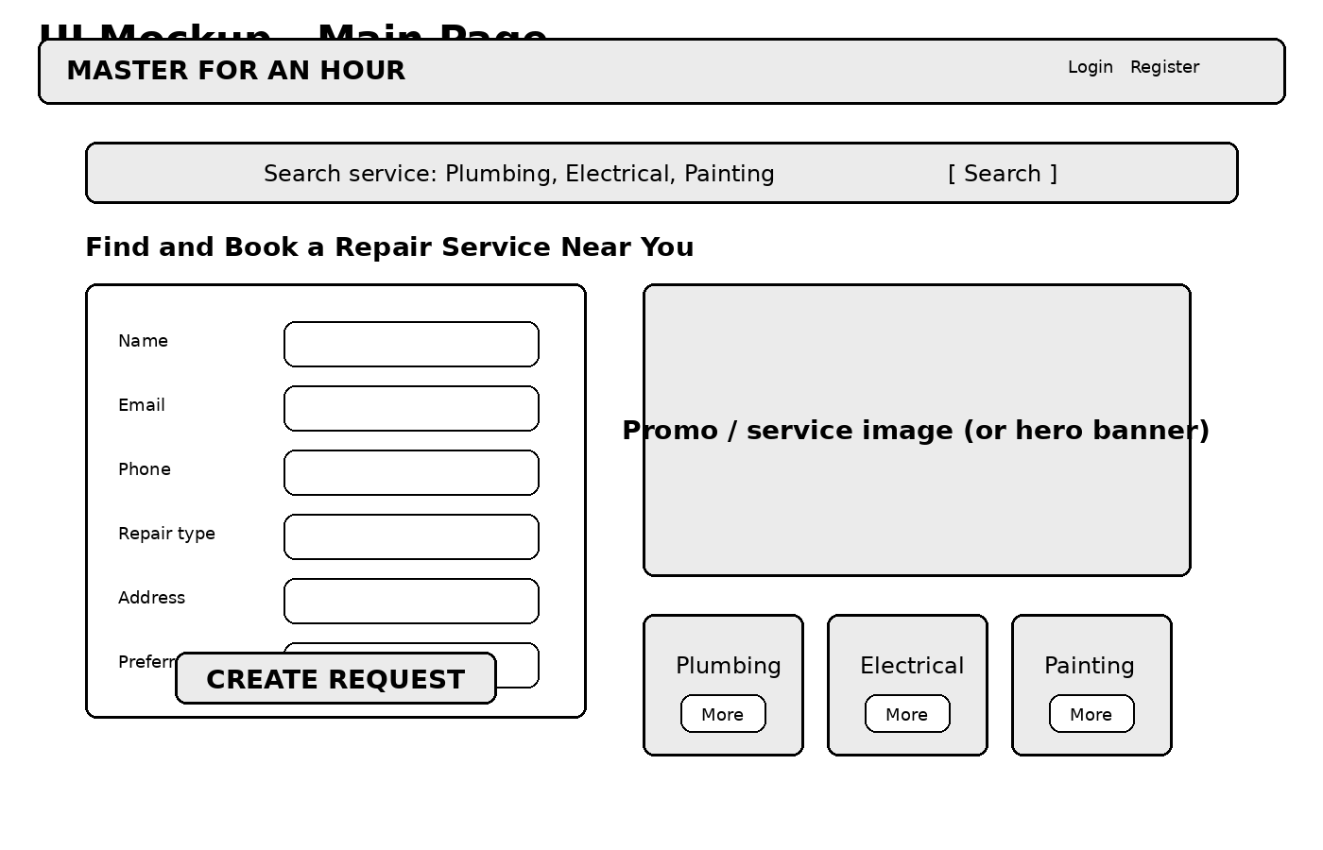

3.2 Customer dashboard
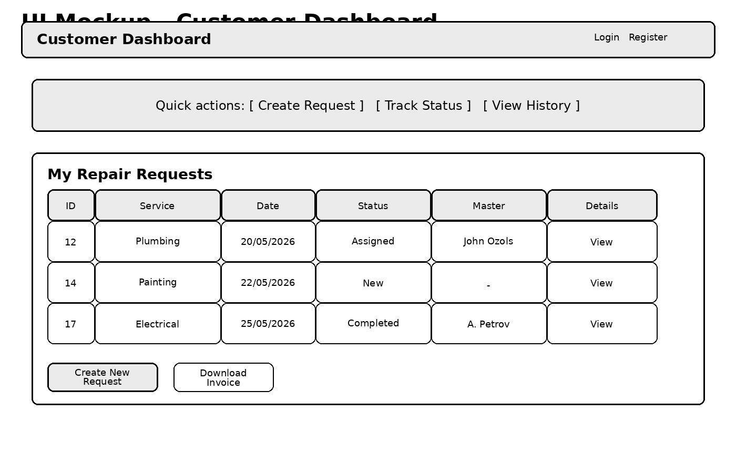

3.3 Operator panel
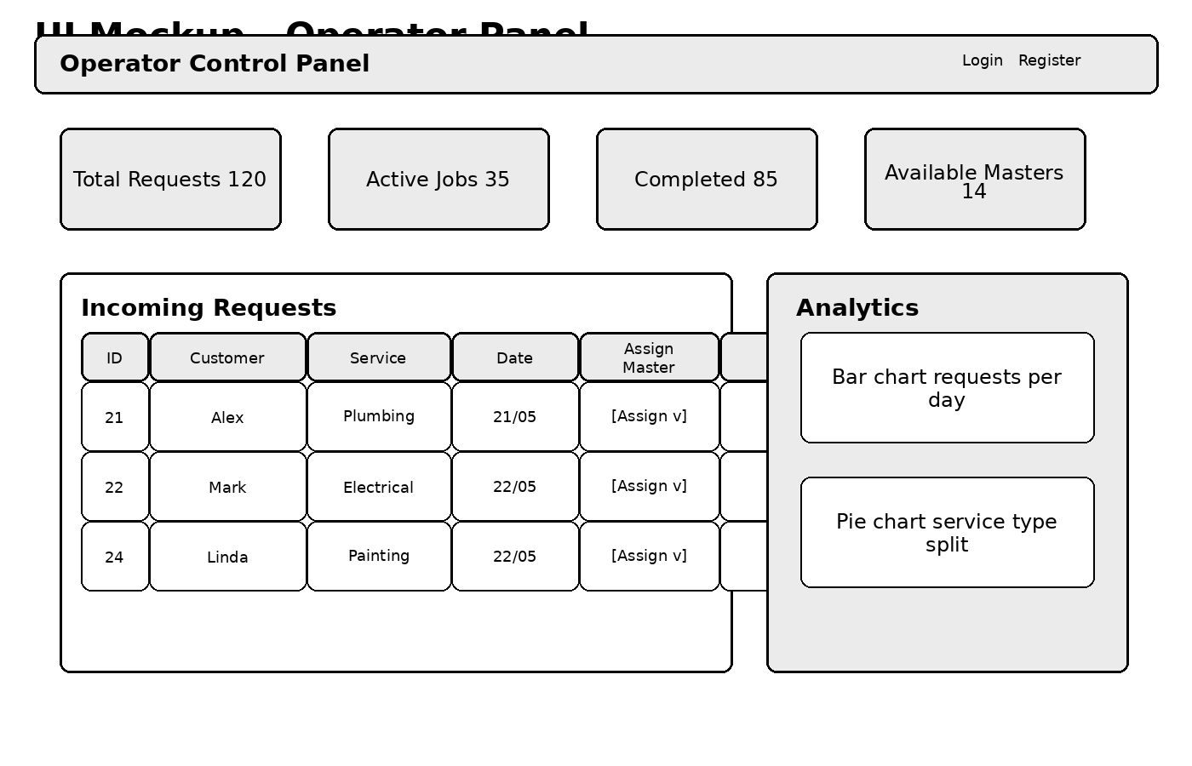

3.4 Master dashboard
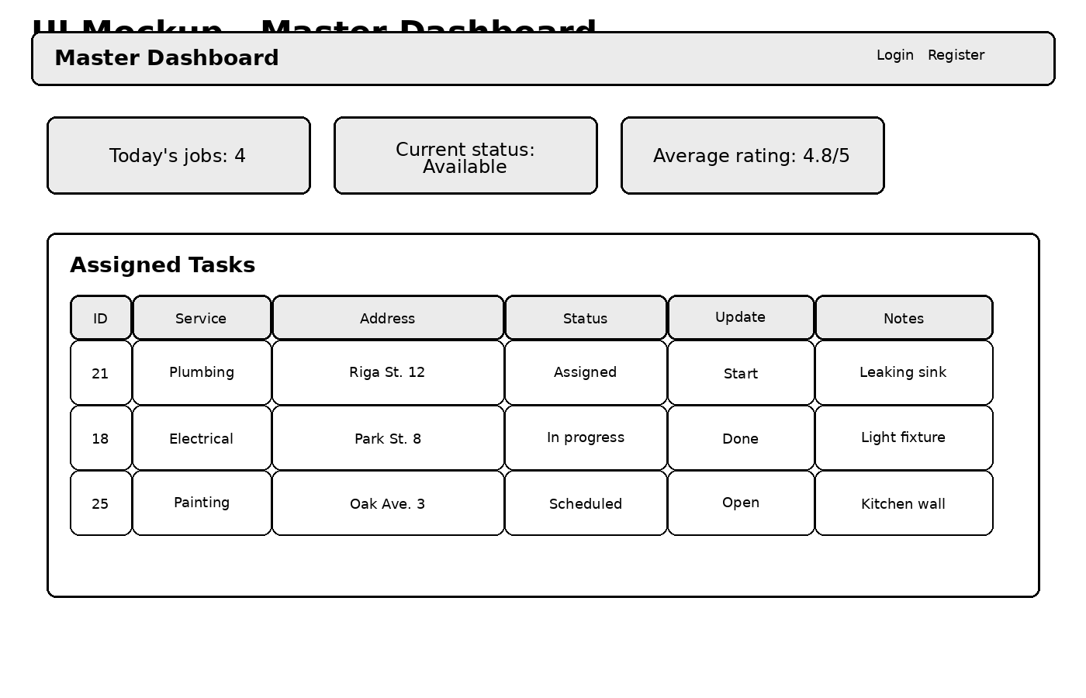

3.5 Reports page
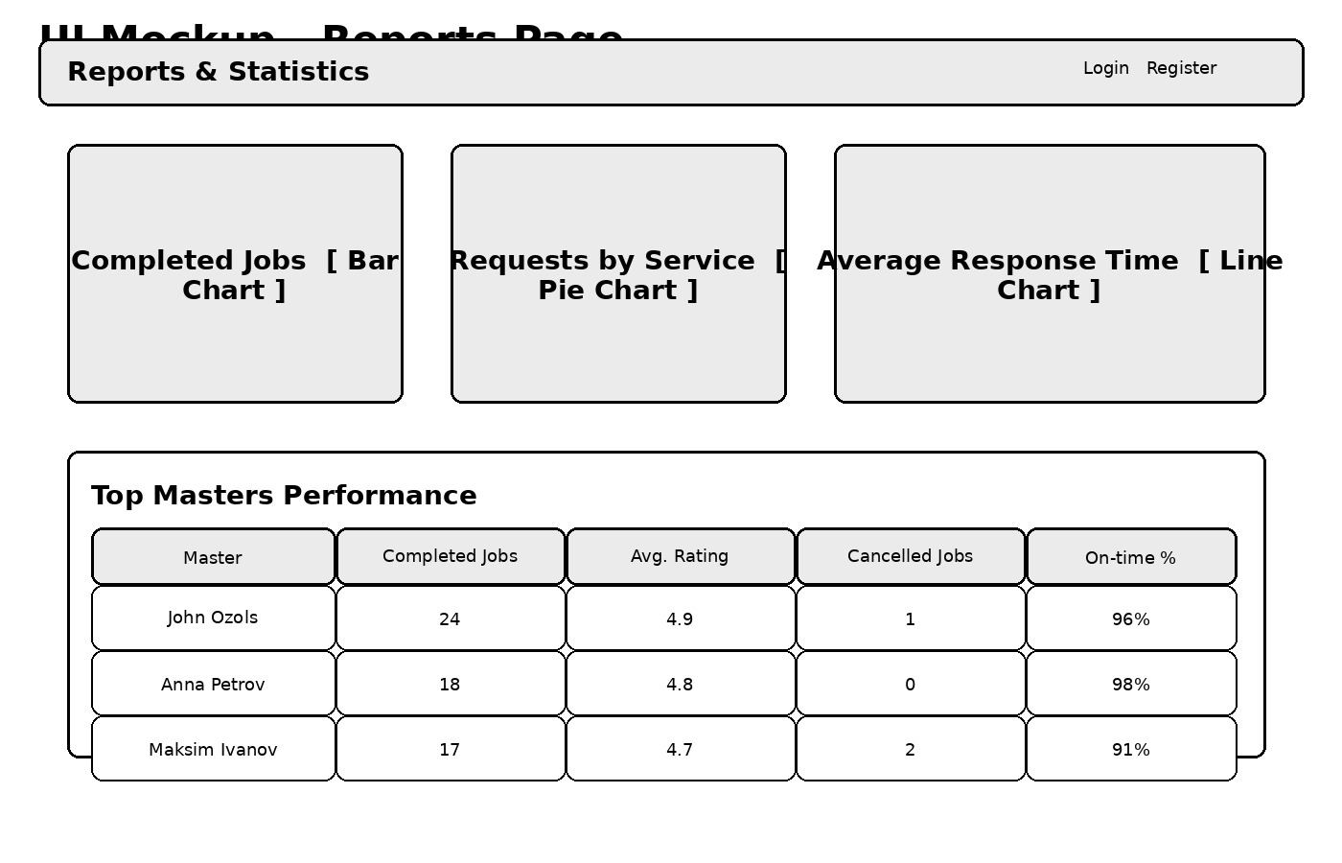

4. Implementation notes
- Map accounts_user.role to Django permissions and group-based access control.
- Store media or attachments in Supabase Storage if you later add repair photos.
- Generate charts on the reports page from request, assignment, and review aggregates.
- Convert each mockup section into reusable Django templates with a shared base layout.

