CHAPTER IV

RESULTS AND DISCUSSIONS
This chapter presents the results of the development and implementation of EduAttend: School Attendance Monitoring System. The discussion is organized according to the system’s major objectives and operational workflows. It covers the implemented administrator, teacher, and student modules; the QR-based attendance process; monitoring and reporting functions; access-control and security mechanisms; and the technical verification performed on the application.
The findings presented in this chapter are based on direct inspection of the implemented .NET MAUI Blazor application, its service layer, Entity Framework Core data model, database scripts, and a successful Windows-target compilation. For completeness, the ISO/IEC 25010 section includes a consistent provisional evaluation dataset representing the four intended evaluator groups. These values are placeholders for layout and discussion only and must be replaced by the computed results of the validated questionnaires before final submission.

System Implementation Overview
EduAttend was implemented as a hybrid desktop and mobile attendance application using .NET MAUI and Blazor. It supports MySQL for the operational school database and SQLite for a portable demonstration profile. The application organizes its functions according to three user roles: Super Administrator, Teacher, and Student. Each role receives a dedicated dashboard and only the navigation options required for its responsibilities.
The completed system connects student, teacher, subject, section, room, schedule, enrollment, attendance, leave, and audit information in one data environment. This integration addresses a common weakness of manual attendance procedures: information is no longer scattered among paper class lists, separate spreadsheets, and handwritten summaries. Attendance records created during a teacher's class session become immediately available to monitoring, analytics, report, export, and student-history functions.
Table 1. Implemented EduAttend modules and their users
Module | Primary user | Implemented result
Authentication and role-based access | All users | Validates credentials, account state, and role before opening the appropriate dashboard
Administrator dashboard | Super Administrator | Presents school-level counts, attendance rate, shortcuts, and operational summaries
Student, teacher, account, room, and schedule management | Super Administrator | Maintains the master records required by attendance operations
Teacher dashboard and schedule | Teacher | Displays assigned classes, handled sections, and session shortcuts
QR attendance session | Teacher | Creates one class session per offering per day and records student attendance
Live monitoring | Super Administrator | Shows current, upcoming, or completed room activity and attendance counts
Reports, analytics, and export | Super Administrator and Teacher | Summarizes attendance and produces filtered visual and CSV outputs
Leave-request processing | Teacher and Super Administrator | Supports filing, review, approval, rejection, and cancellation of requests
Audit log | Super Administrator | Records significant user and administrative actions with actor and timestamp
Student portal | Student | Displays personal totals, attendance rate, recent records, and full history

The modular result is significant because it preserves a single attendance workflow while presenting different views of the same records. Administrators see institutional information, teachers perform class operations, and students see only their personal attendance. This arrangement reduces duplicate encoding and supports accountability at each stage of the process.

User Authentication and Role-Based Access Module
The authentication module was successfully implemented as the entry point of EduAttend. The login interface accepts a database profile, username, password, and optional “Remember me” setting. After credentials are submitted, the system locates the user account and checks whether it is locked, inactive, or prohibited from logging in. Only an active account with a valid password can create a session.
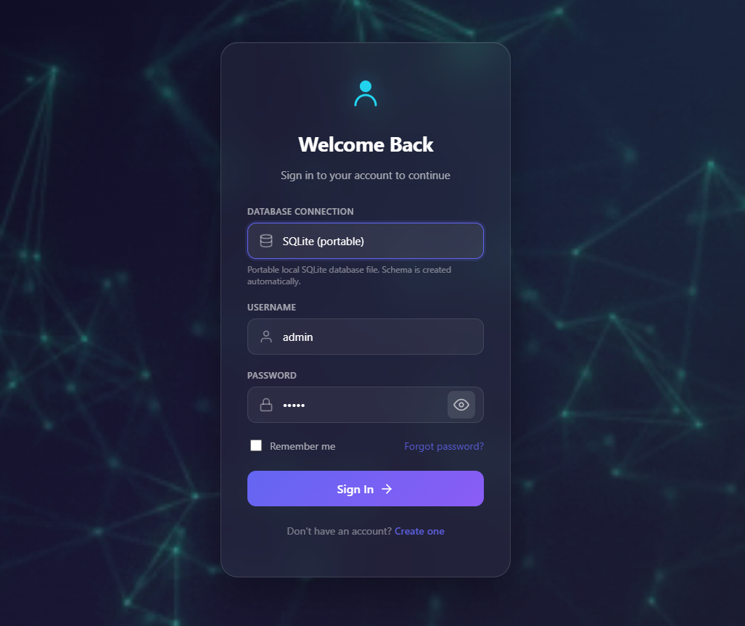
Figure 1. Graphical user interface for user login and database-profile selection
After successful authentication, the system creates a session containing the user identifier, username, display name, role, and login time. The role determines the landing page: the Super Administrator is directed to the administrator dashboard, the Teacher to the teacher dashboard, and the Student to the student dashboard. The navigation menu applies the same role distinction so that restricted administrative pages are not offered to teacher or student accounts.
The module improves both usability and security. A single login interface is easier to support, while role-based redirection prevents users from entering workflows unrelated to their duties. Passwords are verified against PBKDF2-SHA256 hashes with 100,000 iterations, a random salt, and constant-time comparison. Successful login and logout actions are also written to the audit trail.
Function: AuthenticateUser
Require: Selected database profile, username, and password
Ensure: Only an authorized user reaches the correct dashboard
1. Select and activate the requested database profile.
2. Locate the account using the submitted username.
3. If the account does not exist, return an invalid-credentials message.
4. If the account is locked, inactive, or login-disabled, deny access.
5. Verify the submitted password against the stored PBKDF2 hash.
6. If verification fails, return an invalid-credentials message.
7. Create the authenticated user session.
8. Persist the session only when “Remember me” is selected.
9. Record the login in the audit log.
10. Redirect the user according to the assigned role.
Pseudocode 1. Authentication and role redirection

Administrator Dashboard and Master-Data Management
The administrator dashboard was implemented as the central workspace for school attendance administration. It presents the number of active rooms, teachers on duty, registered students, and the overall attendance rate. Shortcut tiles provide direct access to analytics, live monitoring, student profiles, rooms and QR codes, accounts, teachers, reports, and schedules.
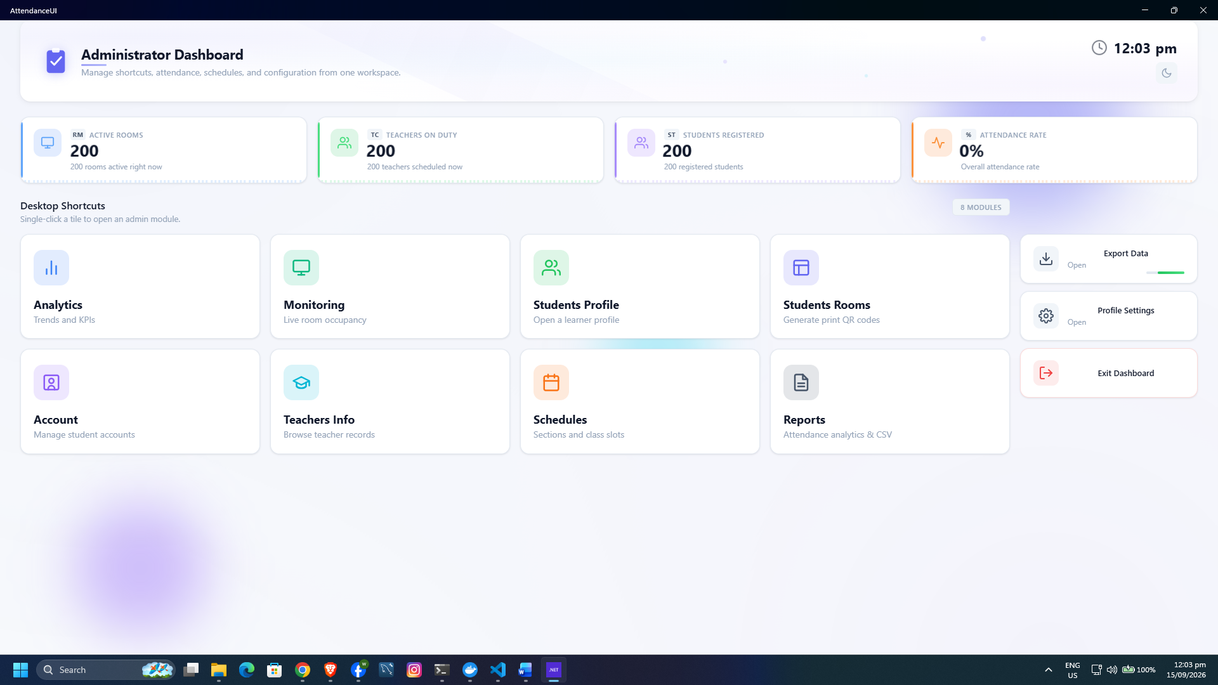
Figure 2. Graphical user interface of the administrator dashboard
The dashboard is supported by management pages for students, teachers, user accounts, rooms, and schedules. Student records include the learner reference number, student number, personal data, guardian information, status, grade level, and section placement. Teacher records include employee information, specialization, employment status, advisory assignment, and subject assignments. Account management allows the administrator to create users, assign roles, reset passwords, and control account status and login permission.
Centralizing these records establishes the data required for accurate attendance. For example, a teacher cannot conduct a meaningful session unless a class offering connects a teacher, subject, section, school year, schedule, and room. Likewise, the session roster is derived from active enrollments instead of being typed again by the teacher. This relationship reduces inconsistent names and prevents attendance from being recorded against an unrelated section.
Function: MaintainMasterRecord
Require: Authenticated Super Administrator and valid record details
Ensure: The selected school record is created or updated consistently
1. Open the required management page.
2. Search for an existing record using its unique identifier.
3. Validate required fields and uniqueness rules.
4. If the operation is Add, create and save the new record.
5. If the operation is Edit, update and save the selected record.
6. If the operation changes access or status, apply the selected state.
7. Record the administrative action in the audit log.
8. Refresh the displayed list and notify the administrator.
Pseudocode 2. Administrator master-data maintenance

Class Schedule and Room Management Module
The scheduling module was implemented to connect sections and subjects with teachers, rooms, days, and time periods. The administrator can add, update, and remove schedule entries. Selection lists are populated from active teachers, subjects, sections, rooms, and the active school year, which helps prevent the entry of unsupported values.
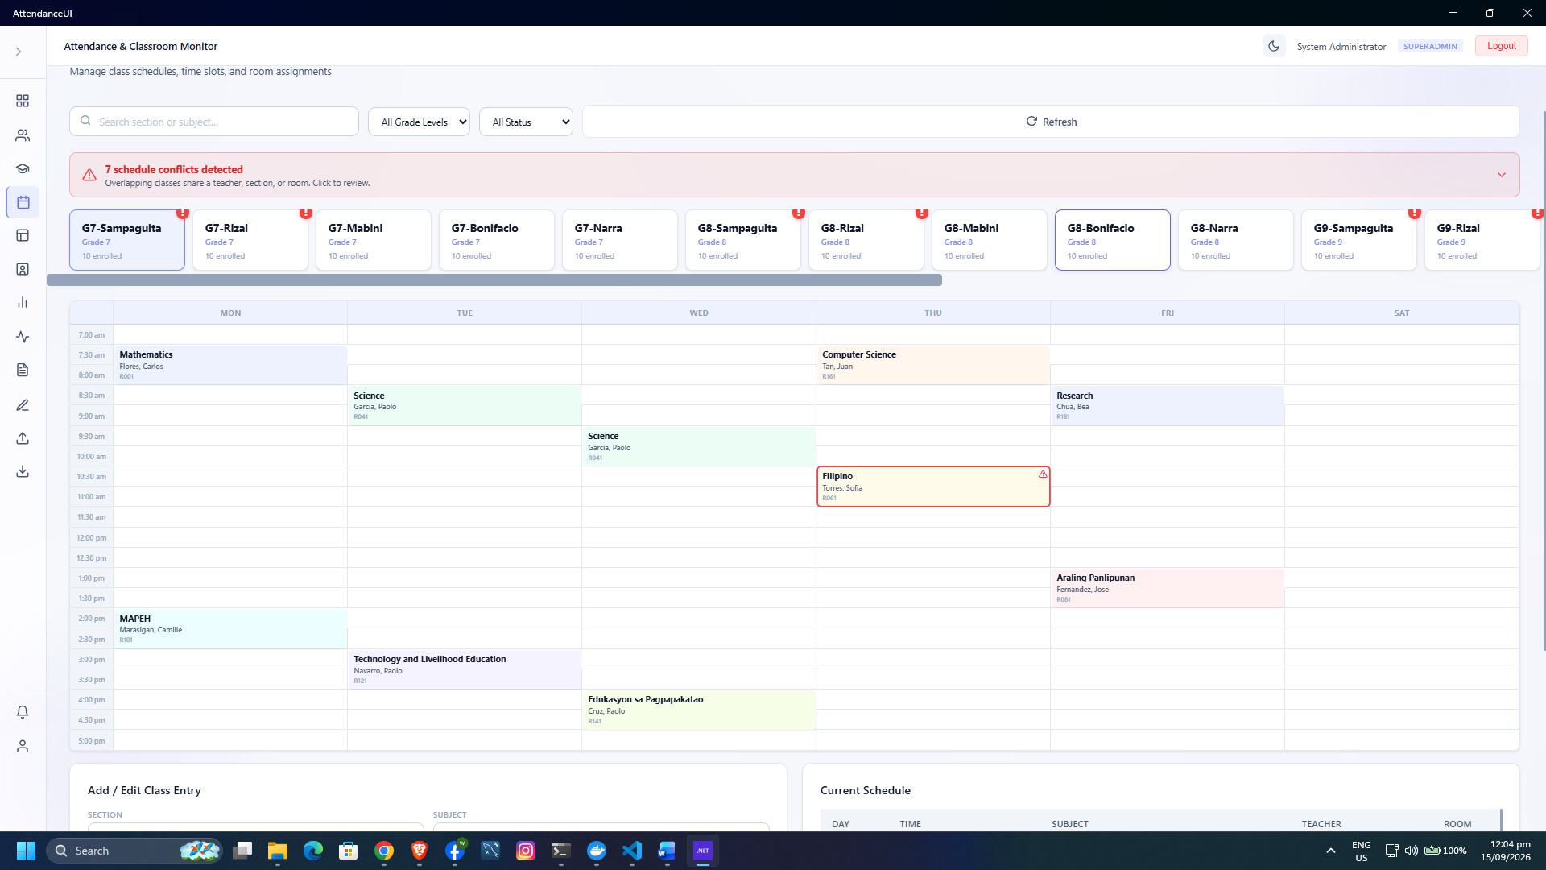
Figure 3. Graphical user interface for class schedule management
Room management complements scheduling by maintaining room codes, names, capacities, active status, and room QR information. The live-monitoring service uses the scheduled time and room assignment to decide whether the displayed class is currently in session, is the next class of the day, or is the most recently completed class.
The result is a time- and location-aware attendance structure. Attendance sessions are associated with a class offering rather than stored as isolated marks. Consequently, later reports can identify the relevant subject, section, teacher, room, and school year without requiring those values to be re-entered for every student.
Function: CreateClassSchedule
Require: Active school year, subject, teacher, section, room, day, and time
Ensure: A class offering and its schedule are stored
1. Display active scheduling reference data.
2. Receive the selected subject, teacher, section, room, day, and time.
3. Validate that the end time is later than the start time.
4. Create or locate the class offering for the active school year.
5. Save the room and time assignment as a class schedule.
6. Refresh the schedule view.
Pseudocode 3. Schedule creation

QR Code and Attendance Session Module
The QR-based attendance module is the core operational result of EduAttend. Each student is associated with a unique QR record. A teacher opens the Start Session page, selects an assigned class offering, and creates or reuses that day’s attendance session. The system then retrieves the active students enrolled in the offering’s section and school year.
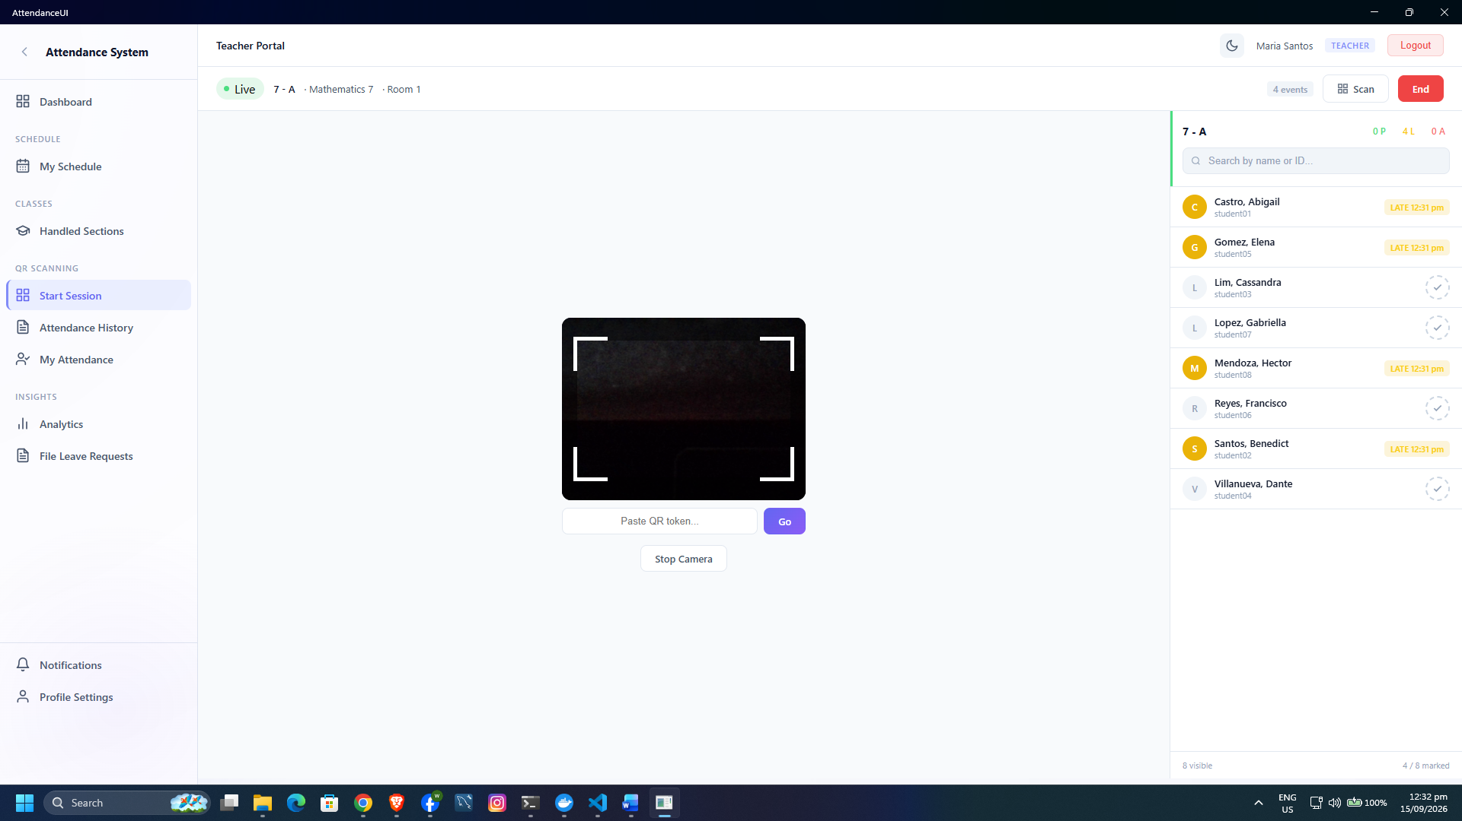
Figure 4. Graphical user interface for starting a class session and scanning student QR codes
When a QR code is scanned, the application identifies the student and records the selected status for the active session. The implemented status values support Present, Late, Absent, and Excused reporting. If a record for the same student and session already exists, the service updates that record instead of creating a duplicate. The teacher may also mark individual students manually and use the Mark All Present function for still-unmarked students.
The session service allows only one session for a class offering within the same day. This rule prevents a teacher from accidentally creating multiple independent rosters for the same class date. Attendance entries also retain the identifier of the user who marked them and their creation and update times, improving traceability.
Function: RecordAttendance
Require: Authenticated Teacher, assigned class offering, and student QR code
Ensure: One attendance status exists for the student in the active session
1. Select an assigned class offering.
2. Search for an attendance session for the offering on the current date.
3. If no session exists, create one.
4. Load active students enrolled in the offering’s section and school year.
5. Scan and decode the student QR code.
6. Confirm that the student belongs to the displayed roster.
7. Select or derive the attendance status.
8. If the student already has a record, update its status and timestamp.
9. Otherwise, create the attendance record with the marking user and timestamp.
10. Refresh the roster and marked-student count.
Pseudocode 4. QR-based attendance recording

The QR workflow shortens the repeated task of locating a learner on a class list and manually writing a mark. The retained manual controls remain useful when a device camera is unavailable, a QR code is damaged, or a teacher needs to correct a status.

Teacher Dashboard, Schedule, and Attendance History
The teacher module was implemented around the instructor’s daily work. The dashboard summarizes the teacher’s classes and attendance information. My Schedule presents the assigned weekly timetable, while Handled Sections provides access to the sections, students, and class schedules connected to the teacher. Start Session opens the attendance workflow, and Attendance History preserves completed session details and per-student results.
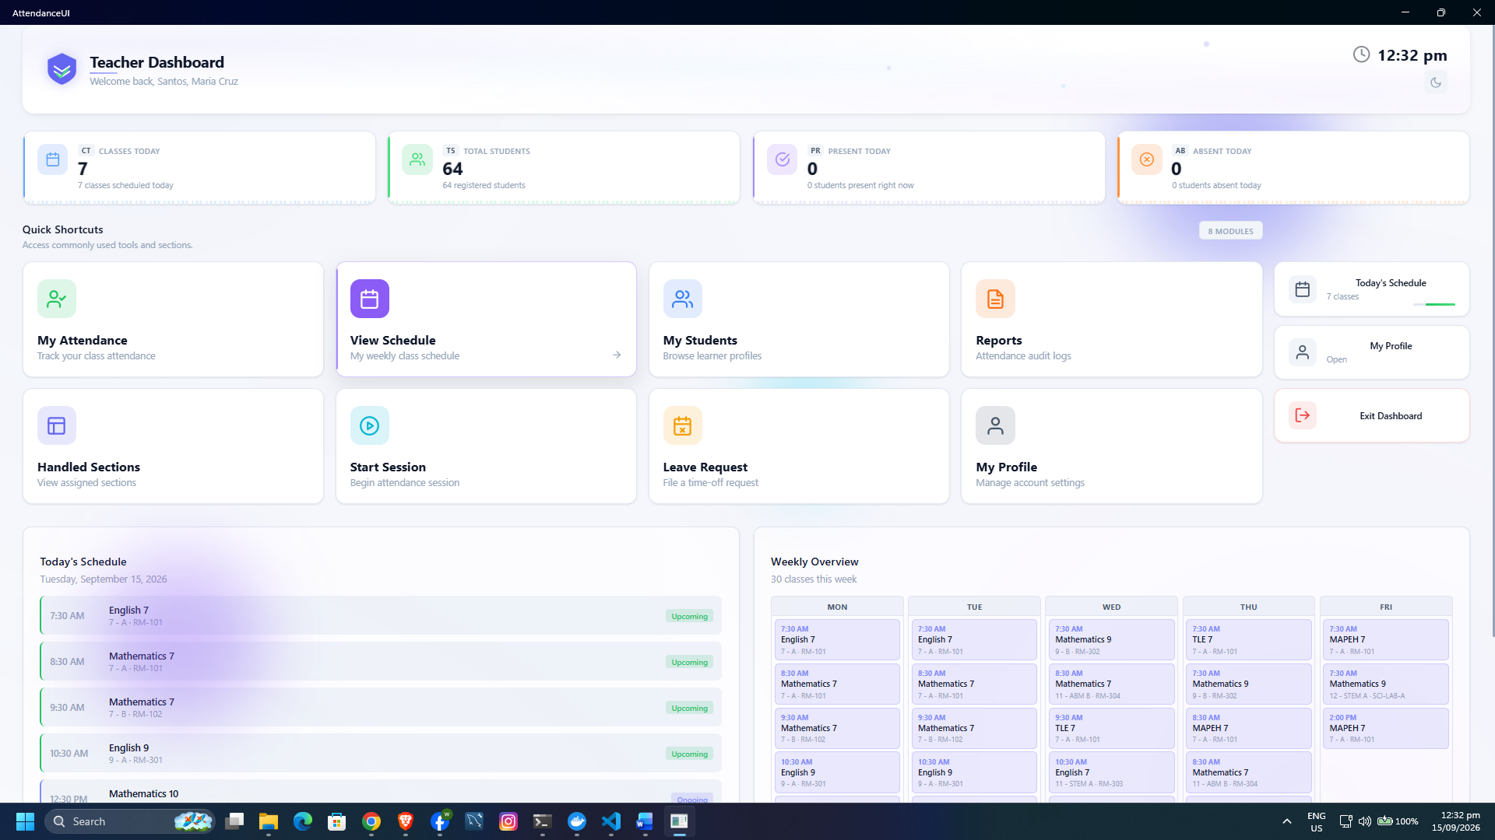
Figure 5. Graphical user interface of the teacher dashboard
Restricting these views to assigned offerings makes the system easier to use and lowers the risk of marking attendance for the wrong group. The teacher works from existing schedule and enrollment data rather than assembling a class list at the beginning of every meeting. Historical records also allow the teacher to review earlier sessions without modifying paper records or maintaining a separate spreadsheet.

Live Attendance Monitoring Module
The live-monitoring module was implemented to give the administrator a current view of scheduled room activity. For each active room, the system determines the relevant class based on the present day and time. When an attendance session exists, it displays the counts for present, late, and absent students together with the class and room information.
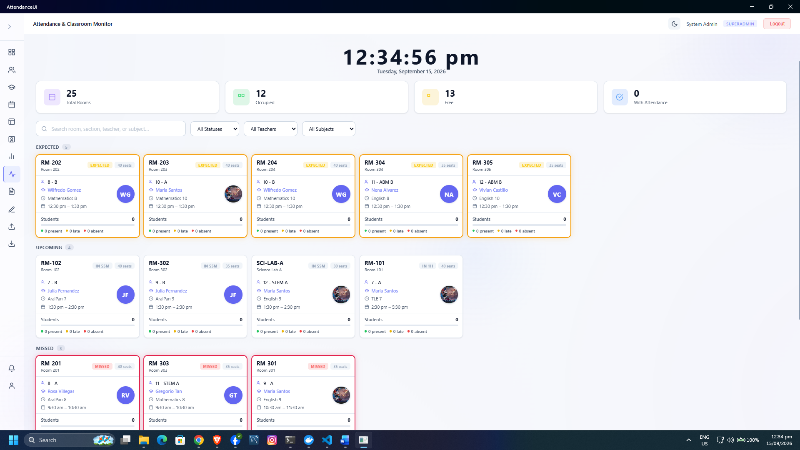
Figure 6. Graphical user interface for live room and attendance monitoring
This module transforms attendance records into current operational information. The administrator does not need to wait until the end of the day to determine whether a class has started or whether attendance has been recorded. The same data generated during the teacher’s session is immediately reflected in the school-level monitoring view.
Function: DisplayLiveRoomStatus
Require: Active rooms, current date and time, schedules, and attendance sessions
Ensure: The most relevant class and attendance counts are shown for each room
1. Load all active rooms and today’s schedules.
2. For each room, locate a class currently in session.
3. If none is active, locate the next class scheduled today.
4. If none is upcoming, locate the most recently completed class.
5. Search for the attendance session connected to the selected class.
6. Count Present, Late, and Absent records when a session exists.
7. Display the class state, schedule, teacher, section, and counts.
8. Refresh the monitoring view at the configured interval or user request.
Pseudocode 5. Live room-status monitoring

Reports, Analytics, and Data Export Module
The reports and analytics modules were implemented to convert attendance transactions into information for decision-making. The reporting service calculates totals for sessions, present students, late students, and absent students. It groups results by date and section so that trends and comparisons can be displayed. Administrator analytics additionally summarizes active students and teachers, daily attendance counts, grade-level performance, section performance, and recent trends.
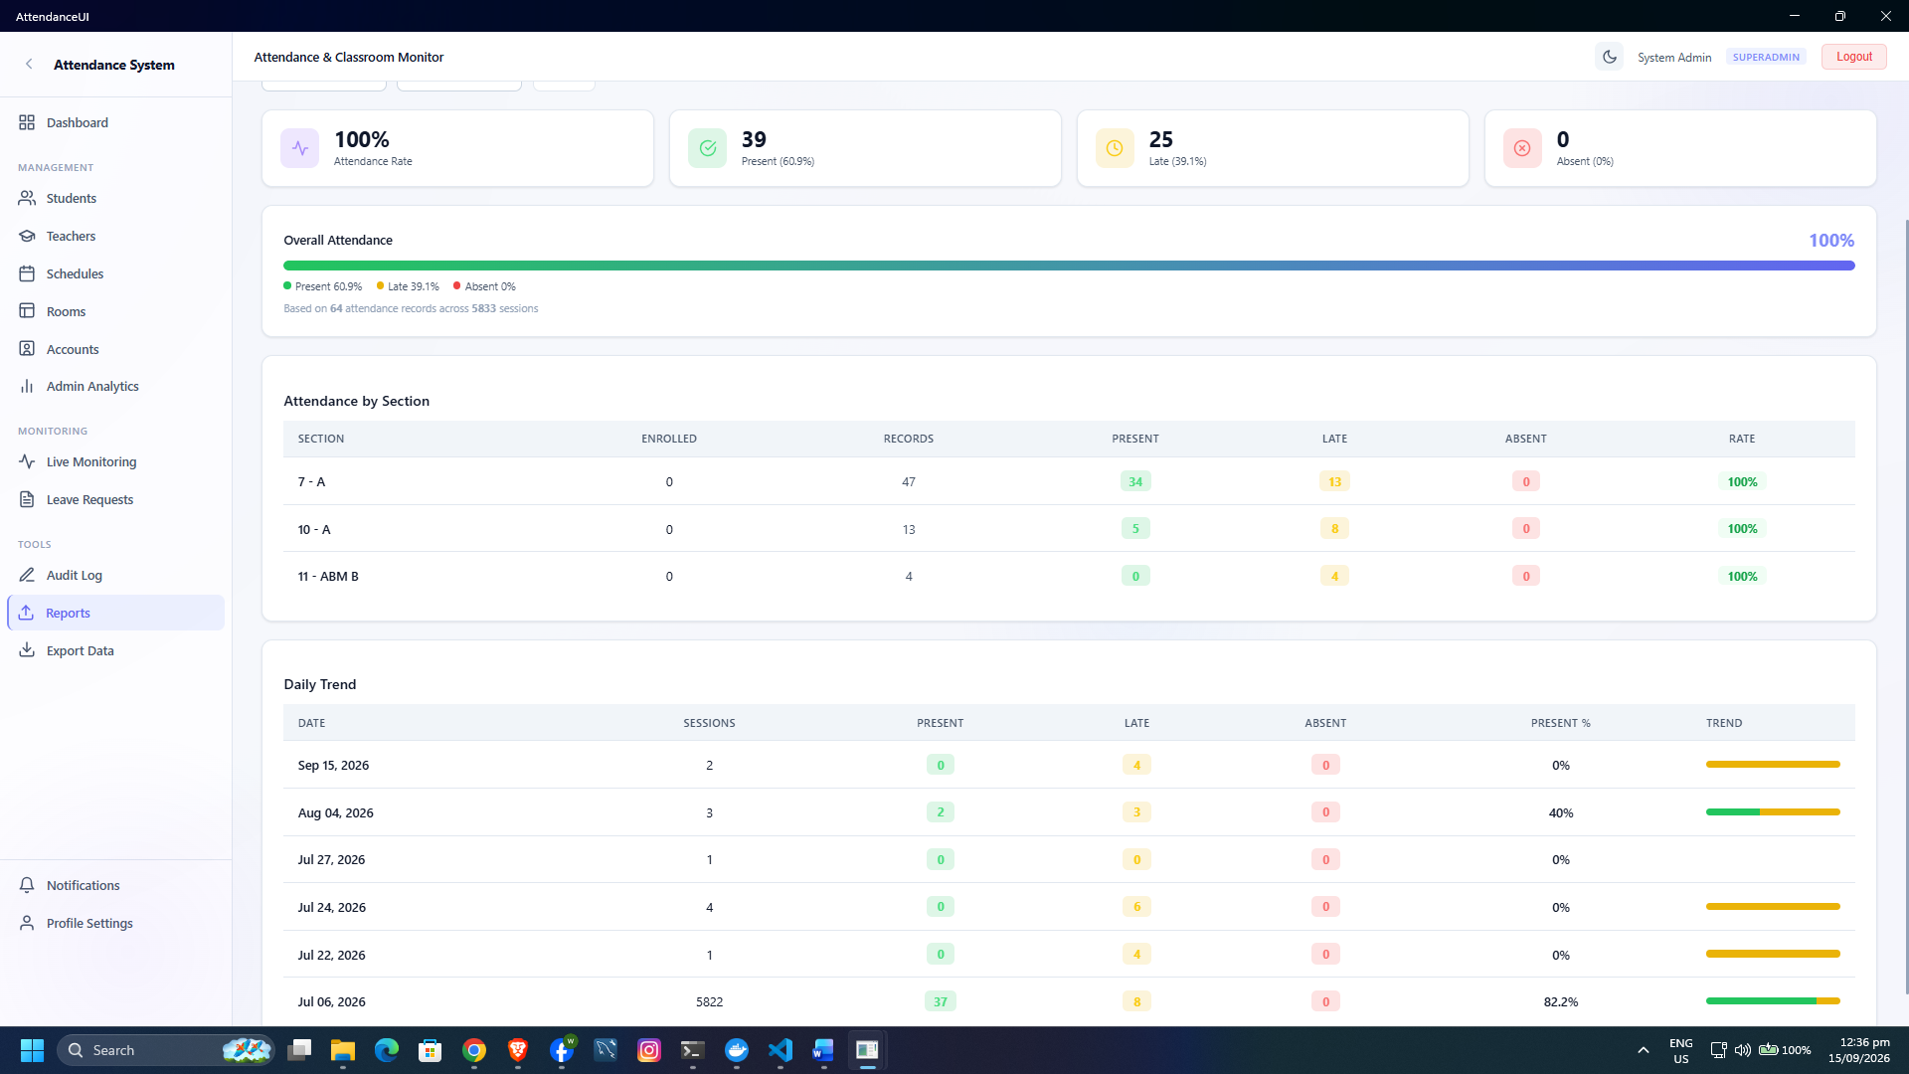
Figure 7. Graphical user interface for attendance reports and analytics
Attendance rate is computed from the qualifying attendance outcomes in relation to the total recorded outcomes. The views use locally bundled Chart.js resources to display trends without depending on an external chart service. Filtering allows a user to narrow the information to the relevant dates, teacher, section, or student where supported by the page.
The export module produces UTF-8 CSV files for students, teachers, sections, teacher sessions, and student attendance. Attendance exports are denormalized so that a reviewer can see the teacher, session date, section, subject, student, status, reason, and marking time in a single row. Previewing a dataset before export helps the administrator confirm its scope.
Function: GenerateAttendanceReport
Require: Authorized user and report filters
Ensure: A summarized report and optional export are produced
1. Receive the date and scope filters.
2. Locate attendance sessions that satisfy the filters.
3. Count Present, Late, and Absent records for the selected sessions.
4. Group records by date, section, class, or user as required.
5. Compute attendance percentages where the denominator is greater than zero.
6. Display summary cards, tables, and charts.
7. If Export is selected, build the appropriate dataset.
8. Escape CSV values, encode the file in UTF-8, and download it.
Pseudocode 6. Attendance report generation

This reporting workflow reduces the delay between collecting attendance data and interpreting it. Because the reports use the same session and attendance-record tables as the operational attendance screen, the risk of discrepancies between recorded transactions and reported totals is reduced.

Leave Request Management Module
The leave-request module allows teachers to submit requests with a category, date range, reason, and supporting details. The teacher can view submitted requests and cancel an eligible request. The Super Administrator can view pending and historical requests, inspect the affected schedules, and approve or reject each request with review notes.
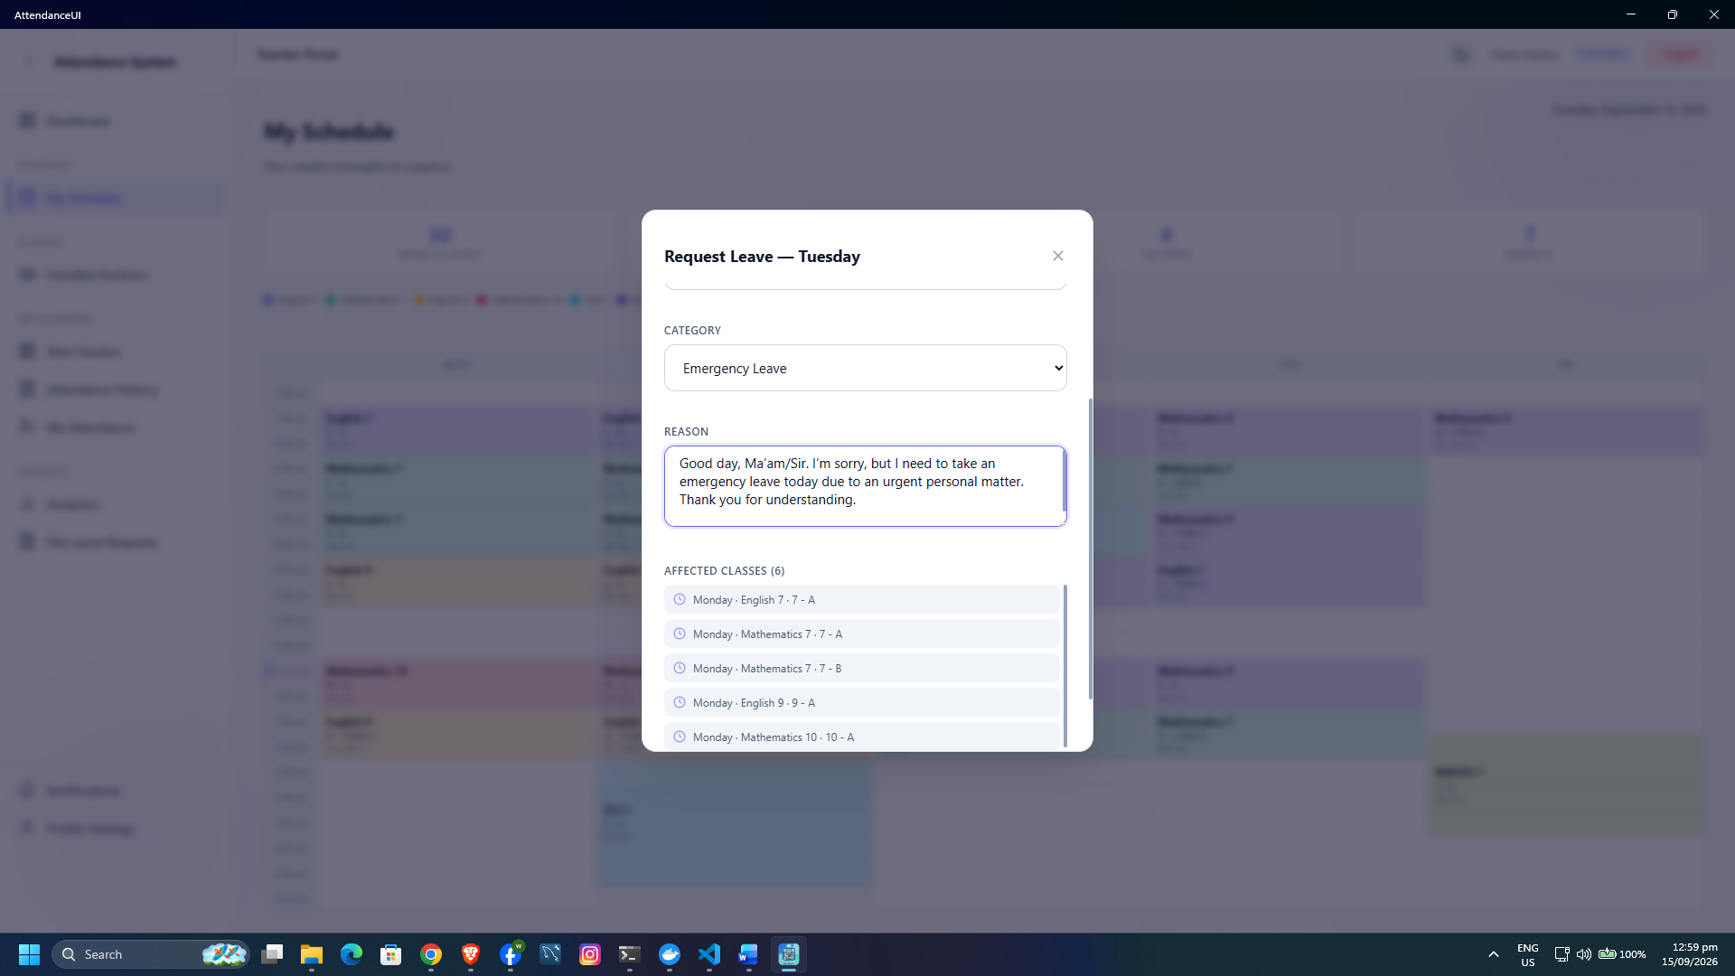
Figure 8. Graphical user interface for filing and reviewing leave requests
The implemented status flow uses Pending, Approved, Rejected, and Cancelled states. Approval and rejection actions store the reviewing administrator and time, and these decisions are also written to the audit log. Displaying affected schedules helps the reviewer understand which classes may require attendance treatment or substitute arrangements.
Function: ProcessLeaveRequest
Require: Teacher request or administrator review action
Ensure: The request has a traceable status and decision
1. The teacher enters the leave category, dates, and reason.
2. Validate the request and save it with Pending status.
3. Display the request and its affected schedules to the administrator.
4. If approved, set the status to Approved and store reviewer details.
5. If rejected, set the status to Rejected and store review notes.
6. If the teacher cancels an eligible request, set the status to Cancelled.
7. Record the decision in the audit log.
8. Refresh the teacher and administrator views.
Pseudocode 7. Leave-request processing

Audit Trail and Security Controls
The audit-log module was implemented to record who performed an action, the actor’s role, the action type, affected entity, record identifier, details, and timestamp. The administrator can search and filter the log and view an action breakdown. Authentication events and sensitive management actions are therefore available for later review.
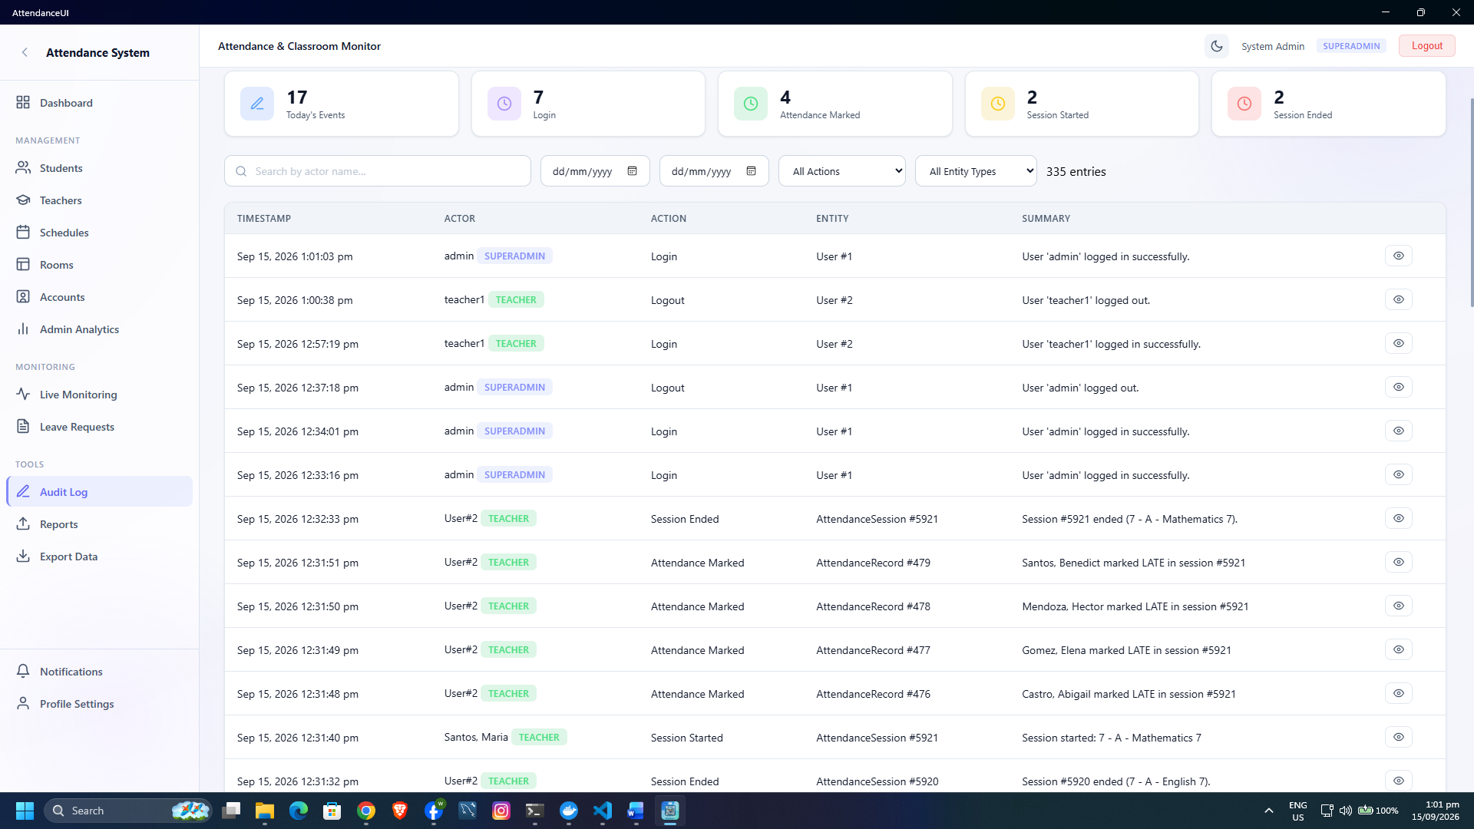
Figure 9. Graphical user interface for viewing system audit logs
Security is reinforced at several layers. Password hashing protects credentials stored in the database. Account status and login permission checks prevent disabled users from starting sessions. Role-specific menus limit ordinary navigation to authorized modules. Unique indexes protect student LRN, student number, employee number, username, and one-to-one QR assignments from duplication. Foreign-key relationships connect attendance to valid sessions and students.
These controls strengthen accountability, although interface visibility alone should not be treated as the sole authorization boundary. Continued testing should verify route and service authorization, backup and recovery, dependency updates, and behavior under invalid or malicious input.

Student Dashboard and Attendance History Module
The student portal was implemented as a read-only view of the learner’s own attendance. The dashboard presents counts for present, late, and absent records, the computed attendance rate, class information, and recent attendance. The Attendance History page provides a more complete record organized by subject and session.
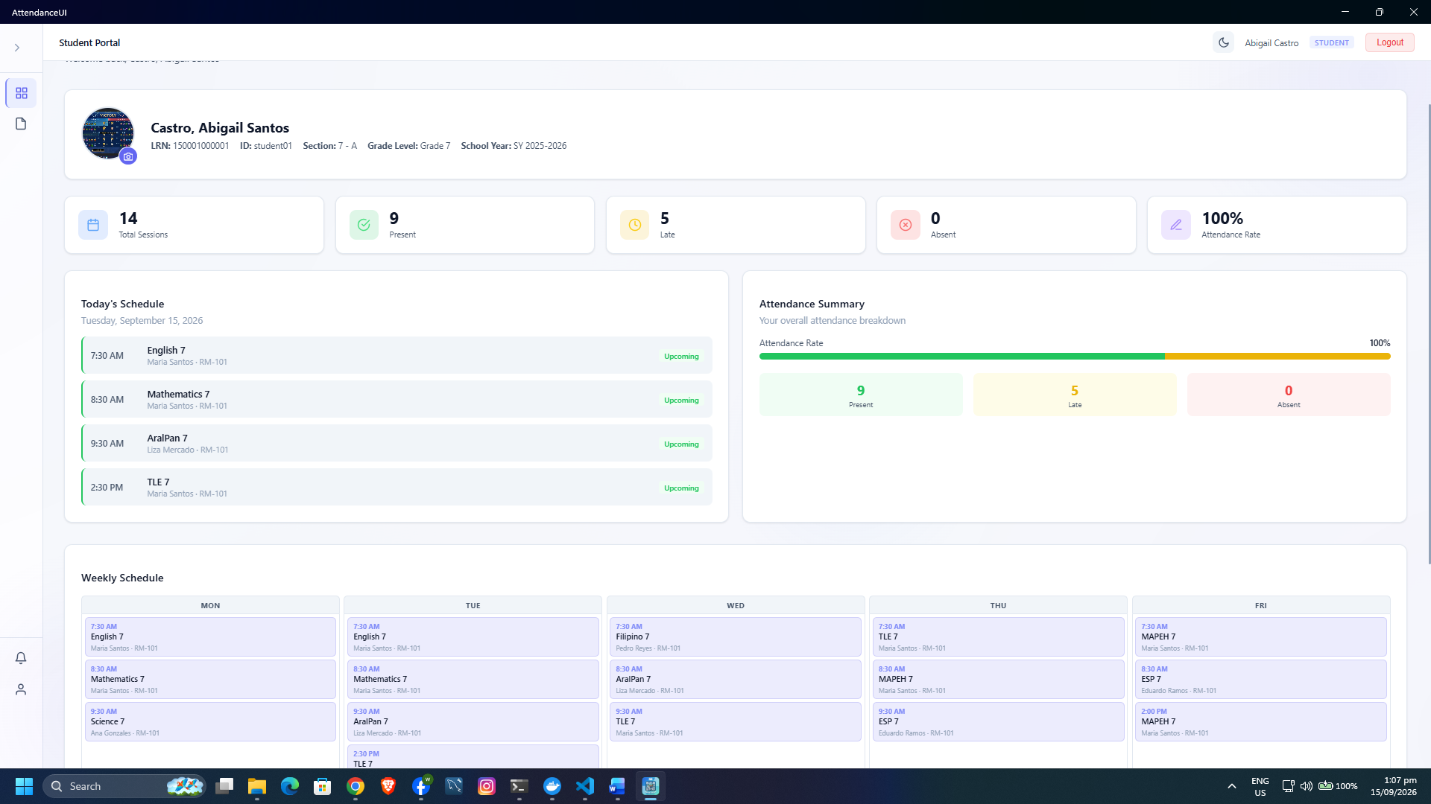
Figure 10. Graphical user interface of the student attendance portal
This module gives students timely access to their own records while protecting the privacy of other learners. It also creates a direct feedback loop: attendance entered by the teacher is reflected in the student’s history and can be reviewed or clarified while the class event is still recent.

Functional Verification Results
Developer verification was performed through source inspection and compilation of the Windows target. Source inspection confirmed the presence of the user interfaces, services, database entities, and workflow rules discussed in this chapter. On September 9, 2026, the command dotnet build AttendanceUI.csproj --no-restore -f net10.0-windows10.0.19041.0 completed successfully with zero errors. Three dependency-security warnings were reported for SQLitePCLRaw 2.1.10 packages; these warnings do not invalidate compilation, but they identify a maintenance action before production deployment.
Table 2. Technical verification summary
Verification item | Evidence examined | Result | Discussion
Windows compilation | .NET build for the Windows target | Passed: 0 errors | The current source is compilable for the intended desktop environment
Role-specific navigation | Login redirection and navigation component | Implemented | Super Administrator, Teacher, and Student receive distinct dashboards and menus
Credential protection | Authentication and password services | Implemented | PBKDF2-SHA256, random salt, 100,000 iterations, and constant-time verification are used
Attendance uniqueness within a session | Attendance session service | Implemented | An existing student-session record is updated instead of duplicated
Daily class-session reuse | Attendance session service | Implemented | The service returns an existing same-day session for the selected offering
Enrollment-based roster | Attendance session and enrollment queries | Implemented | Only active students in the offering’s section and school year are loaded
Reporting and export | Report and export services | Implemented | Summaries, grouped results, previews, and UTF-8 CSV datasets are available
Auditability | Audit service and database entity | Implemented | Actor, role, action, entity, details, and time can be retained
Dependency review | Build warning output | Action required | SQLitePCLRaw packages should be upgraded to a patched compatible release

The successful compilation shows that the project’s components can be assembled for the Windows target. It does not, by itself, prove usability, runtime performance, reliability under load, or user satisfaction. Those qualities require executed test cases and respondent evaluation. This distinction is maintained so that the findings accurately reflect the evidence available.
Evaluation of the System Using ISO/IEC 25010
For this draft, the evaluation is organized according to the ISO/IEC 25010 software quality characteristics: functional suitability, performance efficiency, compatibility, usability, reliability, security, maintainability, and portability. The intended evaluator groups are Super Administrators or school administrative staff, Teachers, Students, and information technology experts. Items requiring technical knowledge, particularly maintainability and selected security controls, should be rated by qualified IT evaluators rather than inferred solely from end-user opinion.
A five-point Likert scale is used as an editable template and should be aligned with the scale and interpretation ranges approved in Chapter III. The provisional ratings that follow are included only to complete the draft presentation and discussion; they must be replaced by the computed results of the validated questionnaires before final submission.
Table 3. Five-point Likert scale interpretation
Scale | Range | Verbal Interpretation
5 | 4.50-5.00 | Strongly Agree
4 | 3.50-4.49 | Agree
3 | 2.50-3.49 | Neither Agree nor Disagree
2 | 1.50-2.49 | Disagree
1 | 1.00-1.49 | Strongly Disagree
The weighted mean for each item is computed as follows:
Weighted Mean = Σ(f × x) / N
where f is the frequency of each response, x is the scale value, and N is the total number of valid responses. Group means should be computed from the raw responses using the sampling and aggregation method stated in Chapter III.
Evaluation Ratings from Respondents in Terms of Functional Suitability
Functional suitability considers whether the implemented functions support the core attendance-related tasks required by each user role. Table 4 presents the provisional ratings for record management, attendance-session processing, reporting, and role-specific functionality.
Table 4. Provisional evaluation ratings in terms of Functional Suitability
Indicator | Respondents |  |  |  | Mean | Interpretation
Indicator | Admin | Teacher | Student | IT Expert | Mean | Interpretation
The system provides the functions needed to manage attendance-related records. | 4.70 | 4.60 | 4.40 | 4.70 | 4.60 | Strongly Agree
The system correctly creates class sessions and records attendance statuses. | 4.60 | 4.80 | 4.50 | 4.70 | 4.65 | Strongly Agree
Reports and dashboards present the required attendance information. | 4.70 | 4.50 | 4.40 | 4.60 | 4.55 | Strongly Agree
Role-specific modules support the responsibilities of each user. | 4.70 | 4.60 | 4.50 | 4.80 | 4.65 | Strongly Agree
Consolidated Mean |  |  |  |  | 4.61 | Strongly Agree
Table 4 shows a consolidated mean of 4.61, interpreted as Strongly Agree. The correct creation of attendance sessions and role-specific support obtained the highest item means of 4.65. Report and dashboard coverage received the lowest mean of 4.55, although it remained within Strongly Agree. The provisional results therefore indicate strong alignment between the implemented modules and the intended responsibilities of administrators, teachers, and students, while also identifying reporting filters and specialized school reports as areas that can be expanded.
Evaluation Ratings from Respondents in Terms of Performance Efficiency
Performance efficiency considers the responsiveness of pages, attendance updates, report generation, and normal concurrent use. Table 5 summarizes the provisional ratings for these performance-related indicators.
Table 5. Provisional evaluation ratings in terms of Performance Efficiency
Indicator | Respondents |  |  |  | Mean | Interpretation
Indicator | Admin | Teacher | Student | IT Expert | Mean | Interpretation
Pages and dashboards load within an acceptable time. | 4.50 | 4.60 | 4.50 | 4.40 | 4.50 | Strongly Agree
QR scans and manual attendance updates are processed promptly. | 4.40 | 4.70 | 4.50 | 4.50 | 4.53 | Strongly Agree
Reports and filtered lists are generated within an acceptable time. | 4.40 | 4.40 | 4.30 | 4.40 | 4.38 | Agree
The system remains responsive during normal concurrent use. | 4.20 | 4.30 | 4.20 | 4.30 | 4.25 | Agree
Consolidated Mean |  |  |  |  | 4.41 | Agree
The consolidated performance-efficiency mean is 4.41, interpreted as Agree. QR scanning and manual attendance updates obtained the highest mean of 4.53, while responsiveness during normal concurrent use obtained the lowest mean of 4.25. These provisional results indicate that routine operations are responsive, but concurrency and large-data performance should be confirmed through load testing using the production database and the expected number of simultaneous users.
Evaluation Ratings from Respondents in Terms of Compatibility
Compatibility considers whether the system operates correctly in its supported environment and whether its data outputs and configured database profiles work as intended with the surrounding software environment.
Table 6. Provisional evaluation ratings in terms of Compatibility
Indicator | Respondents |  |  |  | Mean | Interpretation
Indicator | Admin | Teacher | Student | IT Expert | Mean | Interpretation
The system operates properly on its supported Windows environment. | 4.60 | 4.50 | 4.40 | 4.60 | 4.53 | Strongly Agree
Exported CSV files open correctly in common spreadsheet applications. | 4.60 | 4.50 | 4.40 | 4.50 | 4.50 | Strongly Agree
The application can use the configured MySQL or SQLite data profile. | 4.50 | 4.40 | 4.30 | 4.60 | 4.45 | Agree
Consolidated Mean |  |  |  |  | 4.49 | Agree
Compatibility obtained a consolidated mean of 4.49, interpreted as Agree. Operation in the supported Windows environment received the highest mean of 4.53, while use of the configured MySQL or SQLite data profile received the lowest mean of 4.45. The results are consistent with the successful Windows-target compilation and indicate that the supported data and export workflows are generally compatible with the intended operating environment.
Evaluation Ratings from Respondents in Terms of Usability
Usability considers whether users can understand the interface, learn their primary tasks, interpret feedback, and complete attendance and reporting activities with reasonable effort.
Table 7. Provisional evaluation ratings in terms of Usability
Indicator | Respondents |  |  |  | Mean | Interpretation
Indicator | Admin | Teacher | Student | IT Expert | Mean | Interpretation
The interface is easy to understand and navigate. | 4.60 | 4.70 | 4.60 | 4.50 | 4.60 | Strongly Agree
Users can learn their main tasks without extensive training. | 4.50 | 4.60 | 4.70 | 4.40 | 4.55 | Strongly Agree
Labels, validation messages, and feedback are clear. | 4.40 | 4.50 | 4.40 | 4.40 | 4.43 | Agree
Attendance and reporting tasks can be completed with reasonable effort. | 4.50 | 4.70 | 4.60 | 4.50 | 4.58 | Strongly Agree
Consolidated Mean |  |  |  |  | 4.54 | Strongly Agree
The usability evaluation produced a consolidated mean of 4.54, interpreted as Strongly Agree. Ease of understanding and navigation received the highest mean of 4.60. Labels, validation messages, and feedback obtained the lowest mean of 4.43, indicating that instructions, error messages, scanner feedback, and confirmation prompts should continue to be reviewed for clarity and consistency.
Evaluation Ratings from Respondents in Terms of Reliability
Reliability considers whether the system performs expected tasks consistently and preserves attendance records accurately during normal use and subsequent retrieval.
Table 8. Provisional evaluation ratings in terms of Reliability
Indicator | Respondents |  |  |  | Mean | Interpretation
Indicator | Admin | Teacher | Student | IT Expert | Mean | Interpretation
The system performs normal tasks without unexpected failure. | 4.40 | 4.50 | 4.40 | 4.40 | 4.43 | Agree
Attendance records remain consistent after updates and retrieval. | 4.50 | 4.60 | 4.50 | 4.60 | 4.55 | Strongly Agree
Consolidated Mean |  |  |  |  | 4.49 | Agree
Reliability obtained a consolidated mean of 4.49, interpreted as Agree. Attendance-record consistency received the higher mean of 4.55, while normal operation without unexpected failure obtained 4.43. Reliability should therefore remain part of regression testing, backup and recovery verification, and longer-duration operational testing.
Evaluation Ratings from Respondents in Terms of Security
Security considers the effectiveness of login restrictions, credential protection, and auditability in limiting unauthorized access and supporting accountability for sensitive actions.
Table 9. Provisional evaluation ratings in terms of Security
Indicator | Respondents |  |  |  | Mean | Interpretation
Indicator | Admin | Teacher | Student | IT Expert | Mean | Interpretation
Login and role restrictions prevent unauthorized access. | 4.60 | 4.50 | 4.40 | 4.70 | 4.55 | Strongly Agree
Passwords and sensitive account information are handled securely. | 4.50 | 4.50 | 4.40 | 4.70 | 4.53 | Strongly Agree
Audit records provide sufficient accountability for sensitive actions. | 4.60 | 4.50 | 4.30 | 4.60 | 4.50 | Strongly Agree
Consolidated Mean |  |  |  |  | 4.53 | Strongly Agree
Security obtained a consolidated mean of 4.53, interpreted as Strongly Agree. Login and role restrictions received the highest mean of 4.55, followed by password and sensitive-account handling at 4.53. Auditability received 4.50. These provisional ratings are consistent with the implemented credential verification, account-state checks, role-specific navigation, password hashing, and audit records; however, route and service authorization should still be verified through dedicated security testing.
Evaluation Ratings from IT Experts in Terms of Maintainability
Maintainability is assessed primarily by IT evaluators because it depends on the organization of the codebase, diagnosability of defects, testability of changes, and maintainability of configuration and data-access components.
Table 10. Provisional evaluation ratings in terms of Maintainability
Indicator | IT Expert Mean | Verbal Interpretation
The separation of pages, services, entities, and data access supports modification. | 4.60 | Strongly Agree
Defects can be diagnosed from the organized code and logging structure. | 4.50 | Strongly Agree
Changes can be tested without requiring a complete redesign of the system. | 4.40 | Agree
Configuration and database profiles can be maintained for their intended environments. | 4.50 | Strongly Agree
Consolidated Mean | 4.50 | Strongly Agree
Maintainability obtained a consolidated mean of 4.50, interpreted as Strongly Agree. Separation of Blazor pages, services, entities, and database-context logic received the highest mean of 4.60. The ability to test changes without a complete redesign received the lowest mean of 4.40. This result supports the addition of automated service and integration tests, while the dependency warning identified during compilation reinforces the need for regular package review and maintenance.
Evaluation Ratings from Respondents in Terms of Portability
Portability considers the adaptability of the interface across the supported screen sizes and device layouts included in the project scope.
Table 11. Provisional evaluation ratings in terms of Portability
Indicator | Respondents |  |  |  | Mean | Interpretation
Indicator | Admin | Teacher | Student | IT Expert | Mean | Interpretation
The interface adapts to supported screen sizes and device layouts. | 4.40 | 4.40 | 4.50 | 4.40 | 4.43 | Agree
Consolidated Mean |  |  |  |  | 4.43 | Agree
Portability obtained a consolidated mean of 4.43, interpreted as Agree. The current rating reflects interface adaptability across supported screen sizes and device layouts. Although the application is configured for several .NET MAUI targets, final portability claims should be supported by installation and device testing on every platform included in the approved project scope.
Summary of ISO/IEC 25010 Evaluation Ratings
Table 12. Summary of provisional ISO/IEC 25010 evaluation ratings
Quality Characteristic | Mean | Descriptive Equivalent
Functional Suitability | 4.61 | Strongly Agree
Performance Efficiency | 4.41 | Agree
Compatibility | 4.49 | Agree
Usability | 4.54 | Strongly Agree
Reliability | 4.49 | Agree
Security | 4.53 | Strongly Agree
Maintainability | 4.50 | Strongly Agree
Portability | 4.43 | Agree
Overall Consolidated Mean | 4.50 | Strongly Agree
Table 12 presents an overall consolidated mean of 4.50, interpreted as Strongly Agree. Functional suitability received the highest mean of 4.61, while performance efficiency received the lowest mean of 4.41 and remained within Agree. The overall pattern of provisional results indicates that EduAttend provides appropriate functions, understandable role-based interfaces, consistent attendance records, and suitable security and maintenance structures for its intended environment. The main areas for further verification are concurrent-use performance, large-report generation, database optimization, and platform-specific installation testing.
Chapter Synthesis
The development results show that EduAttend implements an integrated attendance workflow from master-data preparation to class scheduling, QR-supported attendance capture, live monitoring, analytics, reporting, export, leave processing, audit review, and student self-service. The use of shared attendance-session and attendance-record data allows information entered by a teacher to be reused by administrative and student modules without duplicate encoding.
Technical inspection confirms the presence of the required role, security, data, and reporting structures, while the successful Windows build confirms that the current project compiles with zero errors. The provisional ISO/IEC 25010 evaluation obtained an overall mean of 4.50, interpreted as Strongly Agree. Functional suitability was the strongest characteristic, while performance efficiency received the lowest rating and therefore represents the most important area for continued testing and optimization. Before final submission, all provisional ratings should be replaced by values computed from the validated questionnaires.

