Interface Control Document

Purpose:
Defines all physical and logical interfaces between boards, sensors, and the ground station.

Electrical Interface Table:

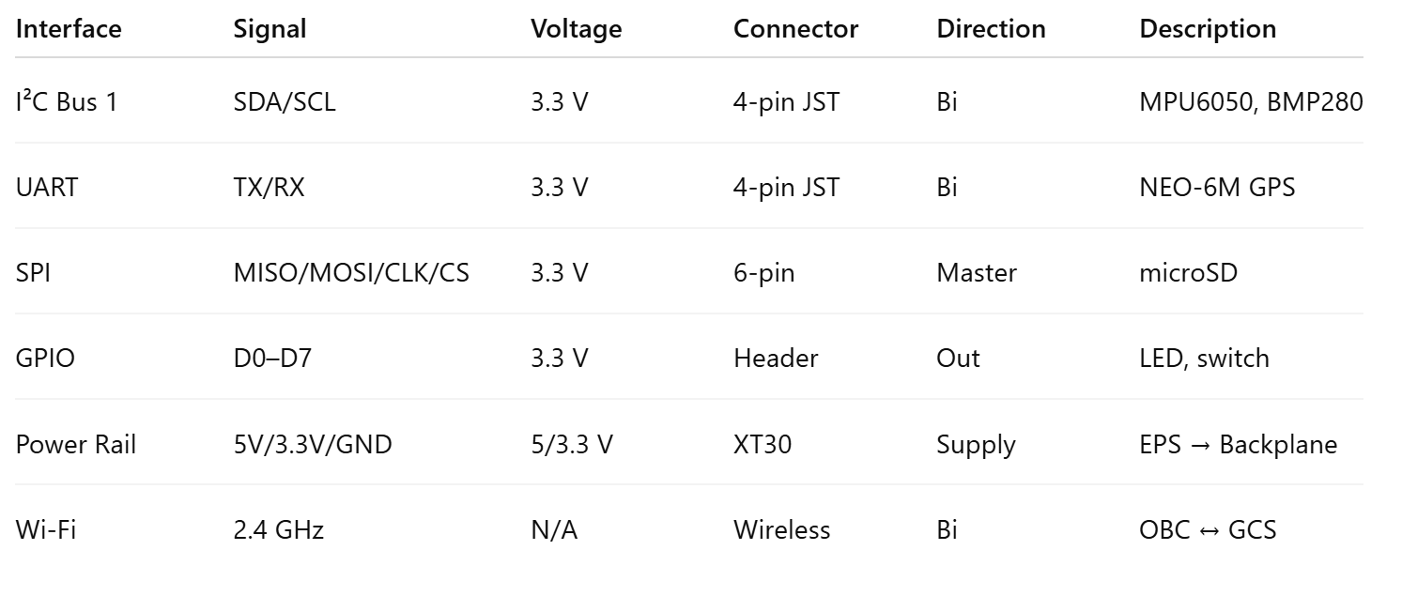
Protocol Summary:
- I²C: standard mode 100 kHz, CRC-8 validation.
- UART: 9600 baud, NMEA (GPS).
- SPI: 8 MHz clock, full duplex.
- Wi-Fi Telemetry: WebSocket/MQTT JSON, topic: sat/<id>/hk.

Timing diagram:
