Controller Program Editor

The Application is intended for creating new, editing existing programs for controller, read, modify and upload data to a controller. The controller is simulated by MC400 Simulator and operations are exposed via Trio.ControllerDirectConnection class provided in TrioControllerConnection.dll.
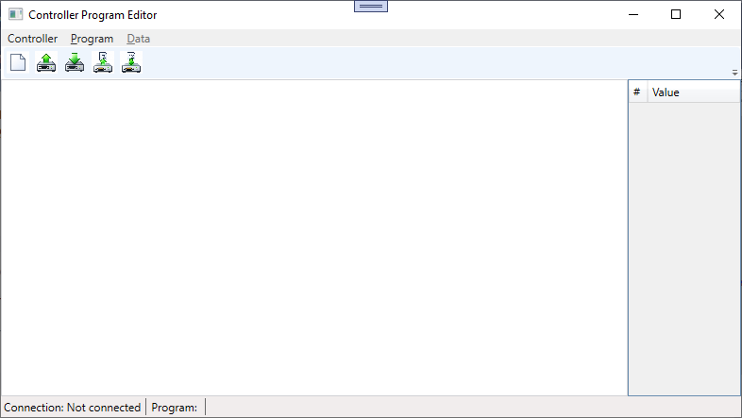
The Controller menu provides functionality to connect and disconnect from specified by name controller. /Currently for the goal of the demo only the DefaultAddress is used no matter what name is provided/
The Program menu provides ability to create new program, read program code from controller and upload it to the controller. Read program dialog also provides the option to delete a selected program.
The Data menu exposes options to read data from controller memory (TABLE Data only) and upload data to the controller.
Program and Data menu are duplicated and via buttons in the tool bar.

Design and implementation
Implementation is in WPF following MVVM architecture pattern.
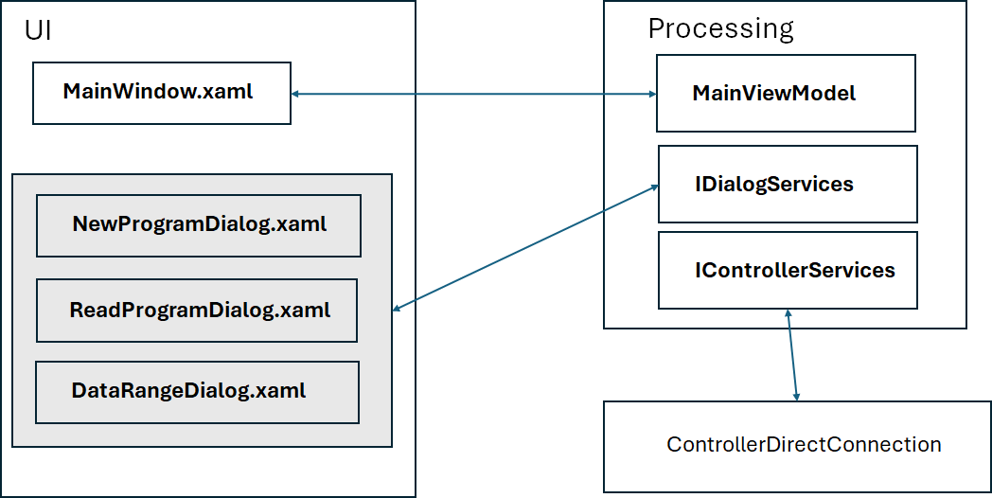

The menu items in the UI are bound to commands defined in the MainViewModel class.
The UI Enable/Disable flags are defined in the MainViewModel and used to set canExecute of commands.
Since commands are with very simple actions and implementation, a general purpose commands RelayCommand and AsyncRelayCommand inheriting ICommand are provided in the implementation. Each command inherits one of them based on if it is to be executed synchronously or asynchronously.
If a command needs any information from the UI, it calls appropriate method on IDialogService provided in the constructor of the MainViewModel. The DialogService class implements the actual messages and handling dialogs.
MainWindow and dialogs are in the UI folder of the solution.
Communication with controller is wrapped in an adapter class ControllerService exposed as IControllerService and provided to the view model in its constructor.

