Entering data

To enter new data select Data > New from the menu or click on the New Data button 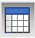 from the tool strip. New data dialog will opened:
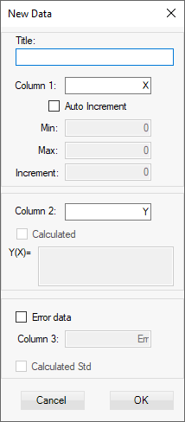

This will open a new empty data table:
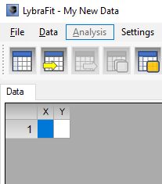
To have the first column values be auto-generated check the Auto Increment check box and enter the start, end value and steps:
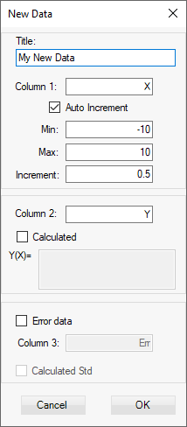
Optionally you can set data to be tabulated by checking Calculated check box and entering a math formula as shown below:
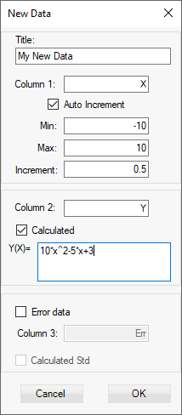
Checking the Error data check box will create third column where the error or uncertainty for each Y value in the second column can be entered manually.
If Calculated Std is checked the error will be automatically calculated every time this value is set or changed as square root of the value.
Switch to Plot tab to see the function graph:


