About LybraFit

Installation

Getting started

Entering data

To enter new data select Data > New from the menu or click on the New Data button 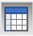 from the tool strip. New data dialog will opened:

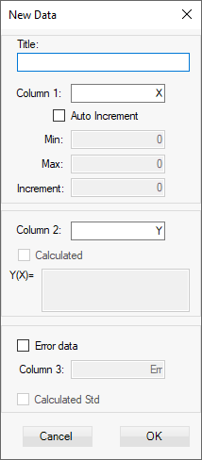

This will open a new empty data table:
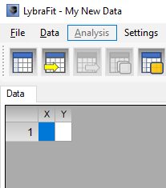
To have the first column values be auto-generated check the Auto Increment check box and enter the start, end value and steps:
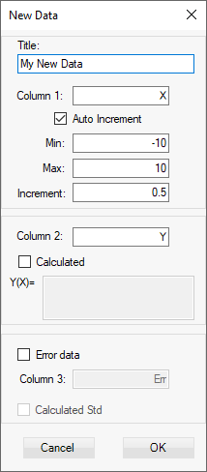
Optionally you can set data to be tabulated by checking Calculated check box and entering a math formula as shown below:
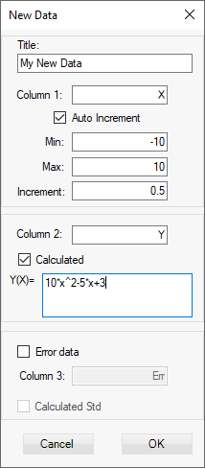
Checking the Error data check box will create third column where the error or uncertainty for each Y value in the second column can be entered manually. If Calculated Std is checked the error will be automatically calculated every time this value is set or changed as $\sqrt{Y}$.

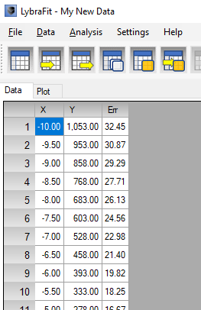

Visualizing data

Non-linear regression with library function

Non-linear regression with user defined function

User interface

Working with data

Entering data

Import data

Data from clipboard

Auto generate data

Data errors

Filter data

Transform data

Undo delete/insert

Copy to clipboard

Export data

Format table

Visualization

Visualize data

Graph settings

Filter graph

Customize plot title

Regression models

Library models

User models

Model parameters

Adding and removing models to project

Perform regression analysis

Add all library models

Copy results to clipboard

Report results

Text report

Graphics report

Projects

Saving project

Loading project

Appendix: Math functions

